PathCraft AI
Enterprise Multi-Agent Career Intelligence Platform
Technical Documentation · Version 1.0 · 2026

Google ADK 2.0 | Gemini 2.5 Flash/Pro | Cloud Run | FastAPI | Streamlit

Section 1 — Project Description
PathCraft AI is a production-grade, autonomous multi-agent platform that redefines how professionals navigate their careers. Built on Google ADK 2.0 (Agent Development Kit) and Gemini 2.5, it orchestrates a team of 10 specialised AI agents that collaborate in real-time to analyse skill gaps, optimise resumes surgically, build personalised upskilling roadmaps, and simulate realistic mock interviews — all grounded in live 2026 hiring market data.
Core Technology Stack
Layer | Technology | Role
AI Orchestration | Google ADK 2.0 + Gemini 2.5 | Multi-agent workflow, tool dispatch, HITL
Language Model | Gemini 2.5 Flash / Pro | Reasoning, generation, evaluation
Semantic Search | Gemini Embeddings + Search Grounding | Vector gap analysis & live market data
Web UI | Streamlit | 4-hub interactive dashboard
REST API | FastAPI | 10 production-ready API endpoints
PDF Engine | ReportLab | Executive-grade ATS-compliant PDF output
Deployment | Google Cloud Run | Serverless, auto-scaling, HTTPS
Learning Content | YouTube + Google Books + arXiv | Free, curated learning resources

The 4 Intelligence Hubs
Hub 1 | Dynamic Skill Gap Diagnostic: Queries live 2026 job requirements and runs a 2-tier 70/30 weighted gap analysis against your resume, highlighting Core Must-Haves (70%) vs Advanced Differentiators (30%), with semantic evidence showing which bullet in your resume proves each skill.

Hub 2 | Authentic In-Place Resume Optimizer: Surgically rewrites only the weak bullets using Google's XYZ formula (Accomplished X, measured by Y, by doing Z). Preserves real companies, dates, and job titles. Delivers a side-by-side diff view and an executive PDF with a 92/100 ATS score.

Hub 3 | Dynamic 30-60-90 Day Upskilling Roadmap: Builds a week-by-week personalised action plan adapted to your study budget (5–30 hrs/week). Integrates free YouTube courses, Google Books textbooks, arXiv research papers, and starred GitHub reference repositories.

Hub 4 | Interactive AI Mock Interview: Conducts a multi-turn Q&A session testing your identified skill gaps. Provides turn-by-turn rubric scoring (0–100), model answers, and a final Hiring Readiness report card.

Section 2 — Project Use Case
PathCraft AI serves any professional who wants to make data-driven career moves. It closes the gap between a candidate's current profile and what the 2026 job market actually demands — backed by live search grounding rather than static templates.
Target Personas
Persona | Challenge | How PathCraft AI Helps
Mid-Career Engineer  (5 yrs exp.) | Resume not shortlisted despite strong background | Hub 2 surgically upgrades every bullet with XYZ formula; Hub 1 reveals the exact missing keywords
Career Switcher  (e.g., QA → Data Eng.) | Unsure which skills to learn first | Hub 1 provides a 70/30 weighted priority list; Hub 3 builds a free 90-day plan with YouTube + books
Fresh Graduate | No experience to benchmark against | Hub 4 runs mock interview practice; Hub 3 suggests real GitHub projects to build & showcase
Job Seeker (Urgent) | Interview in 1 week | Full pipeline in under 2 minutes: gap report + optimised resume PDF + 5 key interview Q&As
Freelancer / Consultant | Multiple niche roles, varying JDs | Re-run the pipeline per JD; each run produces a uniquely tailored resume and roadmap

End-to-End User Journey (5 Steps)
Step 1 | Upload Resume + Enter Target Role: Paste or upload your PDF resume and type your target role (e.g., 'Senior Data Engineer').

Step 2 | AI Parses & Profiles: ResumeParserAgent extracts work history, skills, certs & projects. GitHubInspectorAgent scans your public repositories.

Step 3 | Live Market Gap Analysis: GapAnalyzerAgent queries live 2026 hiring data via Search Grounding and computes a 2-tier 70/30 weighted skill gap score with semantic evidence mapping.

Step 4 | Get Optimised Resume + Roadmap: ResumeGeneratorAgent rewrites weak bullets in-place with the XYZ formula. RoadmapAgent and RAGCuratorAgent generate your 30-60-90 day plan with free resources.

Step 5 | Practice with Mock Interview: InterviewSimulatorAgent asks targeted technical questions, scores each answer 0–100, provides model answers, and delivers a final Hiring Readiness scorecard.

Section 3 — Architecture Diagram
The diagram below illustrates the five-tier architecture of PathCraft AI, showing how a user request flows from the presentation layer through the ADK orchestrator, into the autonomous agent layer, through the unified shared state, and finally down to the foundational AI models and cloud infrastructure.

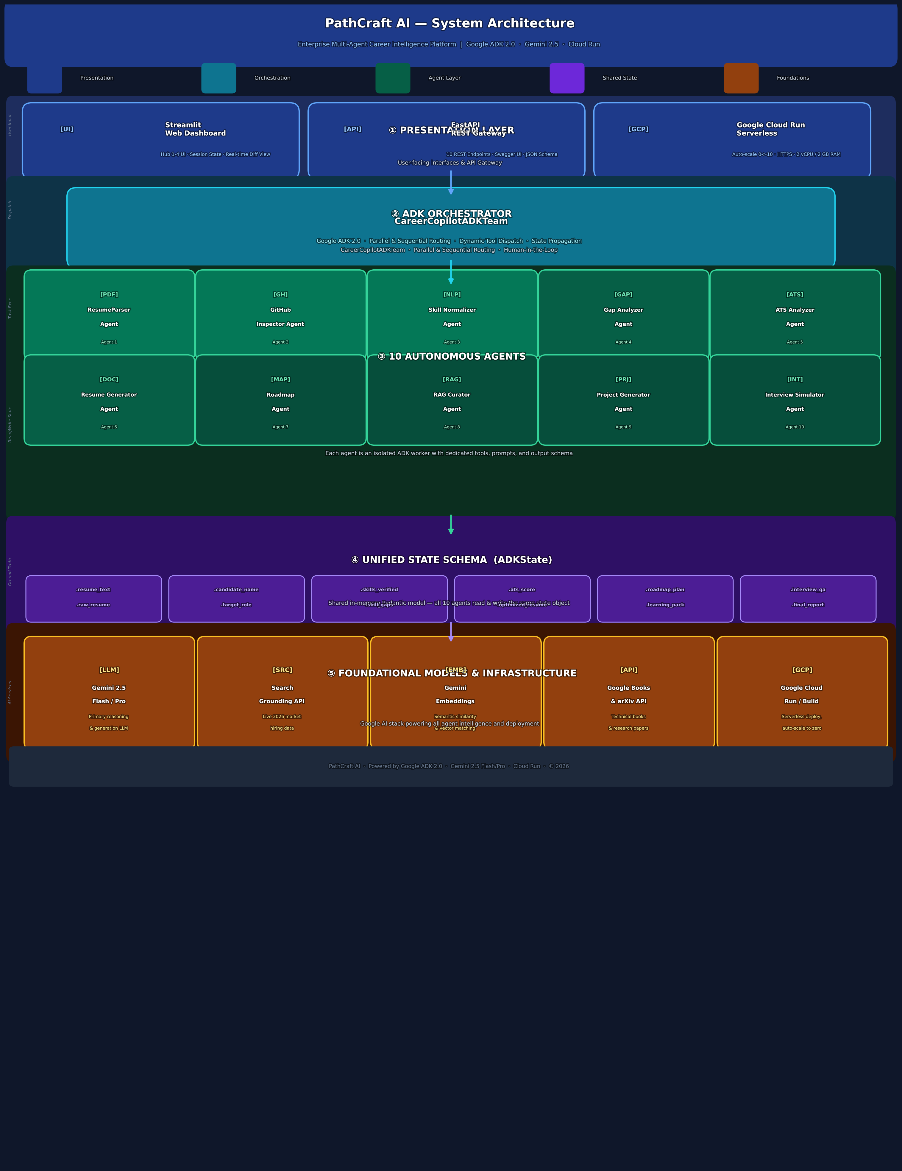

Tier Breakdown
Tier 1 | Presentation Layer: Streamlit Web Dashboard (4 Hubs), FastAPI REST Gateway (10 endpoints), deployed on Google Cloud Run with HTTPS, auto-scaling 0→10 instances, 2 vCPU / 2 GB RAM per container.

Tier 2 | ADK Orchestrator: CareerCopilotADKTeam — the central ADK 2.0 orchestrator that routes user requests to the correct agents in parallel or sequential order, manages tool dispatch, enforces Human-in-the-Loop checkpoints, and propagates shared state.

Tier 3 | 10 Autonomous Agents: Each agent is an independent ADK worker with its own prompt, toolset, and output schema. Agents run concurrently where possible. Key agents: ResumeParserAgent, GapAnalyzerAgent, ATSAnalyzerAgent, ResumeGeneratorAgent, RoadmapAgent, RAGCuratorAgent, InterviewSimulatorAgent.

Tier 4 | Unified State Schema: A shared Pydantic ADKState model (12 fields) is the single source of truth across all agents. Every agent reads from and writes to the same state object, enabling seamless data flow without inter-agent message passing.

Tier 5 | Foundational Models & Infra: Gemini 2.5 Flash/Pro for generation and evaluation; Gemini Embeddings for semantic matching; Google Search Grounding for live 2026 market data; YouTube/Books/arXiv APIs for learning content; Google Cloud Run + Cloud Build for serverless deployment.

PathCraft AI · Powered by Google ADK 2.0 · Gemini 2.5 Flash/Pro · Cloud Run · © 2026

