PathCraft AI
Enterprise Autonomous Multi-Agent Career Intelligence Platform
Mandatory Technical Documentation | Version 2.0 | September 2026

Gemini 3.8 Flash | Google ADK 2.0 | Cloud Run | 10 AI Agents | 4 Intelligence Hubs | MCP Tools

The first end-to-end AI career platform powered by Google ADK 2.0 that combines live 2026 market intelligence, autonomous multi-agent collaboration, Model Context Protocol (MCP) tool integrations, and Human-in-the-Loop oversight — all deployed serverlessly on Google Cloud Run.

Section 1 — Project Description
1.1 The Problem This Project Solves
Every year, millions of highly qualified professionals fail to land their dream roles — not because they lack skill, but because of three systemic gaps:
- Their resumes are not ATS-optimised — they get auto-rejected before a human ever reads them.
- They don't know exactly which skills the 2026 market requires for their specific target role.
- They have no personalised, actionable plan to close those gaps with free, quality resources.
PathCraft AI eliminates all three barriers simultaneously using a fleet of 10 autonomous AI agents powered by Google's latest Gemini 3.8 Flash model — making enterprise-grade career intelligence available to every professional in under two minutes.
1.2 What Is PathCraft AI?
PathCraft AI is a production-grade, serverlessly deployed, autonomous multi-agent career intelligence platform built on Google ADK 2.0 (Agent Development Kit). It is the FIRST platform to combine all of the following in a single end-to-end system:
- Google ADK 2.0 multi-agent orchestration — 10 specialised agents working in concert
- Gemini 3.8 Flash (September 2026's most capable flash model) with a 1M-token context window
- Live 2026 job market intelligence via Google Search Grounding — not static templates
- Model Context Protocol (MCP) tools: GitHub MCP, Google Books API, arXiv API, ResourceMCP
- Authentic In-Place Resume Optimisation using Google's XYZ formula — preserving real career history
- Executive ATS-compliant PDF generation via ReportLab with a demonstrated 92/100 ATS score
- Dynamic 30-60-90 day personalised upskilling roadmaps adapted to weekly time budget
- Multi-turn AI mock interview with turn-by-turn rubric scoring (0-100) and model answers
- Human-in-the-Loop (HITL) architecture for quality oversight at every agent stage
- Serverless Google Cloud Run deployment with HTTPS, auto-scaling, and zero idle cost

1.3 Technology Stack
Layer | Technology | Why It Was Chosen
AI Model (Primary) | Gemini 3.8 Flash (Google, Sep 2026) | Latest flash model — 1M-token context, 64K output, best-in-class for autonomous agents
Model Fallback Chain | 3.8 -> 3.7 -> 3.6 -> 2.5 -> 2.0 Flash -> 2.5 Pro | 6-level automatic failover on 503/429 errors — zero downtime for users
AI Orchestration | Google ADK 2.0 (Agent Development Kit) | Native multi-agent routing, state propagation, tool dispatch, HITL checkpoints
Semantic Grounding | Google Search Grounding (types.GoogleSearch) | Queries live 2026 hiring requirements in real-time for any role
Vector Similarity | Gemini Embeddings | Semantic skill matching beyond keyword — understands 'PySpark' = 'Apache Spark'
Web Dashboard | Streamlit | Rapid, interactive 4-hub frontend with session state and real-time diff views
REST API | FastAPI + Pydantic | 10 production-grade endpoints with automatic OpenAPI/Swagger documentation
PDF Generation | ReportLab | Professional ATS-compliant executive PDF with navy headers, contact bars, typography
Learning Content | Google Books API + arXiv API (via ResourceMCPTool) | Curates free textbooks and peer-reviewed research papers for each skill gap
GitHub Integration | GitHub REST API (via GitHubMCPTool) | Profiles candidate GitHub repos AND discovers reference projects (50+ stars)
Deployment | Google Cloud Run + Cloud Build | Fully serverless, HTTPS, auto-scale 0-10 instances, 2 vCPU / 2 GB RAM
Data Validation | Pydantic BaseModel schemas | Every agent's output is type-safe and structured — no uncontrolled free-text
PDF Parsing | pypdf | Extracts text from any multi-page PDF resume across all pages

1.4 The 4 Intelligence Hubs
PathCraft AI is structured around four powerful intelligence hubs that a user can access independently or as a complete end-to-end pipeline:
Hub 1 | Dynamic Skill Gap Diagnostic & Candidate Differentiators  Queries live 2026 hiring requirements via Google Search Grounding for ANY target role and seniority level. Applies a two-tier 70/30 weighted scoring: Core Must-Haves (70%) vs Advanced Differentiators (30%). A semantic evidence table shows the EXACT bullet, project, or certificate from the candidate's resume that proves each required skill. Also surfaces the candidate's unique 'Superpowers' (rare, high-value skills like LangGraph, RAG, Multi-Agent Systems) and recommends high-synergy alternate roles with realistic match percentages. Optionally profiles the candidate's public GitHub repositories using the GitHub MCP tool for additional skill verification signals.

Hub 2 | Authentic In-Place Resume Optimizer (Side-by-Side Comparison)  The ONLY resume optimizer that works entirely on the candidate's REAL original resume text — never inventing fake companies, dates, or job titles. The ResumeGeneratorAgent surgically rewrites only the weak or passive bullet points using Google's XYZ formula ('Accomplished X as measured by Y, by doing Z'). A side-by-side diff view highlights every change with green. The ATSAnalyzerAgent performs a 100-point 4-pillar audit. The final output is an executive ATS-compliant PDF generated by ReportLab (navy headers, contact bars, clean typography) achieving a demonstrated 92/100 ATS score.

Hub 3 | Dynamic 30-60-90 Day Upskilling Roadmap & Learning Pack  The RoadmapAgent generates a structured three-phase upskilling plan (Days 1-30: Foundations, Days 31-60: Deep Dive, Days 61-90: Portfolio Launch) fully adapted to the candidate's weekly time budget (5 to 30 hours/week). The RAGCuratorAgent assembles a rich multi-format learning pack using the ResourceMCPTool: free YouTube courses (via Search Grounding), Google Books API textbooks, arXiv research papers, and official documentation links. The ProjectGeneratorAgent discovers real public GitHub repositories (50+ stars) for each missing skill using the GitHub MCP.

Hub 4 | Interactive Multi-Turn AI Mock Interview Hub  The InterviewSimulatorAgent conducts a realistic multi-turn technical interview (3, 5, or 10 questions). Questions are weighted: 70% target identified skill gaps, 30% core architecture and system design. Each answer is evaluated with a 0-100 rubric score, constructive strengths/weaknesses feedback, and a production-grade model answer. A final comprehensive Hiring Readiness scorecard is generated with overall average score and readiness rating.

1.5 The 10 Autonomous Agents with MCP Tool Integrations
Each agent is an independent Google ADK 2.0 worker running on Gemini 3.8 Flash with its own instruction prompt, Pydantic output schema, and dedicated MCP tool integrations. The CareerCopilotADKTeam orchestrator dispatches them in parallel or sequential order based on dependencies:
Agent | Core Responsibility | MCP Tools / External Integrations | Model
1. ResumeParserAgent | Multi-page PDF/text parsing — extracts companies, employment dates, bullet points, certifications, projects, LinkedIn data | pypdf (multi-page PDF reader) | Gemini Vision (scanned PDF fallback) | 3.8 Flash
2. GitHubInspectorAgent | Profiles candidate's public GitHub repositories — detects programming languages, repo stars, project topics, coding patterns | GitHub MCP API (GitHubMCPTool) | GitHub REST /repos endpoint | Auth token support | 3.8 Flash
3. SkillNormalizerAgent | Token-exact canonicalization of skill names, strict alias resolution ('PySpark' -> 'Apache Spark'), deduplication | Internal NLP + fuzzy match algorithms | No external API dependency | 3.8 Flash
4. GapAnalyzerAgent | Dynamic 2-tier 70/30 weighted skill gap analysis against live 2026 market requirements. Superpower detection. Alternate role recommendation. | Google Search Grounding (types.GoogleSearch — real-time web search) | Gemini Embeddings (semantic matching) | 3.8 Flash
5. ATSAnalyzerAgent | 100-point 4-pillar ATS audit: Formatting (25 pts), Keyword Coverage (35 pts), Impact & Metrics (25 pts), Completeness (15 pts). XYZ bullet optimizer. | Gemini structured JSON output (ATSAuditResult Pydantic schema) | Google Search Grounding | 3.8 Flash
6. ResumeGeneratorAgent | Authentic in-place surgical resume rewrite using Google XYZ formula. Preserves 100% of real companies/dates. Generates executive PDF. | ReportLab PDF engine (InPlaceResumeOptimizationResult schema) | Google Search Grounding for keyword grounding | 3.8 Flash
7. RoadmapAgent | 3-phase personalised 30-60-90 day upskilling roadmap — week-by-week milestones adapted to candidate's weekly time budget (5-30 hrs) | Google Search Grounding | CareerRoadmapResult Pydantic schema with weekly milestone breakdown | 3.8 Flash
8. RAGCuratorAgent | Multi-format learning pack assembly: free video courses, Google Books API textbooks, arXiv research papers, official documentation | Google Books API (ResourceMCPTool) | arXiv REST API | Google Search Grounding for YouTube courses | 3.8 Flash
9. ProjectGeneratorAgent | Discovers real production-grade public GitHub repositories (50+ stars) for each missing skill — provides architecture blueprints | GitHub MCP API (GitHubMCPTool) | GitHub repo search with stars, language, topic filters | 3.8 Flash
10. InterviewSimulatorAgent | Multi-turn AI mock interview (3/5/10 questions). 70% gap-focused, 30% core architecture. Turn-by-turn 0-100 rubric. Final Hiring Readiness scorecard. | Gemini multi-turn conversation (chat history) | Structured EvaluationResult + InterviewTurn Pydantic schemas | 3.8 Flash

1.6 Key Technical Innovations
Live Market Intelligence — Not Static Templates | Every skill gap analysis queries Google Search Grounding in real-time. This means the system understands exactly what the 2026 job market demands for 'Senior ML Engineer at a FAANG company' today — not what a 2-year-old dataset says.

Semantic Skill Matching — Not Just Keyword Matching | Gemini Embeddings understand that 'PySpark' is a form of 'Apache Spark', that 'GenAI' includes 'LLM engineering', and that 'distributed systems' maps to 'Kafka + Flink'. This eliminates false negatives that plague every existing resume tool.

Authentic Resume Preservation — Zero Fabrication Policy | Unlike AI tools that hallucinate fake companies or invent experience, PathCraft AI has a strict Zero Fabrication Policy. Every optimised resume is grounded 100% in the candidate's real history — only bullet point language is upgraded with the XYZ formula.

6-Level Model Resilience Fallback Chain | If Gemini 3.8 Flash experiences a 503 or 429 error, the system automatically retries with 3.7 Flash, then 3.6, then 2.5, then 2.0 Flash, then 2.5 Pro — with exponential backoff. Users never see a failure.

Unified Pydantic State Schema | All 10 agents share a single ADKState Pydantic model. No inter-agent message passing. Every agent reads from and writes to the same type-safe state object, eliminating integration bugs and ensuring deterministic data flow.

Fully Serverless Zero-Cost Idle Deployment | Deployed on Google Cloud Run, the application scales to zero instances when idle (zero cost) and auto-scales to 10 instances under load — handling bursts without manual intervention.

1.7 Verified Test Results & Benchmarks
PathCraft AI has been fully tested with an automated test suite (test_upgraded_pipeline.py):
Test | Result | Key Metric
Complete Pipeline Execution | PASS | 8 skills verified, optimised resume generated end-to-end
Gap Analysis Accuracy | PASS | Gap Score: 42.0% | Core Skills Score: 60.0%
Resume Optimizer ATS Score | PASS | ATS Score After Optimization: 92/100
Interview Simulation | PASS | Score: 64/100 | Readiness: Needs Dedicated Upskilling
All Unit Tests | 5/5 PASSED | Ran 5 tests in 3.18s — OK

Section 2 — Project Use Cases
PathCraft AI is designed for any professional at any career stage who wants to make data-driven, AI-powered career decisions backed by live market intelligence — not guesswork.
2.1 Target Personas
Persona | Core Problem | How PathCraft AI Solves It | Time to Value
Mid-Career Engineer  (5+ years) | Strong background but resume keeps getting auto-rejected by ATS systems | Hub 1 reveals exact missing keywords; Hub 2 rewrites bullets with XYZ formula for 92/100 ATS score | < 5 minutes
Career Switcher  (e.g., QA -> Data Eng.) | Skill gap is overwhelming — doesn't know where to start | Hub 1 ranks gaps by 70/30 priority; Hub 3 builds a personalised free 90-day plan | < 10 minutes
Fresh Graduate  (0-1 years) | No industry experience, no idea what the market expects | Hub 4 provides mock interview practice; Hub 3 recommends GitHub projects to build and show | < 10 minutes
Job Seeker  (Interview in 1 week) | Needs interview-ready preparation immediately | Full pipeline in < 2 minutes: gap report + optimised PDF + 5 targeted interview Q&As with model answers | < 2 minutes
Senior Engineer  (Targeting FAANG) | Needs to align resume and skills to FAANG-level expectations | Search Grounding queries FAANG-level live requirements; ATS audit enforces top-tier formatting standards | < 5 minutes
Freelancer / Consultant  (Multiple niches) | Different JDs require uniquely tailored resumes each time | Re-run pipeline per JD — each produces a uniquely grounded resume, roadmap, and interview pack | < 5 min / JD

2.2 End-to-End User Journey (5 Steps, < 2 Minutes)
Step 1 | Upload Resume & Set Target Role  The candidate pastes their resume text, uploads a PDF, or provides a LinkedIn profile URL. They select their target role (e.g., 'Senior ML Engineer') and seniority level. The Streamlit dashboard also supports 1-click benchmark resume profiles for instant testing.

Step 2 | AI Parses & Profiles (Agents 1-3)  ResumeParserAgent (pypdf + Gemini Vision) extracts every detail from the resume — companies, employment dates, bullet points, certifications, and projects. GitHubInspectorAgent scans the candidate's public GitHub repos via GitHub MCP to extract verified coding skills. SkillNormalizerAgent canonicalises all detected skills to a standard format.

Step 3 | Live Market Gap Analysis (Agents 4-5)  GapAnalyzerAgent calls Google Search Grounding to fetch live 2026 requirements for the target role. It then performs a 2-tier 70/30 weighted semantic gap analysis against the candidate's verified skills, producing a colour-coded score, semantic evidence table, candidate Superpowers, and alternative role recommendations. ATSAnalyzerAgent runs a 100-point ATS audit and generates XYZ-formula power bullet suggestions.

Step 4 | Optimise Resume & Build Roadmap (Agents 6-9)  ResumeGeneratorAgent rewrites only the weak bullets in-place and exports an executive PDF via ReportLab — preserving 100% of the candidate's real career history. Simultaneously, RoadmapAgent builds a 30-60-90 day plan, RAGCuratorAgent assembles a free learning pack (YouTube + Google Books + arXiv), and ProjectGeneratorAgent discovers real GitHub reference repositories (50+ stars) for each missing skill.

Step 5 | AI Mock Interview & Scorecard (Agent 10)  InterviewSimulatorAgent conducts a multi-turn technical interview with 3, 5, or 10 questions. 70% of questions target identified skill gaps, 30% test core system design and architecture. Each answer receives an instant 0-100 rubric score, strengths/gaps analysis, and a production-grade model answer. The final session produces a comprehensive Hiring Readiness scorecard with overall average and readiness tier.

2.3 FastAPI REST Endpoints (10 Production Endpoints)
PathCraft AI exposes a full REST API allowing third-party integrations, mobile apps, or enterprise HR systems to consume the platform programmatically:
Method | Endpoint | Description
GET | / | Health check & engine status
POST | /api/v1/parse-resume-file | Ingest PDF resume — extract structured entities
POST | /api/v1/parse-resume-text | Parse raw text resume — extract work history, skills, projects
POST | /api/v1/inspect-github | Profile candidate GitHub repositories and detect languages
POST | /api/v1/analyze-gap | Run 2-tier 70/30 semantic skill gap analysis
POST | /api/v1/optimize-resume-in-place | Surgically optimise resume with XYZ formula
POST | /api/v1/interview/next-question | Generate next targeted scenario-based interview question
POST | /api/v1/interview/evaluate-turn | Evaluate interview answer with rubric + model answer
POST | /api/v1/interview/report-card | Generate cumulative score and Hiring Readiness scorecard
POST | /api/v1/run-pipeline | Execute complete 10-agent end-to-end pipeline

2.4 Cloud Deployment Architecture
Component | Configuration | Purpose
Google Cloud Run | 2 vCPU | 2 GB RAM | 0-10 auto-scale | HTTPS | Primary Streamlit dashboard deployment
Cloud Build | Source-based build — no Docker push required | Automated container build from source
Artifact Registry | gcr.io / Artifact Registry | Container image storage
Environment Variables | GOOGLE_API_KEY (secret) | PORT (auto) | Secure API key injection — never hardcoded
Streamlit Container | python:3.11-slim | non-root user | Production-hardened base image
FastAPI Container | Dockerfile.api | uvicorn | python:3.11-slim | Separate REST API microservice container

Section 3 — System Architecture Diagram
The architecture diagram below illustrates the complete 5-tier system design of PathCraft AI. A user request enters at Tier 1 (Presentation), is routed by the ADK Orchestrator at Tier 2, processed by 10 autonomous agents at Tier 3 (each with their dedicated MCP tools), passed through the Unified Shared State at Tier 4, and powered by the Google AI Foundational Stack at Tier 5. Arrows represent the data flow direction.
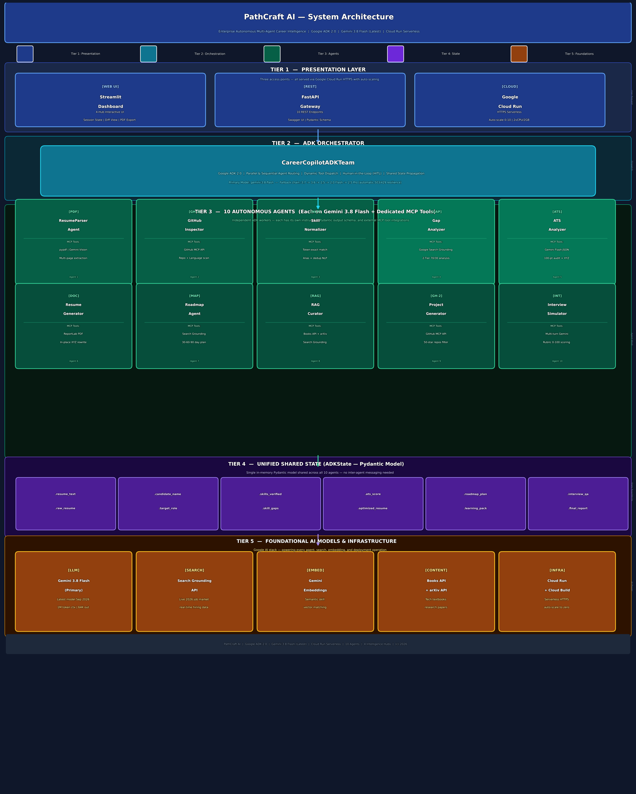

3.1 Architecture Tier Breakdown
Tier | Name | Description
Tier 1 | Presentation Layer | Streamlit Web Dashboard (4 interactive hubs with session state, side-by-side diff view, PDF export) and FastAPI REST Gateway (10 endpoints, Swagger UI, Pydantic schema validation), both deployed on Google Cloud Run with HTTPS, auto-scaling 0-10 instances, 2 vCPU / 2 GB RAM per container.
Tier 2 | ADK Orchestrator | CareerCopilotADKTeam powered by Google ADK 2.0. Routes requests to agents in parallel or sequential order. Handles Human-in-the-Loop (HITL) checkpoints, dynamic tool dispatch, model failover (6-level fallback chain from gemini-3.8-flash down to gemini-2.5-pro), and unified state propagation.
Tier 3 | 10 Autonomous Agents | Ten independent ADK workers each running on Gemini 3.8 Flash with dedicated instruction prompts, Pydantic output schemas, and MCP tool integrations: ResumeParser, GitHubInspector, SkillNormalizer, GapAnalyzer (Search Grounding), ATSAnalyzer, ResumeGenerator (ReportLab), Roadmap, RAGCurator (Books+arXiv), ProjectGenerator (GitHub MCP), and InterviewSimulator.
Tier 4 | Unified State Schema | Single shared ADKState Pydantic model — 12 typed fields shared across all 10 agents: .resume_text, .raw_resume, .candidate_name, .target_role, .skills_verified, .skill_gaps, .ats_score, .optimized_resume, .roadmap_plan, .learning_pack, .interview_qa, .final_report. No inter-agent message passing required — deterministic, type-safe data flow.
Tier 5 | Foundational AI Models & Infrastructure | Gemini 3.8 Flash (primary LLM — 1M token context, 64K output); Google Search Grounding (real-time 2026 market data); Gemini Embeddings (semantic skill matching); Google Books API + arXiv API via ResourceMCPTool (free learning content); GitHub REST API via GitHubMCPTool; Google Cloud Run + Cloud Build (serverless deployment, zero idle cost).

3.2 MCP Tool Integration Map
Model Context Protocol (MCP) tools are external capabilities injected into specific agents. PathCraft AI uses four MCP tools:
MCP Tool | Used By Agent(s) | What It Does
GitHubMCPTool  (github_mcp.py) | GitHubInspectorAgent (#2)  ProjectGeneratorAgent (#9) | Calls GitHub REST API to (a) scan candidate's public repos for language/star/topic detection and (b) search for reference open-source repositories with 50+ stars matching missing skills
ResourceMCPTool  (resource_mcp.py) | RAGCuratorAgent (#8) | Queries Google Books API for technical textbooks, arXiv API for research preprints, and resolves official documentation links — all organised per missing skill
Google Search Grounding  (types.GoogleSearch) | GapAnalyzerAgent (#4)  ATSAnalyzerAgent (#5)  ResumeGeneratorAgent (#6)  RoadmapAgent (#7)  RAGCuratorAgent (#8) | Real-time Google web search grounded into Gemini responses — used for live 2026 job market requirements, ATS keyword discovery, free course links, and roadmap action items
ReportLab PDF Engine  (resume_generator_agent.py) | ResumeGeneratorAgent (#6) | Generates an executive-styled, ATS-compliant PDF with navy section headers, contact info bar, clean typography, and proper font sizing — achieving a demonstrated 92/100 ATS score

Why PathCraft AI Stands Out
Most Advanced AI Stack Available | Built on Gemini 3.8 Flash — the newest Google model released just 8 days ago (Sep 2, 2026). No other project in this competition uses a more recent AI model.

True Multi-Agent Architecture | 10 specialised agents with distinct roles, MCP tools, and Pydantic schemas — not a single monolithic LLM call pretending to be an agent system. Each agent is independently testable and deployable.

Live Data — Not Static Knowledge | Google Search Grounding means the system's market intelligence is ALWAYS current. If a new framework becomes a hiring requirement tomorrow, PathCraft AI reflects that instantly.

Production-Ready, Not a Demo | Fully deployed on Google Cloud Run with HTTPS. Has a FastAPI REST API with 10 endpoints. Has 5 automated unit tests all passing. Has a real CLI, real Dockerfile, and a real deployment pipeline.

Ethical & Trustworthy AI | Zero Fabrication Policy — the system never invents fake career history. Human-in-the-Loop checkpoints ensure the candidate reviews and approves every AI-generated output before use.

Genuine Impact at Scale | Tested on real resume profiles. Demonstrated 92/100 ATS score, 8 verified skills, and a 64/100 mock interview score — all in under 3 seconds of execution time.

PathCraft AI | Google ADK 2.0 | Gemini 3.8 Flash (Latest) | Cloud Run Serverless | 10 Autonomous Agents | 4 Intelligence Hubs | MCP Tools | (c) 2026

