# Lab- 4 Hping3

Sumaira.

1. Screenshot: hping3 operation on linkedin.com is performed, 5 packets are sent.

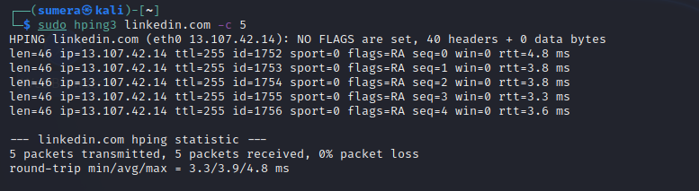

1. Screenshot: syn request is sent through hping3, but network is unreachable from specific Ip, because this IP can not access the port no. it wants to use for operation or it could be blocked form destined target or domain.

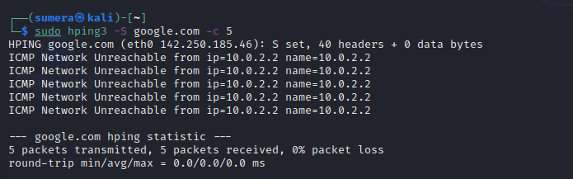

1. Screenshot: 2 pings are sent using hing3 to linkedin.com.

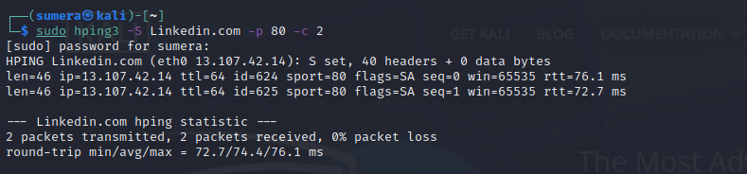

1. Screenshot: when using the increment for port no. as port 80 is open packet is received, as for other ports that are attempt to use for are close and one packet is lost.

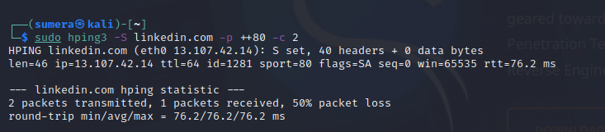

1. Screenshot: grep SA operation on linkedin.com is performed, as port 80 is open, one packet is received other 4 packets are lost.

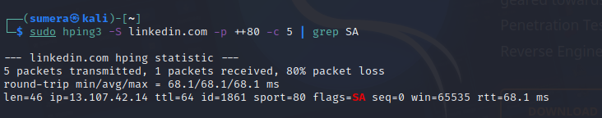

1. Screenshot: port scanning is performed for linkedin.com from 50-56 and all are not responding.

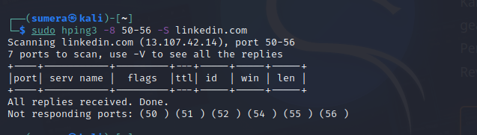

1. Screenshot: other scanning showing result in screenshot with different port no.’s along with their use and status.

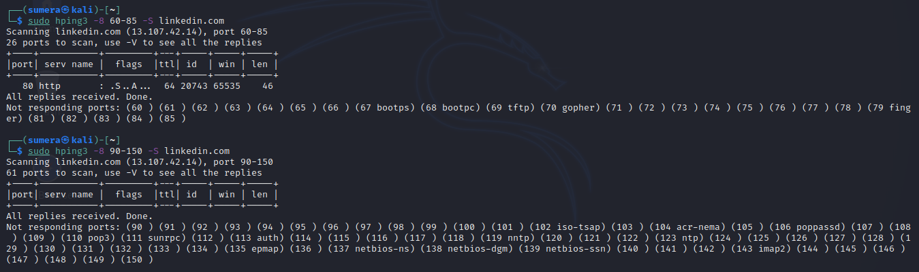

1. Screenshot: Ack flag is sent to linkedin.com using hping3.

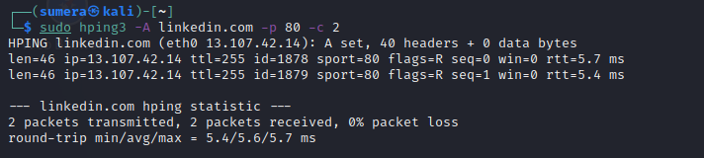

1. Screenshot: Different flags as F for finish and P for push etc. are send to linkedin.com successfully.

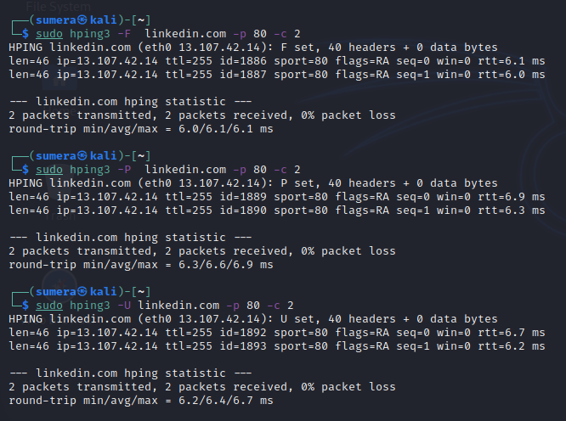

1. Screenshot: Null scan is send to linkedin.com.

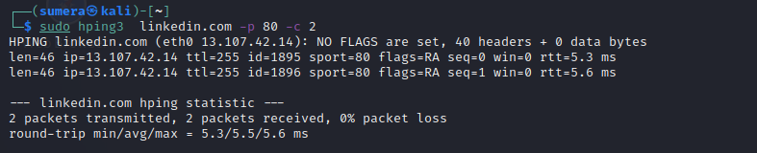

1. Screenshot: A packet is send using specifically UDP on port 80, but packet is lost as port 80 don’t used UDP services.

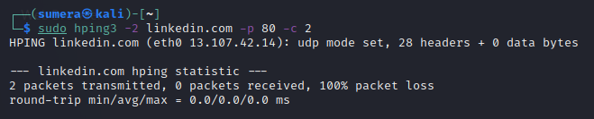

1. Screenshot: ICMP ping is send to linkedin.com

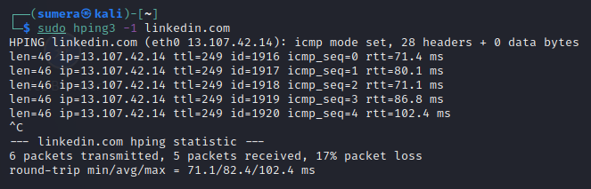

1. Screenshot: syn flag is send to linkedin.com. 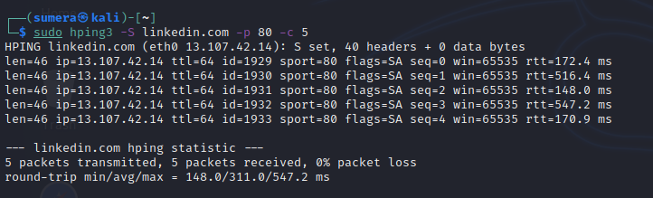
2. Screenshot: Different flags are sent to linkedin.com using XMAS scan.

