# Lab-5

Form: Sumera

1. Screenshot: simple ping command on targeted domain using cmd.

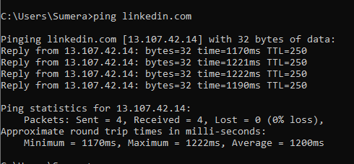

1. Screenshot: ping the router or gateway ip.

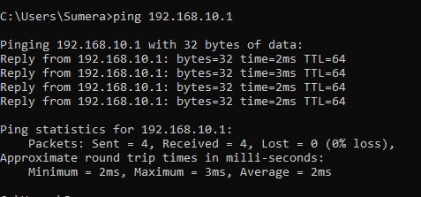

1. Screenshot: ping the NIC router ip.

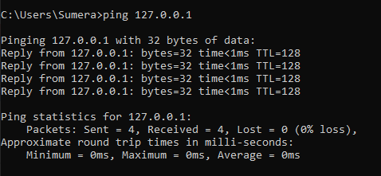

1. Screenshot: nslookup for home router.

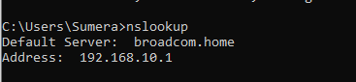

1. Screenshot: nslookup for targeted domain.

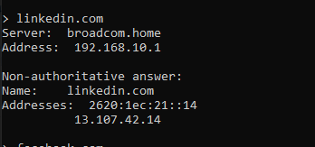

1. Screenshot: ping targeted domain using different record types.

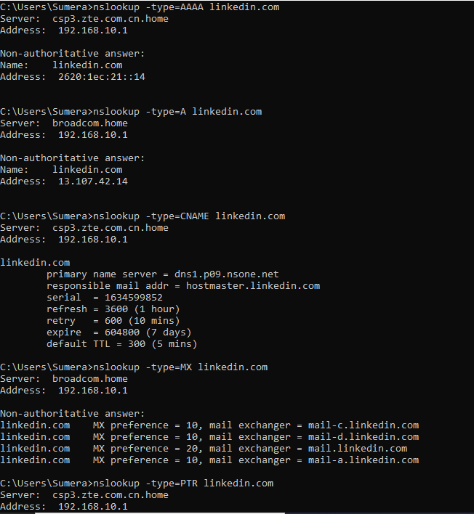

1. Screenshot: tracert command to the targeted remote host, to see the no. of hopes or routers used by packets to reach the remote host.

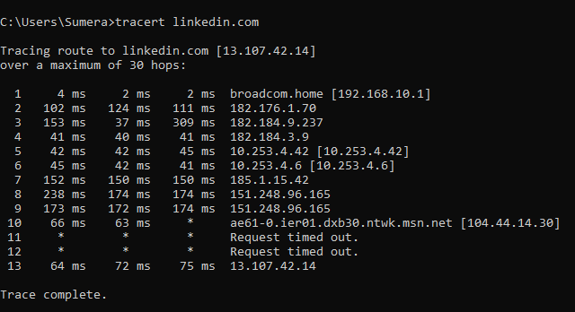

# Sublist3r:

1. Screenshot: sublist3r installed and running.

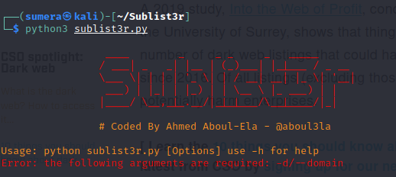

1. Screenshot: using sublist3r to target a remote host to find subdomains for linkedin.com.

