Recon-ng

# Practice Lab

By Sumera

1. Manage workspaces for the recon-ng 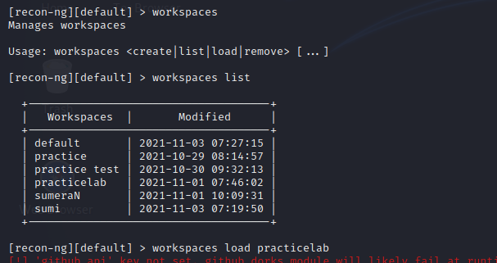
2. Inserting and viewing database domains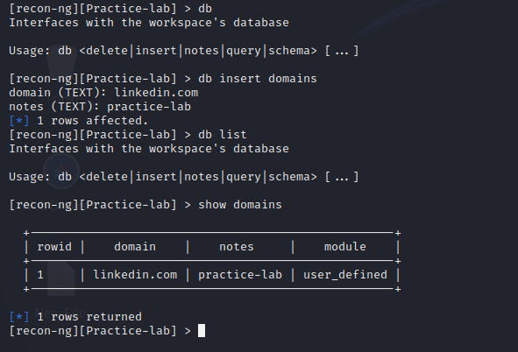
3. Searching and loading modules. 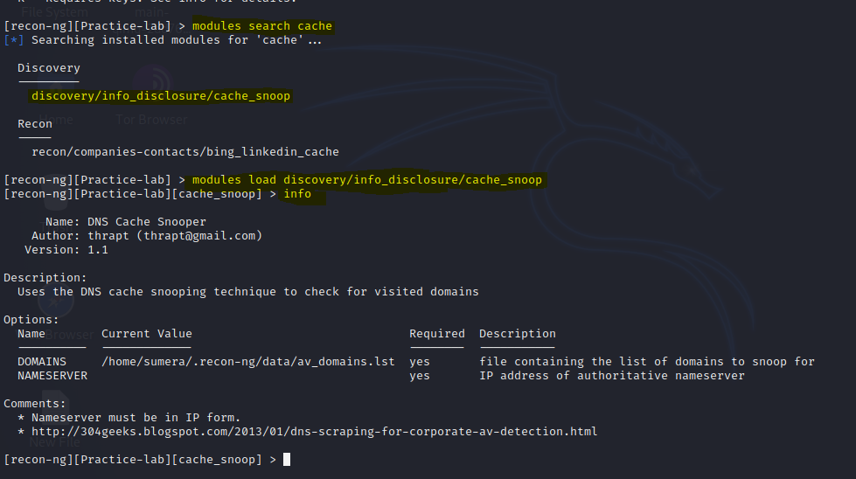
4. Error asking for nameserver. 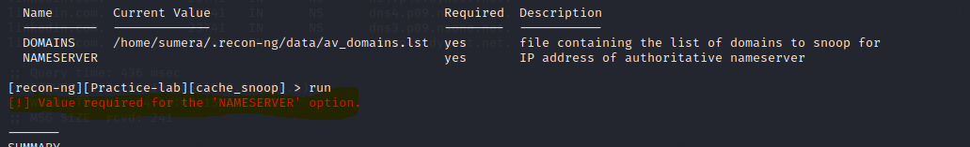
5. Searching for nameserver to provide with complete information for module to run. 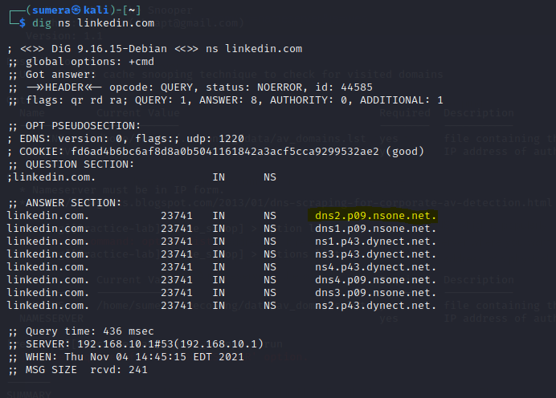
6. Finding ip for a server as ip are only allowed server name cause error. 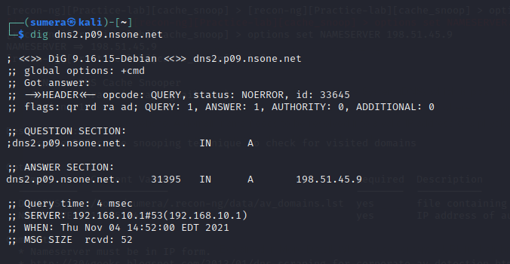
7. Setting Nameserver IP. 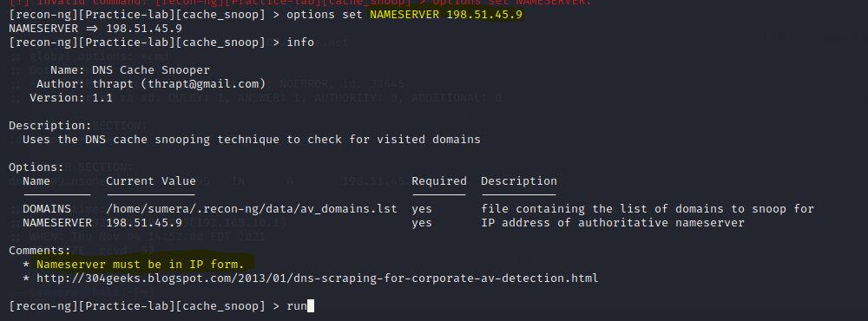
8. No Cache found at targeted NAMESERVER. 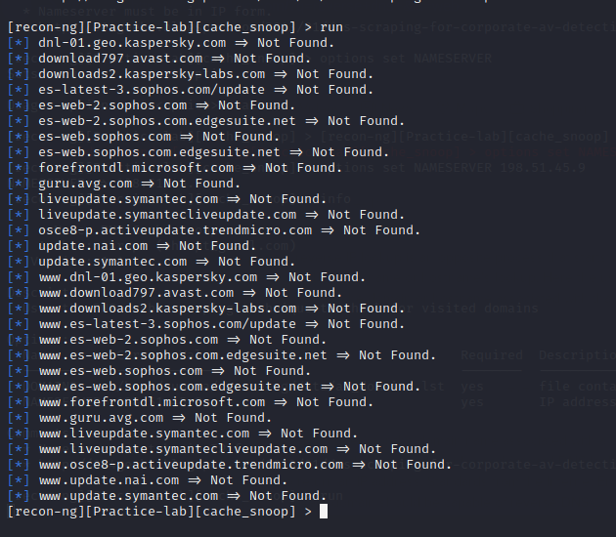
9. Trying on another NAMESERVER. 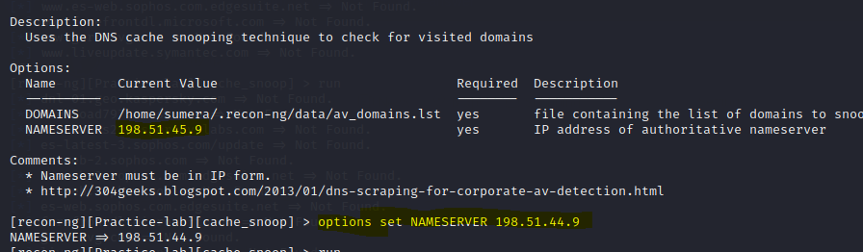
10. No Cache found. 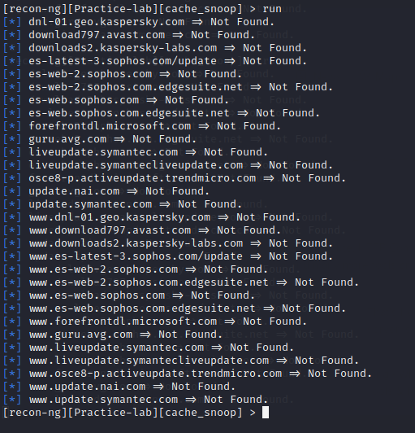
11. No data is generate to report or store. 