**Architectural Firm Management System**



**Session 2023-2027**

**Submitted by:**

Sumaira Hafeez 2023-CS-01

Fajar Shahzad 2023-CS-07

Faraih Nazar 2023-CS-27

Minahil Amjad 2023-CS-29

**Supervised by:**

Mam Aroosh

**Course:**

Computer Networks Lab

Department of Computer Science

**University of Engineering and Technology,**

**Lahore Pakistan**

**Contents**

Project Description: 2

Number of Floors: 3

First Floor: 3

Description: 3

Second Floor: 3

Description: 3

Third Floor: 3

Description: 3

IP addresses: 4

First Floor: 4

VLAN 10(RECEPTION): 4

VLAN 20(SALES): 4

VLAN 30(LOGISTIC): 4

Second Floor: 4

Third Floor: 4

Subnet masks: 5

Number of network devices: 5

Number of VLANs: 5

Routing Protocol: 5

Wireframes: 6

Shortcomings: 7

# Project Description:

An architectural firm’s management network spans three floors, using **VLANs**, **DHCP**, and **subnetting** for efficient traffic control and organization. Each department is assigned its own subnet, and **VLANs** are used to segment different teams for security and optimized performance. A central **DHCP** server on second floor dynamically assigns IP addresses, simplifying device management. Whereas, other IP addresses are assigned manually. **Inter-VLAN** communication is managed through Layer 3 switches, while Layer 2 switches handle internal traffic. This setup enhances scalability, security, and ease of network management across the firm.

# Number of Floors:

In this project we have three floors. The total number of departments areeight.

# First Floor:

* Reception
* Store
* Logistics

# Description:

In this floor we have created **3 VLANs (VLAN 10(Reception), VLAN 20(Sales), VLAN 30(Sales))** and these VLANs are connected by a central switch. Two bit **Subnetting** is also used for efficient traffic control and enhanced security over there. We also use Wireless access device to establish wireless connection between departments. The router establishes connection between departments of first floor using dot encapsulation where each wire is divided into three parts and each part is having IP address of specific department.

# Second Floor:

* Sales
* HR
* Server Room

# Description:

In this floor we use **DHCP** is used to dynamically assign the IP addresses to the devices. **Gateway** for all the devices is assigned as **192.168.20.1** and **DNS** server as **192.168.20.20**. We also used Wireless access devices to establish wireless connection between devices.

# Third Floor:

* IT
* Admin

# Description:

In this floor we used **subnetting and dual interface router.** One bit subnetting is used to enhance security whereas dual interface router is used for interconnectivity of different networks In this we used two gateways for two different subnets   
**Subnet 1 (IT Department)>> Gateway:192.168.30.3**

**Subnet 2 (Admin)>>Gateway:192.168.30.200**

# IP addresses:

# First Floor:

# VLAN 10(RECEPTION):

* 192.168.20.2/26(Printer)
* 192.168.20.3/26(PC)

# VLAN 20(SALES):

* 192.168.20.65/26(Printer)
* 192.168.20.67/26(PC)

# VLAN 30(LOGISTIC):

* 192.168.20.129/26(Printer)
* 192.168.20.130/26(PC)
* 192.168.20.132/26(Laptop1)
* 192.168.20.132/26(smartphone)

# Second Floor:

* 192.168.20.2/24
* 192.168.20.3/24
* 192.168.20.6/24
* 192.168.20.7/24
* 192.168.20.4/24
* 192.168.20.5/24
* 192.168.20.8/24
* 192.168.20.9/24

# Third Floor:

* 192.168.30.1/25
* 192.168.20.2/25
* 192.168.20.198/25
* 192.168.20.199/25

# Subnet masks:

To find the subnet mask, we can:

1. Use the IP address class or CIDR notation to determine the default subnet mask (e.g., /24 corresponds to 255.255.255.0).
2. Subtract the number of host bits from 32 in CIDR, then convert to dotted decimal format.

# Number of network devices:

* Routers:3
* Switches:3
* PC:8
* Laptops:2
* Wireless devices:2
* SmartPhones:2
* Printers:9

# Number of VLANs:

We use a total of **three** VLANs on the first floor.

# Routing Protocol:

Dynamic routing protocol is used for routing among different floors and their networks as it is the easiest and fastest way to transfer data from one department to another enhancing the communication. Furthermore, in case of one router shutdown the communication will still work using its dynamic way of finding the routes.

# Wireframes:

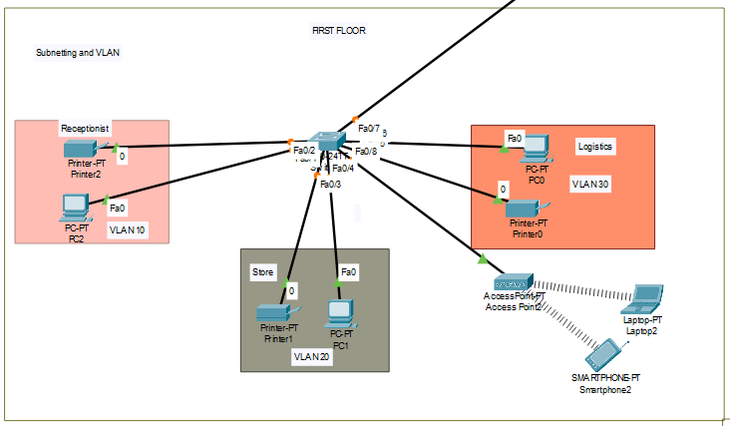

First Floor

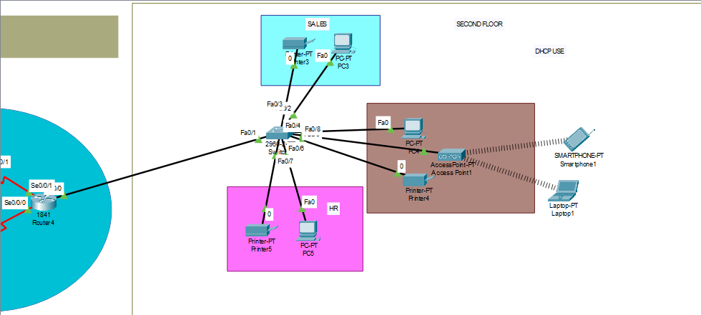

Second Floor

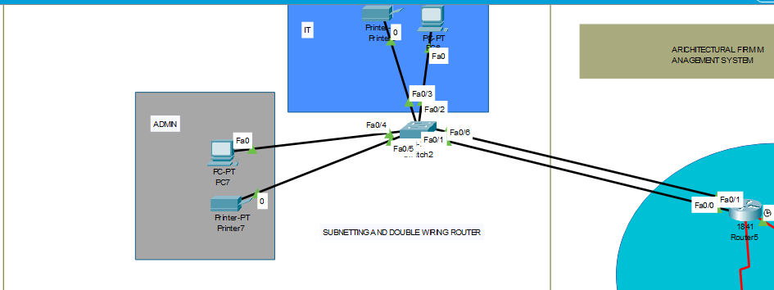

Third Floor

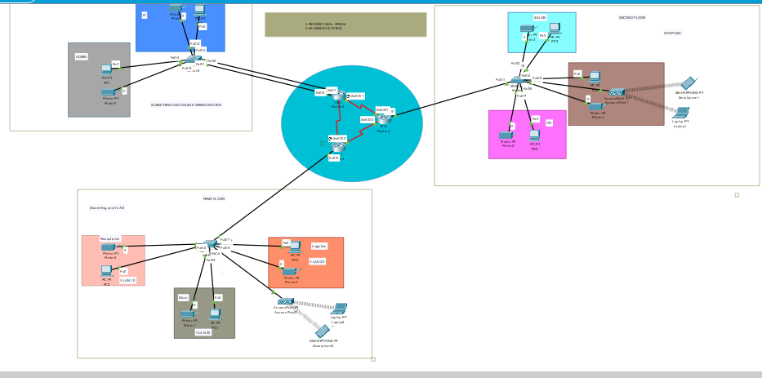

Full Model

# Shortcomings:

The given model has following shortcomings:

* + - 1. The given model encompasses everything learnt so far.
      2. It has security concerns at some specific places.
      3. Its wireless system needs more time to start working.