**Project Archive Module:**

1. Create new project details: In this page new project details are created by providing necessary information.

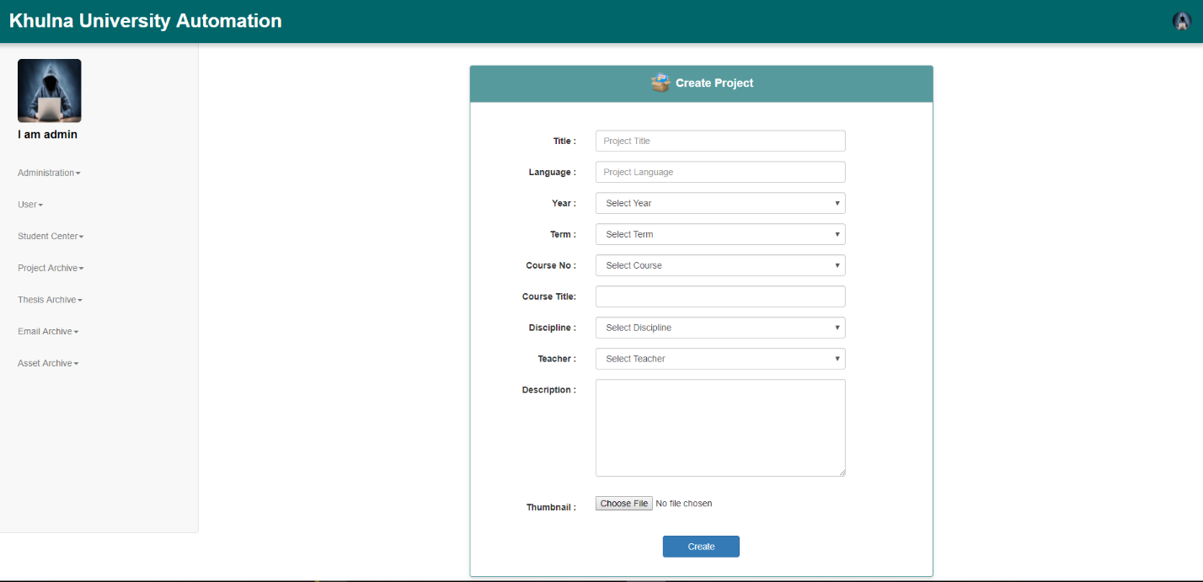

1. Display created project details: Here a table of all created projects are shown. The project details can be updated or deleted from here.

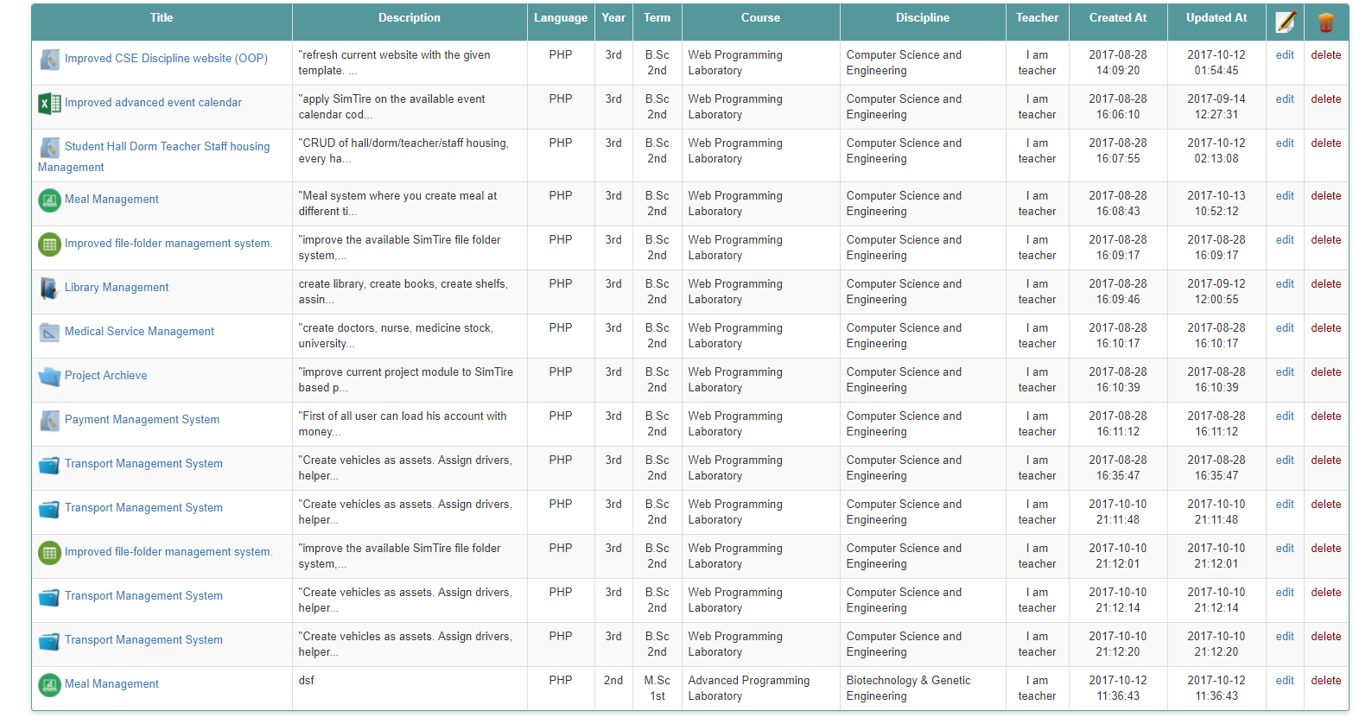

3.Browse All created projects: In this page all the project records are displayed with pagination.

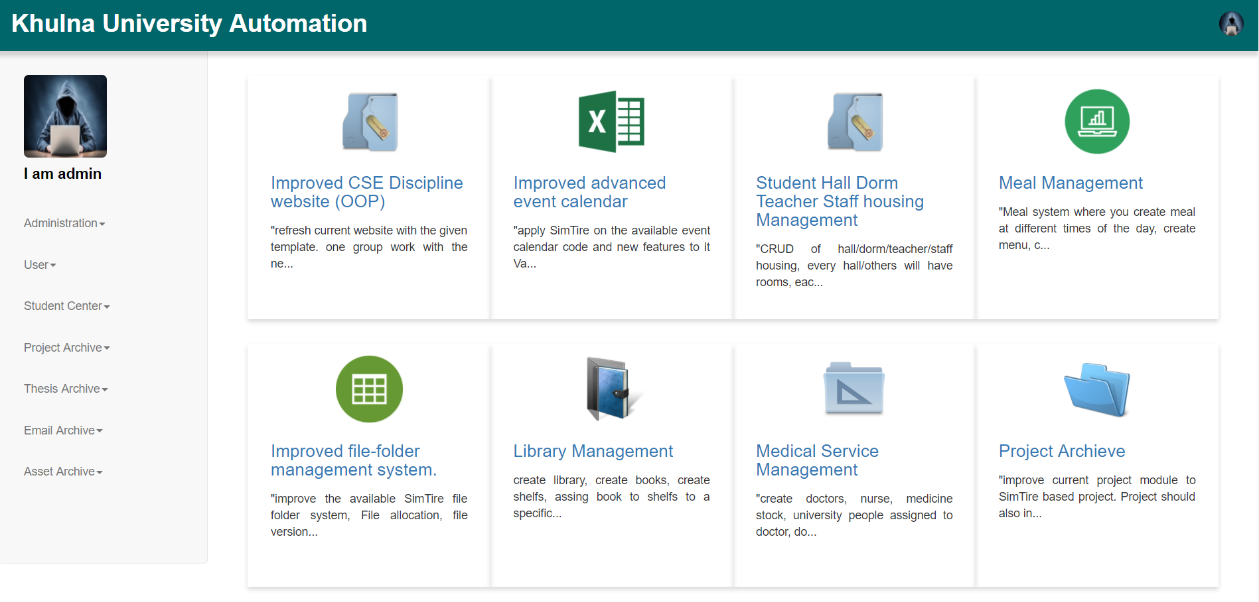

4.View details of a project: In this page all the details of the project are displayed. There are options for adding project members and their contribution in the project.

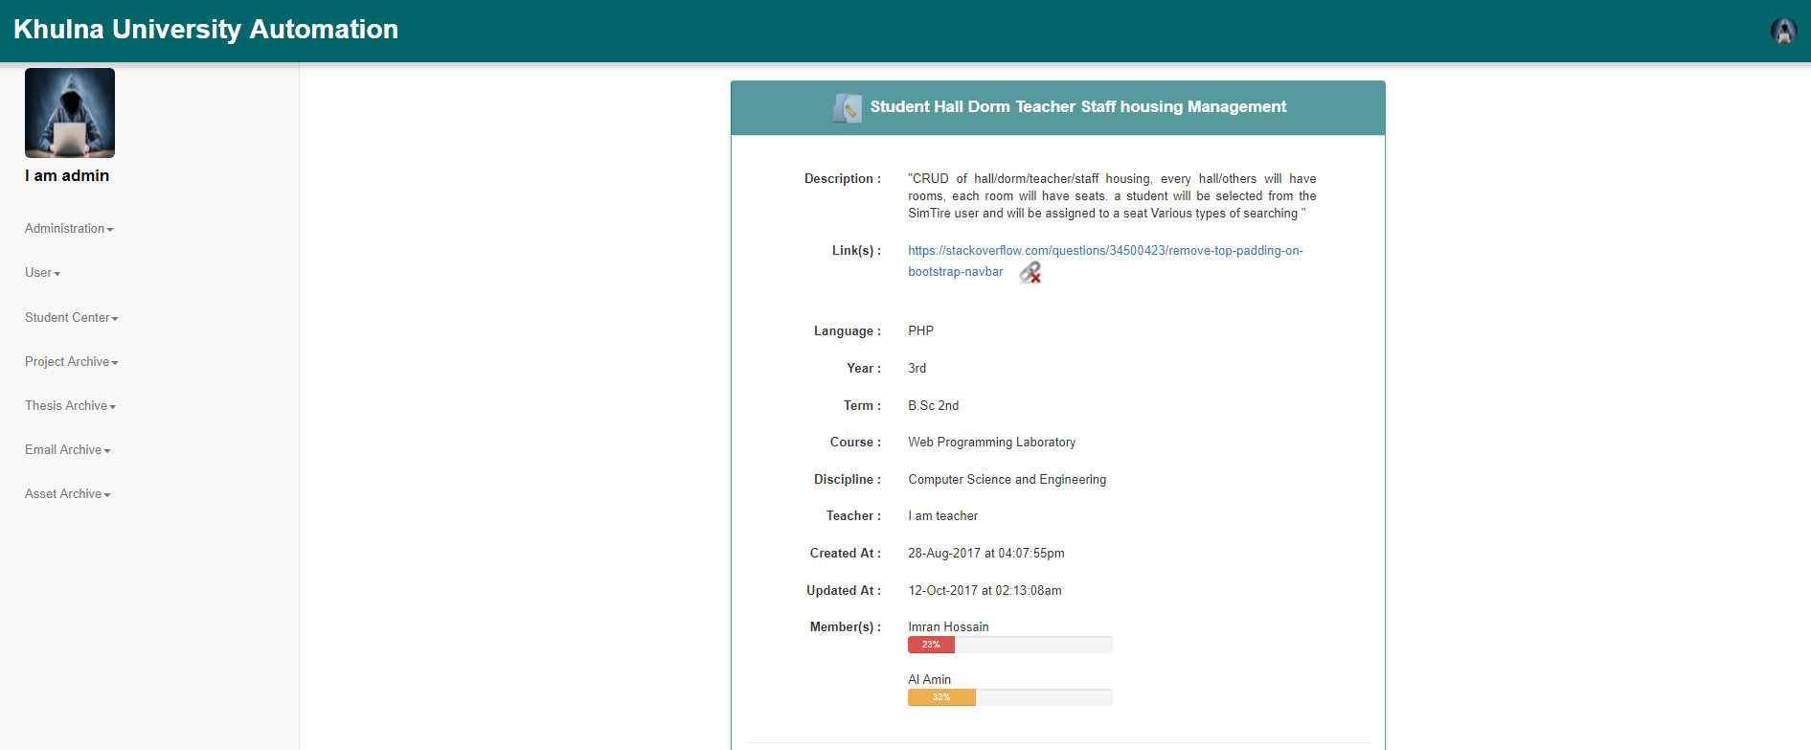

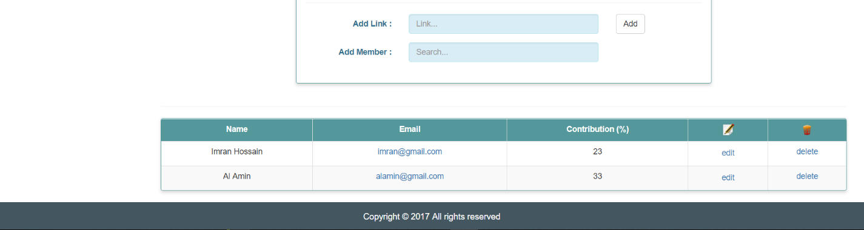

5.Search projects by different criteria: In this page projects can be searched by different criteria like title, year, term, course etc.

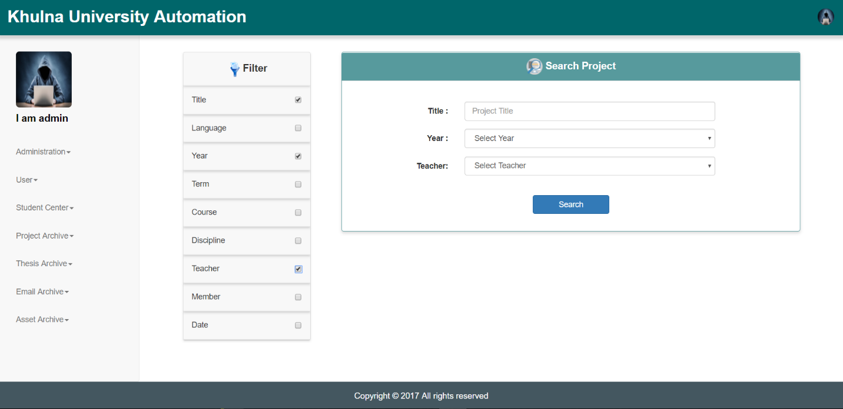

**Thesis Archive Module:**

1. Create new thesis details: In this page new thesis details are created by providing necessary information.

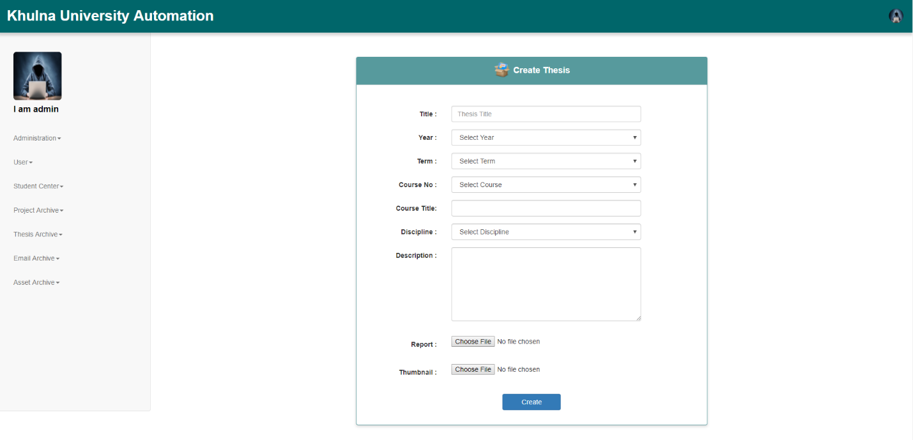

1. Display created thesis details: Here a table of all created thesis are shown. The thesis details can be updated or deleted from here.

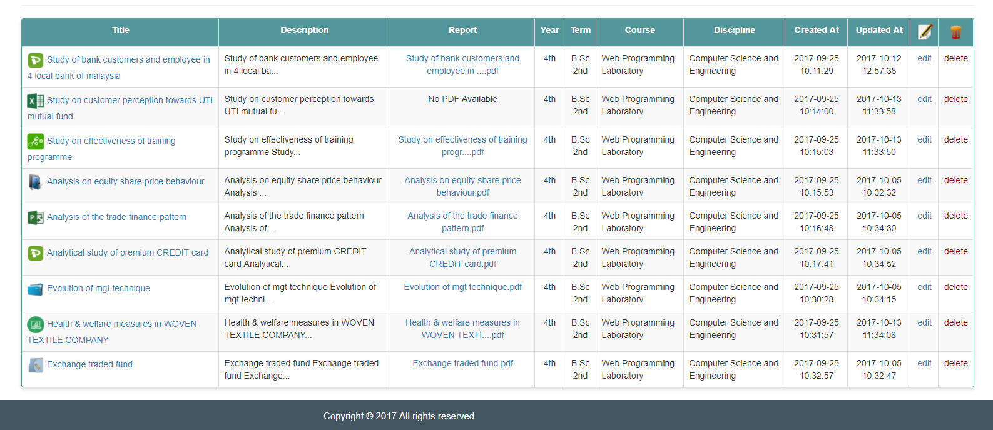

1. Browse All created thesis: In this page all the thesis records are displayed with pagination.

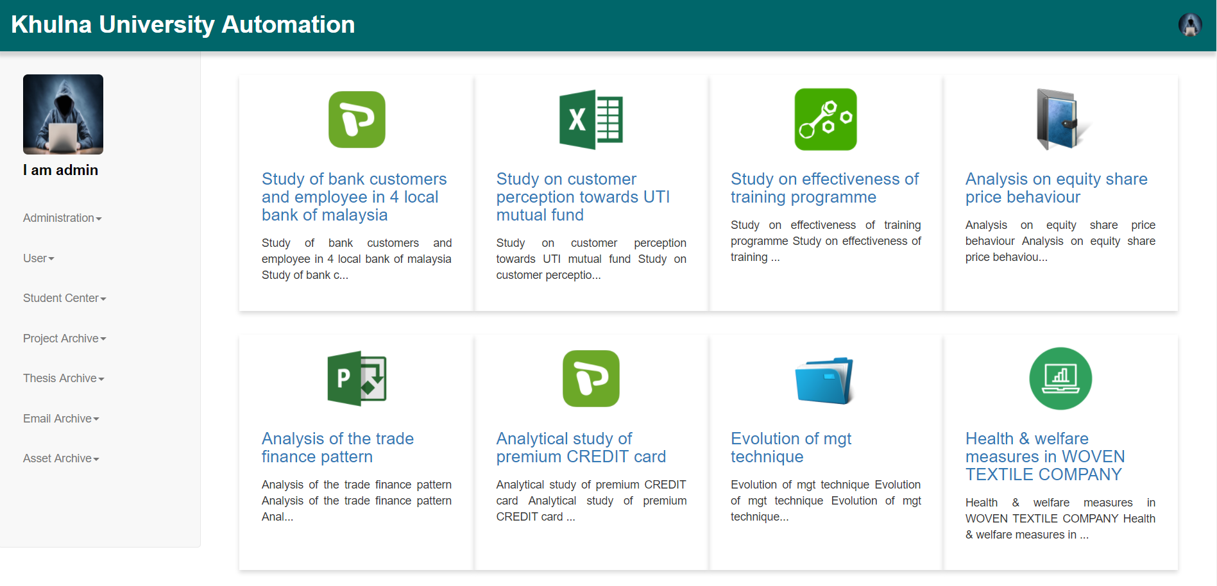

1. View details of a thesis: In this page all the details of the thesis are displayed. There are options for adding thesis members and thesis supervisor and their contribution in the thesis.

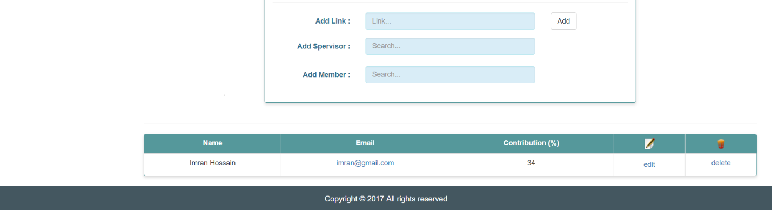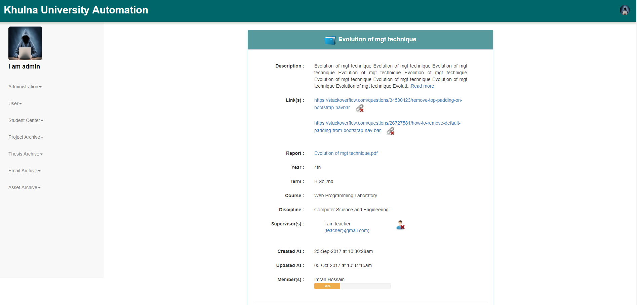

1. Search thesis by different criteria: In this page thesis can be searched by different criteria like title, year, term, course etc.

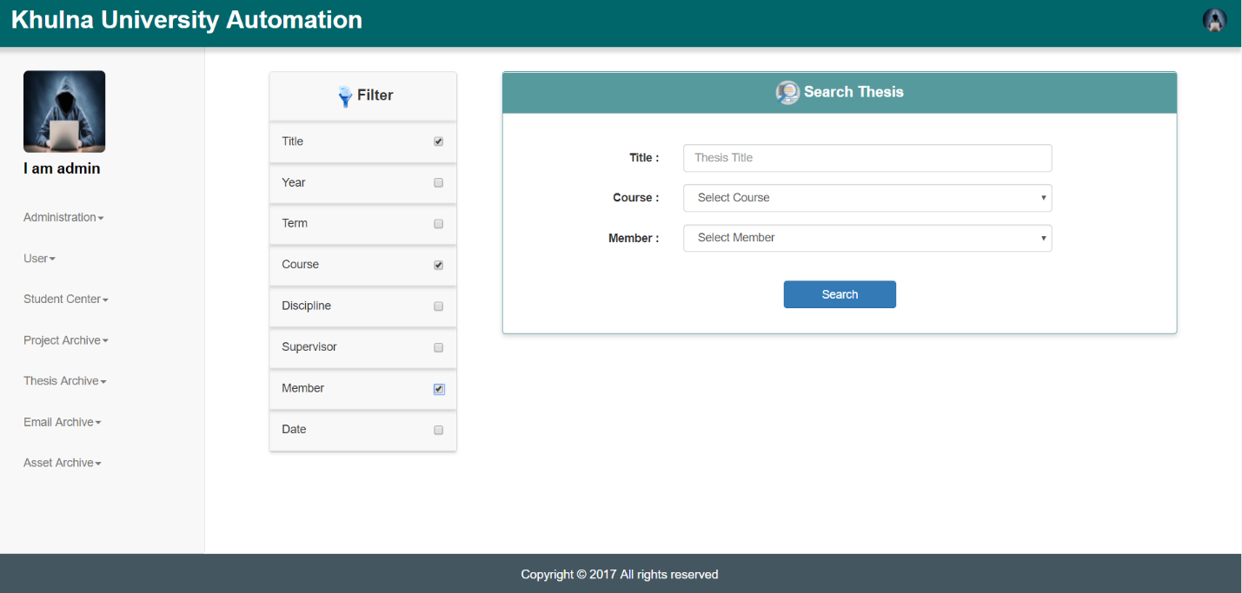

**Email Archive Module:**

1. 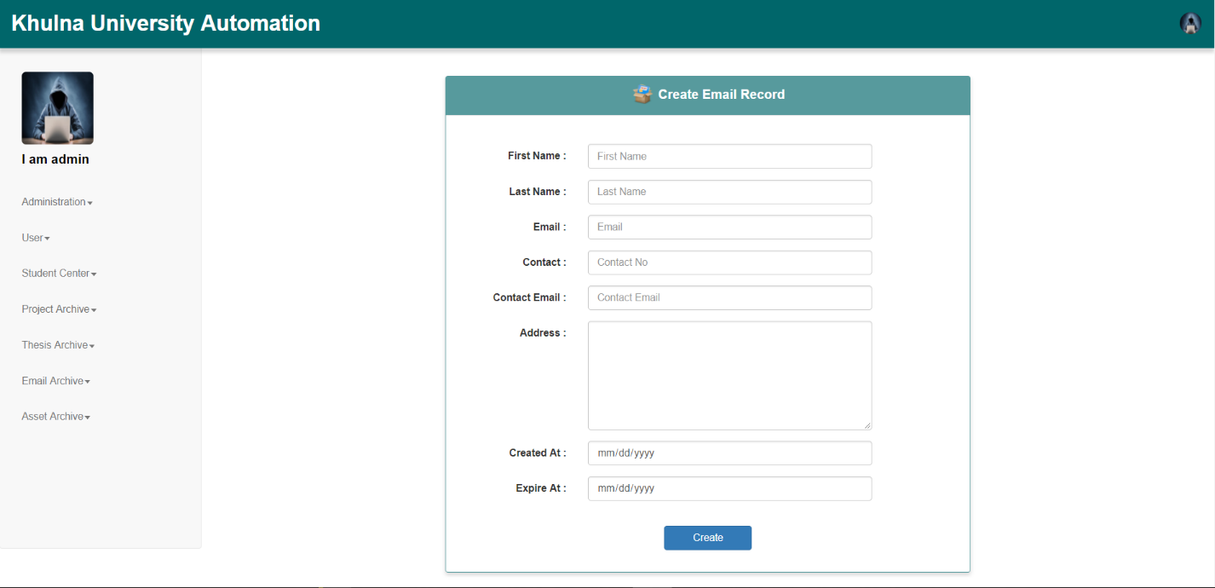Create new email details: In this page new email details are created by providing necessary information.
2. 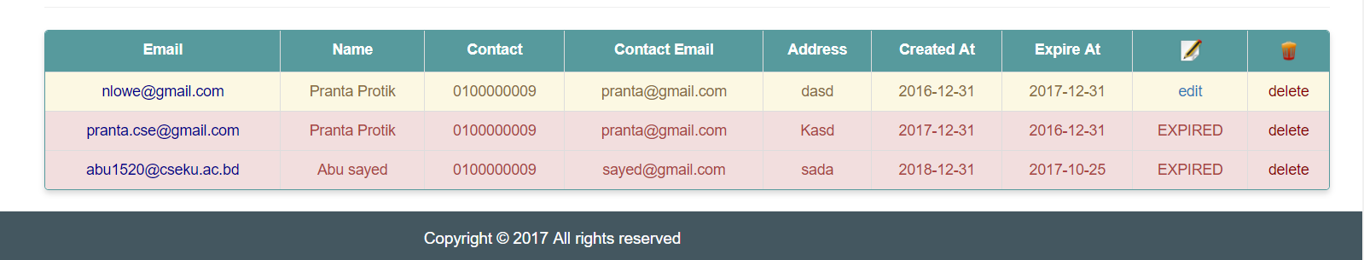Display created email details: Here a table of all created emails are shown. The email details can be updated or deleted from here.
3. Renew valid emails: Here a table of all valid emails are shown. The emails can be renewed by extending the expire date from here.

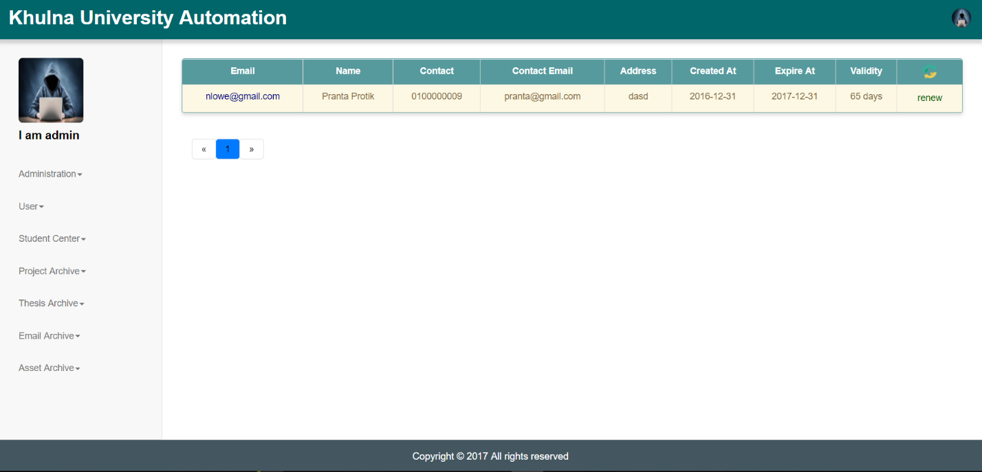

1. Extend expired emails: Here a table of all expired emails are shown. The emails validity can be extended from here.

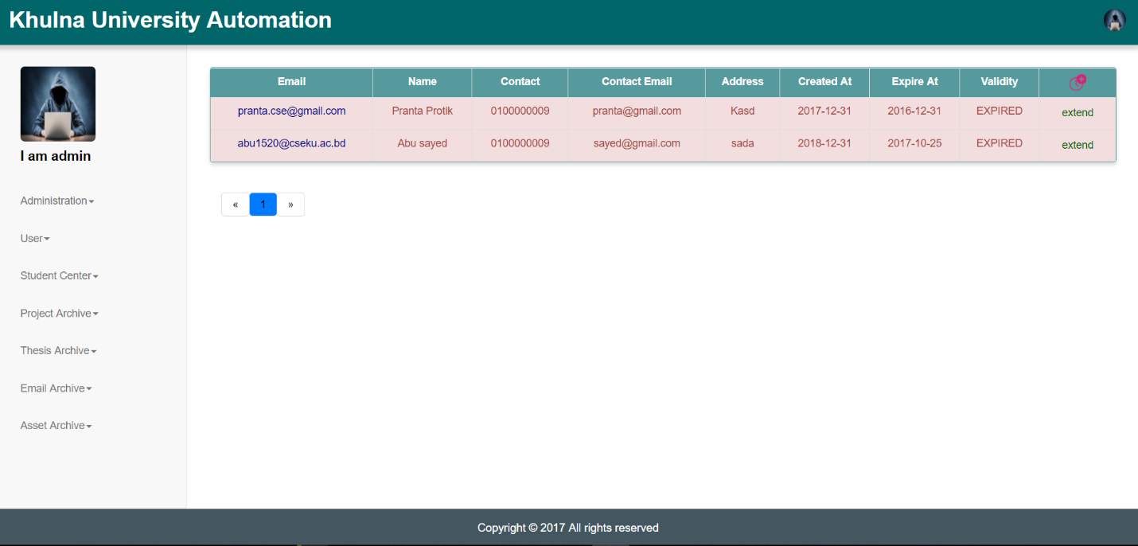

**Asset Archive Module:**

1. Create new asset type: In this page new asset types are created.

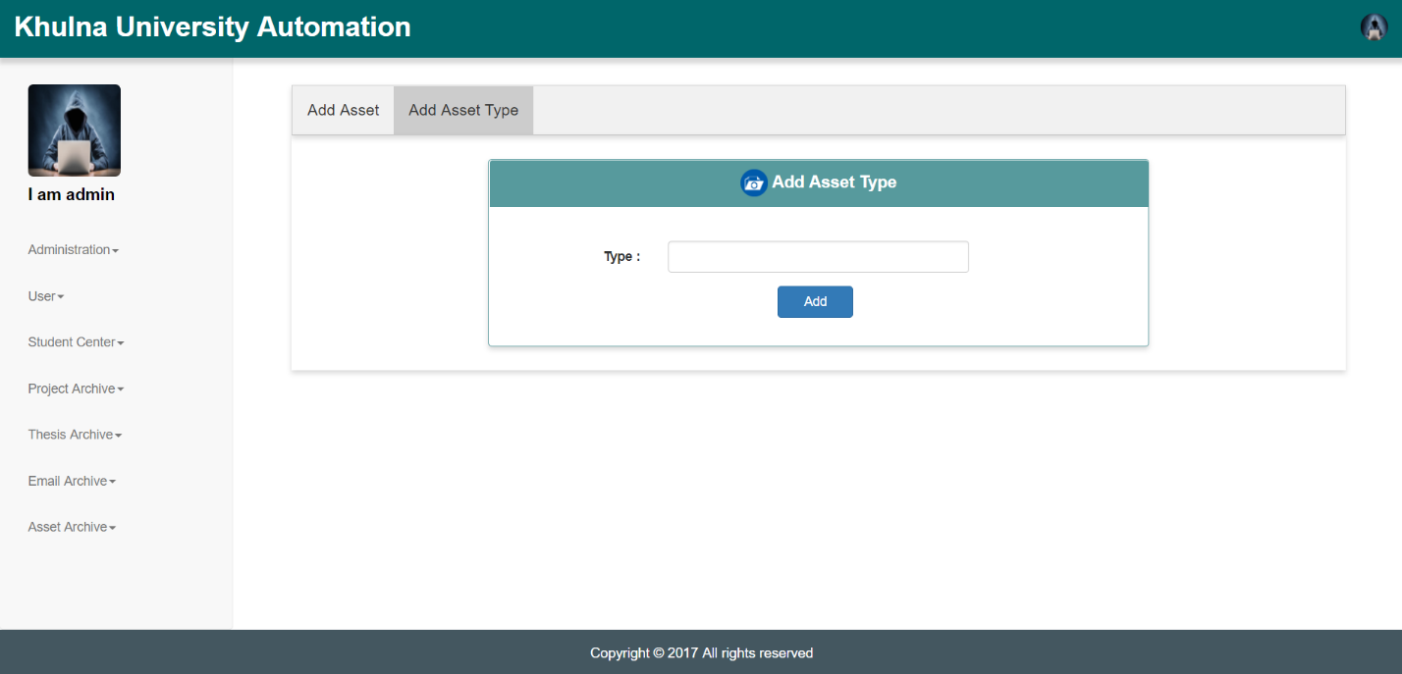

1. Create new asset details: In this page new asset details are created by providing necessary information.

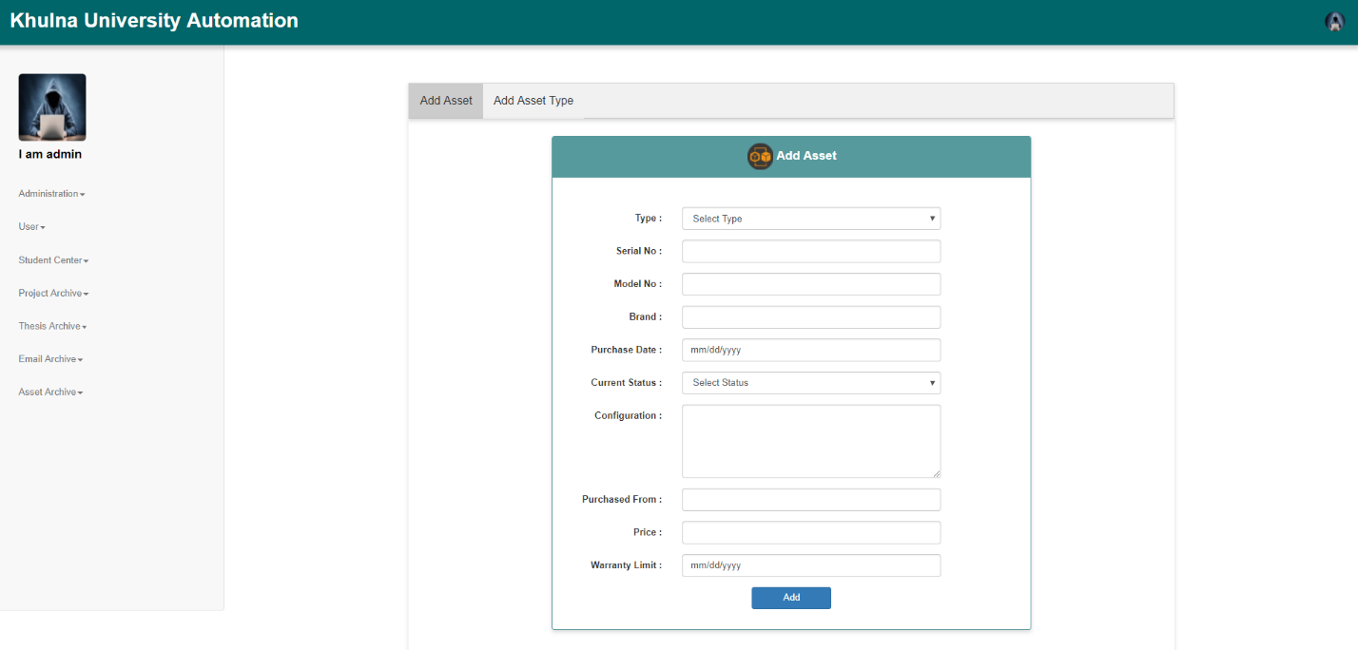

1. 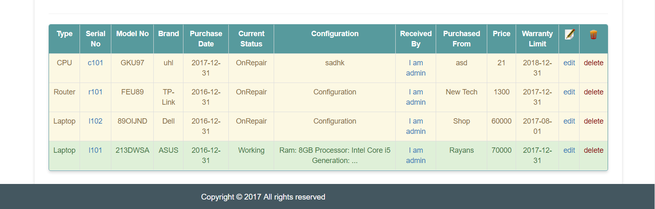Display created asset details: Here a table of all created assets are shown. The asset details can be updated or deleted from here.
2. Send asset to repair: Here the damaged asset having specific serial No is sent to repair and the status of the asset is changed.

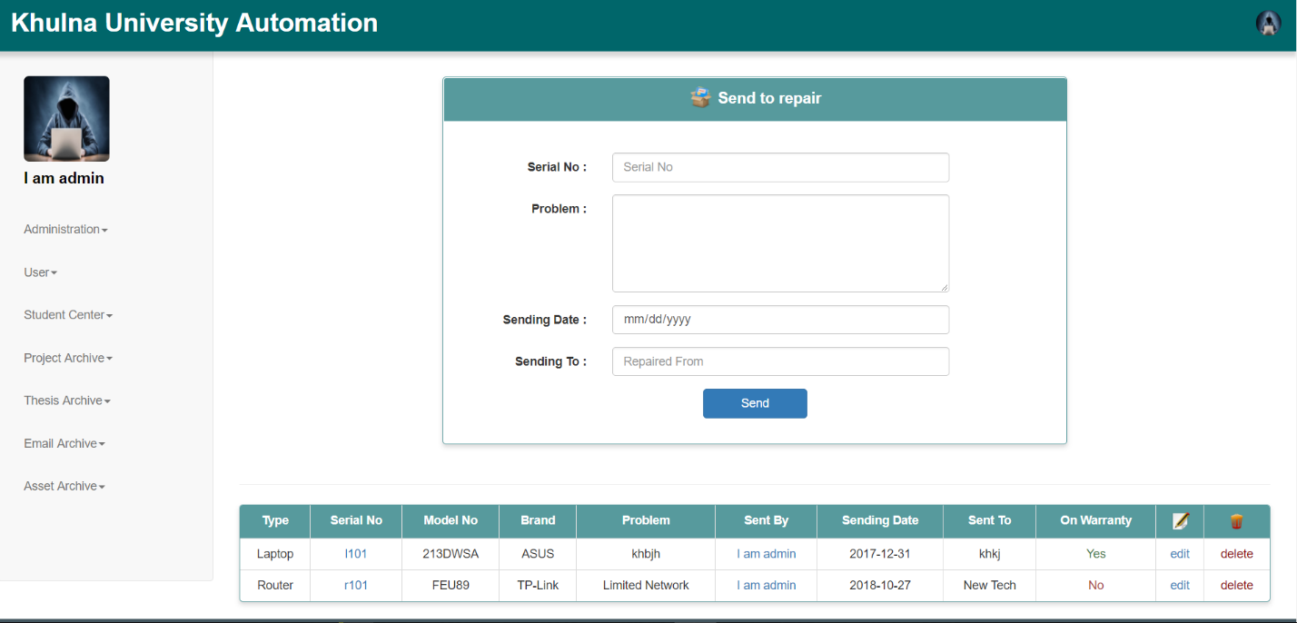

1. Receive asset from repair: In this page the repaired assets are received and if it is fully repaired then the status is changed to working. If the product is on warranty then the cost remains 0.

