
AMERICAN INTERNATIONAL UNIVERSITY BANGLADESH
Faculty of Science and Technology

LAB COVER SHEET

Assignment Title: | Familiarization with a microcontroller, the study of blink test and implementation of a traffic control system using microcontrollers.
Assignment No: | 01 |  | Date of Submission: | 23 June 2026
Course Title: | Microprocessor and Embedded Systems Laboratory
Course Code: | EEE4103 |  | Section: | U
Semester: | Summer | 2025-26 | Course Teacher: | DEBRAJ DAS

Declaration and Statement of Authorship:
- I/we hold a copy of this Assignment/Case-Study, which can be produced if the original is lost/damaged.
- This Assignment/Case-Study is my/our original work and no part of it has been copied from any other student’s work or from any other source except where due acknowledgement is made.
- No part of this Assignment/Case-Study has been written for me/us by any other person except where such collaboration has been authorized by the concerned teacher and is clearly acknowledged in the assignment.
- I/we have not previously submitted or currently submitting this work for any other course/unit.
- This work may be reproduced, communicated, compared and archived for the purpose of detecting plagiarism.
- I/we give permission for a copy of my/our marked work to be retained by the faculty for review and comparison, including review by external examiners.
- I/we understand that Plagiarism is the presentation of the work, idea or creation of another person as though it is your own. It is a formofcheatingandisaveryseriousacademicoffencethatmayleadtoexpulsionfromtheUniversity. Plagiarized material can be drawn from, and presented in, written, graphic and visual form, including electronic data, and oral presentations. Plagiarism occurs when the origin of their arterial used is not appropriately cited.
- I/we also understand that enabling plagiarism is the act of assisting or allowing another person to plagiarize or to copy my/our work.

* Student(s) must complete all details except the faculty use part.
** Please submit all assignments to your course teacher or the office of the concerned teacher.

Group Name/No.: | 03

No | Name | ID | Program | Signature
1 | Sumaiya Binte Kamal | 23-54657-3 | BSc [CSE] | sumaiya

Faculty use only
FACULTY COMMENTS | Marks Obtained
 | Total Marks

Title : Familiarization with a microcontroller, the study of blink test and implementation of a traffic control system using microcontrollers.

Introduction:
The main objective of this experiment was to understand the use of Timer0 in the Arduino microcontroller and apply it to generate accurate time delays. The timer was configured using control registers and used to implement an LED blink test and a simple traffic light control system.

Timers are hardware modules inside the ATmega328 microcontroller that count clock pulses to create time delays. Timer0 is an 8-bit timer, meaning it counts from 0 to 255 before overflowing. By setting the timer registers and pre-scaler, precise delays can be generated without using the built-in delay() function. In this experiment, a custom timer-based delay was used to control LED blinking and traffic light sequencing, showing how timers manage time-based operations in embedded systems.

Experimental Setup:
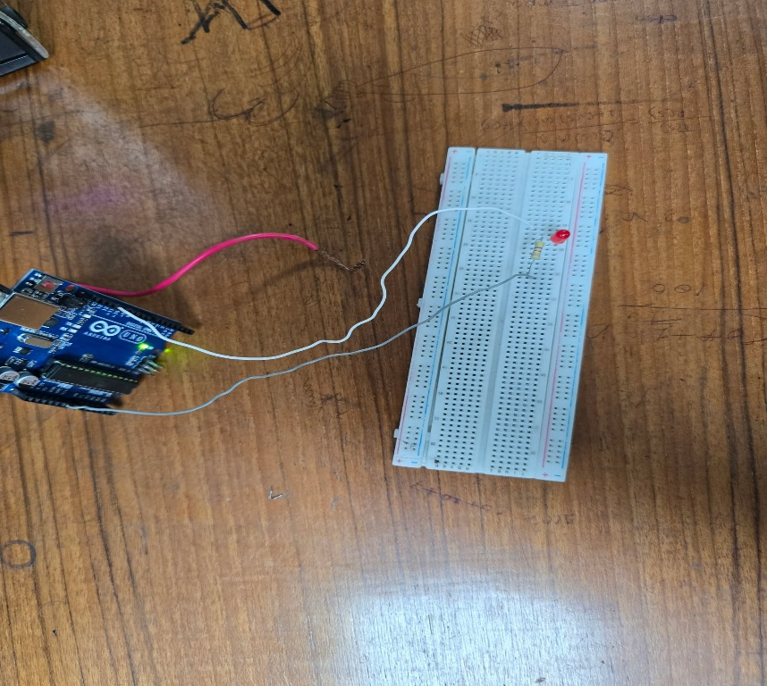

Fig 01: Circuit Connections for a LED blink test
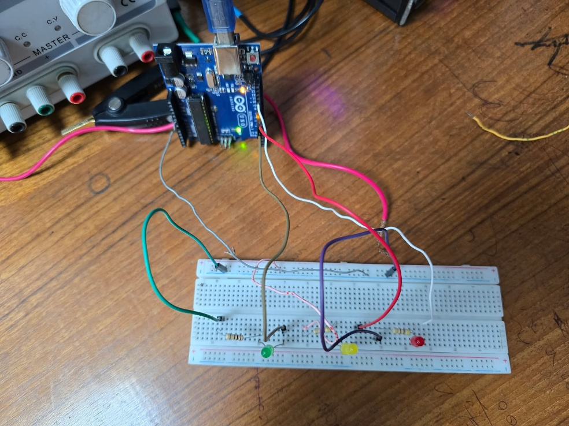

Fig 02: Circuit Connection for a LED blink test and Traffic light control system

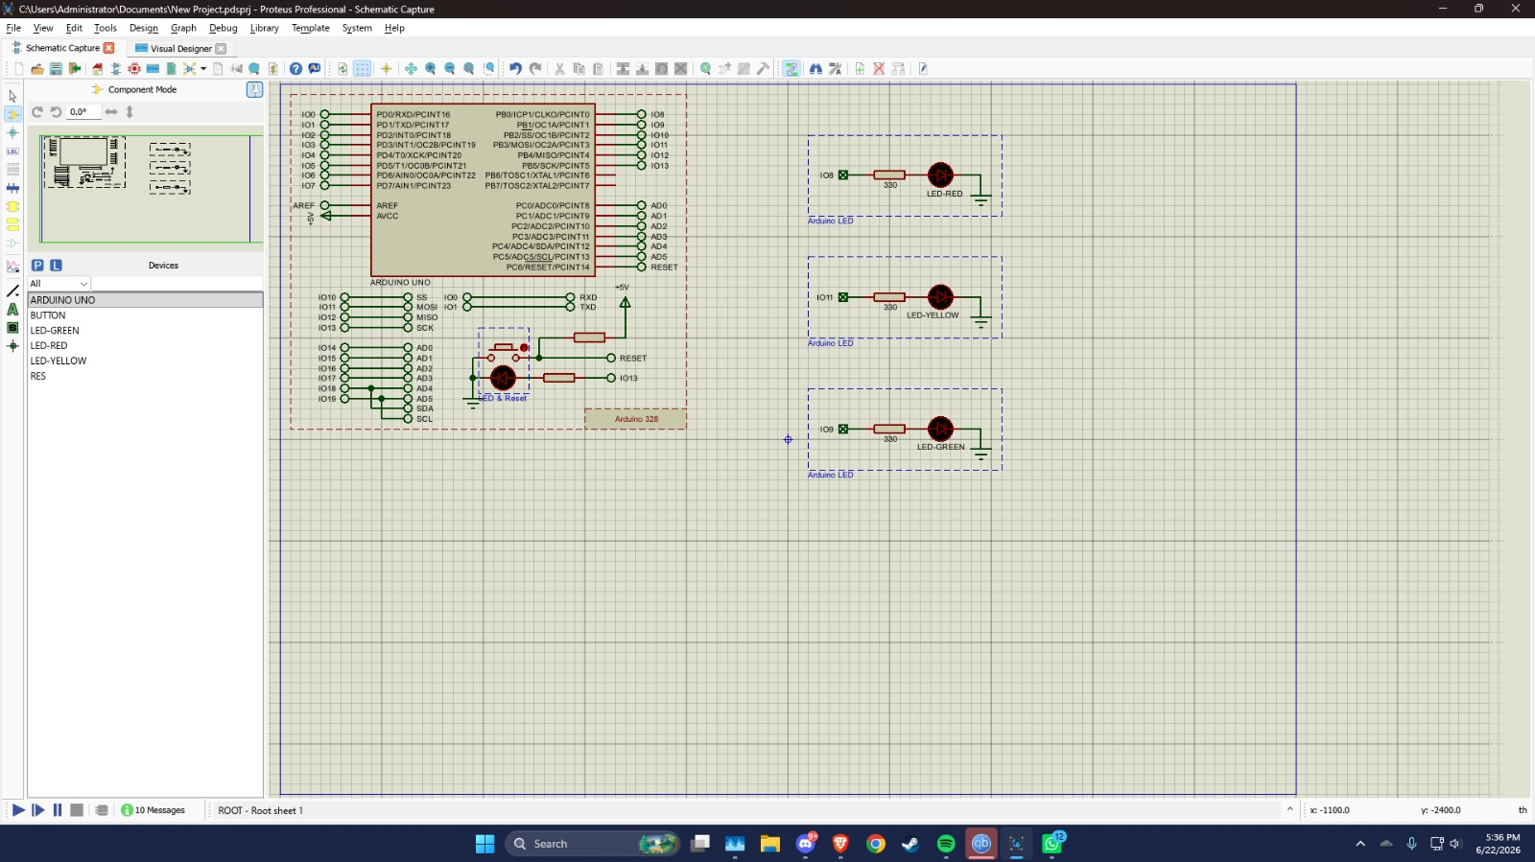
Fig 03: Simulation Setup of a Traffic Light Control System
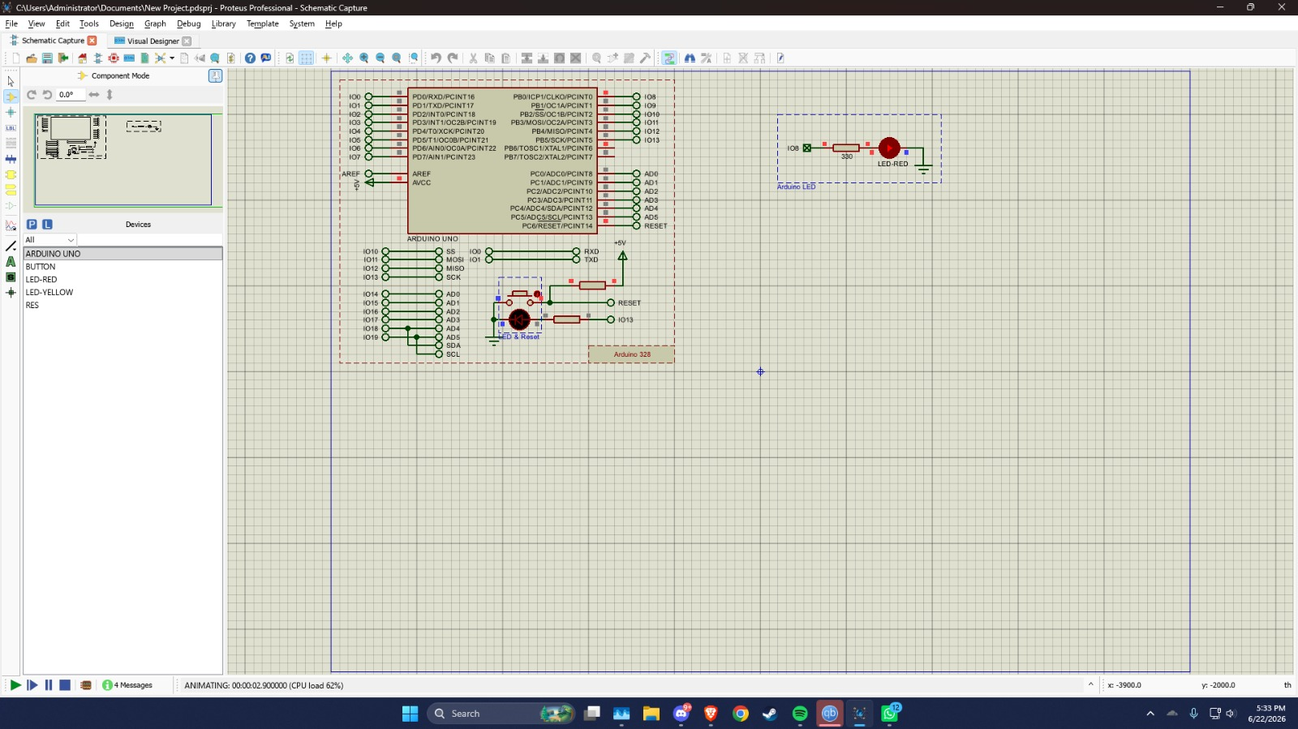 Fig 04: Simulation Setup of LED Blink Test
Result Analysis:
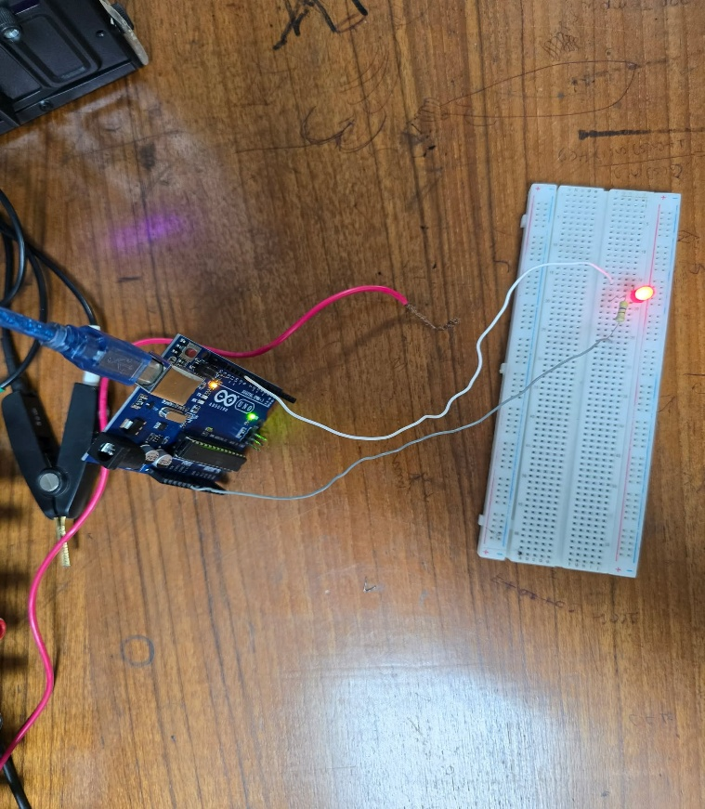
- Hardware Implementation Results
Fig 05: LED blink test experiment
Figure 5 illustrates the LED blinking test using Arduino Board through hardware. The LED is connected to the digital pin of the Arduino and set as an output. It turns ON for 1 second (HIGH) and OFF for 1 second (LOW) repeatedly.
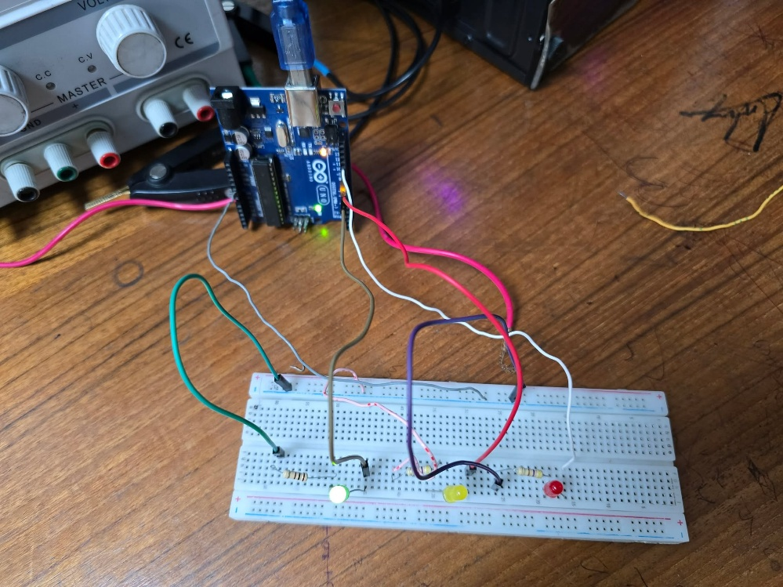
Fig 06: Traffic Light Control System (Green Light blink)
In figure 6, the green LED is ON, indicating the go signal. The Arduino timer maintains this state for the programmed duration before automatically switching to the next traffic light phase.
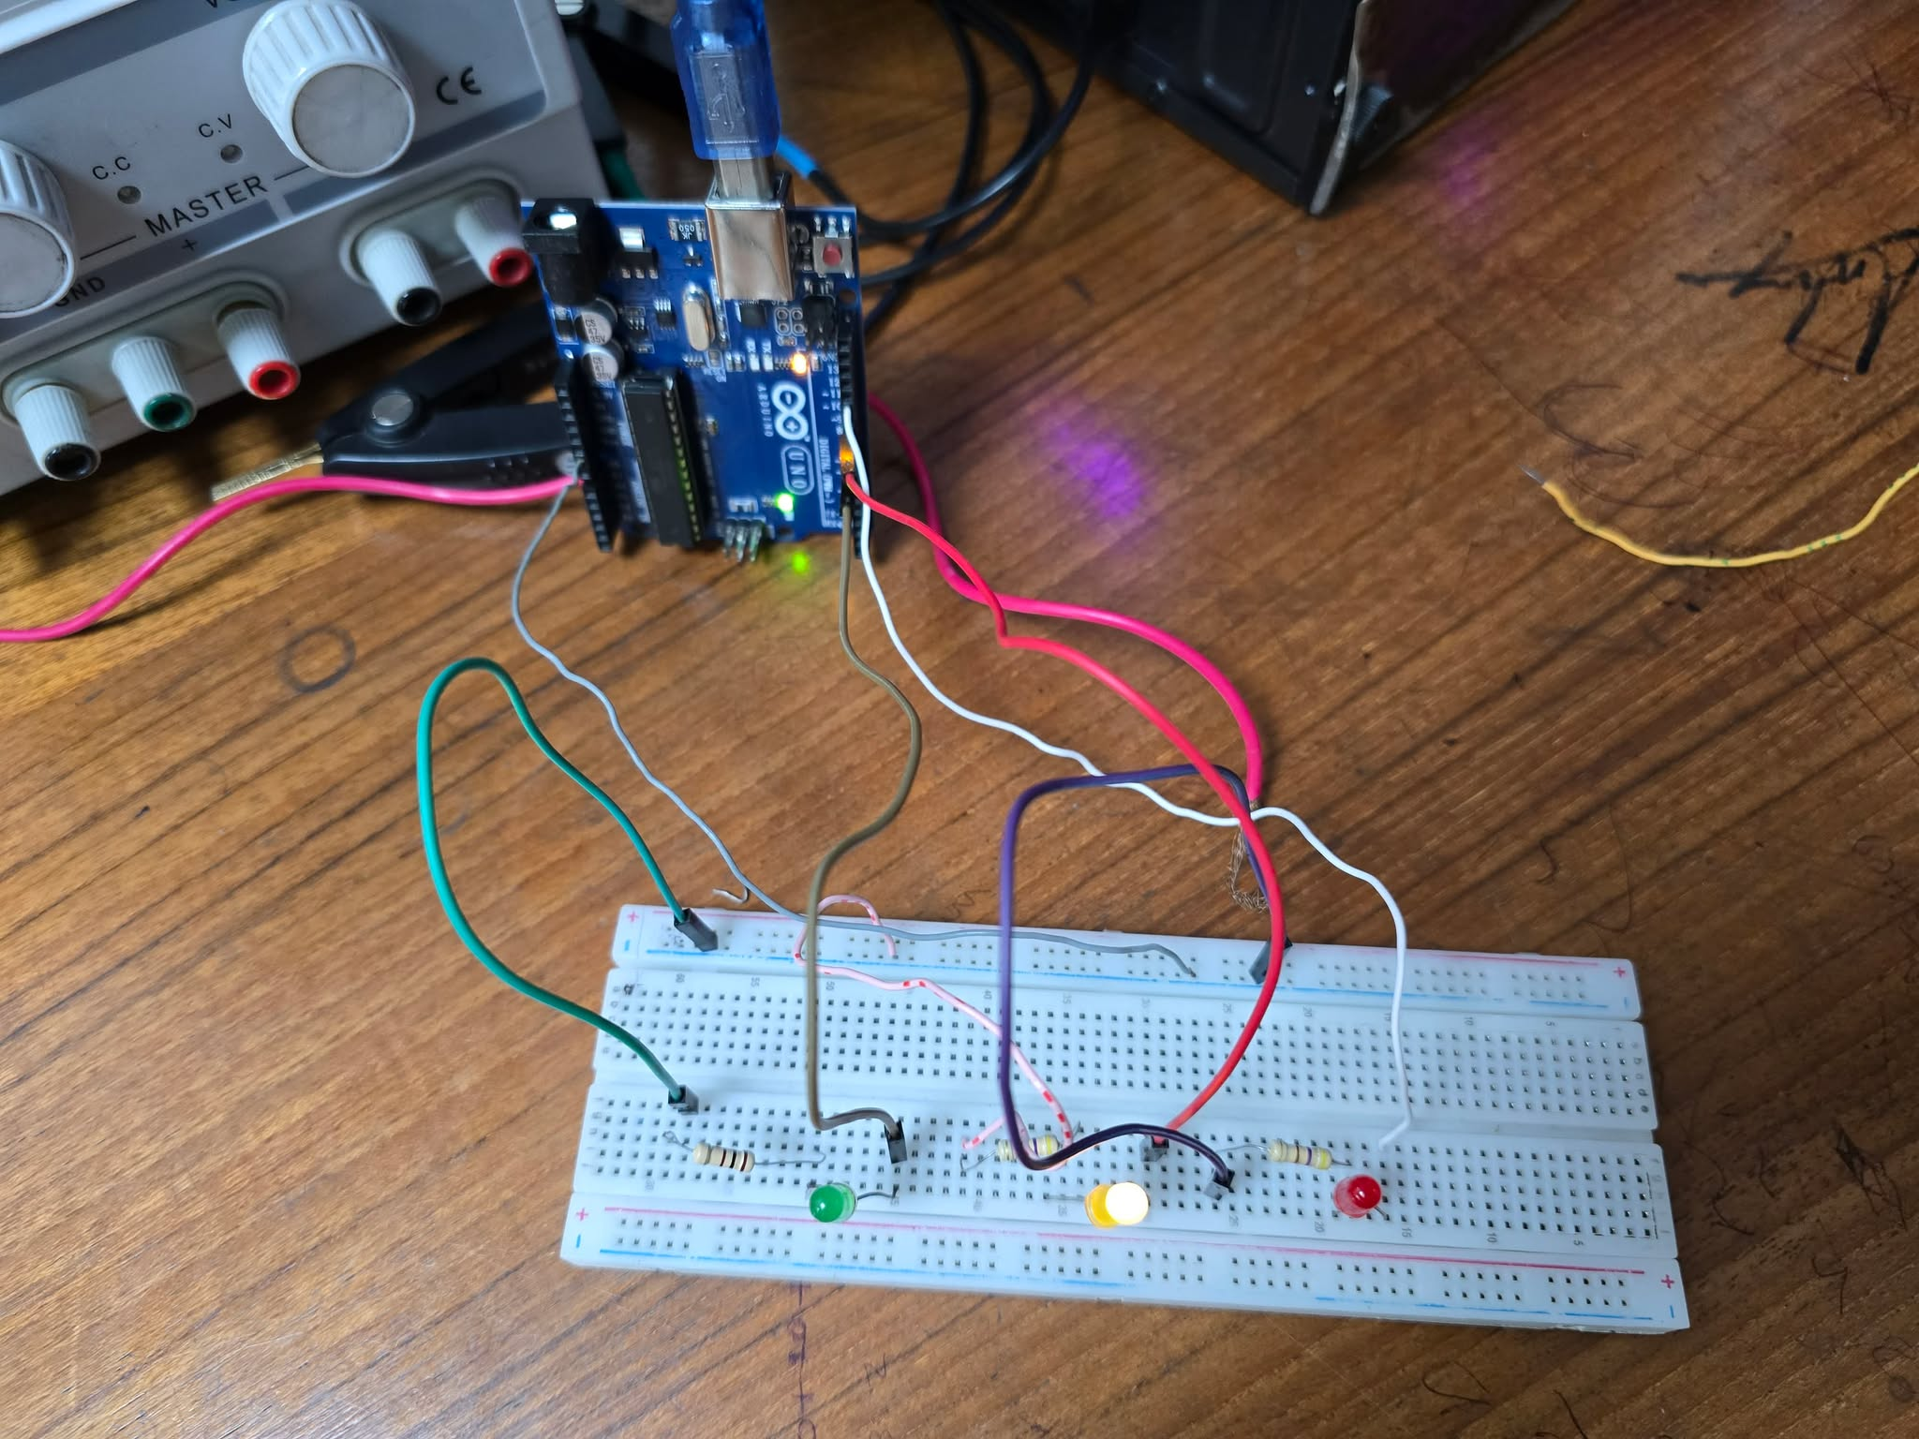
Fig 07: Traffic Light Control System (Yellow Light blink)
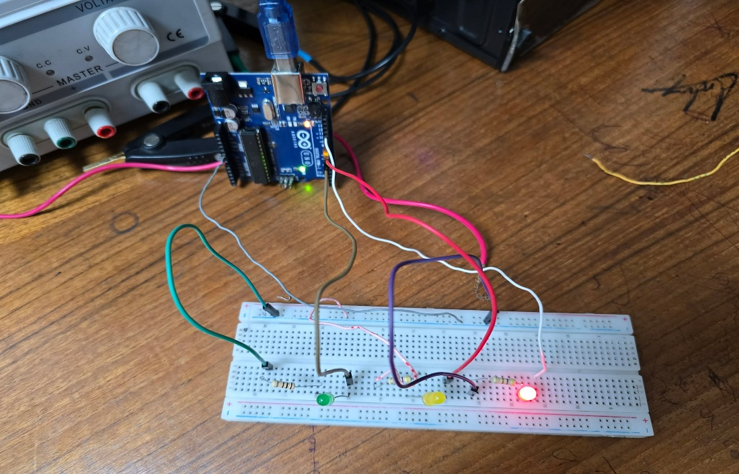
In figure 7, the yellow LED is ON, indicating the caution signal before switching to green. The Arduino timer manages the sequential change of traffic lights automatic
Fig 08: Traffic Light Control System (Red Light blink)

Figure 8 shows the initial state of the traffic control system where the red LED is ON, representing the stop signal. The Arduino Uno controls the LEDs using programmed timers on the breadboard setup.
- Simulated Verification Results
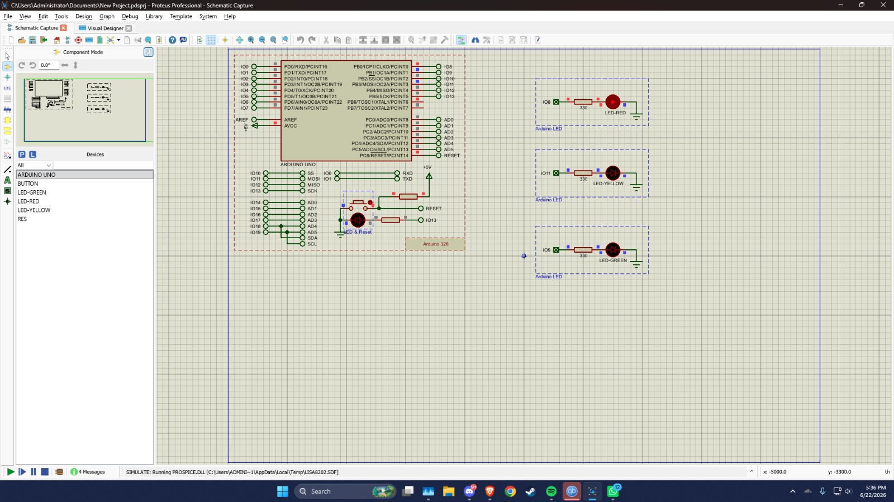
Fig 9: Simulation of Traffic Light Control System (Red Light Blink)
In Figure 9, simulation shows the initial stage of the timer-based traffic control system in Proteus. The red LED (RED) is turned ON while the yellow and green LEDs remain OFF, indicating the stop condition controlled by the Arduino Uno.
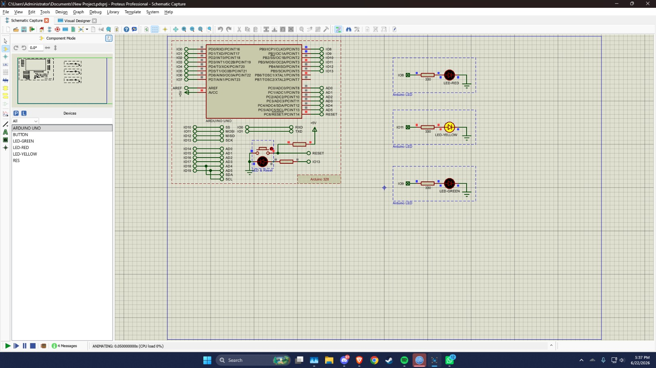

Fig 10: Simulation of Traffic Light Control System (Yellow Light Blink)
Figure 10 illustrates the transition phase where the yellow LED (YELLOW) is ON. It indicates the caution period before switching between red and green signals, controlled automatically through programmed time delays.
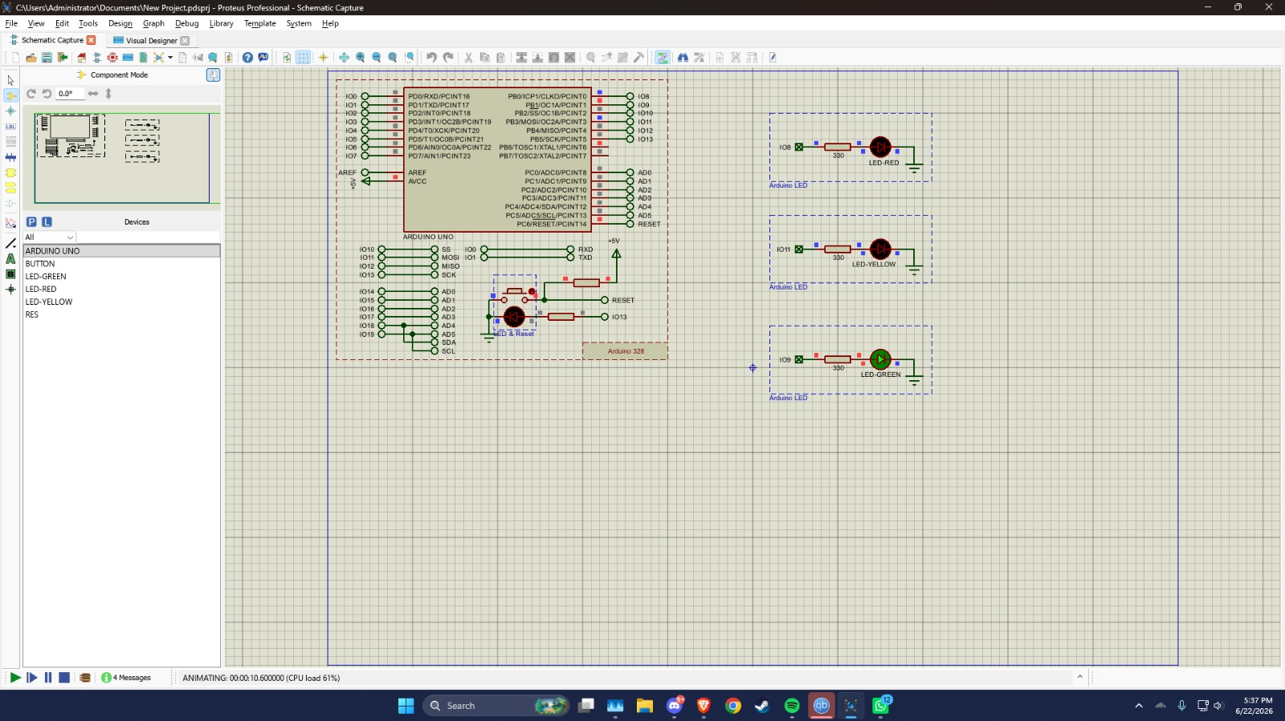
Fig 11: Simulation of Traffic Light Control System (Green Light Blink)
In figure 11, the green LED (GREEN) is ON, representing the go signal. The Arduino timer switches the output pins sequentially, turning OFF the red and yellow LEDs to allow vehicle movement.
 Fig 12: Simulation of LED Blink Test (Red Light Blink)

Figure 12, simulation shows the Arduino-controlled LED blinking in Proteus. The LED turns ON and OFF with a set delay. The regular blinking of the LED confirms that the code is working correctly and that the Arduino can control an external device using digital output and delay functions.

Conclusion:
The primary objective of this experiment was to study the timer features of the Arduino microcontroller, particularly the operation of Timer0, and to understand how timers are used for generating accurate delays and controlling sequential operations. The experiment successfully demonstrated timer configuration, timer-based programming techniques, LED blinking, and traffic light control. The implementation of both hardware and simulation verified the correct operation of Timer0 and achieved the intended objectives of the experiment.
In this experiment, I explored the practical use of timers in embedded systems and learned how Timer0 can be configured to generate precise timing delays. I gained hands-on experience in writing timer-based programs, controlling digital outputs, and designing sequential systems such as LED blink circuits and traffic light controllers. The experiment also improved my understanding of Arduino programming, timing calculations, simulation techniques, and hardware interfacing. Overall, it enhanced my knowledge of embedded system design and the importance of timers in real-time applications.

References:
[1] M. A. Mazidi, J. G. Mazidi, and R. D. McKinlay, The 8051 Microcontroller and Embedded Systems: Using Assembly and C, 2nd ed. Upper Saddle River, NJ, USA: Pearson Prentice Hall, 2006.
[2] J. Blum, Exploring Arduino: Tools and Techniques for Engineering Wizardry. Hoboken, NJ, USA: John Wiley & Sons, 2013.
[3] Arduino, “Arduino Uno Hardware Reference,” Arduino. [Online]. Available: https://www.arduino.cc/en/Main/ArduinoBoardUno. Accessed: Jun. 15, 2026.
[4] Labcenter Electronics, “Proteus Design Suite: Schematic Capture and PCB Layout Software,” Labcenter Electronics. [Online]. Available: https://www.labcenter.com/. Accessed: Jun. 15, 2026.

