“Read In The Name of Almighty Allah, Who Has Created You”

Department of

Computer Science & Engineering (CSE)

“Project Report on Online Floral Shop”

Name: Sumaiya Tabassum Sanzida

Id: WB220110
Project name: Online Floral Shop.
Introduction:
The aim of this project is to automate the booking system of a flower shop through the computer with satisfactory user interactions. The developed software will be easier and more flexible to handle. Computerization of the booking system will be able to give fast services to the customers. We chose this system because it is more efficient, it is cost effective and manual errors will be lessened. The software is user friendly and menu driven.
Objectives:
Objectives of my projects are following:
- The main purpose of my shop is to fulfill the customer needs and give them better product so that customer will please.
- Easy to purchase.
- Multiple choice of flower.
- Prices & descriptions
- And to increase sell & to create maximum earnings.
Technology:
Languages-
- HTML
- CSS
Software-
- Vscode
Developer guidelines:
1. Home page:
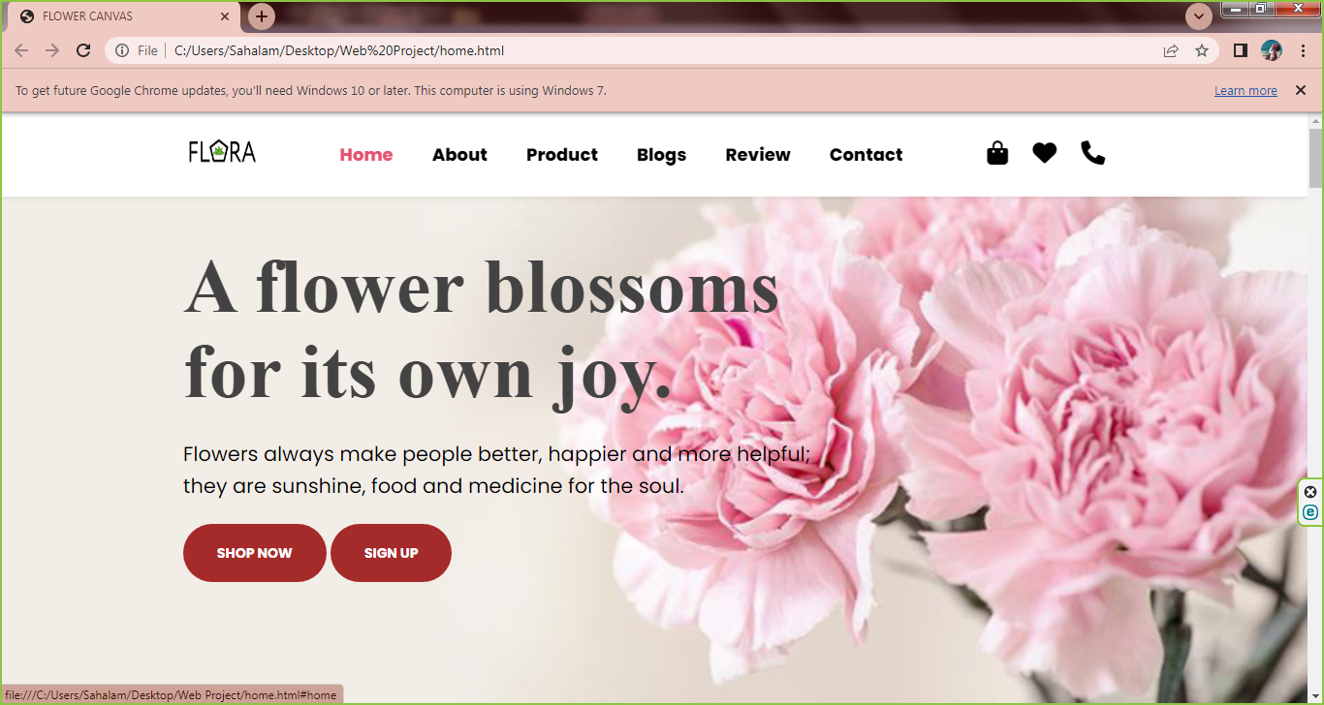

2. About us:
It contains all about the Flower Shop information and working process.

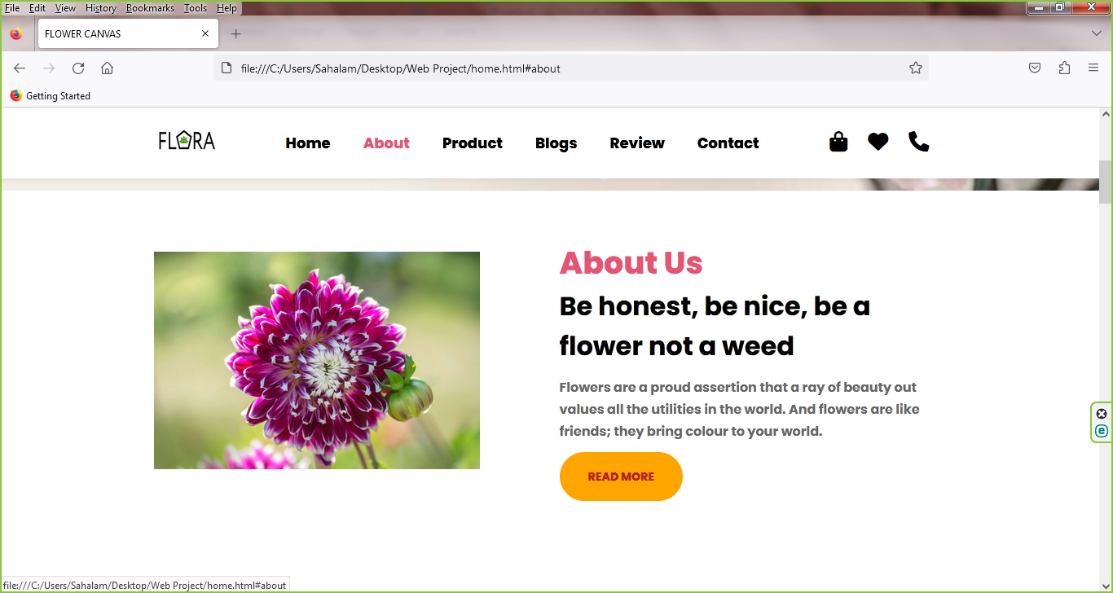
3. Product page:
The product page offers the user the chosen product, and the final details to place the order. It also shows to the user, related products that can be of his/her interest.
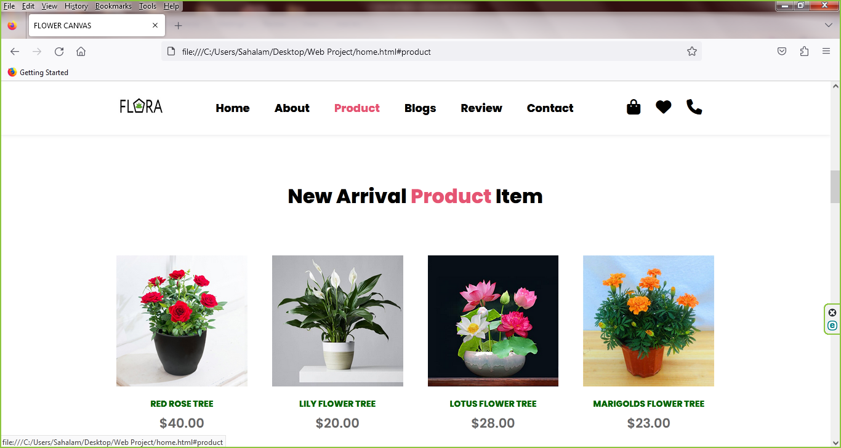
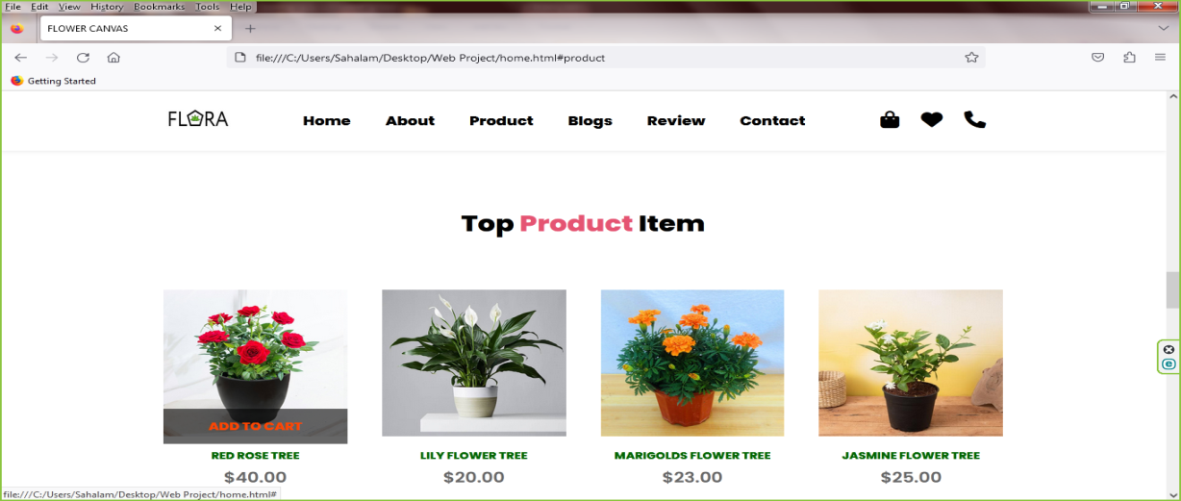

4. Blogs:
A blog page is a section on the website where we can display unlimited separates articles relating to our website, typically used to keep user up-to-date.

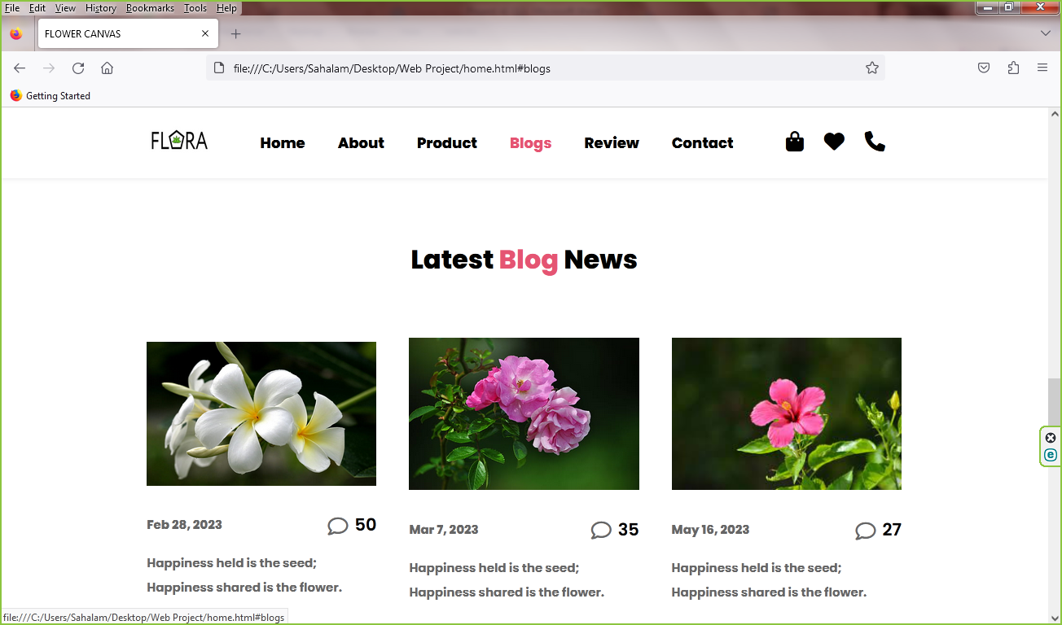
5. Review:
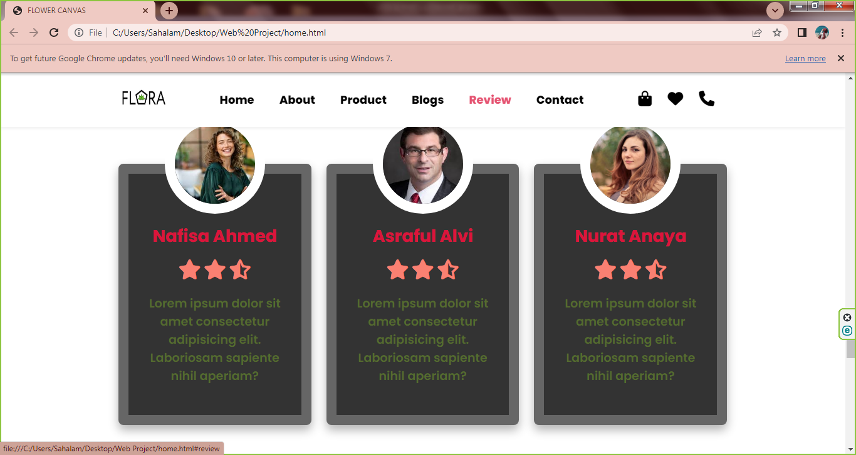

6. Contact:
In this page, the user will get to contact with the owner.
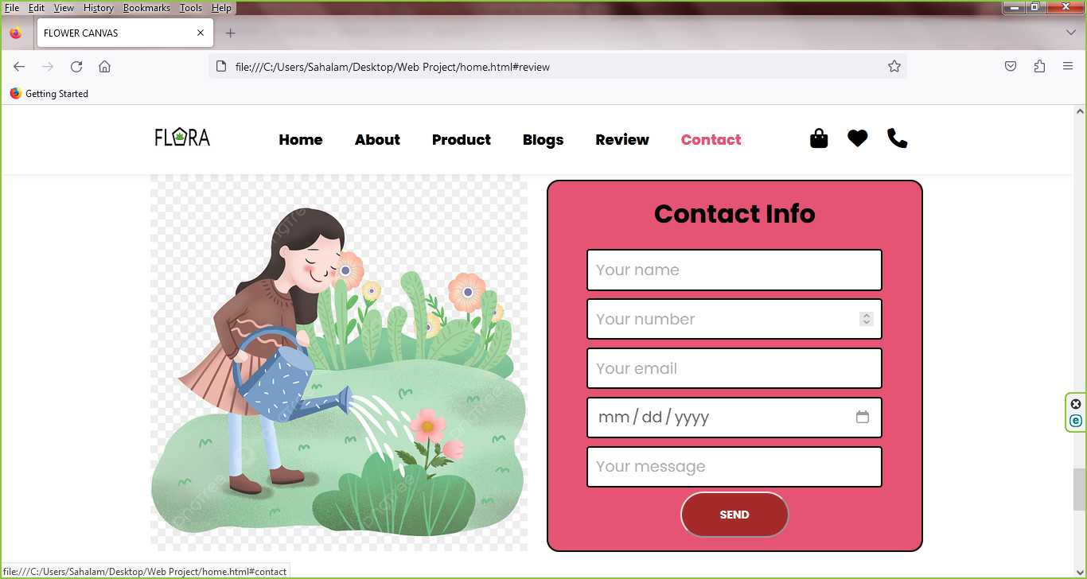
Footer Section:
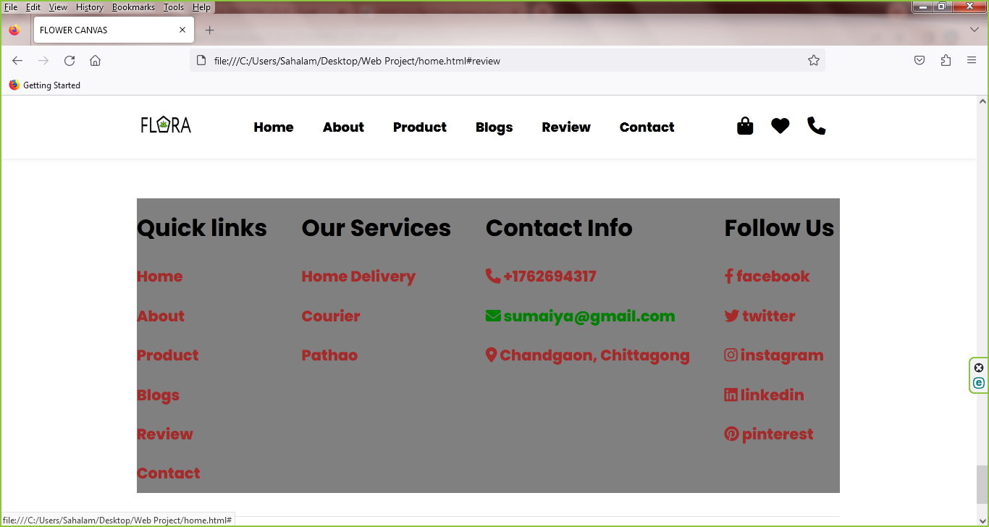
Future enhancement:
- As the technology emerges, it is possible to upgrade the system and can be adaptable to desired environment.
- Based on the future security issues, security can be improved using emerging technologies.
- Can add more requirements with additional module can be added
Source code:
https://github.com/SumaiyaTabassum19/WEB-PROJECT-.git
Conclusion:
This Web application "Online Floral Shop" avoids the manual work and the problems concern with it. It is an easy way to obtain the information regarding the various products information that is present in the markets. This system is an improved application better than the existing one’s regarding the information about the various activities.
This Web application” FLOWER SHOP MANAGEMENT SYSTEM”
avoids the manual work and the problems concern with it. It is an easy way to
obtain the information regarding the various products information that is
present in the markets. This system is an improved application better than the
existing one’s regarding the information about the various activities

This Web application” FLOWER SHOP MANAGEMENT SYSTEM”
avoids the manual work and the problems concern with it. It is an easy way to
obtain the information regarding the various products information that is
present in the markets. This system is an improved application better than the
existing one’s regarding the information about the various activities.
This Web application” FLOWER SHOP MANAGEMENT SYSTEM”
avoids the manual work and the problems concern with it. It is an easy way to
obtain the information regarding the various products information that is
present in the markets. This system is an improved application better than the
existing one’s regarding the information about the various activities.
This Web application” FLOWER SHOP MANAGEMENT SYSTEM”
avoids the manual work and the problems concern with it. It is an easy way to
obtain the information regarding the various products information that is
present in the markets. This system is an improved application better than the
existing one’s regarding the information about the various activities.
This Web application” FLOWER SHOP MANAGEMENT SYSTEM”
avoids the manual work and the problems concern with it. It is an easy way to
obtain the information regarding the various products information that is
present in the markets. This system is an improved application better than the
existing one’s regarding the information about the various activities.
This Web application” FLOWER SHOP MANAGEMENT SYSTEM”
avoids the manual work and the problems concern with it. It is an easy way to
obtain the information regarding the various products information that is
present in the markets. This system is an improved application better than the
existing one’s regarding the information about the various activities.
This Web application” FLOWER SHOP MANAGEMENT SYSTEM”
avoids the manual work and the problems concern with it. It is an easy way to
obtain the information regarding the various products information that is
present in the markets. This system is an improved application better than the
existing one’s regarding the information about the various activities.

