# Structure of an HTML Document

An HTML document has a structured format made of various elements. Below is a breakdown of a standard HTML5 document and explanations of key parts.

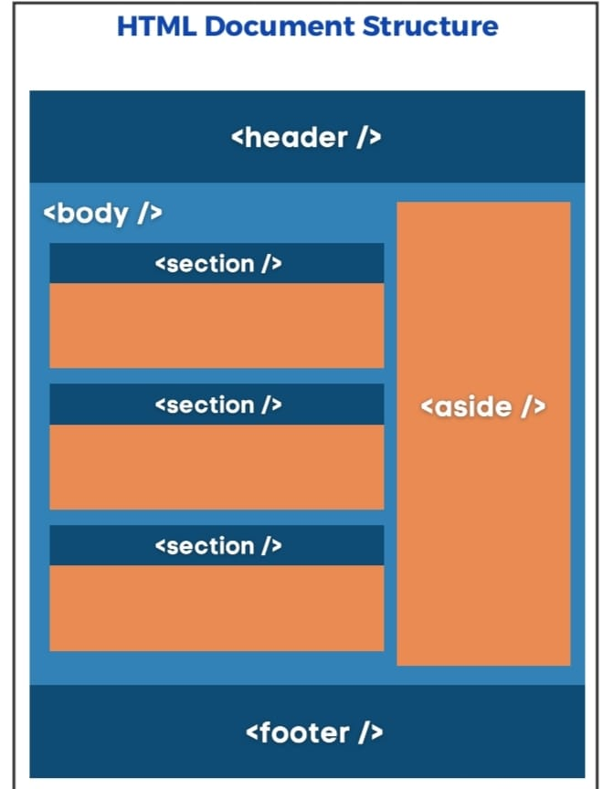

Example of structure:

<!DOCTYPE html>  
<html lang="en">  
<head>  
 <meta charset="UTF-8">  
 <meta name="viewport" content="width=device-width, initial-scale=1.0">  
 <title>Document Title</title>  
</head>  
<body>  
 <h1>This is a Heading</h1>  
 <p>This is a paragraph.</p>  
</body>  
</html>

## 1. <!DOCTYPE html>

It is used to tell the browser the type of document.

- Declares the document type.  
- Specifies the use of HTML5.  
- Helps browsers render the page correctly.

## 2. <head>

To define the head position of the document.

- Contains meta-information about the document.  
- Includes title, meta tags, styles, and links.  
- Not displayed directly on the web page.

## 3. <body>

- Contains all visible content of the web page.  
- Includes headings, text, images, links, etc.

## Summary

|  |  |
| --- | --- |
| Tag | Purpose |
| <!DOCTYPE> | Declares HTML version |
| <html> | Root of the HTML document |
| <head> | Metadata and settings (not visible) |
| <body> | All visible elements of the page |