**Program no : 02**

**Program Title : Traffic Light Controller**

**Hardware Required :**

* Arduino Board
* Breadbooard
* Wires
* 3 LED
* Resistor

**Circuit Diagram :**

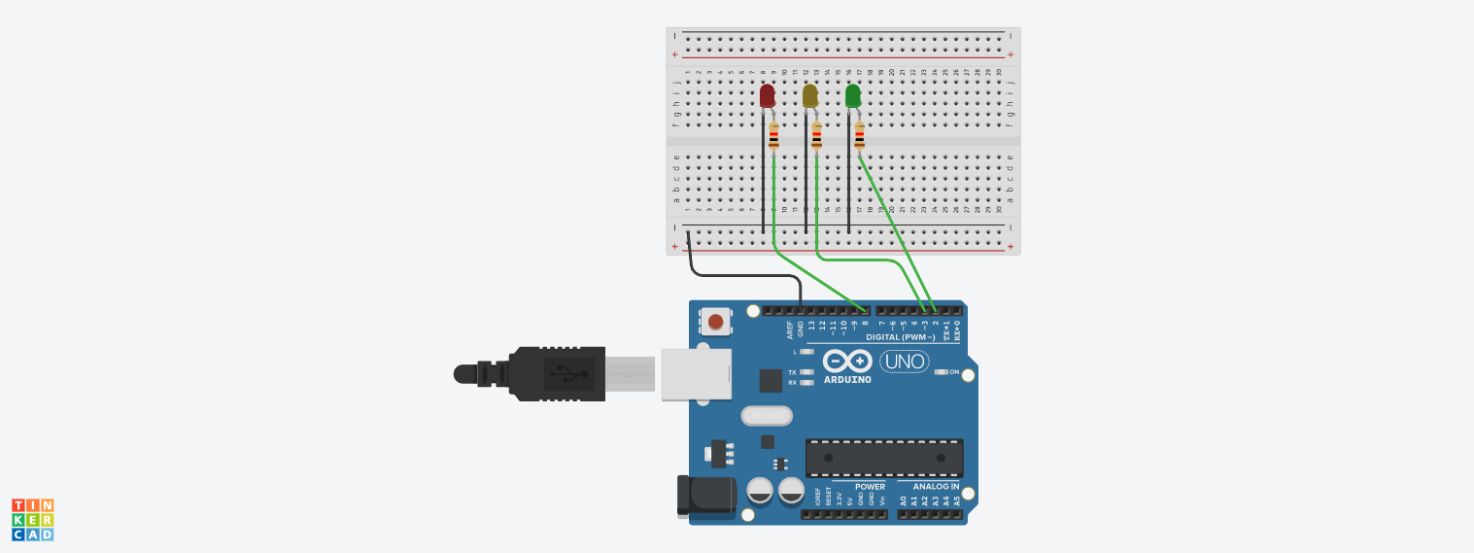

**Code:**

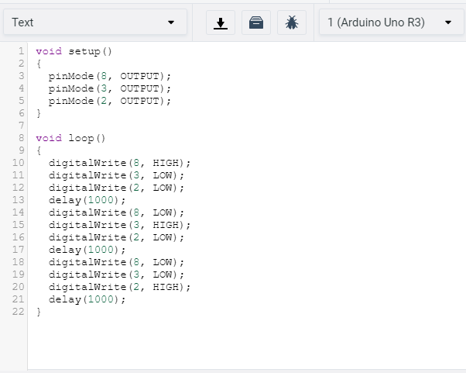

**Observation /Output :**

