**Program no : 03**

**Program Title : Push Button**

**Hardware Required :**

* Arduino Board
* Breadbooard
* Wires
* LED
* Resistor
* Push Button

**Circuit Diagram :**

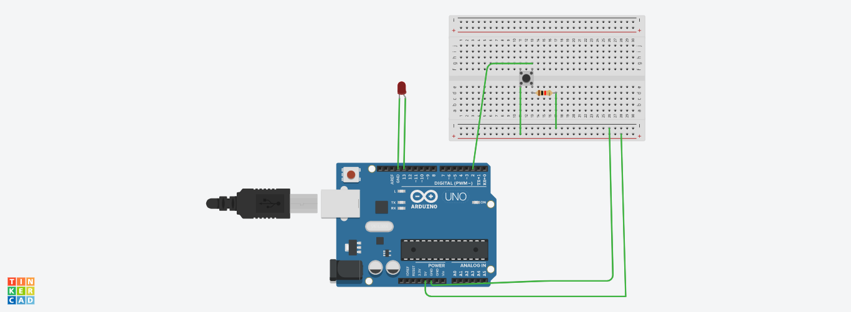

**Code:**

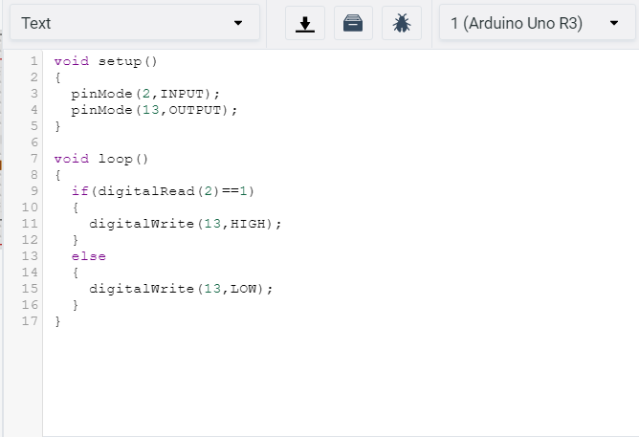

**Observation /Output :**

