**Program no : 04**

**Program Title : LED Fading**

**Hardware Required :**

* Arduino Board
* Wires
* LED

**Circuit Diagram :**

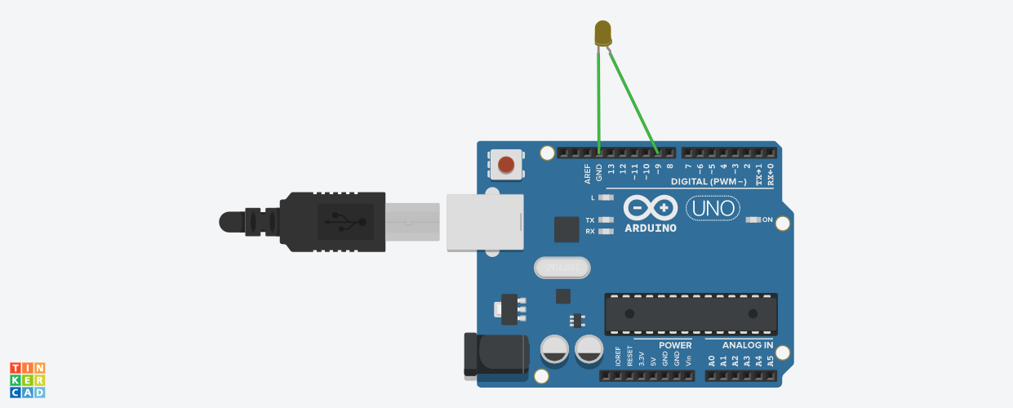

**Code:**

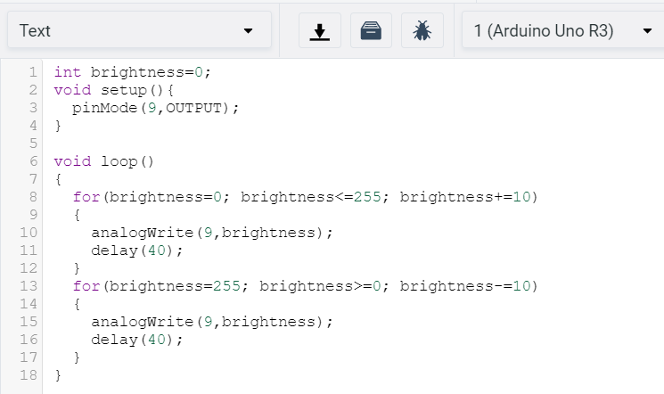

**Observation /Output :**

