**Program no : 05**

**Program Title : Potentiometer**

**Hardware Required :**

* Arduino Board
* Wires
* LED
* Potentiometer

**Circuit Diagram :**

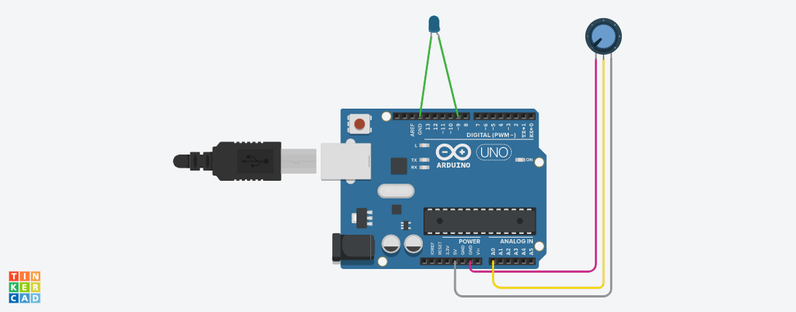

**Code:**

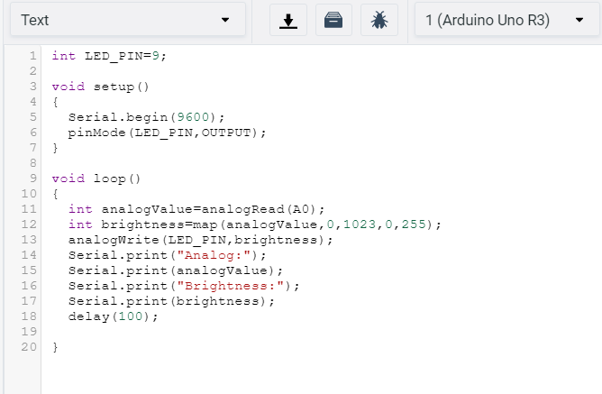

**Observation /Output :**

