Deployment & Test Guide
Oracle Fusion Manufacturing RFP-Winning System — Agents hosted on Blueverse Foundry

1. Purpose and scope
This runbook takes the system from a fresh copy to a live deployment in which all seven agents are hosted on Blueverse Foundry. It covers local validation, hosting the agents in Blueverse, configuring and integration-testing the orchestrator against Blueverse, production deployment, and an acceptance sign-off. Follow the phases in order; each phase ends with a test gate that must pass before moving on.

2. Architecture recap
The orchestrator application runs the four-phase, seven-agent pipeline. Each agent is hosted on Blueverse; grounding data is reached only through governed tools, never the public internet.
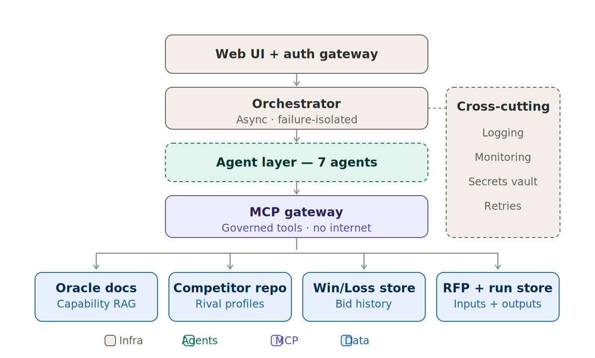
Figure 1 — Production planes. The application is the orchestration layer; the agents and the MCP/RAG grounding live on Blueverse.

3. Prerequisites
Item | Detail
Runtime | Python 3.10+ and pip on the host that runs the orchestrator app
Blueverse access | Foundry workspace (space) with permission to create agents and attach knowledge bases / MCP tools
Blueverse credentials | API base URL, bearer token, space name
Model | A reasoning model available in your space (e.g. GPT-5-mini) for each agent
Grounding data | Your real competitor profiles, win/loss history, Oracle capability docs and case studies
Server (prod) | A host able to run gunicorn behind HTTPS, with a secrets store

4. Phase A — Local validation (gate before deploying)
Validate the build offline first. This needs no Blueverse credentials and confirms the pipeline, the prompts, and the tests are healthy.
pip install -r requirements.txt
cp .env.example .env # PROVIDER_MODE stays 'local'
python -m pytest -q # expect: 9 passed
python -m scripts.run_cli samples/sample_rfp.txt
Gate: all 9 tests pass and the CLI prints a win probability, a decision, and a non-zero action count. Do not proceed until this passes.

5. Phase B — Host the seven agents in Blueverse

5.1 Choose a grounding option
Option A (default, matches the shipped code): keep the data/ knowledge base deployed alongside the app. The app performs retrieval locally and passes grounding context to each Blueverse agent. No Blueverse knowledge base setup is required.
Option B (Blueverse-native, recommended for production): upload your documents as a Blueverse RAG knowledge base or expose them through an MCP tool, and attach the relevant tool to each data-hungry agent. Grounding then happens inside Blueverse. Choose this once your corpus is stable.

5.2 Create the agents
- In your Blueverse space, create one Standalone agent per row in the table below, selecting your reasoning model.
- If using Option B, attach the listed grounding tool (RAG knowledge base or MCP tool) to each agent.
- You do NOT need to paste the prompts into Blueverse — the application sends the full system+task prompt as the query (see prompts/prompts.py). Keep the agent's own system prompt minimal.
- Open each agent, run it once, and copy its flowId. Copy the space name once.

5.3 Agent configuration map
Agent (create in Blueverse) | Grounding tool to attach (Option B) | App env var for flowId | Phase
RFP Understanding | none (reads RFP text) | FLOW_RFP_UNDERSTANDING | 1
Oracle MFG Capability | Oracle capability RAG | FLOW_ORACLE_CAPABILITY | 2
Competitor Intelligence | Competitor profiles RAG | FLOW_COMPETITOR_INTEL | 2
Battlecard Generator | Case studies RAG | FLOW_BATTLECARD | 3
Positioning & Messaging | Case studies + win/loss RAG | FLOW_POSITIONING | 3
Go / No-Go | Win/Loss history (MCP/RAG) | FLOW_GO_NOGO | 3
Recommendation & Outcomes | none (synthesises inputs) | FLOW_RECOMMENDATION | 4
Gate: seven agents exist in the space, each returns a response when tested in the Blueverse UI, and you have recorded the space name and all seven flowIds.

6. Phase C — Point the orchestrator at Blueverse
Edit .env on the app host. Switch the mode and fill in the credentials and the seven flowIds captured in Phase B.
PROVIDER_MODE=blueverse
BLUEVERSE_BASE_URL=https://<your-host>/api/v1/chat
BLUEVERSE_TOKEN=<bearer-token>
BLUEVERSE_SPACE_NAME=OR_Pythia_26
FLOW_RFP_UNDERSTANDING=<flowId>
FLOW_ORACLE_CAPABILITY=<flowId>
FLOW_COMPETITOR_INTEL=<flowId>
FLOW_BATTLECARD=<flowId>
FLOW_POSITIONING=<flowId>
FLOW_GO_NOGO=<flowId>
FLOW_RECOMMENDATION=<flowId>
Variable | Notes
PROVIDER_MODE | Set to blueverse to call the hosted agents.
BLUEVERSE_TOKEN | Keep in a secrets store / environment, never in the repo.
FLOW_* | One flowId per agent, from Phase B 5.2 step 4.
BLUEVERSE_TIMEOUT / _MAX_RETRIES | Optional; defaults 120s and 3 retries with backoff.

7. Phase D — Integration test against Blueverse
With PROVIDER_MODE=blueverse, confirm connectivity and a full grounded run.
# 1) connectivity
python -c "import config; print(config.PROVIDER_MODE)" # blueverse
python run.py # then in another shell:
curl http://127.0.0.1:5000/health # {"mode":"blueverse"}
# 2) full pipeline against the live agents
python -m scripts.run_cli samples/sample_rfp.txt
Expected: each agent returns valid JSON, the orchestrator completes all four phases, and Go/No-Go returns a probability and decision. Then repeat through the web app (upload an RFP, watch all seven agents reach 'done').

7.1 Troubleshooting
Symptom | Likely cause | Fix
ProviderError: base_url/token not configured | Mode is blueverse but .env empty | Fill BLUEVERSE_* values; restart
401 / 403 from Blueverse | Bad or expired token | Re-issue the bearer token
Agent output is raw JSON envelope, not parsed | Response key differs | Add the key to _extract() in core/llm_provider.py
One agent shows 'failed', others 'done' | That agent errored | By design — isolated; check outputs/<job>/<agent>.json
Ungrounded / generic answers | No tool attached (Option B) | Attach the RAG/MCP tool from 5.3, or use Option A

8. Phase E — Production deployment
- Serve via a production WSGI server, not the Flask dev server:
pip install gunicorn
gunicorn -w 2 -b 0.0.0.0:8000 'app:create_app()'
- Place a reverse proxy (nginx) in front, terminate HTTPS, and add authentication (SSO or token) before the app.
- Load BLUEVERSE_TOKEN and FLASK_SECRET_KEY from a secrets vault / environment — never commit them.
- Set FLASK_SECRET_KEY to a strong random value; confirm debug is off (it is, outside local mode).
- Mount a persistent volume for outputs/ so run history survives restarts; ship logs to your monitoring stack.
- If using Option B, schedule the ingestion job (outside Blueverse) that refreshes the knowledge base from approved public sources.

9. Phase F — Acceptance test and sign-off
Acceptance check | Expected | Pass/Fail
Local test suite | 9 passed
All 7 agents created and reachable in Blueverse | Yes
/health returns mode=blueverse | Yes
Full pipeline completes on sample RFP (blueverse) | All 7 ok
Go/No-Go returns probability + decision + historical basis | Yes
Competitor agent output cites real grounded sources | Yes
One forced agent failure does not crash the run | Run completes
App served via gunicorn behind HTTPS with auth | Yes
Secrets loaded from vault, not repo | Yes
Outputs persisted and logs visible | Yes

10. Operations
- Each run is saved under outputs/<job_id>/ as job.json plus per-agent .json/.txt — use these for audit and debugging.
- The Blueverse client retries with backoff (default 3); raise BLUEVERSE_MAX_RETRIES for flaky networks.
- To roll back to a safe demo at any time, set PROVIDER_MODE=local — the system runs fully offline.
- Refresh grounding data by updating data/ (Option A) or re-running ingestion into the Blueverse KB (Option B).

Appendix A — Quick reference
Path / command | Purpose
prompts/prompts.py | The seven agent prompts (system+task, JSON contracts)
core/llm_provider.py | Blueverse + Local providers; _extract() response parsing
agents/orchestrator.py | Four-phase pipeline, parallelism, failure isolation
data/ | Grounding knowledge base (replace with real data)
python -m pytest -q | Run the test suite
python -m scripts.run_cli <rfp> | Run the full pipeline from the CLI
bash scripts/smoke_test.sh | Tests + a sample run in one command

