Oracle Fusion Manufacturing
RFP-Winning System
Production Architecture

Programme: LTIMindtree Pythia · Unit OR_Pythia_26
Platform: Blueverse Foundry (governed, no public internet egress)

1. Executive overview
This system ingests an Oracle Fusion Manufacturing RFP and produces the pursuit artifacts a bid team needs: an Oracle capability fit, a competitor battlecard, a positioning pitch, a Go/No-Go decision with a win probability, and a synthesized recommendation with actionable next steps.
It is built as a multi-agent pipeline on the Blueverse Foundry platform. The defining design principle is grounding: every agent that asserts a fact about competitors, past wins, or win probability reads that fact from governed internal data through an MCP layer, never from the public internet and never from model memory alone. This is what separates a credible decision system from a generic language-model wrapper.

2. Architecture at a glance
The system is organized as five layered planes. Control flows top to bottom; data access is brokered exclusively by the MCP gateway. Operational concerns (logging, monitoring, secrets, retries) are cross-cutting.
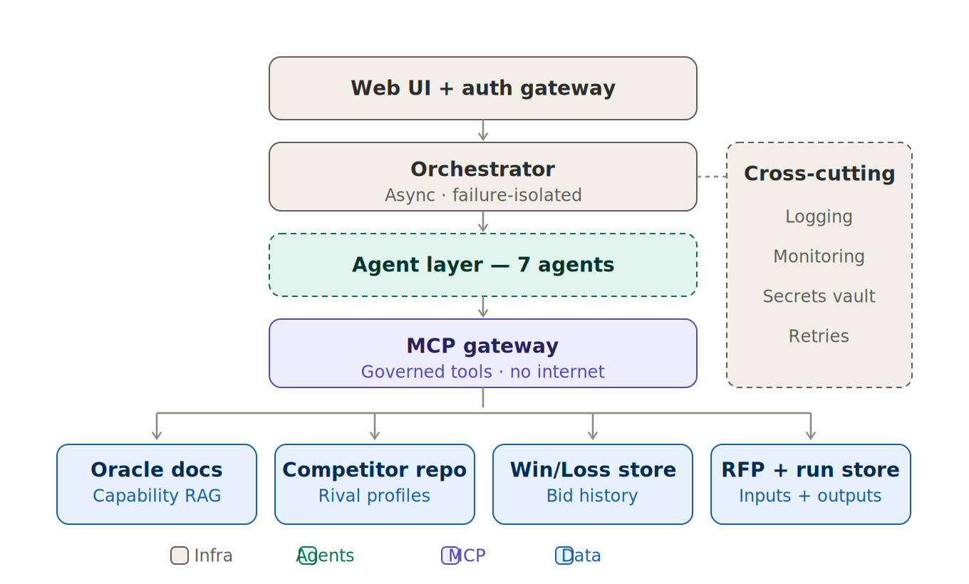
Figure 1 — Production planes: entry, orchestration, agents, MCP gateway, and data.
- Entry plane: a web UI for RFP upload and tabbed reports, behind an authenticating API gateway.
- Orchestration plane: an asynchronous, failure-isolated orchestrator that runs the four-phase pipeline. One failing agent degrades gracefully rather than crashing the run.
- Agent plane: seven single-responsibility agents (expanded in Section 3).
- MCP gateway: the only path from agents to data. Governed, auditable, with no public internet egress — satisfying Blueverse security restrictions.
- Data plane: a RAG index over Oracle capability docs, a competitor profile repository, a historical win/loss store, and a persistent RFP and run store.

3. The seven-agent pipeline
Agents run in four sequential phases. Agents within a phase run in parallel; each phase depends on the previous one.
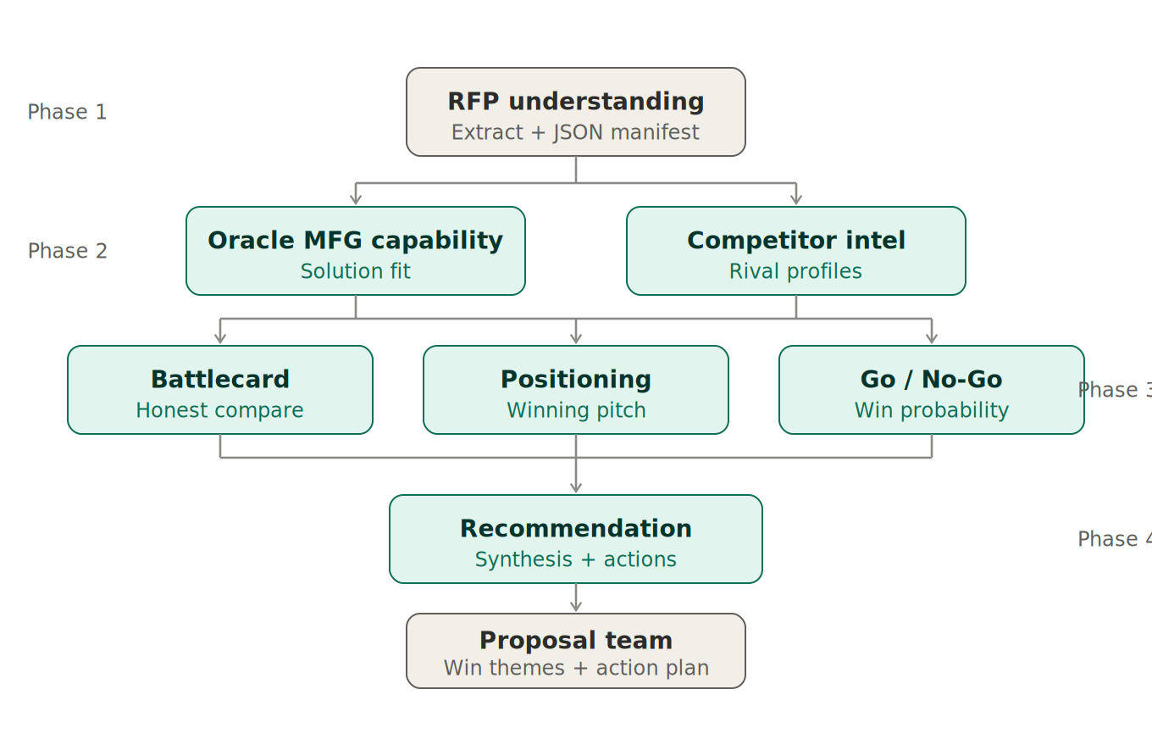
Figure 2 — Seven agents across four phases, feeding the proposal team.
Phase | Agent | Responsibility and grounding
Phase 1 | RFP Understanding | Extracts and classifies the RFP into a structured JSON manifest (scope, must-haves, evaluation factors, risks, manufacturing fit). This manifest is the contract passed to later phases.
Phase 2 | Oracle MFG Capability | Maps RFP requirements to Oracle Fusion Manufacturing modules. Grounded by the Oracle docs RAG index.
Phase 2 | Competitor Intelligence | Identifies likely competitors and their real strengths/weaknesses. Grounded by the competitor repository — not live web search.
Phase 3 | Battlecard | Produces an honest head-to-head picture (our strengths and our weaknesses). Grounded by competitor repo + win/loss store.
Phase 3 | Positioning & Messaging | Builds the winning pitch from proven win themes and prior wins/losses. Grounded by win/loss + case-study references.
Phase 3 | Go/No-Go | Produces a win probability from capability fit, competitive position, and historical base rates. Grounded by the win/loss store.
Phase 4 | Recommendation | Synthesizes all inputs into gaps and an actionable plan, handed to the proposal team.

4. MCP data layer and the no-internet constraint
Blueverse restricts outbound internet access. Rather than treat that as a limitation, the architecture uses it as a strength: agents reach only curated, governed internal data through MCP tools. This removes data-leakage and compliance risk and makes every asserted fact traceable to a source.
MCP tool | Backing data | Agents served
Oracle Capability | RAG index over Oracle Fusion docs | Oracle MFG Capability
Competitor Intelligence | Internal competitor / battlecard repository | Competitor Intelligence, Battlecard
Win/Loss History | Past Oracle bids (won/lost, competitor, value) | Positioning, Go/No-Go, Recommendation
Case Studies | Library of past winning proposals & references | Positioning, Recommendation

5. Security and operations (production readiness)
- Authentication in front of the application; secrets (the Blueverse bearer token) loaded from a vault or environment, never committed.
- Asynchronous execution: the pipeline runs as a background job with real progress (polling or SSE), so long runs never hit browser or proxy timeouts.
- Failure isolation: each agent call is wrapped; a single failure returns a degraded result while the other reports still render.
- Pinned response parsing against the Blueverse response schema (no key guessing).
- Persistence: runs, inputs, and outputs stored durably so analyses survive restarts and can be reopened and audited.
- Observability: structured logging and monitoring across every agent call, with retries and backoff on the Blueverse API.
- Served behind a production WSGI server, not the Flask development server.

6. What changed from the previous architecture
Gap in the earlier design | Fix in this architecture
“Competitor Websites” as a live data source | Replaced by an internal competitor repository reached via MCP — no internet access.
Knowledge layers floating with no access path | All data access brokered by a single governed MCP gateway.
Duplicate / ambiguous nodes (recommendation, manifest, bid decision) | Single responsibility: Go/No-Go owns the verdict and probability; Recommendation owns synthesis and actions.
No entry, persistence, or operations shown | Added auth gateway, run store, logging, monitoring, secrets, retries, failure isolation.
Orphan “Extract & Classify” and JSON manifest boxes | Folded into the RFP Understanding agent as its output contract.
Continuous-learning loop | Removed by design decision; win/loss history remains as a read-only grounding source.

7. Why it competes — mapping to the RFP evaluation
The RFP scores proposals out of 1000 points. This system strengthens several weighted categories directly:
Category | Weight | How this architecture helps
Innovation & Differentiation | 5% | Grounded AI agents producing a movable win probability — a unique, demonstrable capability.
Functional Fit | 15% | Oracle capability mapping grounded in Oracle documentation rather than guesswork.
Pricing & Value / ROI | 25% | Recommendation and positioning draw on real historical outcomes, lending credibility to claims.
Vendor Qualifications | 20% | Battlecards and positioning reference verifiable prior wins and case studies.

8. Production-readiness status and next steps
The architecture is production-grade as a blueprint. Reaching live production and a competitive demo depends on completing the build against it:
- Stand up the MCP gateway and the four data tools, seeded with internal data so the system runs end-to-end offline.
- Refactor the orchestrator for async execution, real progress, and per-agent failure isolation.
- Pin the Blueverse response contract and pass structured JSON between agents.
- Add auth, persistence, logging, monitoring, secrets handling, and a production server.
Once grounding is wired and the win-probability story is demonstrable, this design is a strong front-runner.

