Working of browser:
- HTML
- Loading the file
- Converting to Raw bytes
- Tokenization: Character to tokens i.e. h1, p html, body
- Relation: Tokens are structured and linked together in the parsing phase of a browser’s rendering process.
- Parsing [Tokens → Nodes).]
- Creating the DOM [Document Object Model]
- CSS
- Raw – character – token – object – relation – model
- CSSOM [CSS Object Model]
Note: They both don’t have the existence of the one another.
- Rendering Tree (DOM + CSSOM):
- The browser combines the DOM (structure) and CSSOM (styles) to create the Render Tree.
- The Render Tree only contains visible elements (e.g., elements with display: none; are ignored).
- Painting (Rendering Pixels on Screen)
Note:
- If there is Java Script then, first priority will be given than HTML since it has the power for the DOM manipulation.
- JS Execution will be halted until CSSOM is ready.
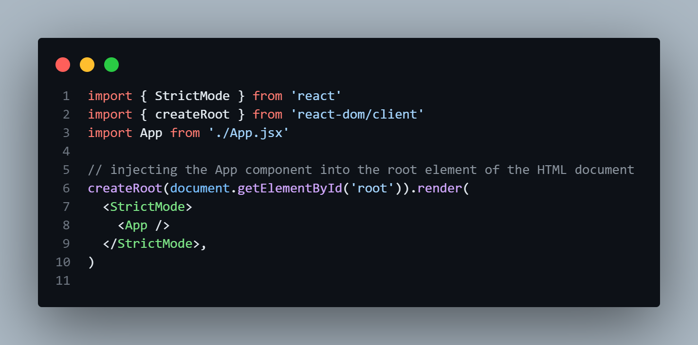

Main.jsx
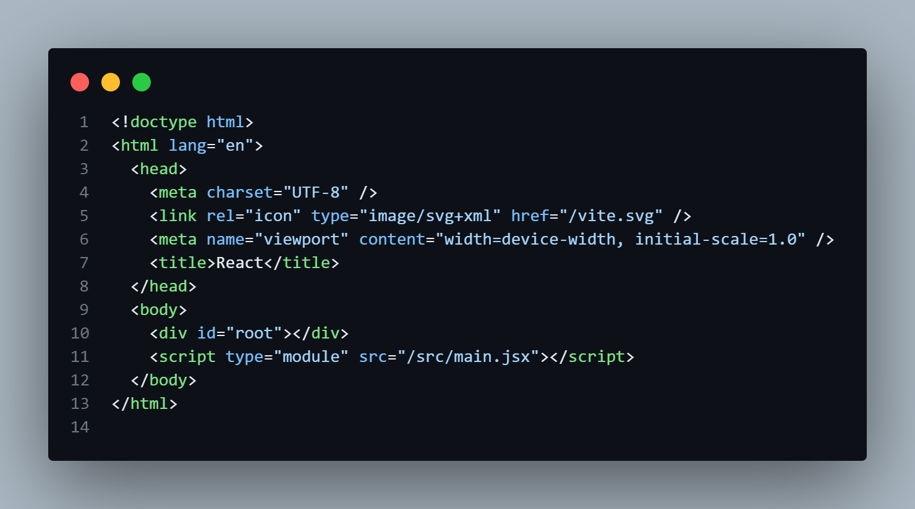
index.html

app.jsx: this file in rendered in the main.jsx
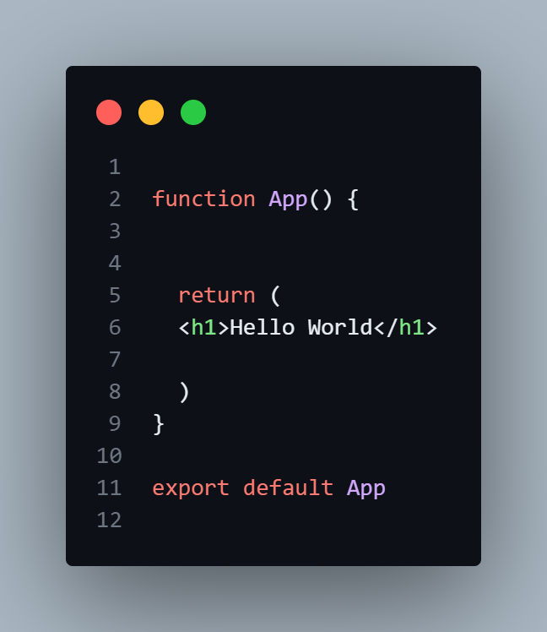

Creating a custom React.
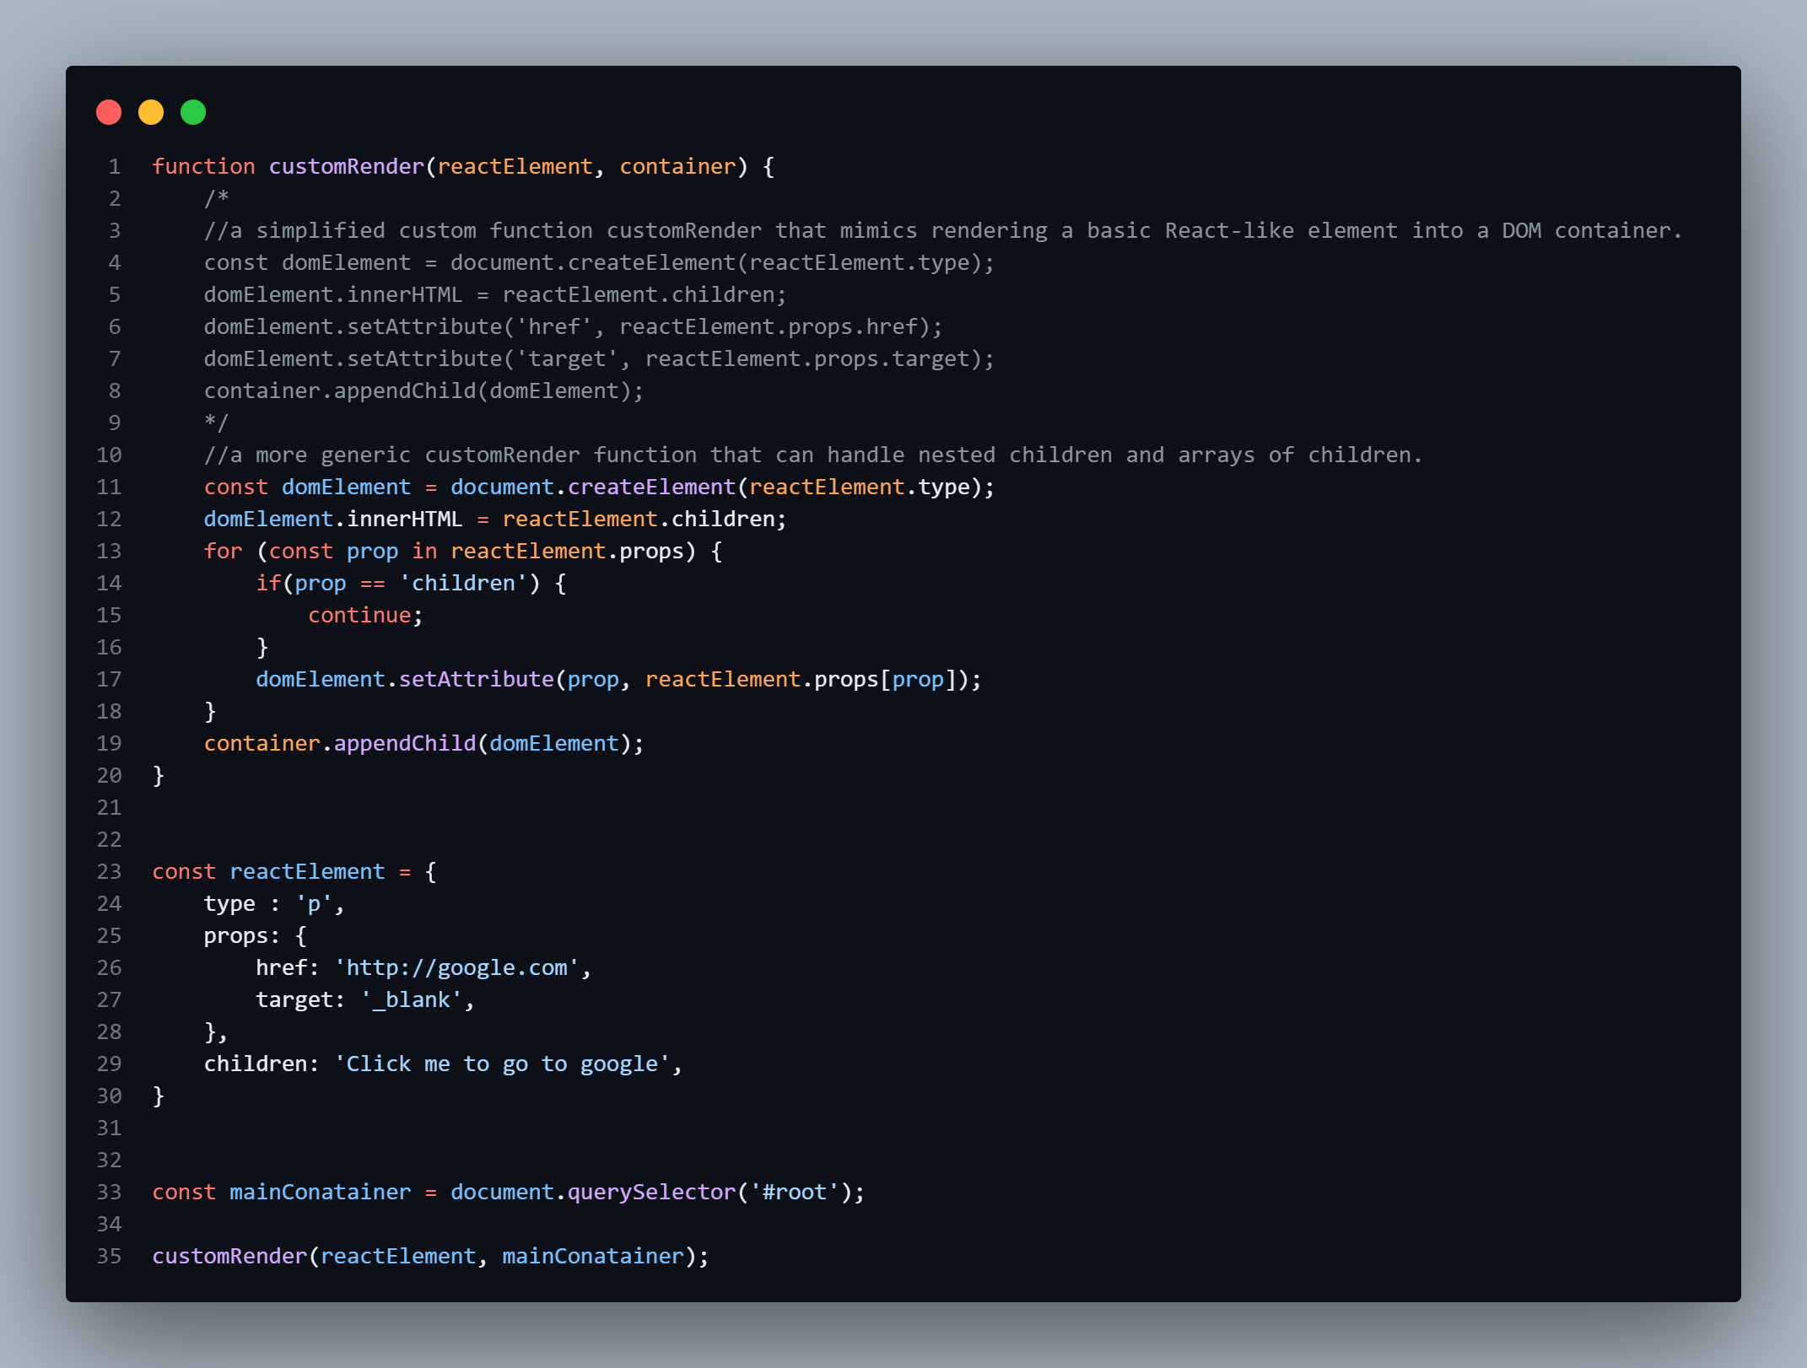

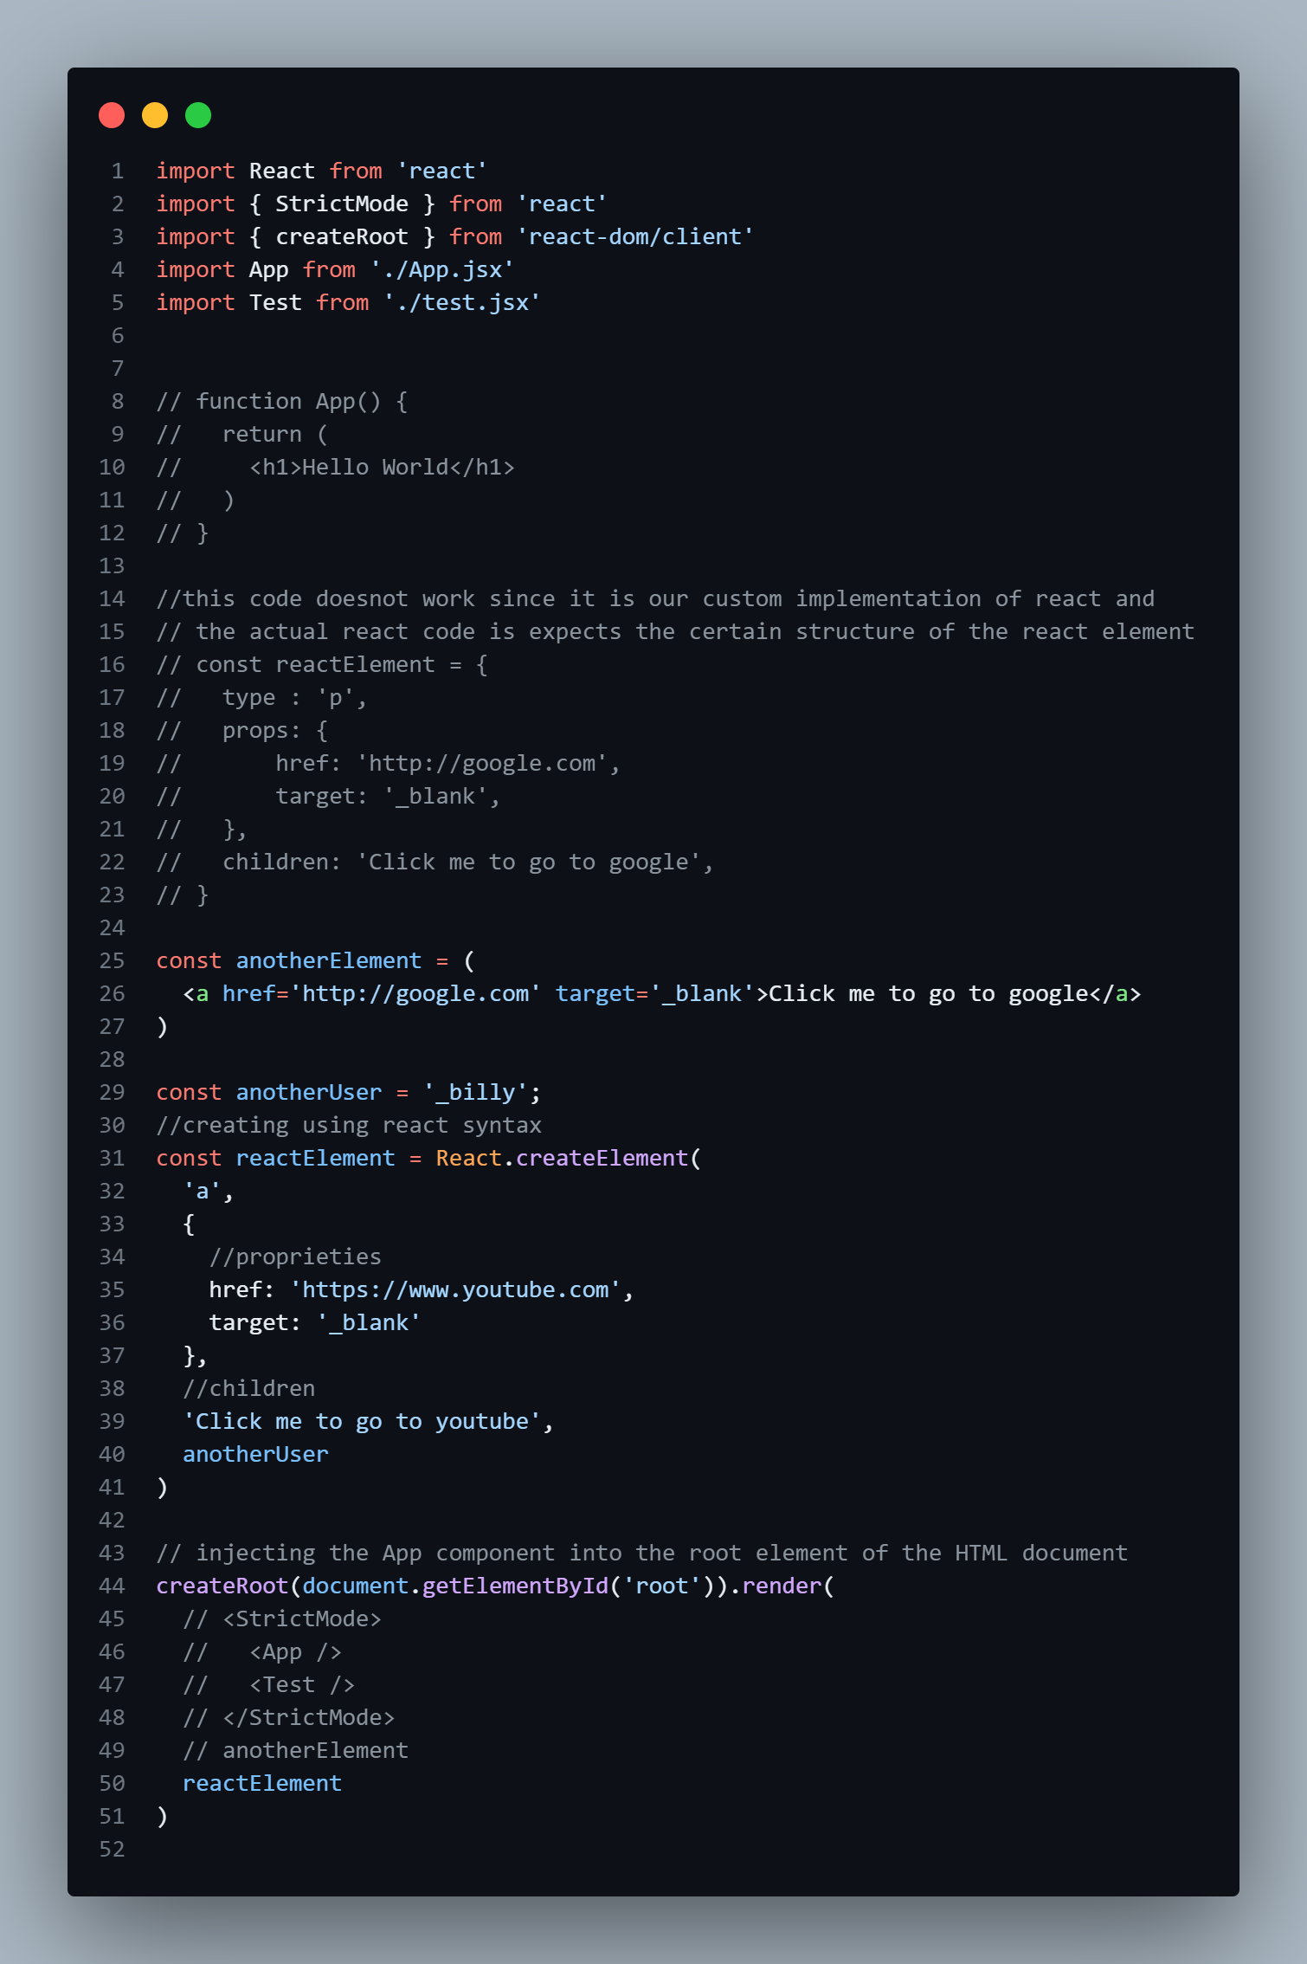
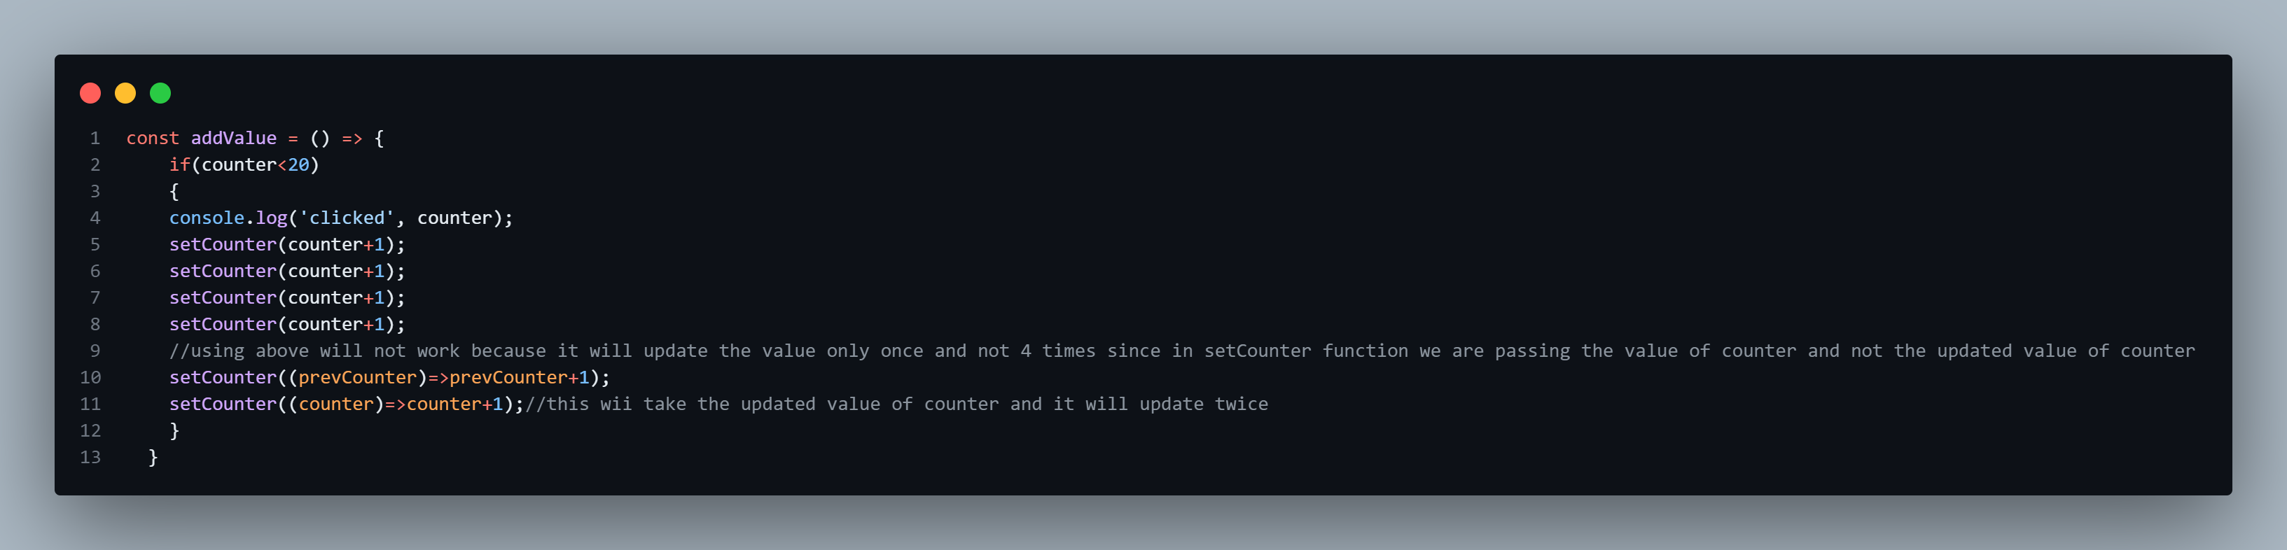
Learning of useState Hook:’
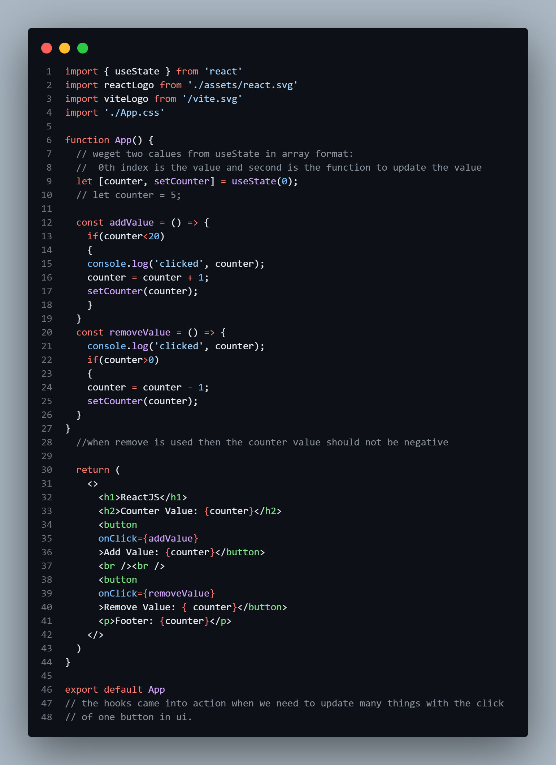

React Fiber:

The goal of React Fiber is to increase its suitability for areas like animation, layout, and gestures. Its headline feature is incremental rendering: the ability to split rendering work into chunks and spread it out over multiple frames
Reconciliation
The algorithm React uses to diff one tree with another to determine which parts need to be changed.
update
A change in the data used to render a React app. Usually the result of `setState`. Eventually results in a re-render.
Reconciliation is the algorithm behind what is popularly understood as the "virtual DOM." When you render a React application, a tree of nodes that describes the app is generated and saved in memory. This tree is then flushed to the rendering environment — for example, in the case of a browser application, it's translated to a set of DOM operations. When the app is updated (usually via setState), a new tree is generated. The new tree is diffed with the previous tree to compute which operations are needed to update the rendered app.
Key Points: [React Fiber]
- In a UI, it's not necessary for every update to be applied immediately; in fact, doing so can be wasteful, causing frames to drop and degrading the user experience.
- Different types of updates have different priorities — an animation update needs to complete more quickly than, say, an update from a data store.
- A push-based approach requires the app (you, the programmer) to decide how to schedule work. A pull-based approach allows the framework (React) to be smart and make those decisions for you.

Scheduling
scheduling
the process of determining when work should be performed.
work
any computations that must be performed. Work is usually the result of an update (e.g. setState).
A primary goal of Fiber is to enable React to take advantage of scheduling.
- pause work and come back to it later.
- assign priority to different types of work.
- reuse previously completed work.
- abort work if it's no longer needed.
The Virtual DOM (VDOM) is a programming concept used in libraries like React to improve the efficiency of UI updates. It is a lightweight copy of the actual DOM (Document Object Model) that helps in minimizing direct manipulation of the real DOM, which is slow.

How It Works:
- Render a Virtual DOM: When the state of an application changes, a new Virtual DOM tree is created.
- Compare with Previous Virtual DOM (Diffing Algorithm): React compares the new Virtual DOM with the previous one to find the differences.
- Update Only the Changed Parts (Reconciliation): React efficiently updates only the changed elements in the real DOM instead of re-rendering the entire page.

useCallBack:
useCallback is a React hook that memoizes a function to prevent unnecessary re-creations on every render. It’s useful for optimizing performance, especially when passing functions as props to child components.

const memoizedFunction = useCallback(() => {
// function logic
}, [dependencies]);
- If dependencies change, the function is recreated.
- If dependencies stay the same, the function remains the same between renders.

useEffect Hook:

Connection to external system
1. Connecting to a chat server
2. Listening to a global browser event
3. Triggering an animation
4. Controlling a modal dialog
5. Tracking element visibility

Fetching data with Effects …..
useEffect is a React Hook used for handling side effects in functional components. Common use cases include:
- Fetching data from an API 📡
- Subscribing to events 🎧
- Updating the DOM 🖼️
- Setting up timers ⏳

useRef
useRef is a React Hook that creates a mutable reference that persists across renders without causing re-renders. It is often used for:
- Accessing DOM elements (like document.getElementById)
- Storing mutable values that don’t trigger re-renders
- Keeping track of previous values
Mutable reference means a value that can change without triggering a component re-render.

React Routee:
React Router is a library for handling navigation in React applications. It enables client-side routing, allowing you to create single-page applications (SPAs) where users can navigate between different views without a full page reload

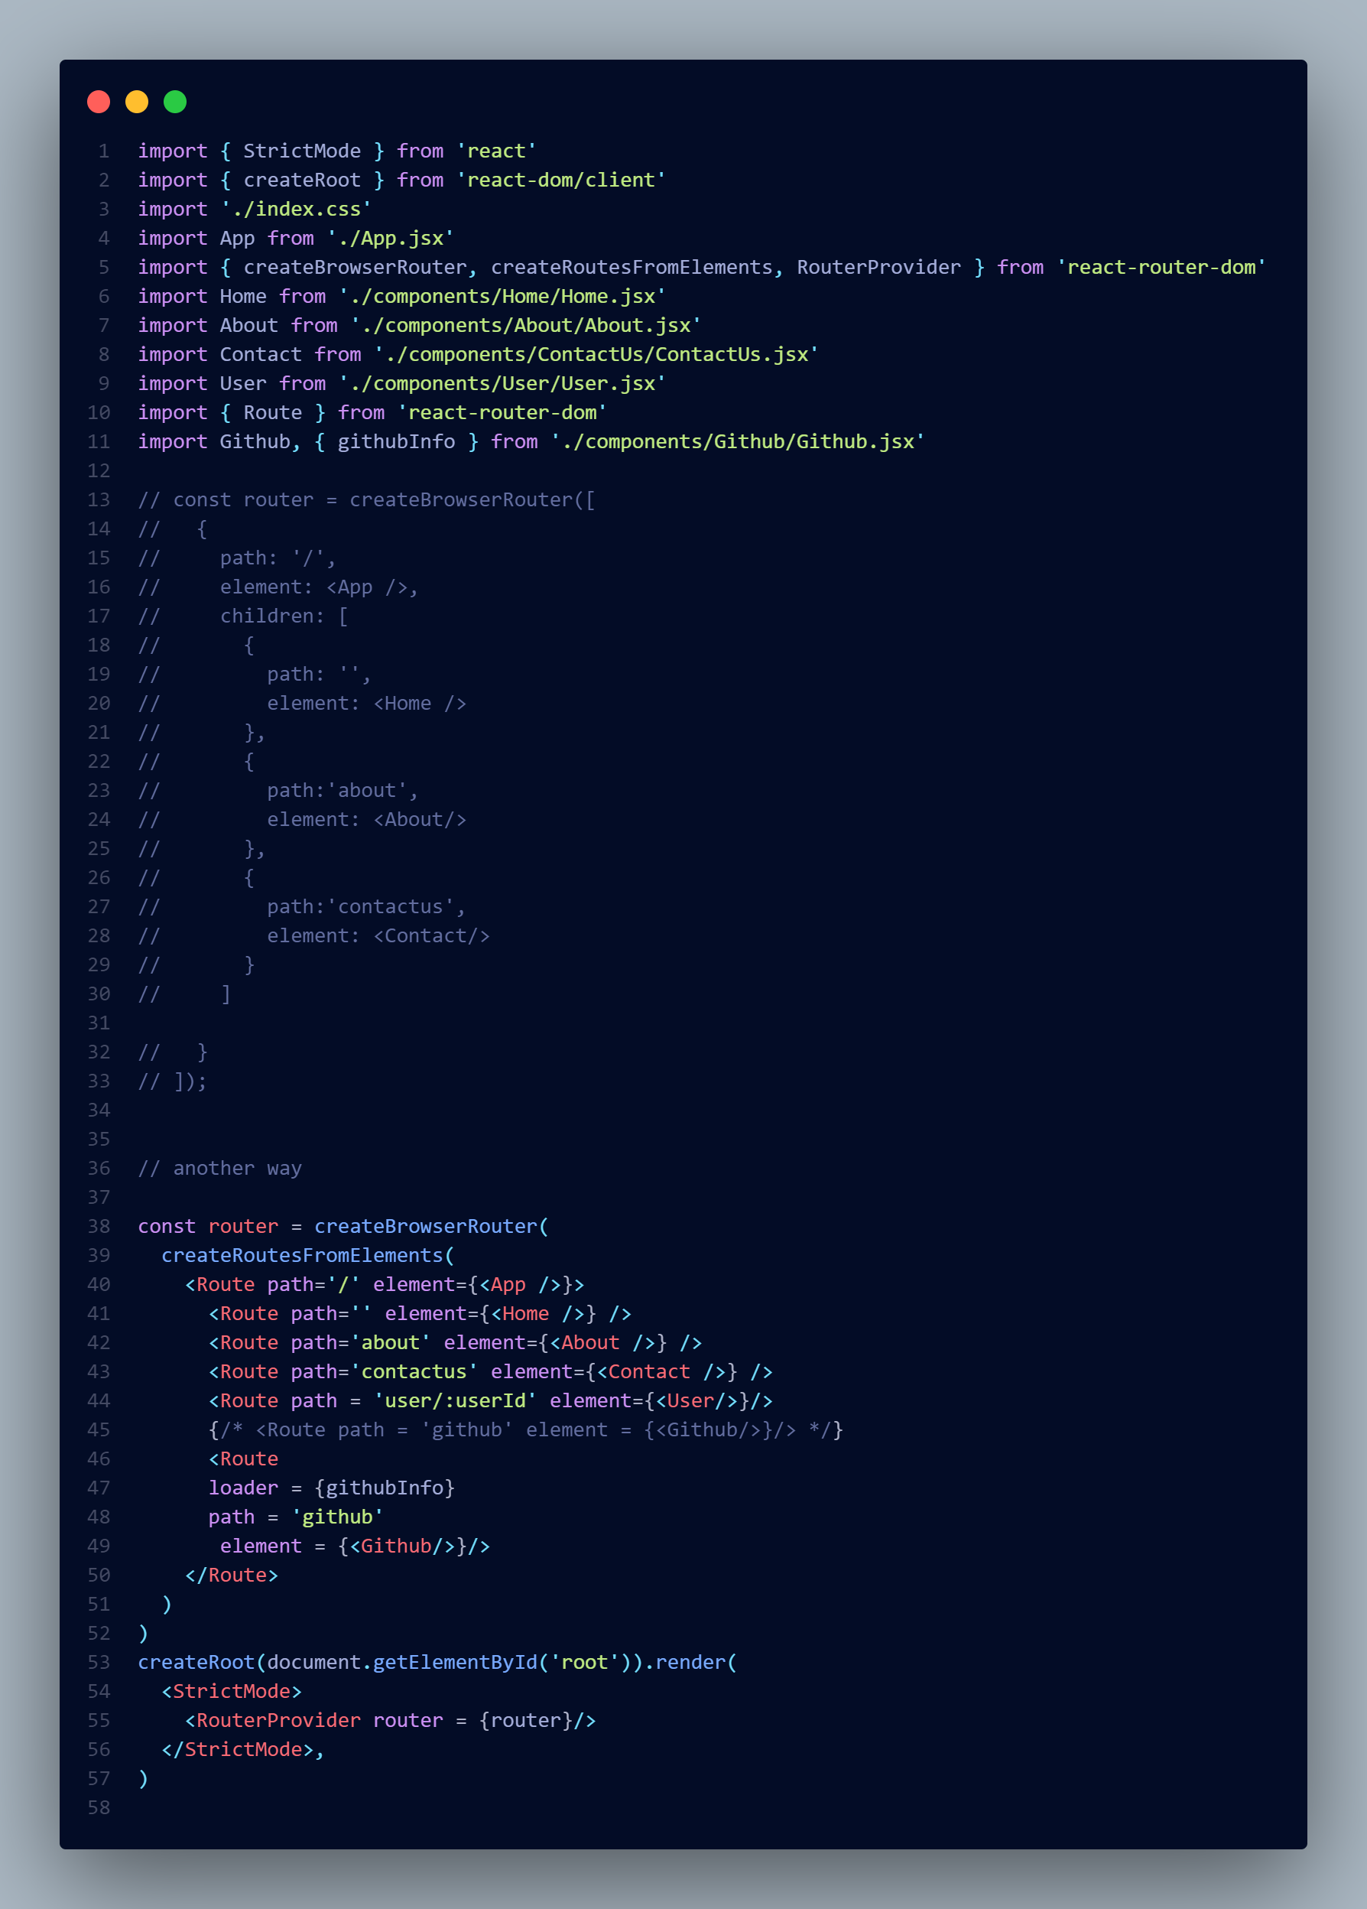

Useprams:
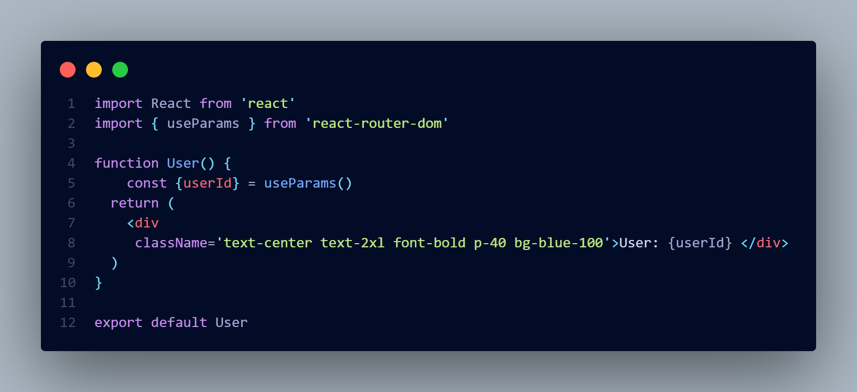
It is a React Router hook used to access route parameters (dynamic segments in URLs).

React Router Loaders (Data Fetching in Routes)
In React Router v6.4+, loaders allow you to fetch data before rendering a component. They work with createBrowserRouter instead of BrowserRouter.
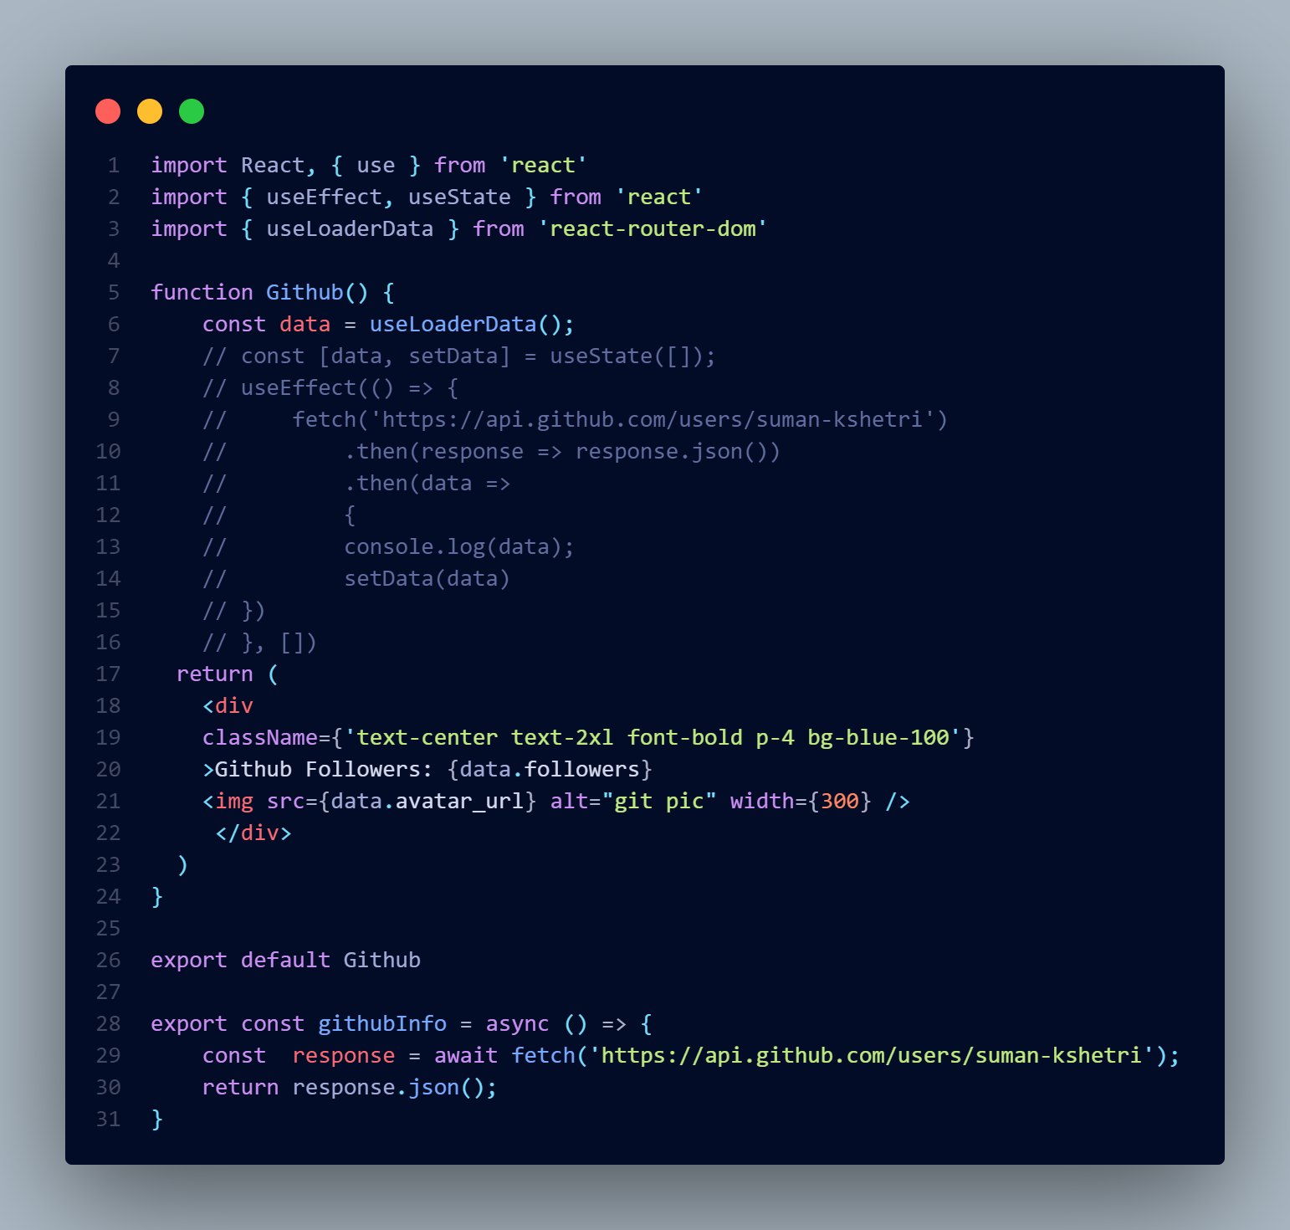
Loaders can fetch data before rendering a route, and the data is cached for efficient re-use. If the data is fetched when hovering over a Navbar link (GitHub) and stored in a catache,

Context API:
In React, passing data from one component to another through multiple intermediate components is called prop drilling, and it can make the code harder to manage. To avoid this, we use Context API.

How Context API Solves This Issue
Instead of passing props through each intermediate component, Context API allows us to create a global state that any component in the component tree can access, without manually passing props at every level.

State Management in React
State management refers to how data (state) is handled within an application. In React, we manage state using built-in tools like useState and useReducer, or external libraries like Context API, Redux, Recoil,Redux-Toolkit, Zustand, etc.
As applications grow, managing state effectively becomes complex. Some common problems include: ✅ Prop Drilling – Passing props down multiple levels unnecessarily.
✅ State Synchronization – Keeping multiple components updated with the latest data.
✅ Complex Business Logic – Handling large amounts of data with dependencies.
✅ Performance Optimization – Preventing unnecessary re-renders and improving efficiency.
State management libraries and tools help solve these problems by providing a structured way to store, update, and share state.
Steps:
- Creating context →const userContext = React.createContext()
- Creating provider of the context like <> </> ie: < userContext> <Card/> <userContext/>
Ie: the component inside the userContext can have the access of the state
- Sending data
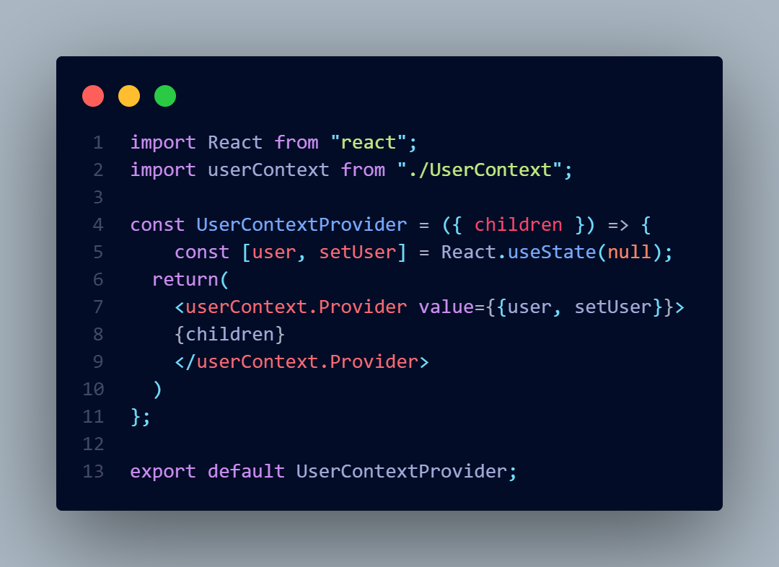
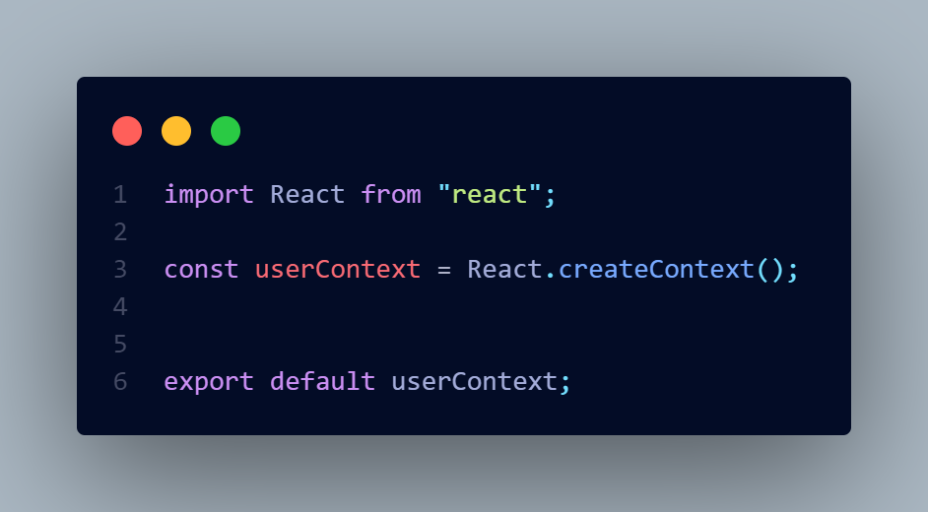
- Receiving data
User.context.js userContextProvider.jsx →
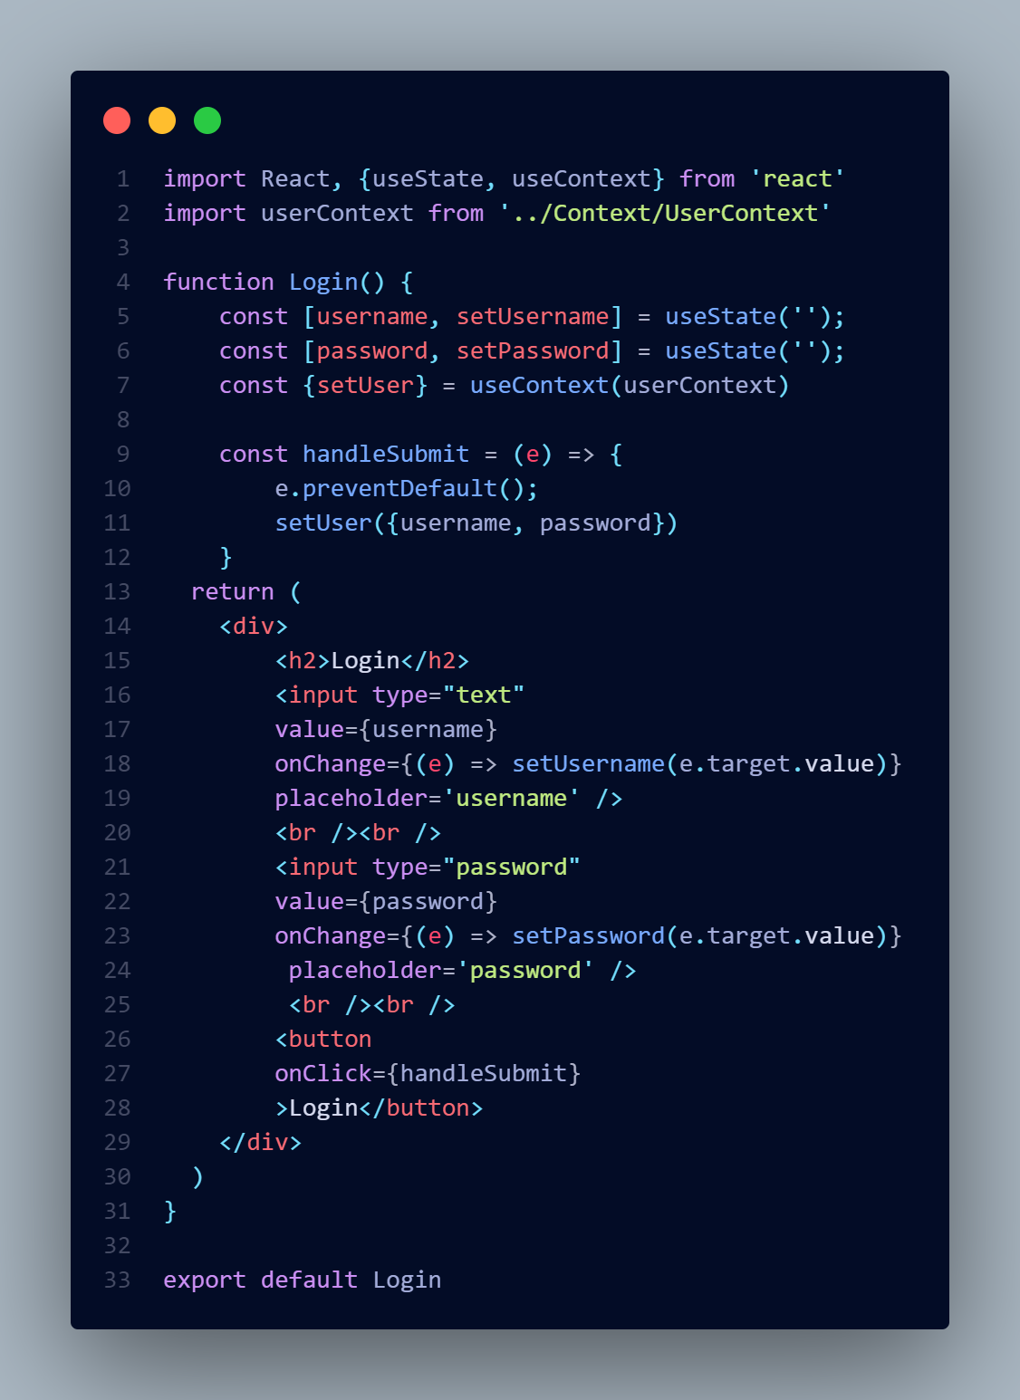
Login.jsx
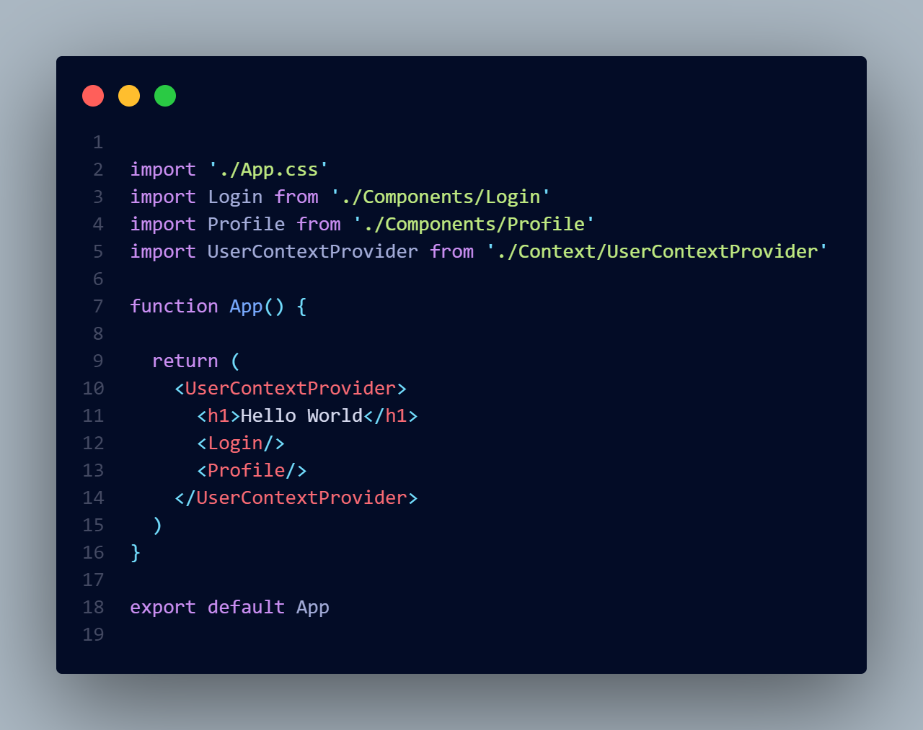
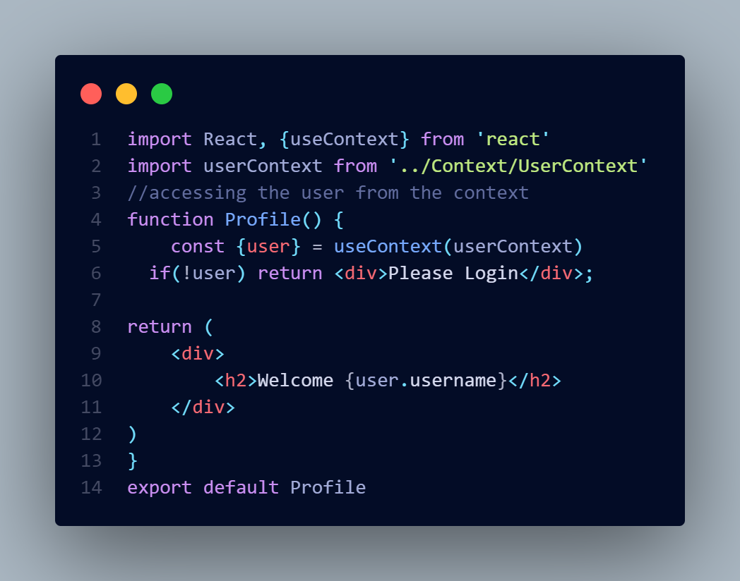
Profile.jsx
App.jsx

