**Prolog**

1. **Write prolog program to perform below operations.**

* Logical AND, OR, NOT, NOR, NAND.
* Fibonacci Series.
* If a number is member of a list or not.
* Find the minimum and maximum of a list.
* GCD of a number.
* Concatenation of two list.
* Reverse of a list.
* Union, intersection of two list.

1. Logical AND, OR, NOT, NOR, NAND.

Program:

and(0, _, 0).

and(_, 0, 0).

and(1, 1, 1).

or(X, 0, X).

or(0, X, X).

or(1, X, 1).

not(X, R):- R is 1-X.

nor(A, B, R):- or(A, B, Res), not(Res, R).

nand(A, B, R):- and(A, B, Res), not(Res, R).

Output:

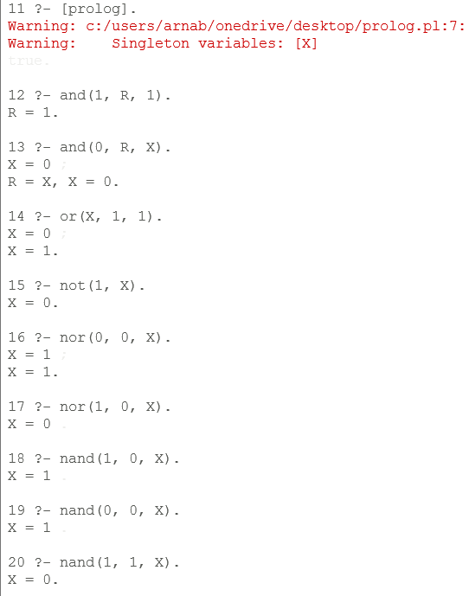

1. Fibonacci Series.

fib(N, F):- N > 2, N1 is N - 1, N2 is N - 2, fib(N1, F1), fib(N2, F2), F is F1 + F2.

fib(N, 1):- N =< 2, N > 0.

Output:

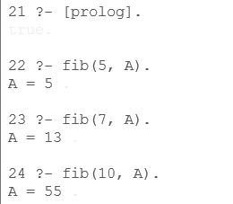

1. If a number is a member of a list or not.

Program:

is_member(X, [X|_]).

is_member(X, [_|Tail]) :- is_member(X, Tail).

Output:

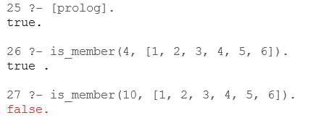

1. Find the minimum and maximum of a list.

Program:

minm(X, Y, X):- Y > X.

minm(X, Y, Y):- X >= Y.

minl([X, Y|T], M):- minm(X, Y, Z), minl([Z|T], M).

minl([X], X).

maxm(X, Y, X):- X >= Y.

maxm(X, Y, Y):- Y > X.

maxl([X, Y|T], M):- maxm(X, Y, Z), maxl([Z|T], M).

maxl([X], X).

Output:

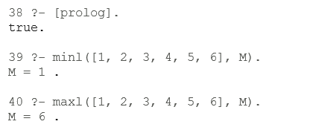

1. GCD of two numbers.

Program:

gcd(X, Y, Z):- X > Y, X1 is X - Y, gcd(X1, Y, Z).

gcd(X, Y, Z):- Y > X, Y1 is Y - X, gcd(X, Y1, Z).

gcd(X, X, X).

Output:

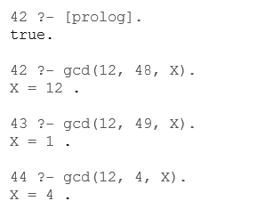

1. Concatenation of two lists.

Program:

concat([H|T], L, [H|C]):- concat(T, L, C).

concat([], L, L).

Output:

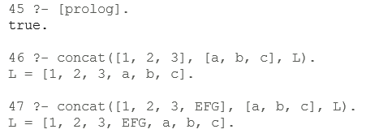

1. Reverse of a list.

Program:

rev([H|T], L):- rev(T, A), concat(A, [H], L).

rev([], []).

Output:

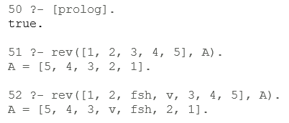

1. Union & Intersection of two list.

Program:

union([H|T], Y, Z):- is_member(H, Y), union(T, Y, Z).

union([H|T], Y, [H|Z]):- \+is_member(H, Y), union(T, Y, Z).

union([], L, L).

intersection([H|T], Y, [H|Z]):- is_member(H, Y), intersection(T, Y, Z).

intersection([H|T], Y, Z):- not(is_member(H, Y)), intersection(T, Y, Z).

intersection([], _, []).

2. Write a PROLOG program to calculate the sum of two numbers.

% Rule to calculate the sum of two numbers

sum(X, Y, Result) :-

Result is X + Y.

--------------------------------------------------------------------------------

3. Write a PROLOG program to find the maximum of two numbers.

% Rule to find the maximum of two numbers

max(X, Y, Max) :-

(X >= Y, Max = X) ; (Y > X, Max = Y).

-----------------------------------------------------------------------------------

4. Write a PROLOG program to find the area and perimeter of a square with the side length

being provided by the user.

% Rule to calculate the area of a square

square_area(Side, Area) :-

Area is Side * Side.

% Rule to calculate the perimeter of a square

square_perimeter(Side, Perimeter) :-

Perimeter is 4 * Side.

% Rule to display the area and perimeter of a square

display_square_info(Side) :-

square_area(Side, Area),

square_perimeter(Side, Perimeter),

format('Square with side length ~w has area ~w and perimeter ~w.~n', [Side, Area, Perimeter]).

--------------------------------------------------------------------------------------------------------

5. Write a PROLOG program to find the area and perimeter of a circle with the radius

being provided by the user.

% Rule to calculate the area of a circle

circle_area(Radius, Area) :-

Area is pi * Radius * Radius.

% Rule to calculate the perimeter (circumference) of a circle

circle_perimeter(Radius, Perimeter) :-

Perimeter is 2 * pi * Radius.

% Rule to display the area and perimeter of a circle

display_circle_info(Radius) :-

circle_area(Radius, Area),

circle_perimeter(Radius, Perimeter),

format('Circle with radius ~w has area ~w and perimeter ~w.~n', [Radius, Area, Perimeter]).

-------------------------------------------------------------------------------------------------------

6. Write a PROLOG program to print a Fibonacci series with stating numbers are provided

by user.

% Rule to print Fibonacci series without using lists

print_fibonacci(First, Second, N) :-

N > 0,

write(First), nl,

Next is First + Second,

print_fibonacci(Second, Next, N - 1).

% Example usage

% print_fibonacci(FirstNumber, SecondNumber, NumberOfTerms).

------------------------------------------------------------------------------------------------------

7. Write a PROLOG program to calculate the sum of natural numbers up to a limit (using

recursion).

% Rule to calculate the sum of natural numbers up to a limit

sum_of_naturals(0, 0). % Base case: sum of 0 natural numbers is 0

sum_of_naturals(N, Sum) :-

N > 0,

N1 is N - 1,

sum_of_naturals(N1, SubSum),

Sum is N + SubSum.

% Example usage

% To calculate the sum of natural numbers up to the limit of 5:

% ?- sum_of_naturals(5, Result).

% Result will be unified with 15.

-------------------------------------------------------------------------------------------------------

8. Write a PROLOG program to calculate the sum of a range.

% Rule to calculate the sum of a range of numbers

sum_of_range(Start, End, Sum) :-

sum_of_range_helper(Start, End, 0, Sum).

% Base case: Sum of the range [N, N] is N

sum_of_range_helper(N, N, Acc, Sum) :-

Sum is Acc + N.

% Recursive case: Sum of the range [Start, End] is Start + Sum of [Start+1, End]

sum_of_range_helper(Start, End, Acc, Sum) :-

Start < End,

NextStart is Start + 1,

NewAcc is Acc + Start,

sum_of_range_helper(NextStart, End, NewAcc, Sum).

% Example usage

% To calculate the sum of the range from 1 to 5:

% ?- sum_of_range(1, 5, Result).

% Result will be unified with 15.

------------------------------------------------------------------------------------------------------------

9. Write a PROLOG program to calculate the factorial of a given number.

% Rule to calculate the factorial of a number

factorial(0, 1). % Base case: factorial of 0 is 1

factorial(N, Result) :-

N > 0,

N1 is N - 1,

factorial(N1, SubResult),

Result is N * SubResult.

% Example usage

% To calculate the factorial of 5:

% ?- factorial(5, Result).

% Result will be unified with 120.

-------------------------------------------------------------------------------------------------------------

10. Write a PROLOG program to find the last element of a list(list must have at least 4

items).

% Rule to find the last element of a list

last_element([X], X). % Base case: last element of a list with one item is the item itself

last_element([_|Tail], Last) :-

last_element(Tail, Last).

% Example usage

% To find the last element of a list [1, 2, 3, 4]:

% ?- last_element([1, 2, 3, 4], Result).

% Result will be unified with 4.

------------------------------------------------------------------------------------------------------------

11. Write a PROLOG program to find the length of a list (list must have at least 4 elements).

% Rule to find the length of a list

list_length([], 0). % Base case: length of an empty list is 0

list_length([_|Tail], Length) :-

list_length(Tail, TailLength),

Length is TailLength + 1.

% Example usage

% To find the length of a list [1, 2, 3, 4]:

% ?- list_length([1, 2, 3, 4], Result).

% Result will be unified with 4.

-----------------------------------------------------------------------------------------------------------

12. Write a PROLOG program to find the average of a list of numbers

% Rule to calculate the sum of a list of numbers

sum_list([], 0). % Base case: sum of an empty list is 0

sum_list([X|Xs], Sum) :-

sum_list(Xs, TailSum),

Sum is X + TailSum.

% Rule to calculate the length of a list

list_length([], 0). % Base case: length of an empty list is 0

list_length([_|Tail], Length) :-

list_length(Tail, TailLength),

Length is TailLength + 1.

% Rule to calculate the average of a list of numbers

average_list([], 0). % Base case: average of an empty list is 0

average_list(List, Average) :-

sum_list(List, Sum),

list_length(List, Length),

Length > 0, % To avoid division by zero

Average is Sum / Length.

% Example usage

% To find the average of a list [1, 2, 3, 4]:

% ?- average_list([1, 2, 3, 4], Result).

% Result will be unified with 2.5.

------------------------------------------------------------------------------------------------------

13. Write a PROLOG program to implement maxlist(List,Max) so that Max is the greatest

among all the elements present in the list (list must have at least 4 items).

% Rule to find the maximum element in a list

maxlist([X], X). % Base case: maximum element in a list with one item is the item itself

maxlist([H|T], Max) :-

maxlist(T, TailMax),

(H > TailMax, Max = H; H =< TailMax, Max = TailMax).

% Example usage

% To find the maximum element in a list [3, 1, 5, 2]:

% ?- maxlist([3, 1, 5, 2], Result).

% Result will be unified with 5.

------------------------------------------------------------------------------------------------------

14. Write a PROLOG program to calculate the sum of numbers present in the List. ( At first

create a list of numbers. The length of the list must not be less than 4.)

% Rule to calculate the sum of numbers in a list

sum_list([], 0). % Base case: sum of an empty list is 0

sum_list([X|Xs], Sum) :-

sum_list(Xs, TailSum),

Sum is X + TailSum.

% Example usage

% To calculate the sum of numbers in a list [1, 2, 3, 4]:

% ?- sum_list([1, 2, 3, 4], Result).

% Result will be unified with 10.

---------------------------------------------------------------------------------------------

15. Write a PROLOG program to find out the GCD and LCM of two numbers. Use these

predicates to find out the GCD and LCM of a list of numbers.

% Rule to find the GCD of two numbers

gcd(X, 0, X) :- X > 0.

gcd(X, Y, GCD) :-

Y > 0,

Z is X mod Y,

gcd(Y, Z, GCD).

% Rule to find the LCM of two numbers

lcm(X, Y, LCM) :-

gcd(X, Y, GCD),

LCM is abs(X * Y) // GCD.

% Rule to find the GCD of a list of numbers

gcd_list([], 0).

gcd_list([X], X).

gcd_list([X, Y | Rest], GCD) :-

gcd(X, Y, TempGCD),

gcd_list([TempGCD | Rest], GCD).

% Rule to find the LCM of a list of numbers

lcm_list([], 1).

lcm_list([X], X).

lcm_list([X, Y | Rest], LCM) :-

lcm(X, Y, TempLCM),

lcm_list([TempLCM | Rest], LCM).

% Example usage

% To find the GCD and LCM of a list of numbers [12, 18, 24]:

% ?- gcd_list([12, 18, 24], GCDResult).

% GCDResult will be unified with 6.

%

% ?- lcm_list([12, 18, 24], LCMResult).

% LCMResult will be unified with 72.

------------------------------------------------------------------------------------------------

16. Write a PROLOG program to insert an element at the kth position of a list.

% Rule to insert an element at the kth position of a list

insert_at(Element, 1, List, [Element|List]).

insert_at(Element, K, [Head|Tail], [Head|Result]) :-

K > 1,

K1 is K - 1,

insert_at(Element, K1, Tail, Result).

% Example usage

% To insert the element 42 at the 3rd position of the list [1, 2, 3, 4]:

% ?- insert_at(42, 3, [1, 2, 3, 4], Result).

% Result will be unified with [1, 2, 42, 3, 4].

---------------------------------------------------------------------------------------------

17. Write a PROLOG program to compute the sum of the digits of an integer.

% Rule to compute the sum of the digits of an integer

sum_of_digits(0, 0). % Base case: sum of digits of 0 is 0

sum_of_digits(N, Sum) :-

N > 0,

Digit is N mod 10,

N1 is N // 10,

sum_of_digits(N1, SubSum),

Sum is Digit + SubSum.

% Example usage

% To compute the sum of digits of the integer 12345:

% ?- sum_of_digits(12345, Result).

% Result will be unified with 15.

---------------------------------------------------------------------------------------------------

19. Write a PROLOG program to print the reverse of a given list.

% Rule to reverse a list

reverse_list([], []).

reverse_list([Head|Tail], Reversed) :-

reverse_list(Tail, TailReversed),

append(TailReversed, [Head], Reversed).

% Example usage

% To reverse the list [1, 2, 3, 4]:

% ?- reverse_list([1, 2, 3, 4], Reversed).

% Reversed will be unified with [4, 3, 2, 1].

----------------------------------------------------------------------------------------------------

20. Write a PROLOG program to concatenate two given lists.

% Rule to concatenate two lists

concatenate_lists([], L, L).

concatenate_lists([Head|Tail1], L2, [Head|Result]) :-

concatenate_lists(Tail1, L2, Result).

% Example usage

% To concatenate the lists [1, 2, 3] and [4, 5, 6]:

% ?- concatenate_lists([1, 2, 3], [4, 5, 6], Result).

% Result will be unified with [1, 2, 3, 4, 5, 6].

-------------------------------------------------------------------------------------------------------

21. Write a PROLOG program to find the union, difference and intersection of two given

lists.

% Rule to find the union of two lists

union_lists([], L, L).

union_lists([Head|Tail], L2, Union) :-

member(Head, L2), % Check if Head is in L2

!,

union_lists(Tail, L2, Union).

union_lists([Head|Tail], L2, [Head|Union]) :-

union_lists(Tail, L2, Union).

% Rule to find the difference of two lists

difference_lists([], _, []).

difference_lists([Head|Tail], L2, Difference) :-

member(Head, L2), % Check if Head is in L2

!,

difference_lists(Tail, L2, Difference).

difference_lists([Head|Tail], L2, [Head|Difference]) :-

difference_lists(Tail, L2, Difference).

% Rule to find the intersection of two lists

intersection_lists([], _, []).

intersection_lists([Head|Tail], L2, Intersection) :-

member(Head, L2), % Check if Head is in L2

!,

Intersection = [Head|Rest],

intersection_lists(Tail, L2, Rest).

intersection_lists([_|Tail], L2, Intersection) :-

intersection_lists(Tail, L2, Intersection).

% Example usage

% To find the union, difference, and intersection of the lists [1, 2, 3, 4] and [3, 4, 5, 6]:

% ?- union_lists([1, 2, 3, 4], [3, 4, 5, 6], UnionResult).

% UnionResult will be unified with [1, 2, 3, 4, 5, 6].

%

% ?- difference_lists([1, 2, 3, 4], [3, 4, 5, 6], DifferenceResult).

% DifferenceResult will be unified with [1, 2].

%

% ?- intersection_lists([1, 2, 3, 4], [3, 4, 5, 6], IntersectionResult).

% IntersectionResult will be unified with [3, 4].

--------------------------------------------------------------------------------------------------

22. Write a PROLOG program to check whether a given list is palindrome or not.

% Rule to check if a list is a palindrome

is_palindrome(List) :-

reverse_list(List, List).

% Rule to reverse a list

reverse_list([], []).

reverse_list([Head|Tail], Reversed) :-

reverse_list(Tail, TailReversed),

append(TailReversed, [Head], Reversed).

% Example usage

% To check if the list [1, 2, 3, 2, 1] is a palindrome:

% ?- is_palindrome([1, 2, 3, 2, 1]).

% This will succeed, indicating that the list is a palindrome.

% To check if the list [1, 2, 3, 4] is a palindrome:

% ?- is_palindrome([1, 2, 3, 4]).

% This will fail, indicating that the list is not a palindrome.

------------------------------------------------------------------------------------------------------

23. Write a PROLOG program to check whether a given number is prime or not. Use this

predicate to print all the prime numbers upto a given number.

% Rule to check if a number is prime

is_prime(2).

is_prime(3).

is_prime(N) :-

N > 3,

N mod 2 =\= 0,

\+ has_factor(N, 3).

% Rule to check if a number has a factor

has_factor(N, Factor) :-

Factor * Factor =< N,

N mod Factor =:= 0.

has_factor(N, Factor) :-

NextFactor is Factor + 2,

has_factor(N, NextFactor).

% Rule to print prime numbers up to a given number

print_primes_up_to(N) :-

between(2, N, X),

is_prime(X),

write(X), write(' '),

fail. % Backtrack to find more primes

print_primes_up_to(_).

% Example usage

% To check if 17 is a prime number:

% ?- is_prime(17).

% This will succeed, indicating that 17 is a prime number.

% To print all prime numbers up to 30:

% ?- print_primes_up_to(30).

% This will print: 2 3 5 7 11 13 17 19 23 29

-----------------------------------------------------------------------------------------

24. Write a PROLOG program to print the reverse of a given list.

% Rule to print the reverse of a list

print_reverse([]).

print_reverse([Head|Tail]) :-

print_reverse(Tail),

write(Head), write(' ').

% Example usage

% To print the reverse of the list [1, 2, 3, 4]:

% ?- print_reverse([1, 2, 3, 4]).

% This will print: 4 3 2 1

--------------------------------------------------------------------------------------------

25. Write a PROLOG program to delete the kth element of a list.

% Rule to delete the kth element of a list

delete_kth(_, K, _, _) :-

K < 1, % K must be a positive integer

write('Invalid value for K. K should be a positive integer.').

delete_kth(Element, 1, [Element|Tail], Tail).

delete_kth(Element, K, [Head|Tail], [Head|Result]) :-

K > 1,

K1 is K - 1,

delete_kth(Element, K1, Tail, Result).

% Example usage

% To delete the 3rd element of the list [1, 2, 3, 4, 5]:

% ?- delete_kth(_, 3, [1, 2, 3, 4, 5], Result).

% Result will be unified with [1, 2, 4, 5].

--------------------------------------------------------------------------------------------

26. Write a PROLOG program to check whether a path exists between two nodes of a graph.

You can implement any arbitrary graph. Print the series of the nodes in the path(s) if

some path exists.

% Facts defining the directed edges in the graph

edge(a, b).

edge(b, c).

edge(c, d).

edge(d, e).

edge(b, e).

edge(e, f).

% Rule to check if there is a path between two nodes

path(X, Y) :-

path_helper(X, Y, [X]).

% Base case: There is a path between X and Y if there is a direct edge from X to Y

path_helper(X, Y, _) :- edge(X, Y).

% Recursive case: There is a path between X and Y if there is a direct edge from X to Z,

% and there is a path from Z to Y

path_helper(X, Y, Visited) :-

edge(X, Z),

\+ member(Z, Visited), % Ensure we don't revisit nodes

path_helper(Z, Y, [Z | Visited]).

% Rule to print the nodes in the path between X and Y

print_path(X, Y) :-

path(X, Y),

write('Path between '), write(X), write(' and '), write(Y), write(': '),

print_path_helper(X, Y, [X]),

nl.

print_path_helper(X, X, _).

print_path_helper(X, Y, [Next | Rest]) :-

write(Next), write(' '),

print_path_helper(Next, Y, Rest).

% Example usage:

% To check if there is a path between 'a' and 'f' and print the nodes in the path:

% ?- print_path(a, f).

% This will print: "Path between a and f: a b e f"