TABLEAU ASSIGNMENT-4

1 Create a bar chart to compare two measures against a dimension

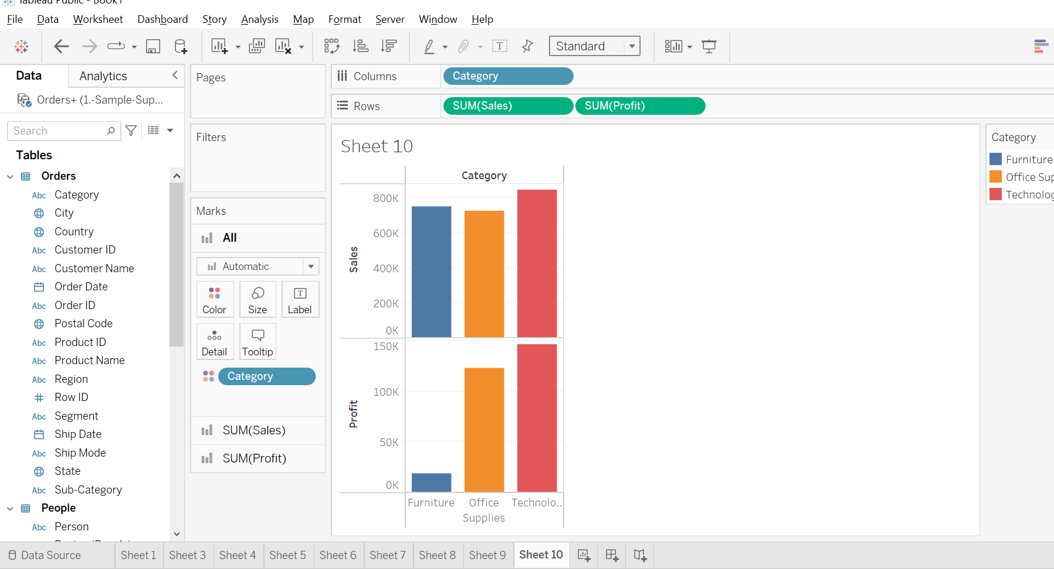

2 Which of these explains the conceptual difference between a line chart and an area chart?

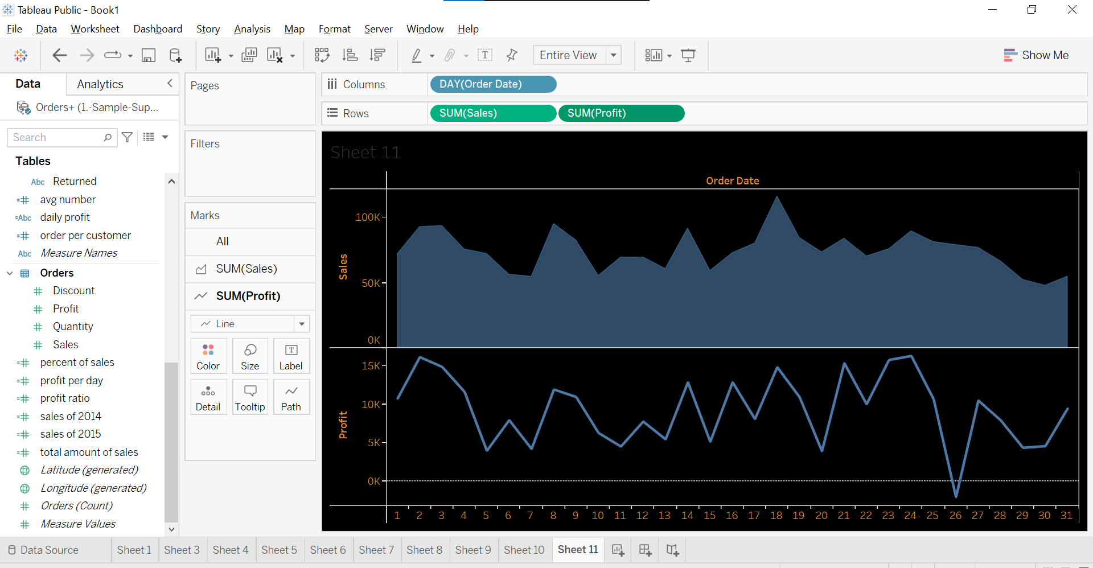

3 Create a tree map to show whole location hierarchy What is the main visual element of a tree map

Called?

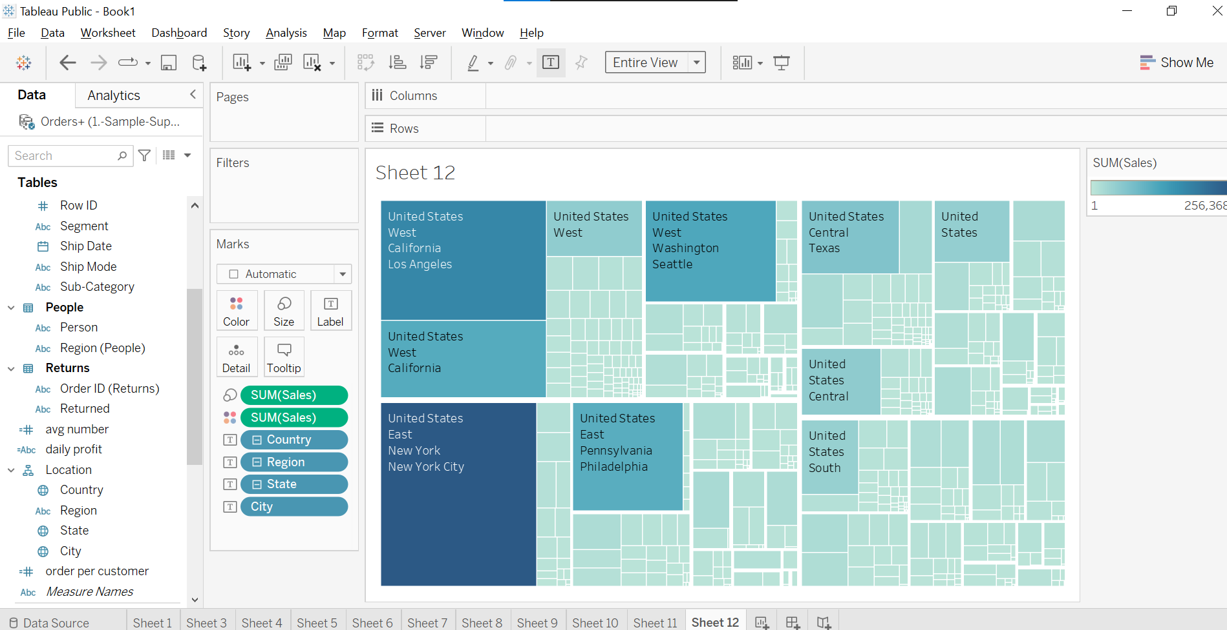

4 Show Category wise sales on State Map

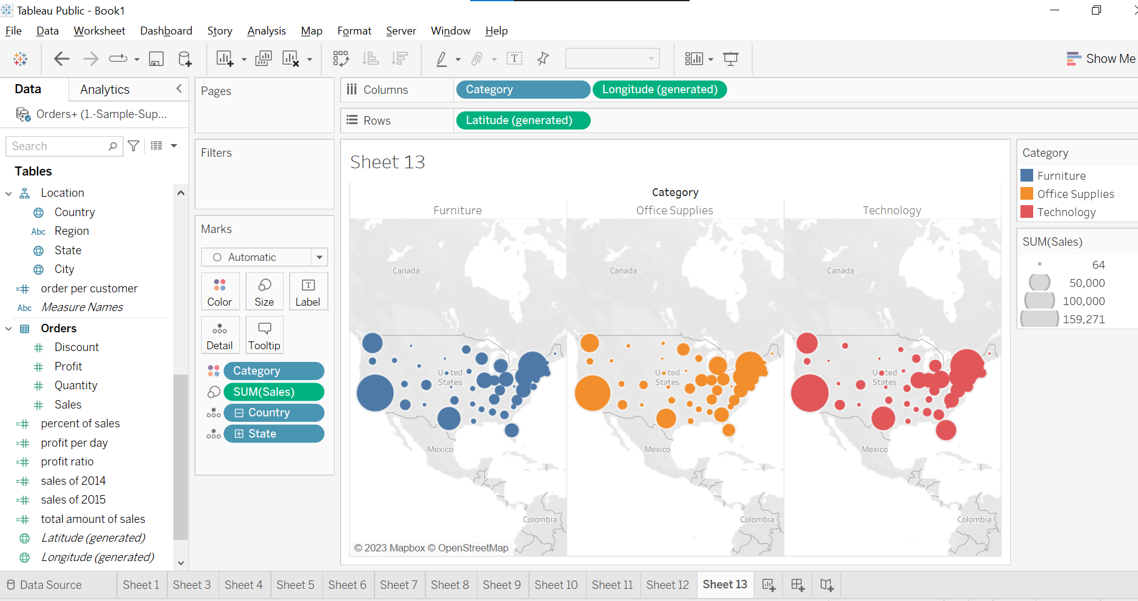

5 Create Dual Axis maps to show state and city on same map

