1 How do you set geographic roles?

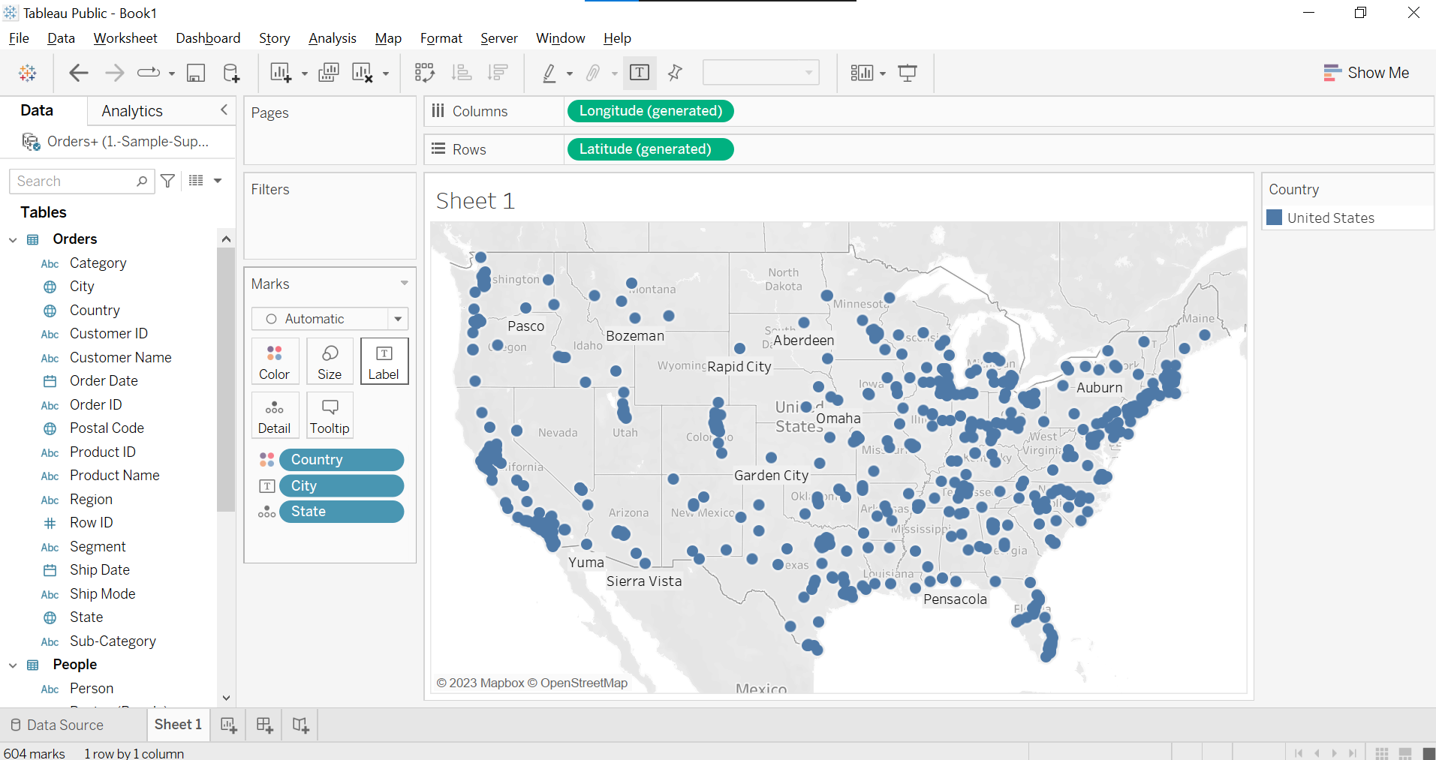

2 what is the main difference between calculated fields and table calculations?

The main difference between calculated fields and table calculations in Tableau is their scope and the way they operate on data.

1. Calculated Field

They can be used in various visualizations, calculations, and data analysis throughout the

Workbook.

Calculated fields are typically used for manipulating and transforming data at the row-level or creating new derived values based on existing data.

1. Table calculations

Table calculations in Tableau are computations performed on the results of a visualization, such as a table, chart, or crosstab.

Table calculations operate on the values displayed in the visualization, taking into account the structure and layout of the view.

3 Find no of P’s in the customer name

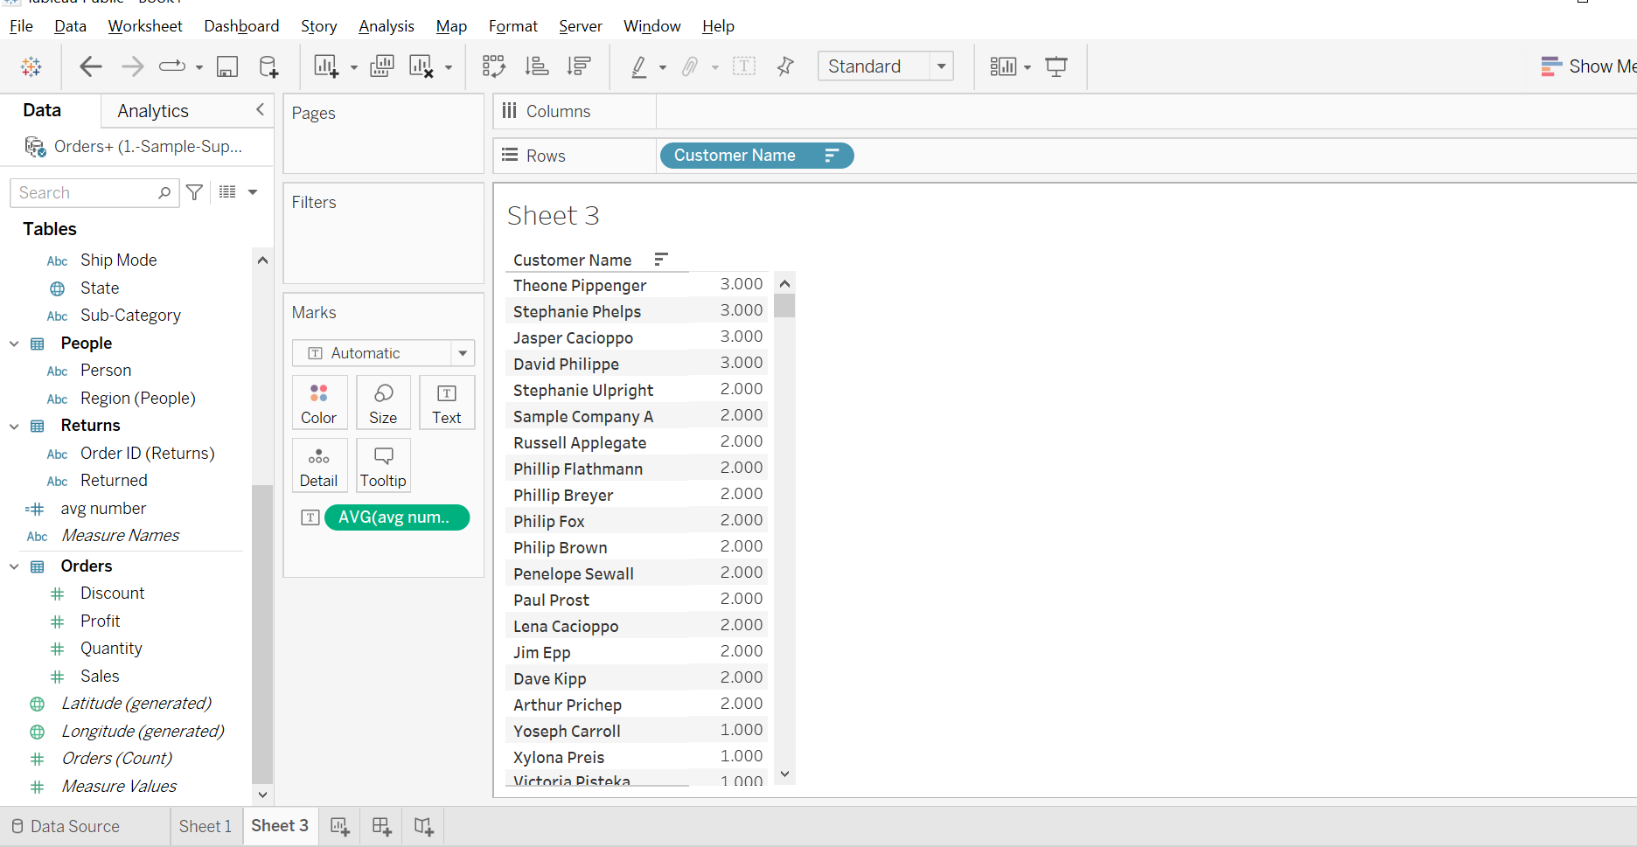

4 Calculate the rank and sort the region and sub category based on sales

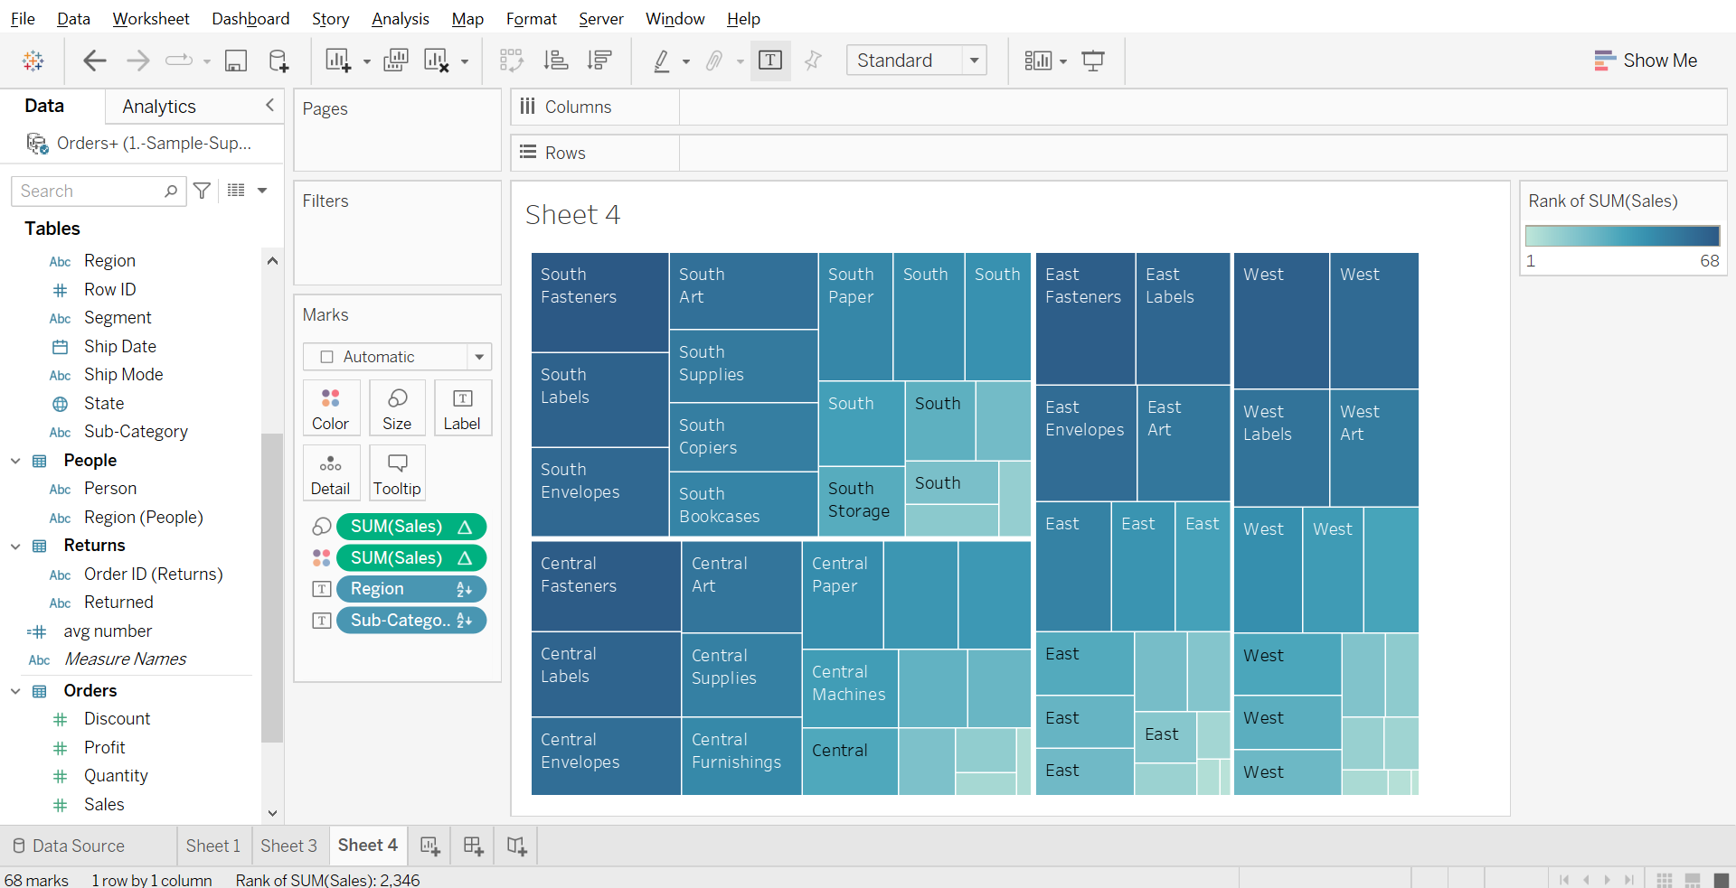

5 which country has the highest profit ratio ?

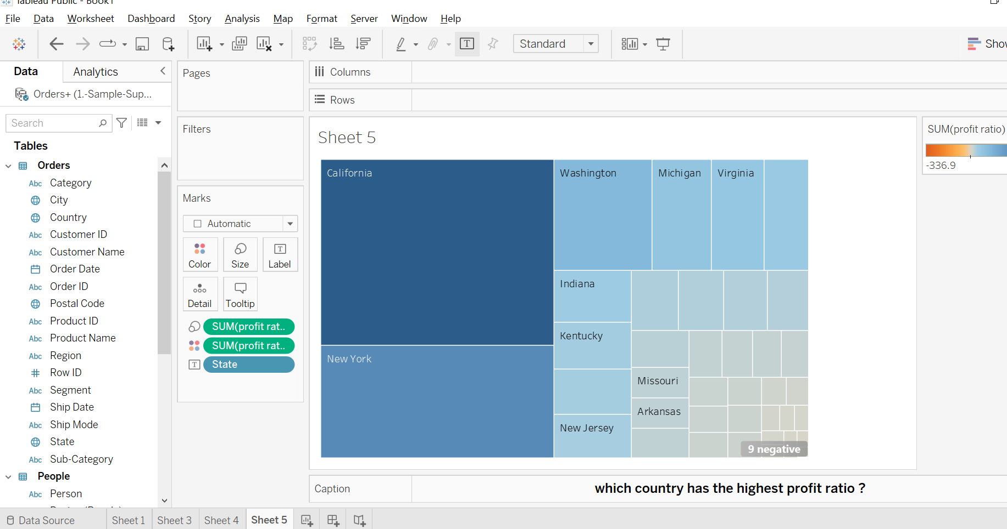

6 Show the difference of current and previous year in the line chart

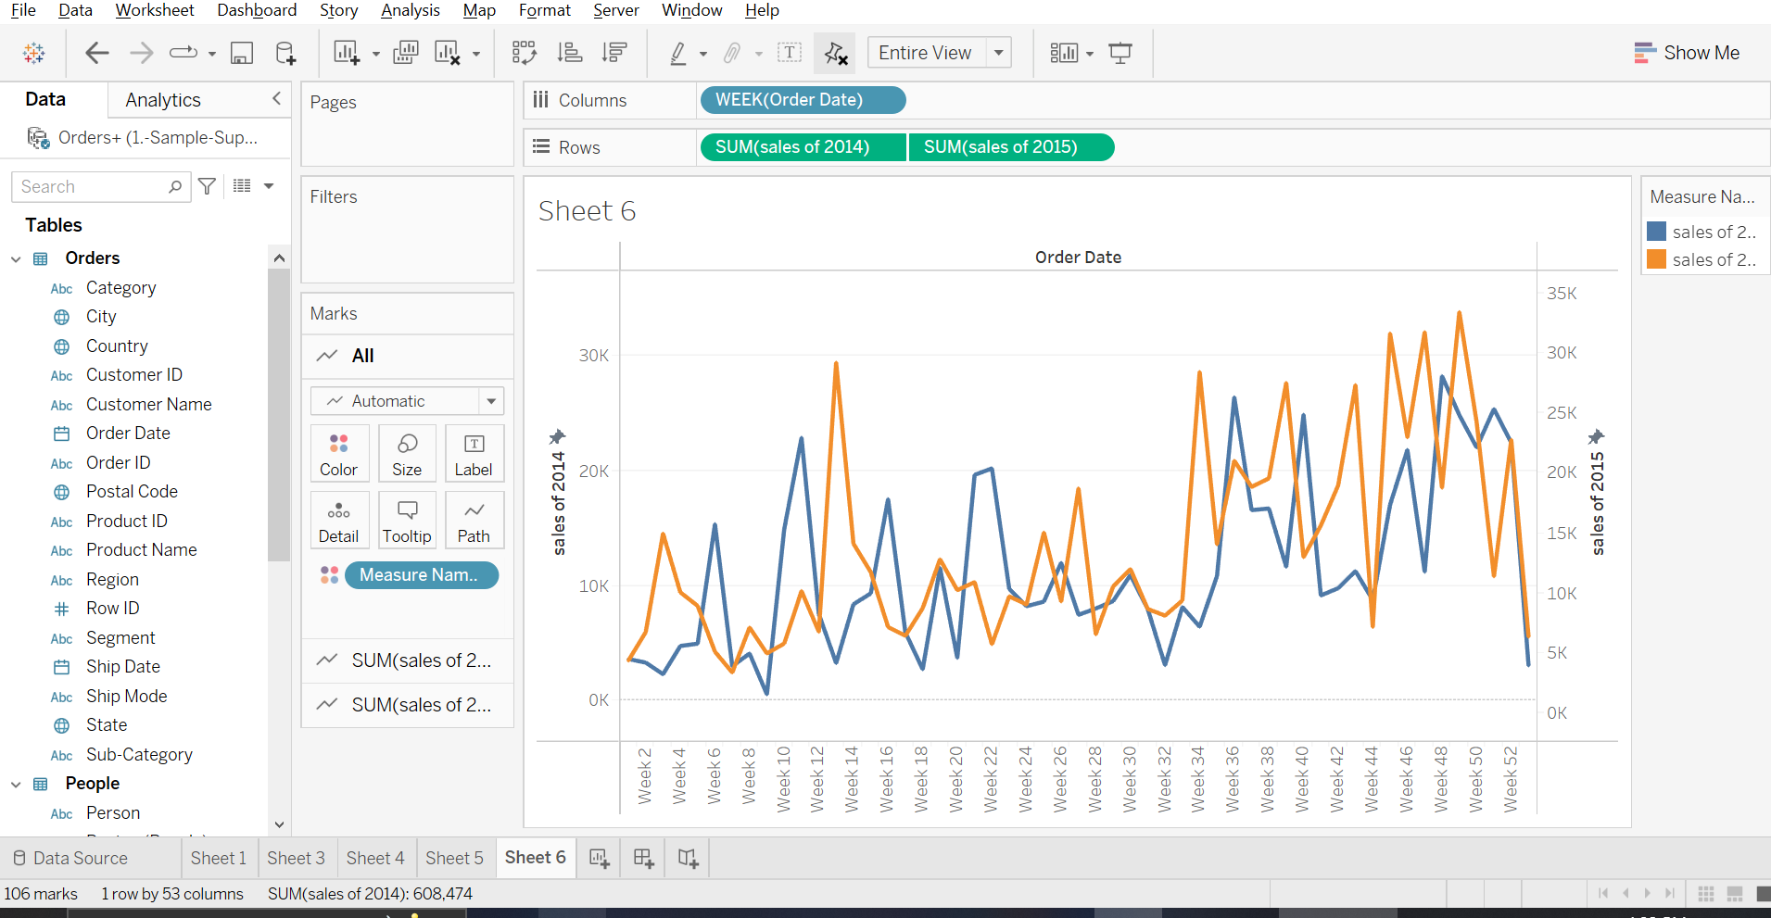

7 How many customers have made 1,2,3 N orders?

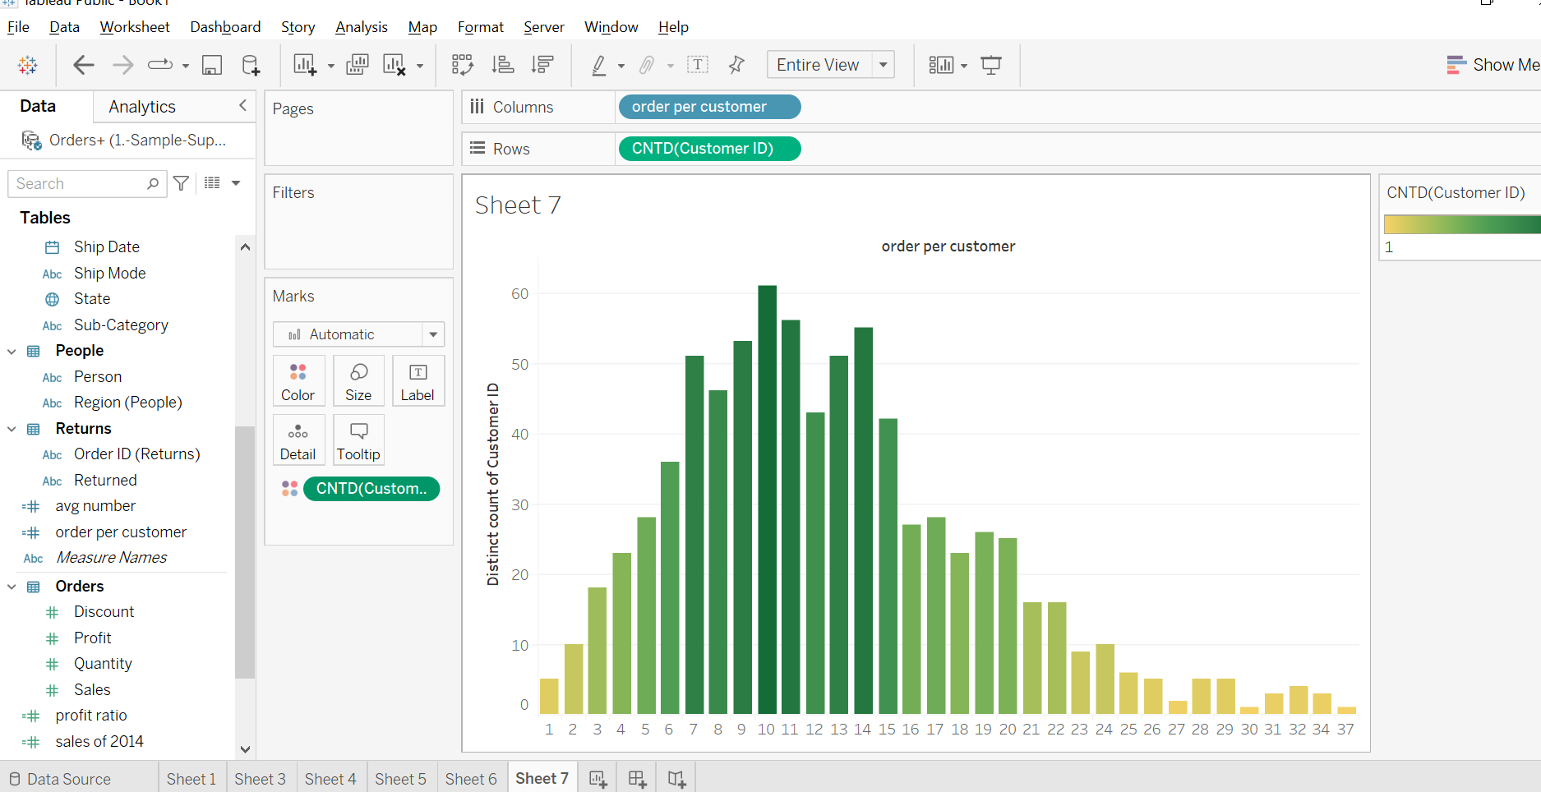

8 For a given market what is each country‘s percent of total global sales?

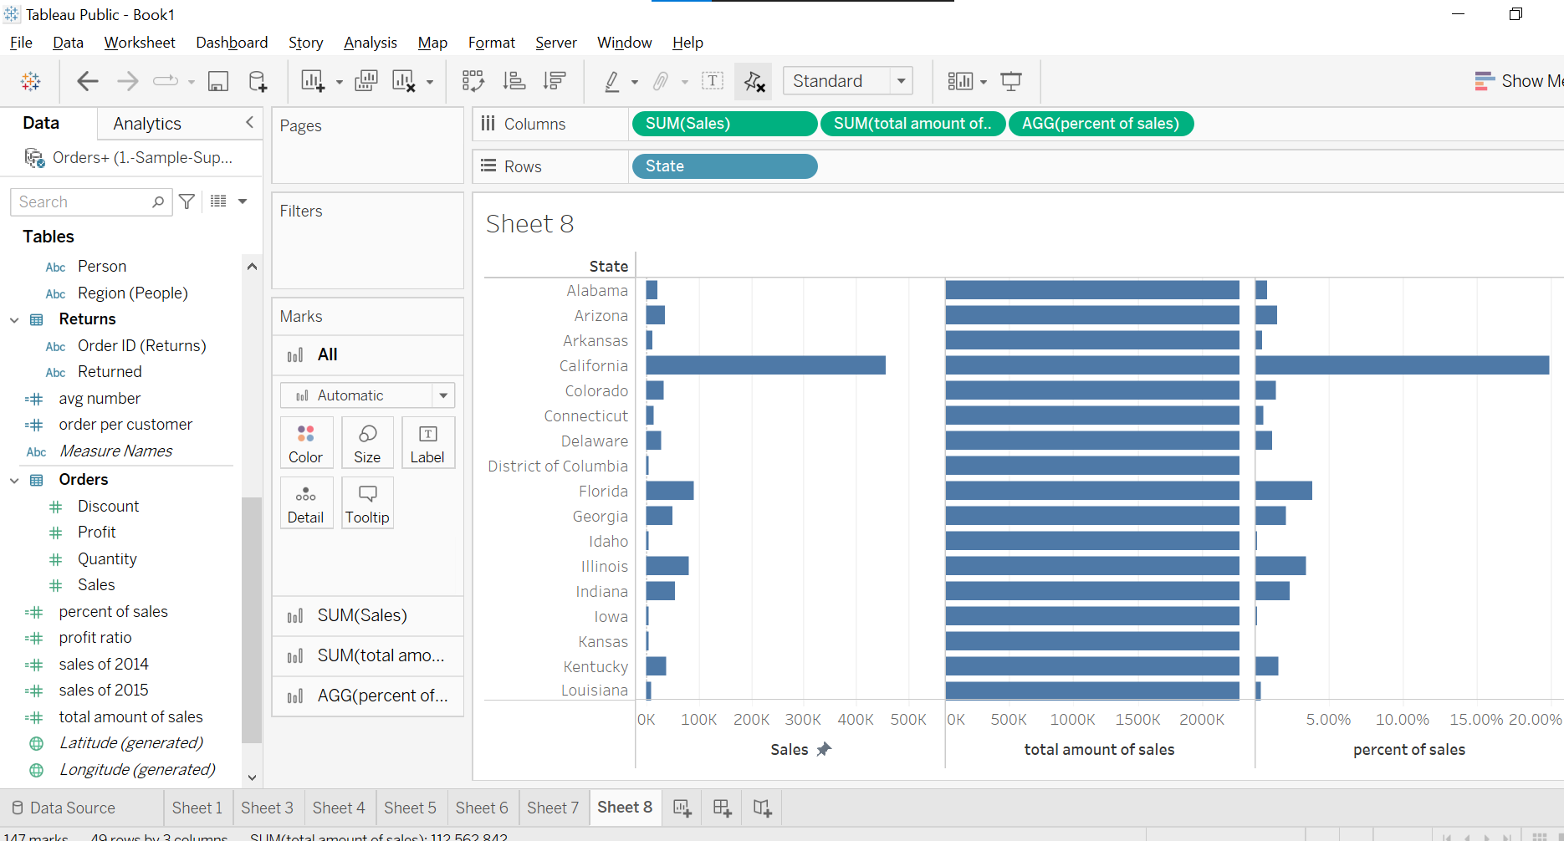

9 How many days each month are highly profitable, profitable, or unprofitable?

