1 Create a Location Hierarchy

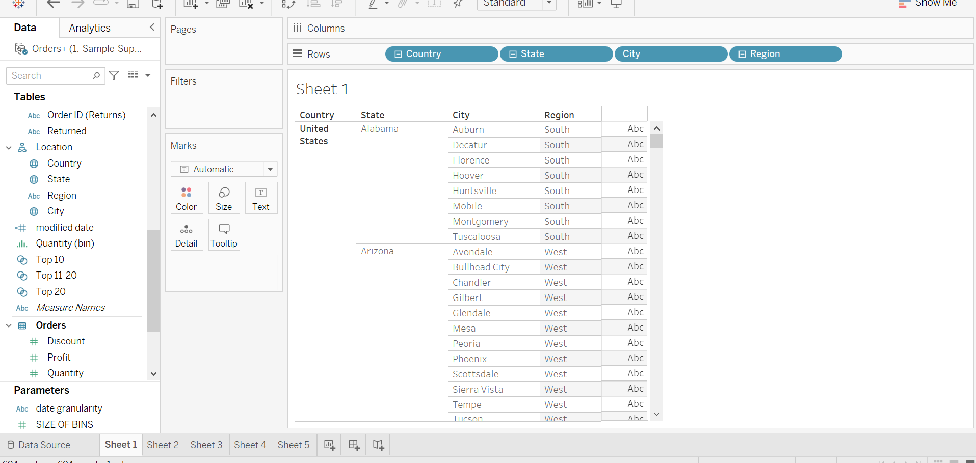

2 Create a Condition Filter to show sales >10000 and Profit >0 for customer dimension

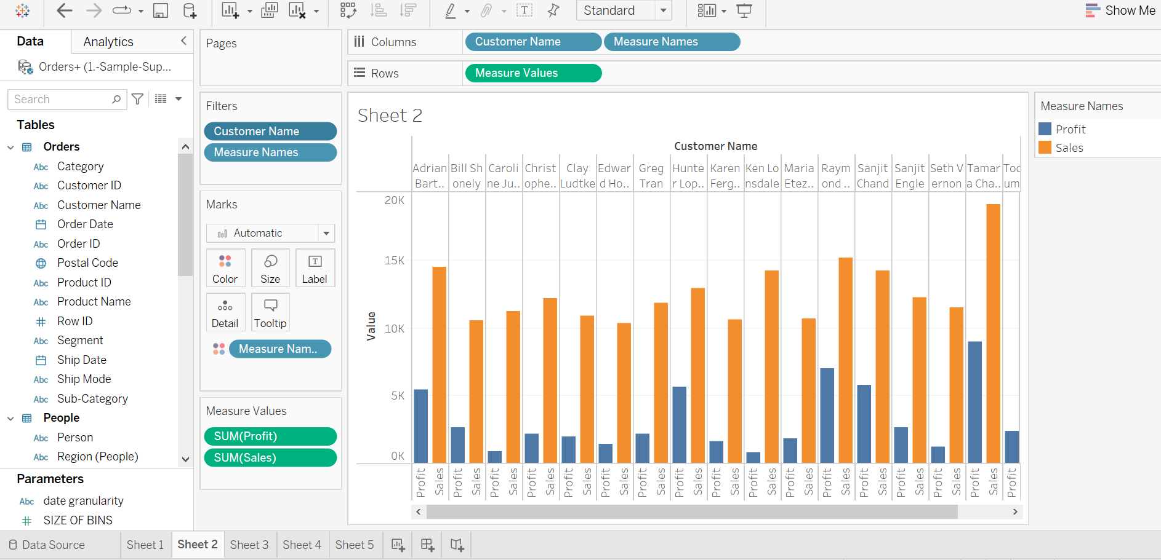

3 Create a set to show Top 11 to 20 Customers

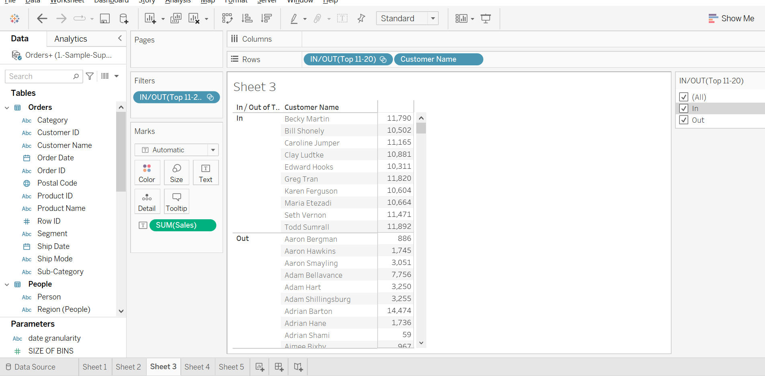

4 Create a Date Parameter to dynamically change the Date Granularity view

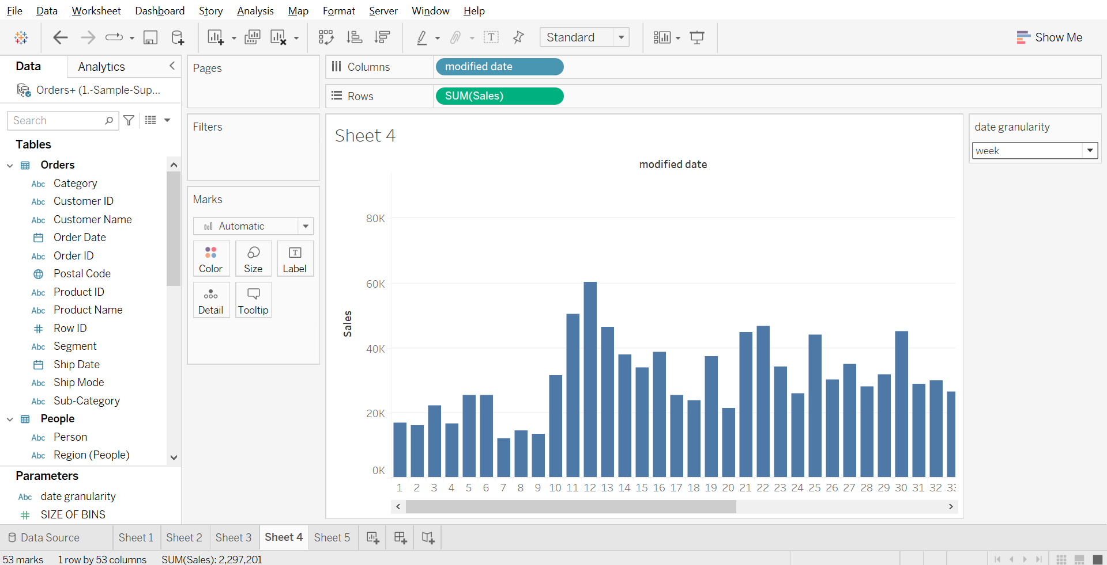

5 Create a Quantity Bins using Parameter

