PROJECT WORK

Objective: The objective of this project is to understand the global covid-19 mortality rates.

The description of the dataset mentioned below.

Use the default data sets (.csv files) available. Data sets are to be related, joined or blended to solve the following problem statements.

Problem statement: Based on the csv. files for global mortality rates, we are going to analyze and develop a dashboard to understand the covid-19 global cases. Use filters, parameters and actions wherever possible to make the dashboard interactive.

• Comparing the global confirmed vs. death cases in a world map using pie charts.

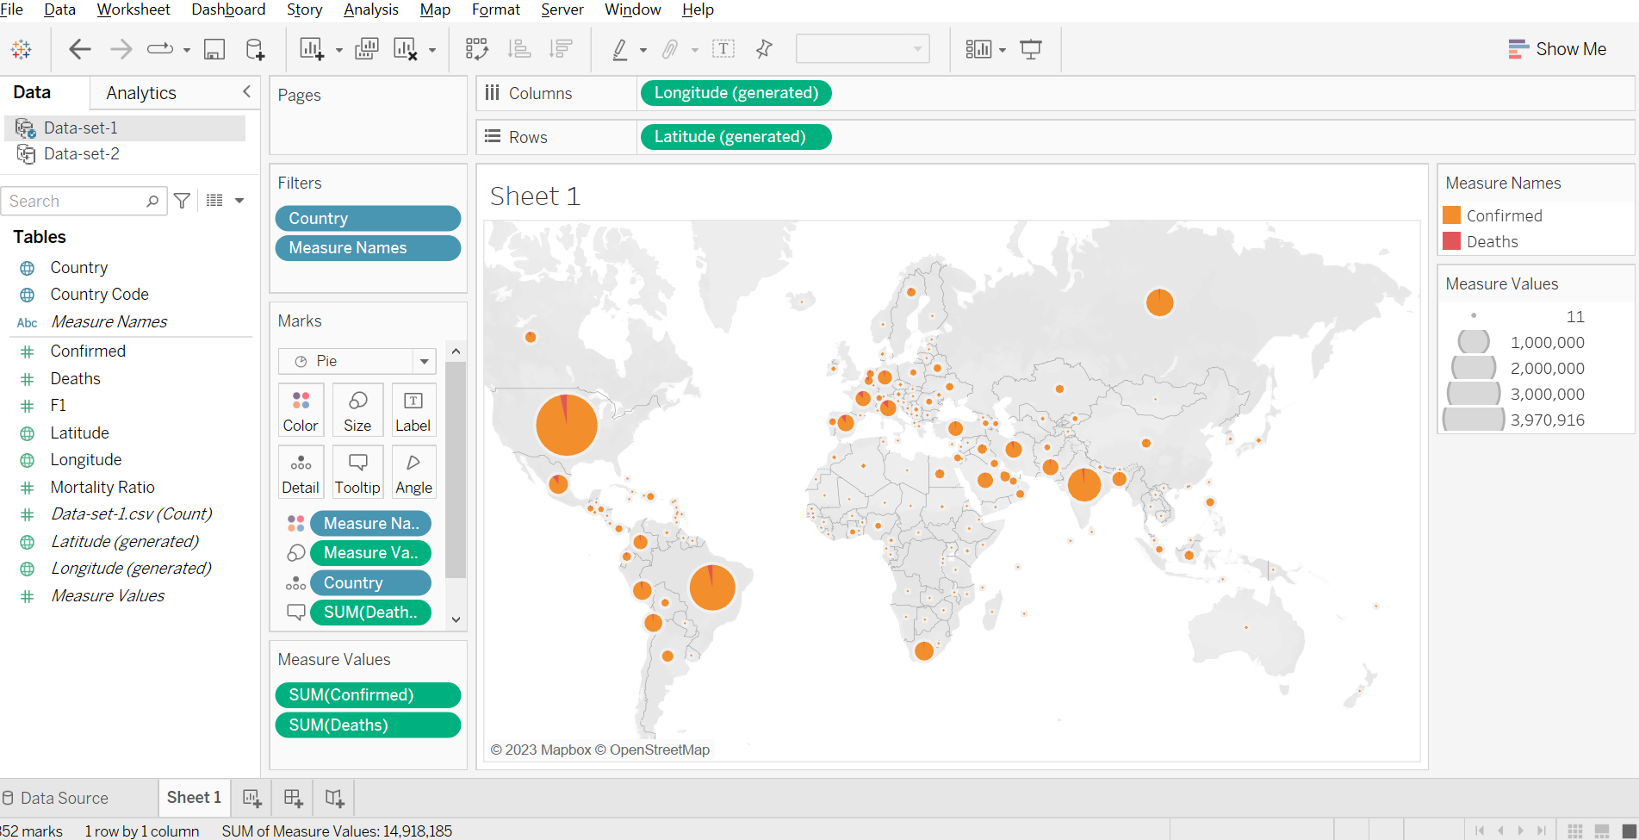

• Top 5 countries based on confirmed and death cases in numbers.

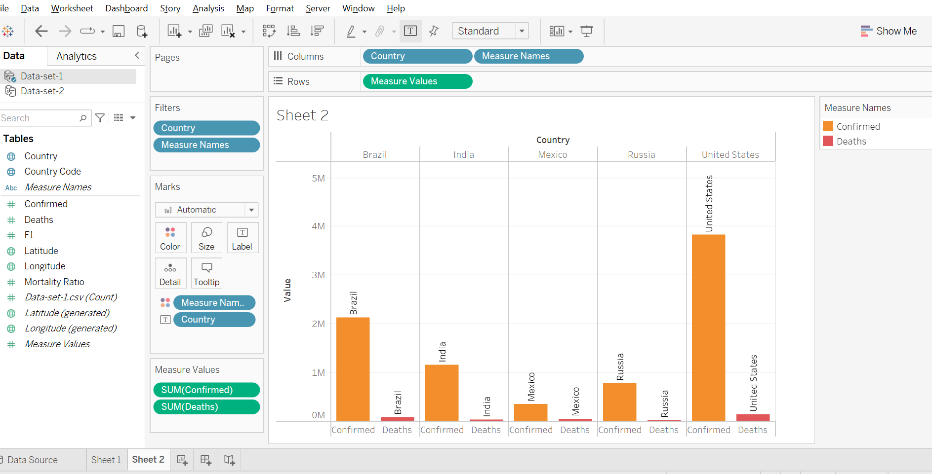

• Create a parameter for percentile comparison between countries based on confirmed or death cases.

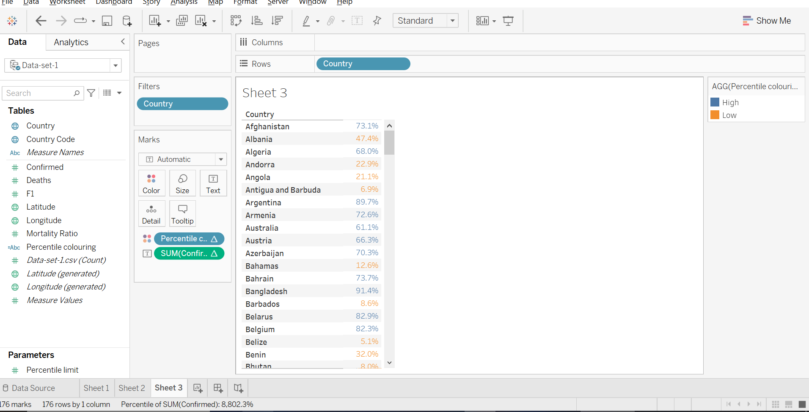

• Comparing the country wise cases using logarithmic axes. Dashboard should display both log axis chart and a default axis chart in an alternate interactive way.

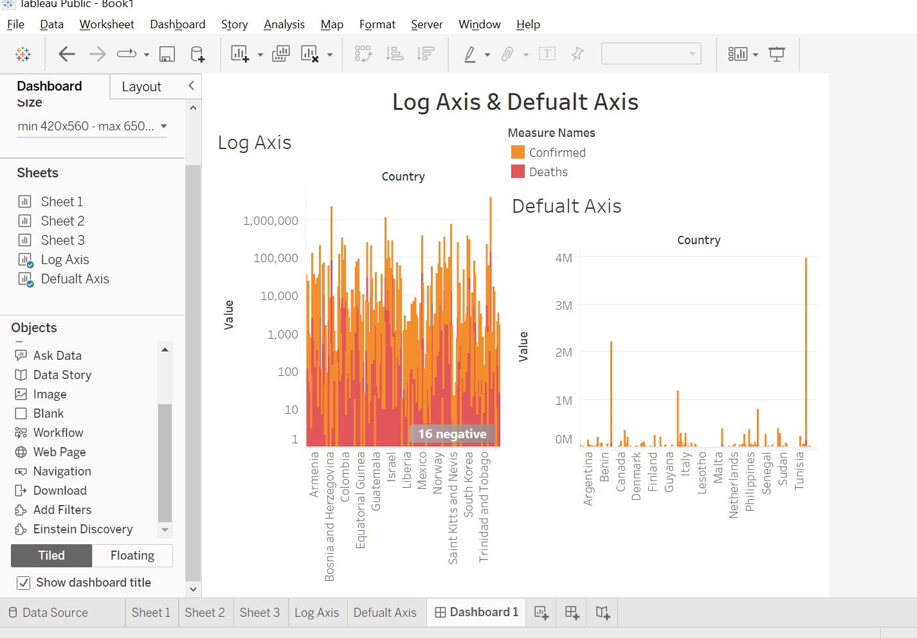

• New cases per day in China and India – compared in a date wise chart.

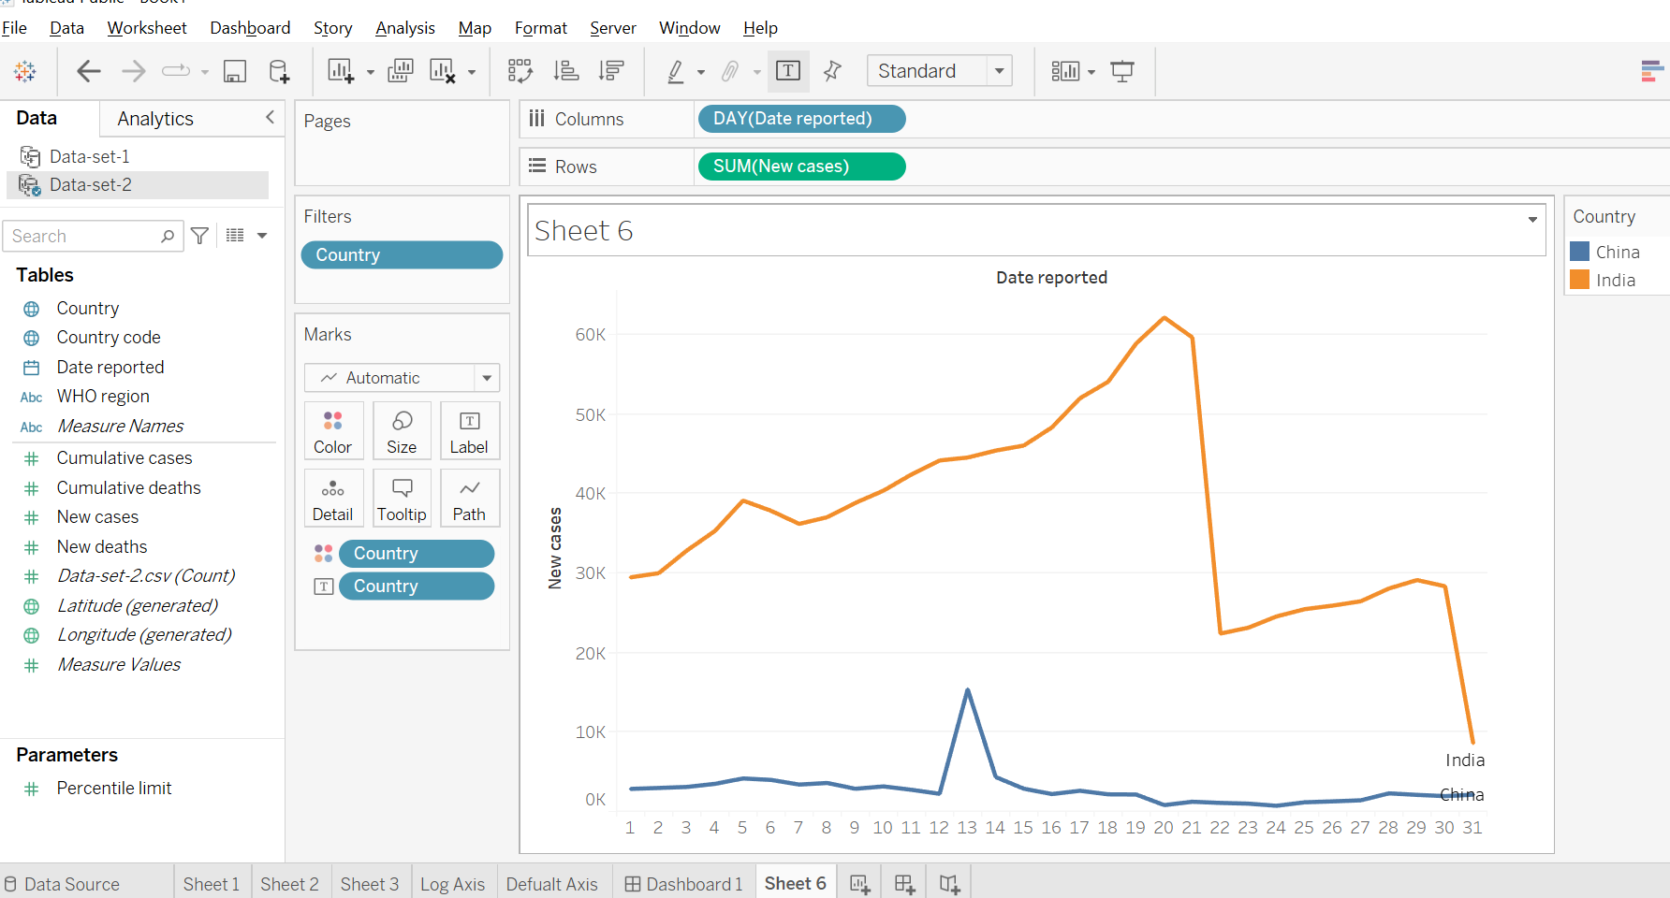

• Which day has the highest new death cases?

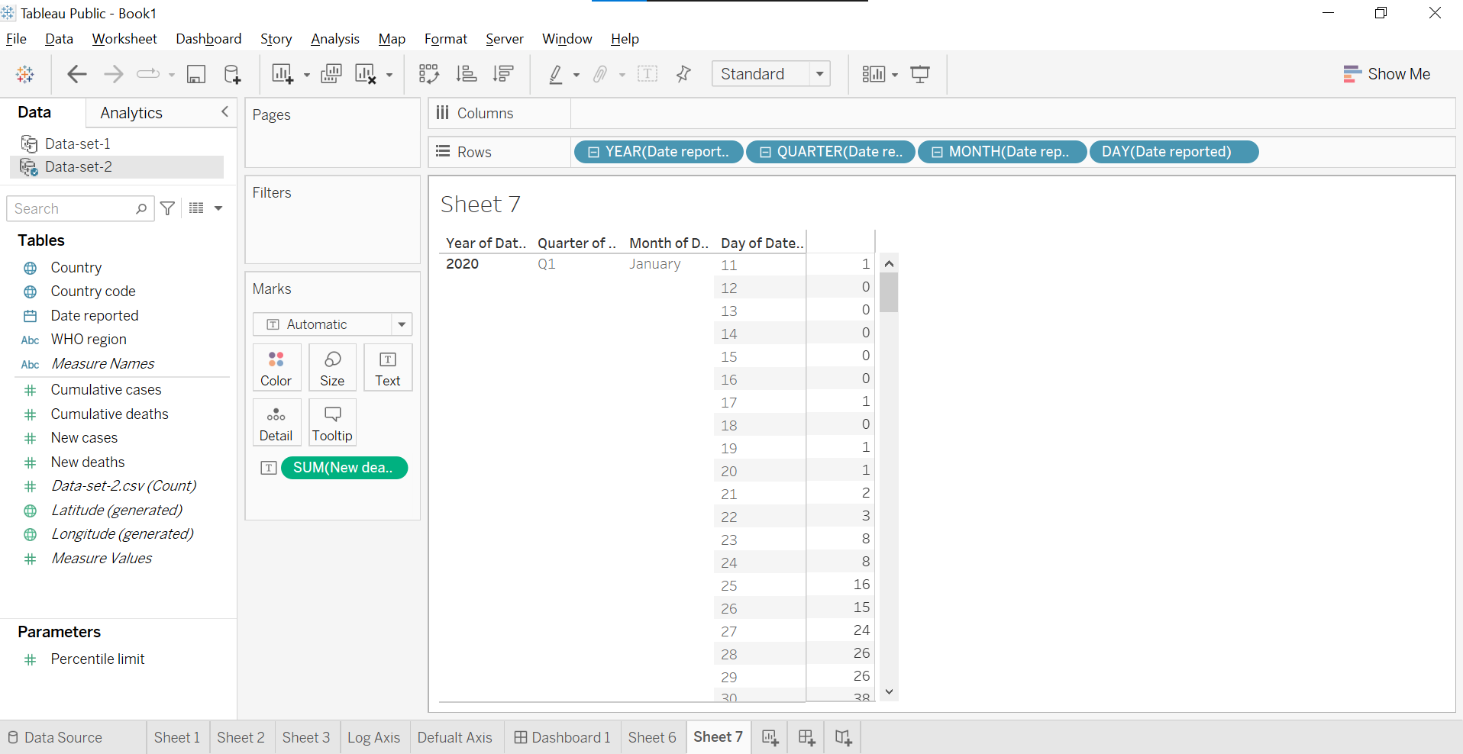

• Which WHO region has the highest new cases verses new deaths ratio?

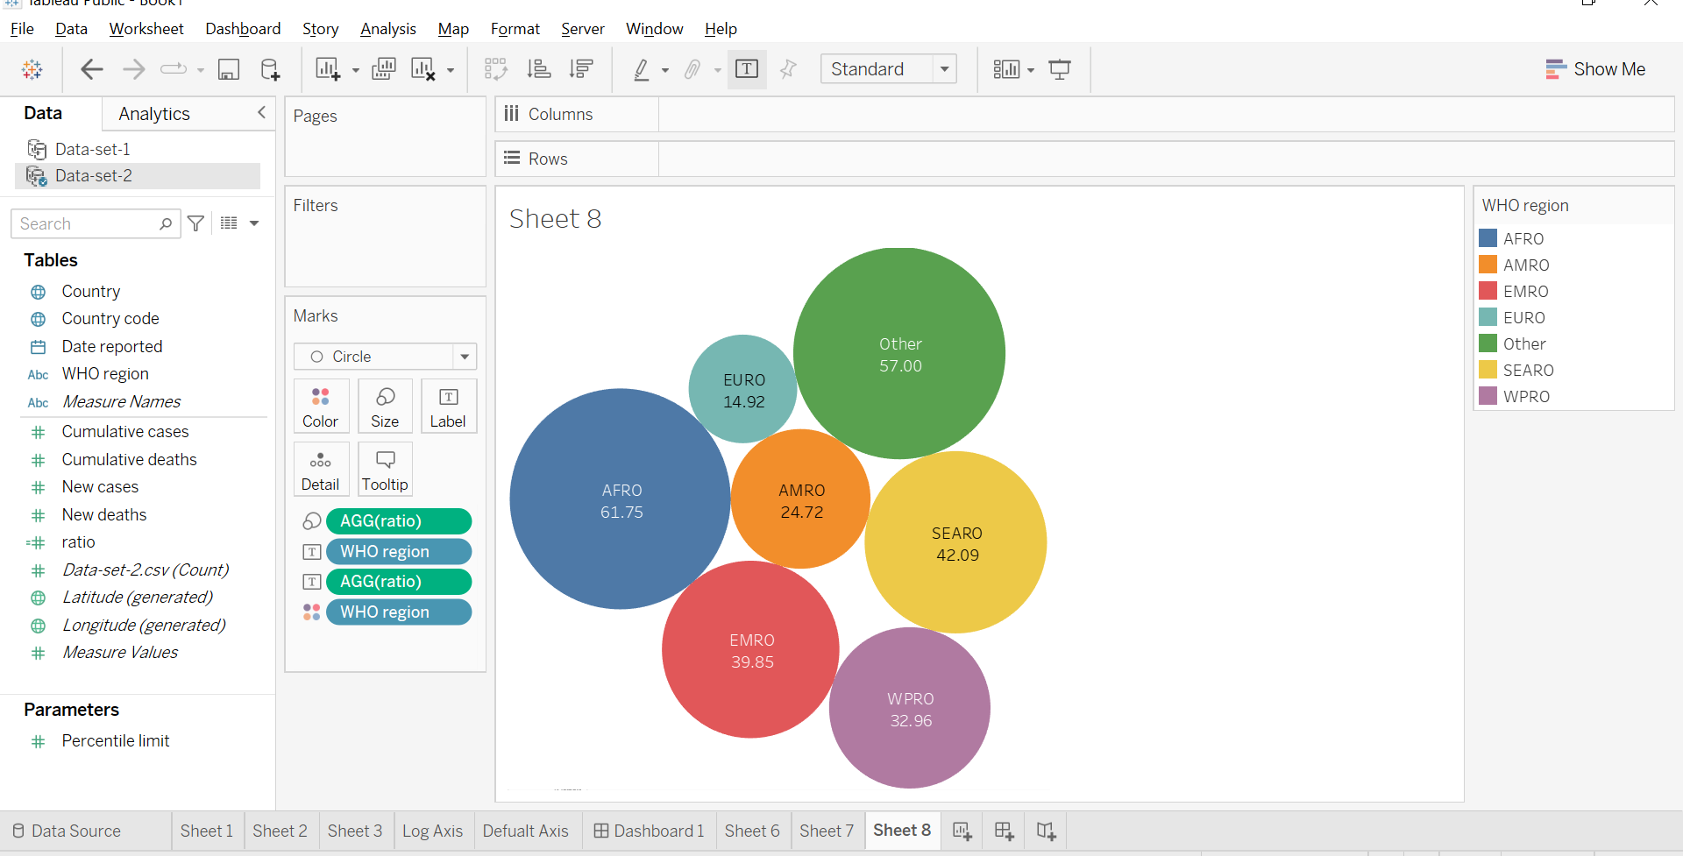

• Create a parameter to dynamically view Top N WHO regions based on cumulative new cases and death cases ratio.

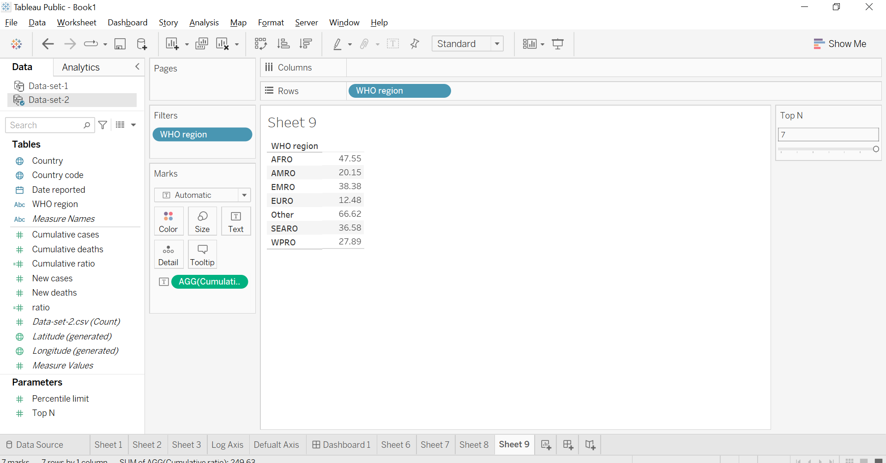

• Average WHO region wise cumulative cases to be visualized using a funnel chart.

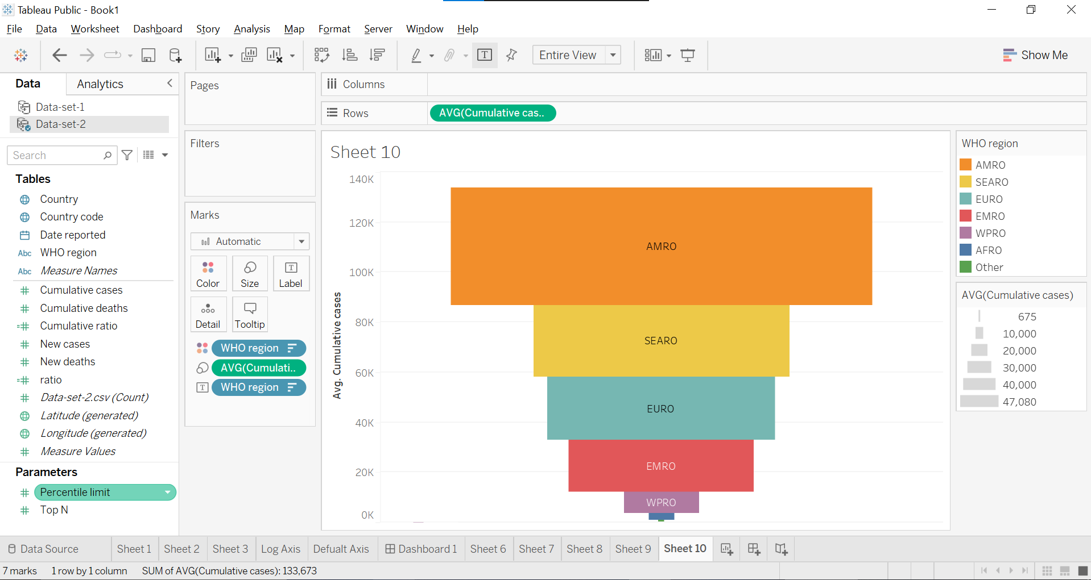

• Dashboard should have a drop down menu to view the WHO region wise data using a bar chart, line chart or a map as per user’s requirement.

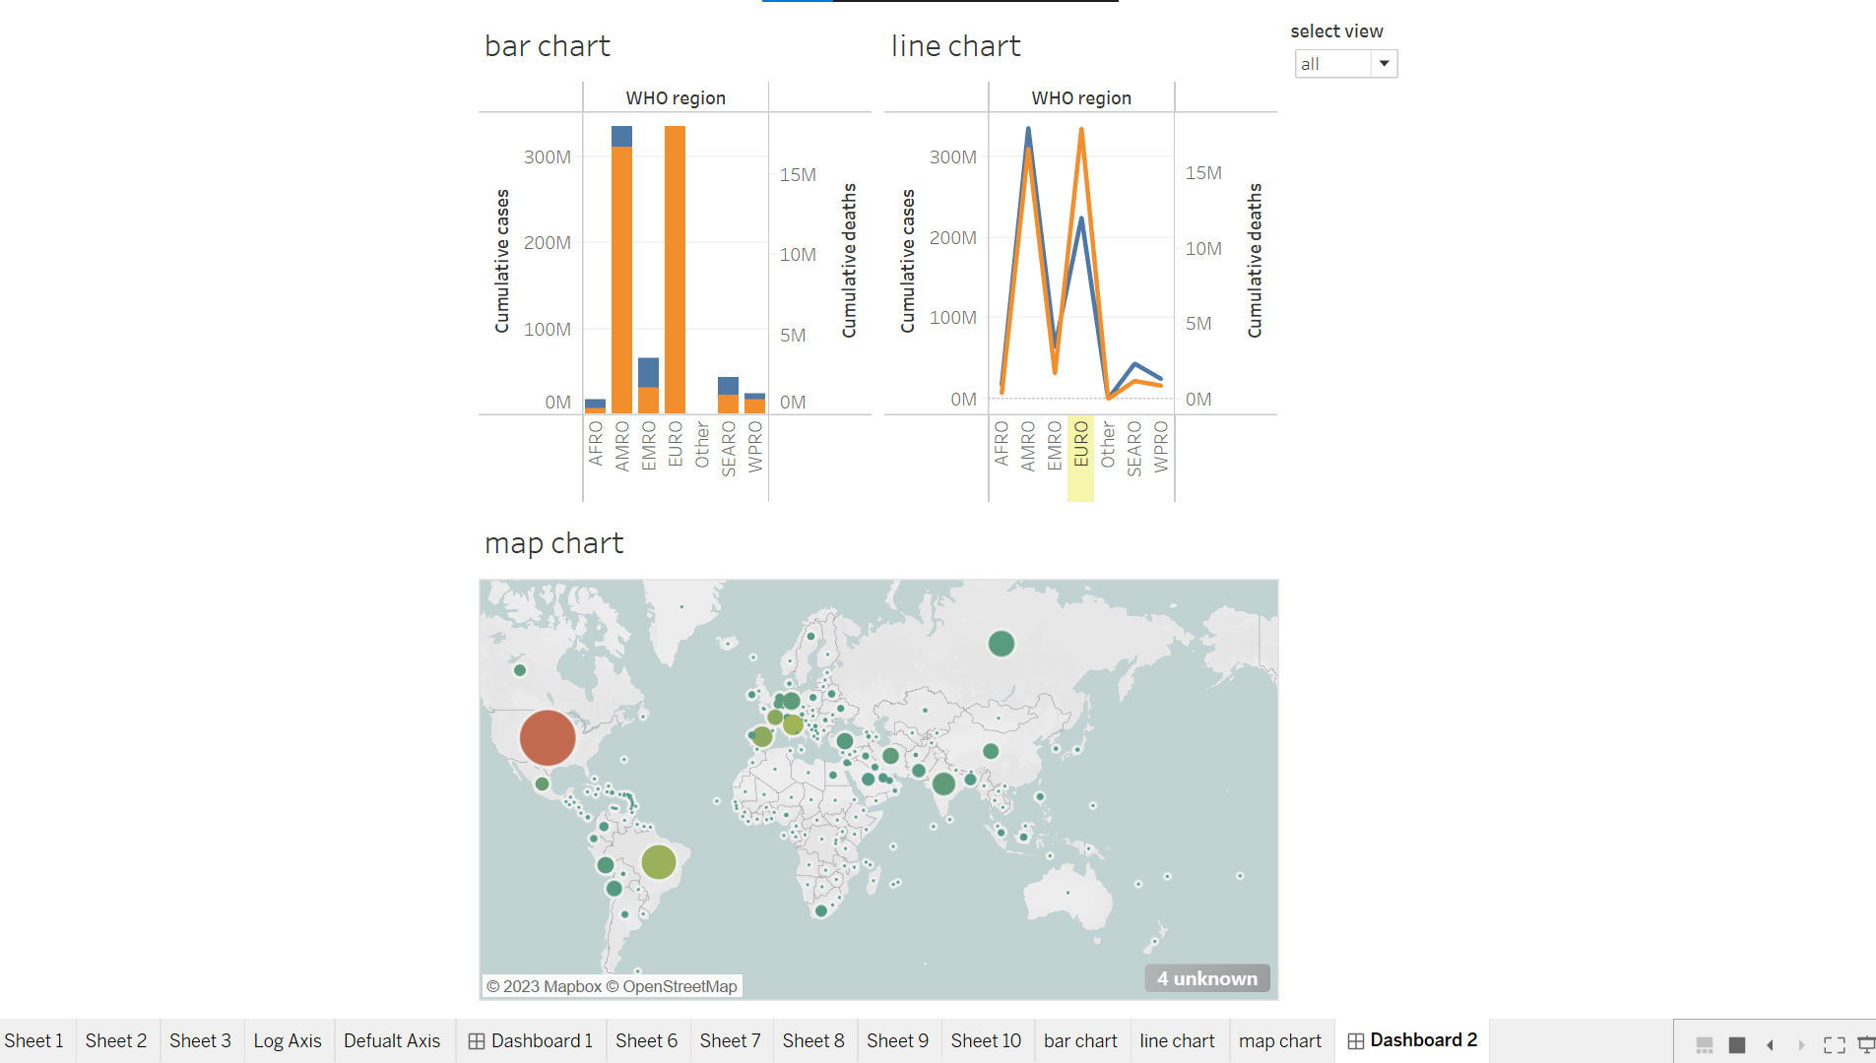

Lab environment: Use Tableau desktop installed in your system.

Domain: Healthcare, Covid-19

Hint for doing the project: Interactive sample dashboard to understand the global COVID-19 cases