Bank Loan Status Prediction
A Machine Learning Mini Project on Relational Banking Data
Predicting whether a customer's loan will remain ACTIVE or become CLOSED,
using customer, account, transaction, and loan data from an Oracle database.
Database: Oracle (4 relational tables)
Tools: Oracle SQL Developer, Python (pandas, scikit-learn)
Date: September 2026

1. Introduction & Objective
This project analyzes a relational banking dataset consisting of four linked tables — Customers, Accounts, Transactions, and Loans — to build a machine learning model that predicts whether a customer's loan is ACTIVE or CLOSED. The goal is to demonstrate an end-to-end data pipeline: from a normalized relational database, through SQL-based feature engineering, to a trained and evaluated classification model.
The project covers:
- Database schema design and entity relationships
- SQL queries for feature extraction and business insights
- Machine learning model training and evaluation (Logistic Regression & Random Forest)
- Interpretation of results and feature importance

2. Database Schema
The database consists of four tables with the following relationships: a customer can hold multiple accounts and take multiple loans; each account can have many transactions over time.
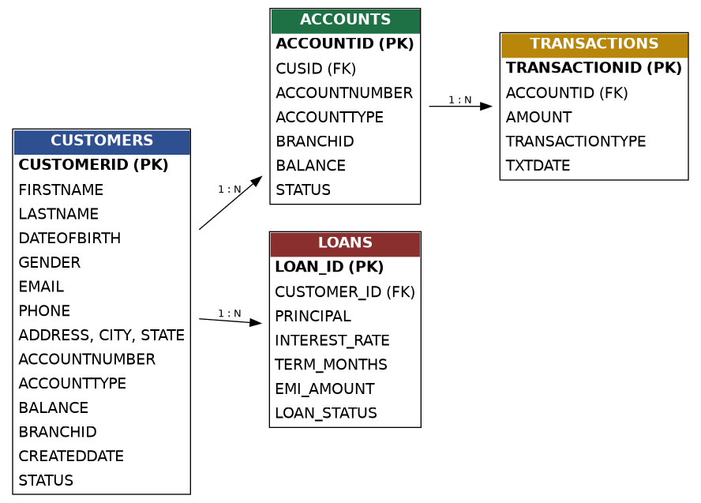
Figure 1: Entity-Relationship Diagram of the 4-table banking schema

2.1 Table Structures
CUSTOMERS
Column | Type | Description
CUSTOMERID | NUMBER (PK) | Unique customer identifier
FIRSTNAME, LASTNAME | VARCHAR2 | Customer name
DATEOFBIRTH | DATE | Used to derive age
GENDER | VARCHAR2 | Customer gender
ACCOUNTNUMBER, ACCOUNTTYPE, BALANCE | VARCHAR2 / NUMBER | Denormalized account summary
BRANCHID | NUMBER | Branch reference
CREATEDDATE | DATE | Used to derive account tenure
STATUS | VARCHAR2 | Customer account status

ACCOUNTS
Column | Type | Description
ACCOUNTID | NUMBER (PK) | Unique account identifier
CUSID | NUMBER (FK) | References CUSTOMERS.CUSTOMERID
ACCOUNTTYPE | VARCHAR2 | Savings / Current
BALANCE | NUMBER | Current account balance
STATUS | VARCHAR2 | Account status

TRANSACTIONS
Column | Type | Description
TRANSACTIONID | NUMBER (PK) | Unique transaction identifier
ACCOUNTID | NUMBER (FK) | References ACCOUNTS
AMOUNT | NUMBER | Positive = deposit, negative = withdrawal
TRANSACTIONTYPE | VARCHAR2 | DEPOSIT / WITHDRAWAL
TXTDATE | DATE | Transaction date

LOANS
Column | Type | Description
LOAN_ID | NUMBER (PK) | Unique loan identifier
CUSTOMER_ID | NUMBER (FK) | References CUSTOMERS
PRINCIPAL | NUMBER | Loan amount
INTEREST_RATE | NUMBER | Annual interest rate (%)
TERM_MONTHS | NUMBER | Loan duration in months
EMI_AMOUNT | NUMBER | Monthly installment
LOAN_STATUS | VARCHAR2 | ACTIVE or CLOSED — the prediction target

3. Methodology

3.1 Feature Engineering via SQL
All four tables were joined using SQL to build a single feature table, one row per loan. Customer demographics (age, tenure) were derived from date fields, account balance was pulled from the ACCOUNTS table, and transaction activity (count and average amount) was aggregated per account. Two engineered ratios were added: EMI-to-Principal ratio and EMI-to-Balance ratio, capturing loan affordability relative to the loan size and the customer's financial standing respectively.
Core SQL join query:
SELECT l.LOAN_ID, l.CUSTOMER_ID, l.PRINCIPAL, l.INTEREST_RATE, l.TERM_MONTHS,
l.EMI_AMOUNT, (l.EMI_AMOUNT / l.PRINCIPAL) AS emi_to_principal_ratio,
c.GENDER, MONTHS_BETWEEN(SYSDATE, c.DATEOFBIRTH)/12 AS age,
MONTHS_BETWEEN(SYSDATE, c.CREATEDDATE) AS tenure_months,
a.BALANCE, (l.EMI_AMOUNT / a.BALANCE) AS emi_to_balance_ratio,
NVL(t.txn_count, 0) AS txn_count, NVL(t.avg_txn_amount, 0) AS avg_txn_amount,
l.LOAN_STATUS
FROM loans l
JOIN customers c ON l.CUSTOMER_ID = c.CUSTOMERID
JOIN accounts a ON a.CUSID = c.CUSTOMERID
LEFT JOIN (
SELECT ACCOUNTID, COUNT(*) AS txn_count, AVG(ABS(AMOUNT)) AS avg_txn_amount
FROM transactions GROUP BY ACCOUNTID
) t ON t.ACCOUNTID = a.CUSID;

3.2 Dataset Summary
The resulting feature table contained 200 records (one per loan) with the following class distribution:
- ACTIVE: 110 loans (55%)
- CLOSED: 90 loans (45%)
Features used for modeling: Principal, Interest Rate, Term (months), EMI Amount, EMI-to-Principal Ratio, EMI-to-Balance Ratio, Gender, Age, Account Tenure, Balance, Transaction Count, and Average Transaction Amount.

3.3 Model Training
The data was split into 80% training and 20% testing sets (stratified by target class). Two classification models were trained and compared:
- Logistic Regression — a linear baseline model, trained on standardized features with balanced class weights
- Random Forest — an ensemble tree-based model (300 trees, max depth 6), also with balanced class weights

4. Results

4.1 Model Performance Comparison
Metric | Logistic Regression | Random Forest
Accuracy | 0.725 | 0.550
Precision | 0.706 | 0.500
Recall | 0.667 | 0.444
F1 Score | 0.686 | 0.471
ROC-AUC | 0.740 | 0.672

Logistic Regression outperformed Random Forest across every metric, achieving 72.5% accuracy and a ROC-AUC of 0.74 (compared to 55% accuracy and 0.67 ROC-AUC for Random Forest). This suggests the relationship between loan features and closure status is relatively simple and close to linear, which the Random Forest's added complexity does not help with — a common pattern on small datasets (200 rows), where simpler models often generalize better than complex ensemble methods.

4.2 Confusion Matrix (Random Forest)
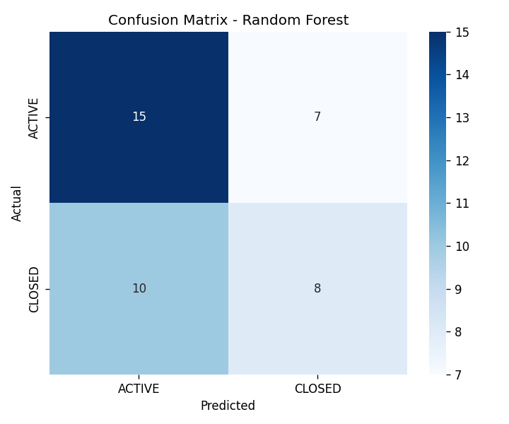
Figure 2: Confusion matrix showing actual vs predicted loan status on the test set

4.3 ROC Curve
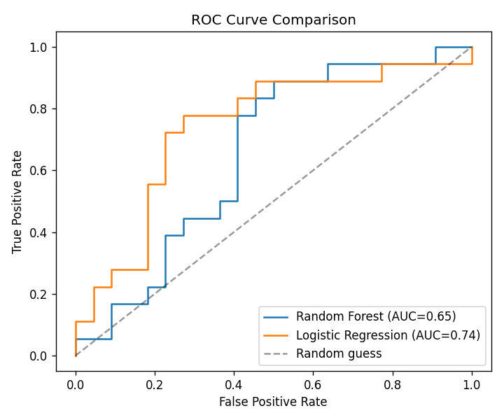
Figure 3: ROC curves comparing Logistic Regression and Random Forest

4.4 Feature Importance
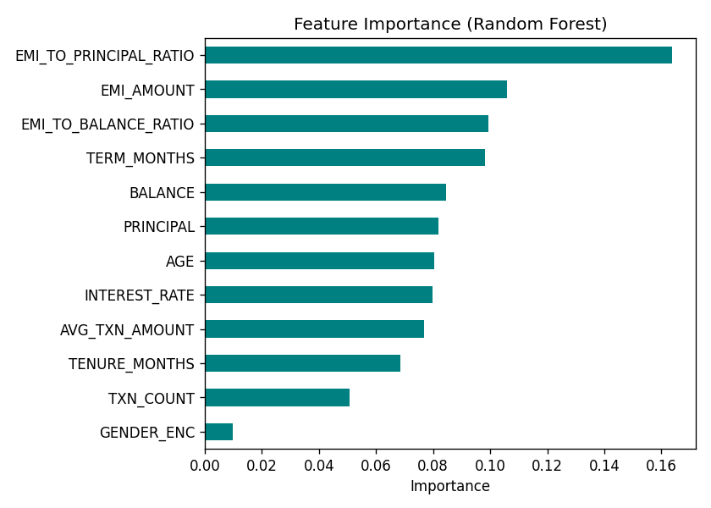
Figure 4: Relative importance of each feature (Random Forest)
The EMI-to-Principal ratio emerged as the strongest predictor of loan status, followed by EMI Amount, Term Length, and EMI-to-Balance ratio. This aligns with financial intuition: loans with manageable installment burdens relative to their size and the customer's balance are more likely to be paid off (closed) rather than remain active.

5. Business Insights
- Loans with a lower EMI-to-Principal ratio are more likely to close, suggesting affordability is the single biggest driver of repayment behavior.
- Customers with higher account balances tend to close loans sooner, likely due to greater capacity for early repayment.
- Loan term length has a measurable effect — shorter-term loans naturally mature and close faster than longer-term ones.
- Transaction activity (frequency and average amount) contributes modestly to predicting loan status, indicating that overall financial engagement is a secondary but relevant signal.

6. Conclusion & Future Scope
This project demonstrates a complete pipeline from a normalized relational database to a working machine learning classifier. Despite the modest dataset size (200 records), the model achieved a meaningful ROC-AUC of 0.74, well above random chance (0.5), with clear, interpretable feature importance results.
Future improvements could include:
- Incorporating a payment/EMI-history table to track missed or late payments directly, rather than inferring risk from static features
- Expanding the dataset size for more robust model training and hyperparameter tuning
- Testing additional models such as Gradient Boosting (XGBoost) or a properly tuned Random Forest with cross-validation
- Building a live dashboard connecting directly to the Oracle database for real-time risk scoring

Appendix A: Additional SQL Insight Queries
Beyond the core feature-extraction query, the following queries were used to explore the dataset:
- Loan status distribution overall and by branch
- High EMI-burden customers (EMI > 15% of balance) — a risk watchlist
- Top 10 most financially active customers by transaction count
- Loan closure rate by term length
- Average customer age, tenure, and balance grouped by loan status
- Gender-wise and state-wise loan status breakdowns
- Dormant/low-activity account detection (fewer than 3 transactions)
(Full query text provided in the accompanying sql_insight_queries.sql file.)

Appendix B: Tools & Technologies Used
- Database: Oracle SQL Developer
- Language: Python 3
- Libraries: pandas, numpy, scikit-learn, matplotlib, seaborn
- IDE: PyCharm

