**McRoberts Total Tour**

**Web Installers**

**Guidelines Document**

**DOCUMENT NUMBER: DCS-HLP-20150216.01.02_McRoberts**



**1880 John F. Kennedy Blvd., 15th Floor, Philadelphia, PA 19103**

**Phone: (215) 243-1990**

**Email:** [**dcs@datacoresystems.com**](mailto:dcs@datacoresystems.com)

**URL:** [**www.datacoresystems.com**](http://www.datacoresystems.com)

**Table of Contents**

1 Version Control 3

2 Objectives 4

3 Notes: 4

4 Database Installer: 5

5 Service Installer: 10

5.1 Pre-requisite for Service Installer: 10

5.2 Service Installer continued: 11

6 Web Installer: 19

7 APK Configuration: 30

8 Trouble Shoot: 31

9 Project Contacts 32

9.1 McRoberts Contacts 32

9.2 Data-Core Systems Contacts 32

# Version Control

|  |  |  |  |  |  |  |
| --- | --- | --- | --- | --- | --- | --- |
| **Sl. No.** | **Rev. No.** | **Release Date** | **Prepared By** | **Reviewed By** | **Approved By** | **Reasons for**  **New Release** |
| 1 | 1.0 | 02.16.2015 | UdayanKanjilal |  |  | Original Release |
| 2 | 1.1 | 02.17.2015 | Angshuman Dash |  |  | Updated |
| 3 | 1.3 | 04.23.2015 | Sanghamitra Ghosh |  |  | Updated |

# Objectives

McRoberts Protective Agency,Inc., is a privately-held, full-service security provider with national scope.

This document will act as a guideline which describes how to install all the necessary installer packages step by step. Snapshots & necessary guidelines are provided in relevant sections.

# Notes:

* Ports used any where during installation should be unused ports.
* Please check inline comments as examples for IPs / Ports used as they are examples and should be changed as per system where it is being installed.

# Database Installer:

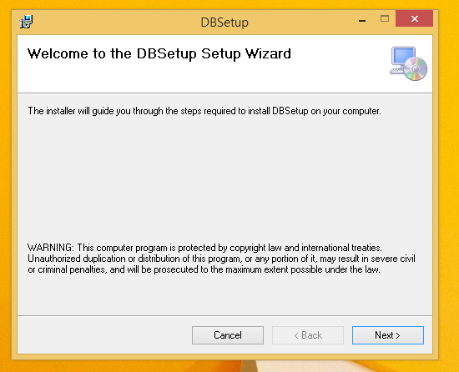

Click on the ‘Next’ button.

**This screen sets up the connection string of the database to be created. This connection string information will later be supplied in the configuration files for web-service and web-site.**

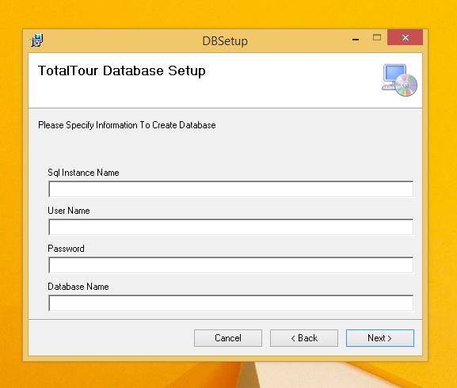

|  |  |
| --- | --- |
| **Field** | **Meaning** |
| SqlInstance Name | Provide the intranet server ip address where the database is to be hosted.(like : 10.12.1.61)  Or  If database & web server in same machine, please provide the database server name from SQL Ser ver 2008 R2. |
| User Name | UserName to be provided for Sql server authentication (like: sa ) |
| Password | Password to be provided for Sql server authentication (like: Reset123) |
| Database Name | Name of the database to be created. (Like: TotalTourPro or your intended database name) |

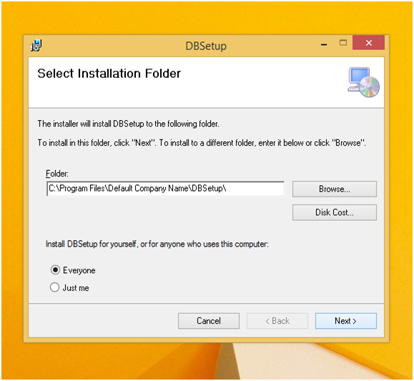

|  |  |
| --- | --- |
| **Field** | **Value** |
| Folder | Directory for providing location for creation of database |

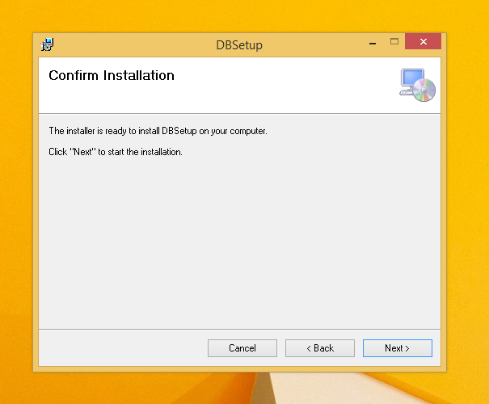

Database installation is going on.

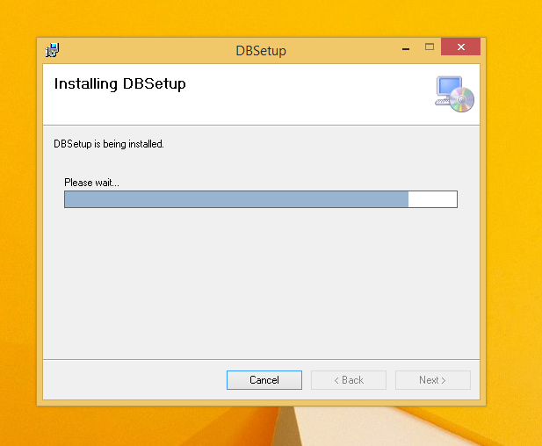

Database installation is going on.

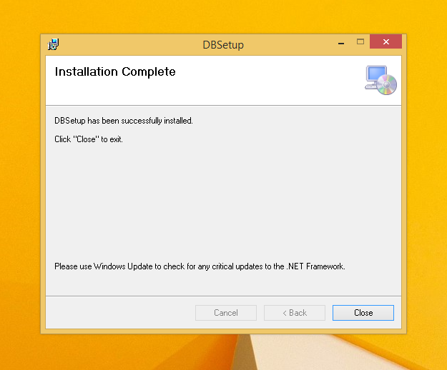

Database installation has been completed.

Now start Service installer explicitly.

# Service Installer:

## Pre-requisite for Service Installer:

**Before proceeding to installation of Service Application, you have to create 1 site in IIS from where the service will be hosted**.

Total Tour Web service screen site - IIS or hosted pc IP

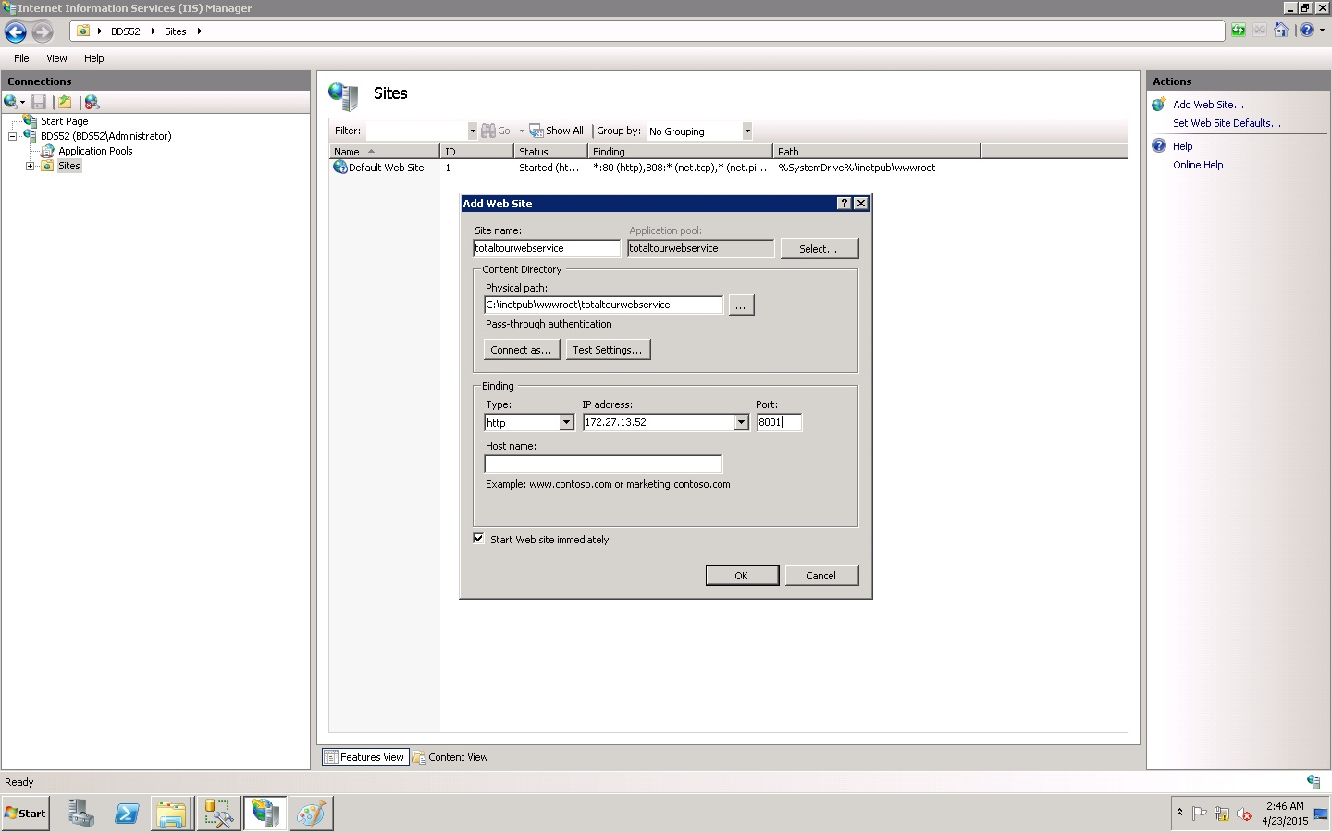

Application Pool 🡪 Edit Application Pool to framework 4 (if framework is different)

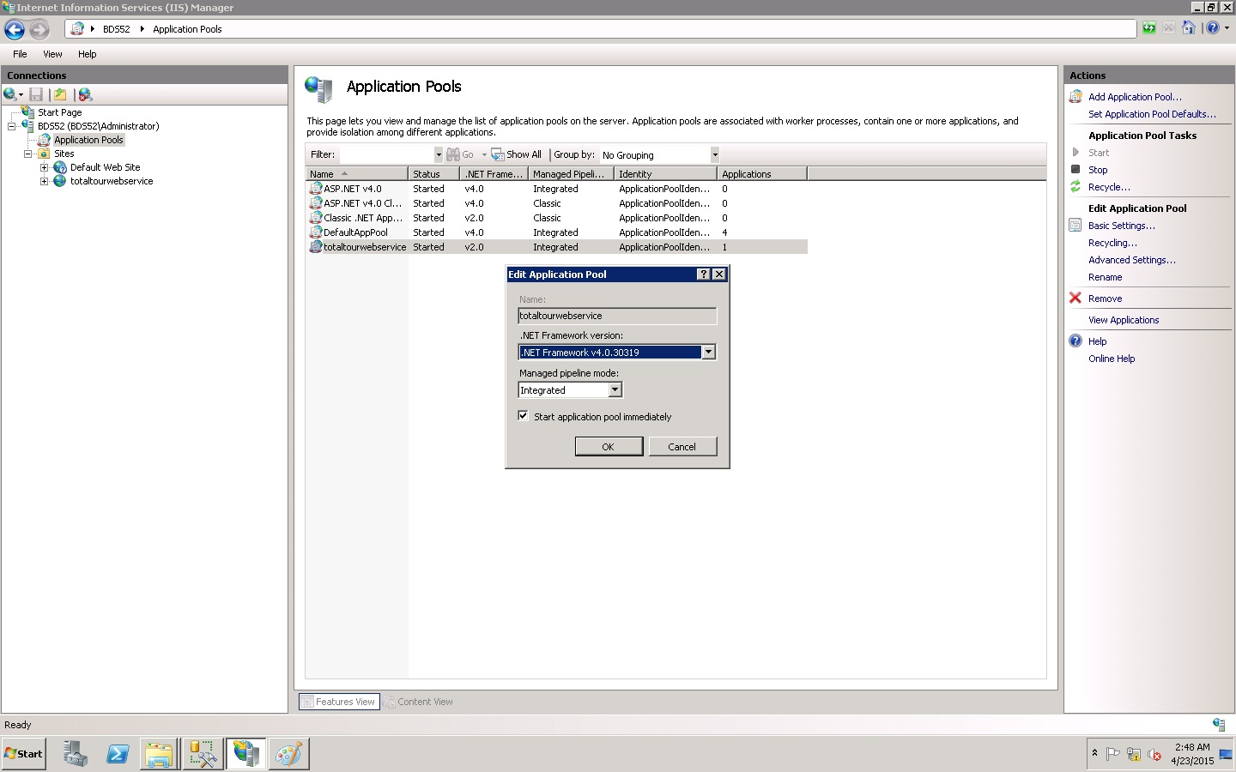

[Otherwise, **default website** will be selected and default virtual directory will be **ServiceWebSetup**. In the last phase of installation, you will have the option to change the Site and you can also modify the Virtual Directory path. Application pool name also a another setting which initially will be selected as DefaultAppPool. In our case the Application pool will .Net 4.0 frameworks.]

## Service Installer continued:

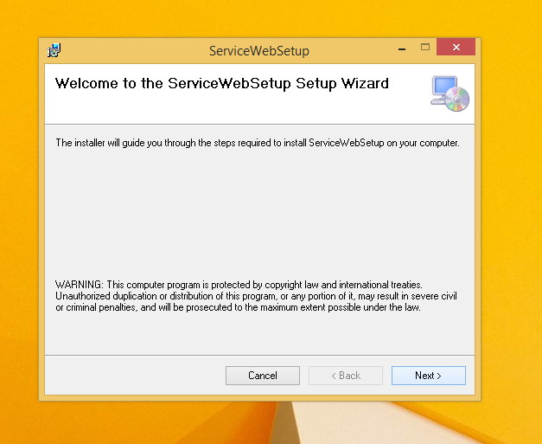

Click on the ‘Next’ button

**Provide the connection string value that was supplied earlier during database creation. These values should match.**

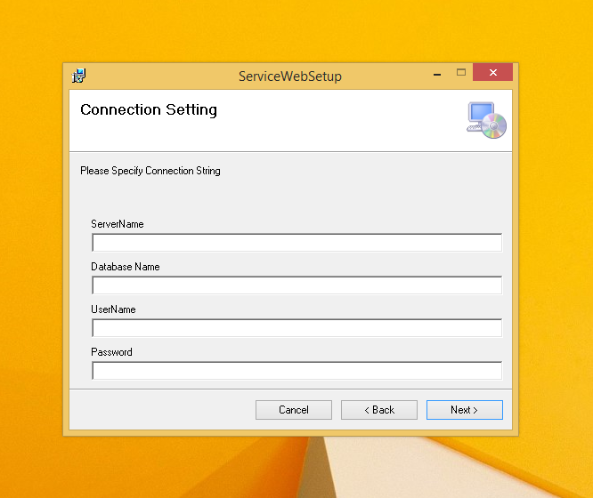

Server Name – SQL Server Name (MS SQL Server Management Studio 🡪 File Connect 🡪 copy the server name)

UserName to be provided for Sql server authentication (like: sa)

Name of the database to be created. (Like: TotalTourPro or your intended database name )

Password to be provided for Sql server authentication (like: Reset123)

Provide url path values for storage of xml files that are used for data submission via android devices and report generations. One path maps to the WebService and the other maps to the WebSite.

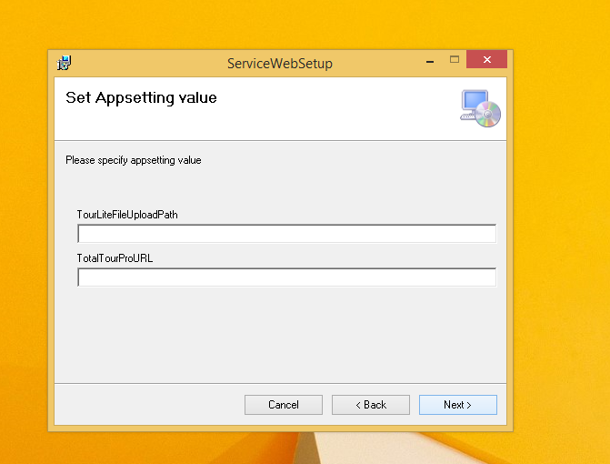

|  |  |
| --- | --- |
| **Field** | **Value** |
| TourLiteFileUploadPath | This path should point to the intended web-service name appended by a folder named ‘XMLData’ and then a frontslash. Ex: If the web-service is to be named tourliteservice.mcroberts1876.com , then the value for this would be:  http://tourliteservice.mcroberts1876.com/XMLData/  As this is an intranet site hence , the site will only be accessible via machine ip and port number that was used during creation of site in IIS. This info would be appended by intended virtual directory name (optional and provided later in the setup ) , appended by a folder named ‘XMLData’ and then a front slash.  Ex: If machine IP is 10.12.1.61 hosting port is 92 and virtual directory is named VD, then the following value would be applicable for this field  <http://10.12.1.61:92/VD/XMLData/>    If no virtual directory is provide then the value would be  <http://10.12.1.61:92/XMLData/> |
| TotalTourProURL | This path should point to the intended web-application name. Ex: : If machine IP is 10.12.1.61 hosting port is 95 and there is no virtual directory, then the following value would be applicable for this field  http://10.12.1.61:95 |

Configure the site for Web-service earlier created via IIS in this page. **Give a name for the directory that needs to be mapped to the site OR leave this empty if all files are to be kept under root site (we have done the latter)** . Provide the application pool name created during site creation as well. **The .Net framework for the app pool needs to be 4.0.** Click on next.

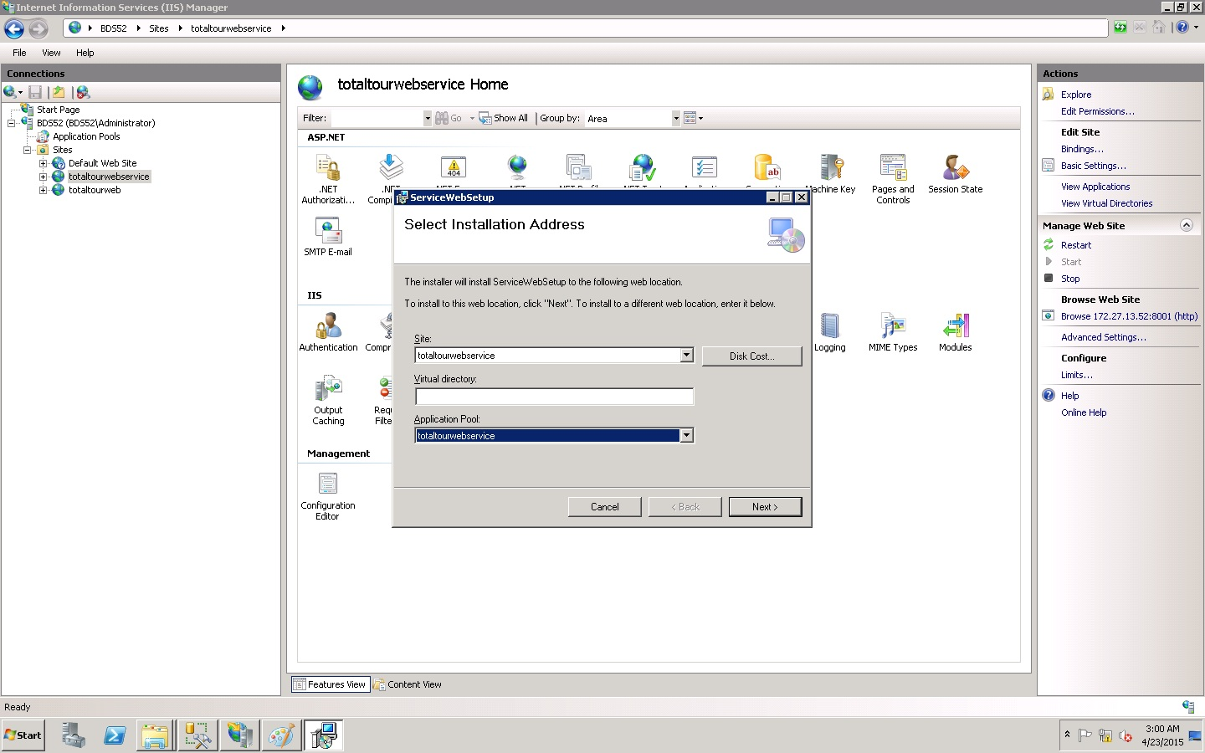

Click on next.

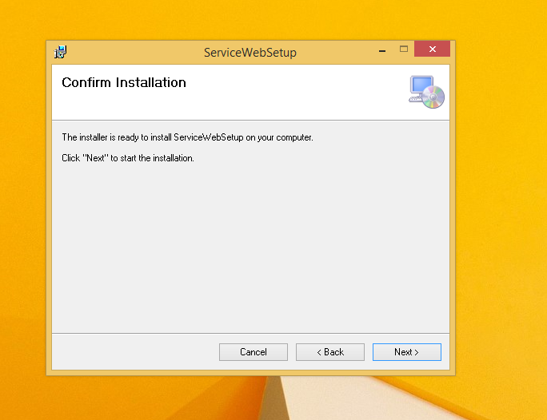

Wait for the installation

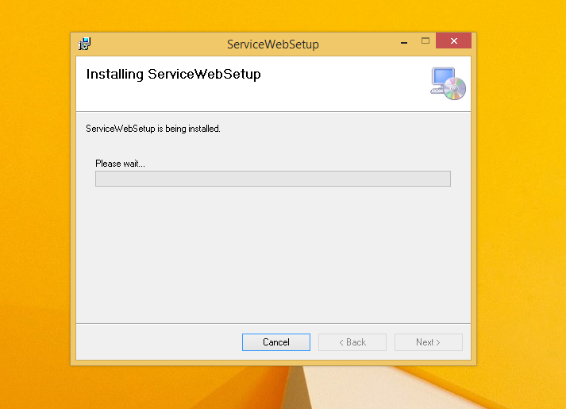

Installation completes. Proceed with the next section of Web Installer.

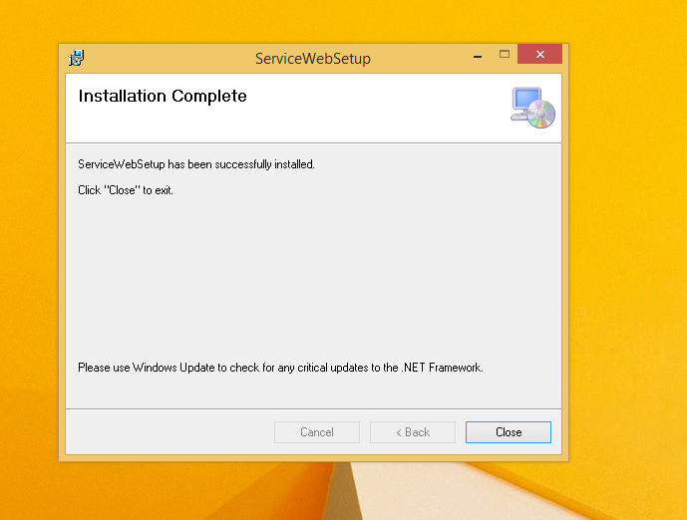

# Web Installer:

**Before proceeding to installation of Web Application, you have to create a site in IIS from where the Web will be hosted**.

Total Tour Web site

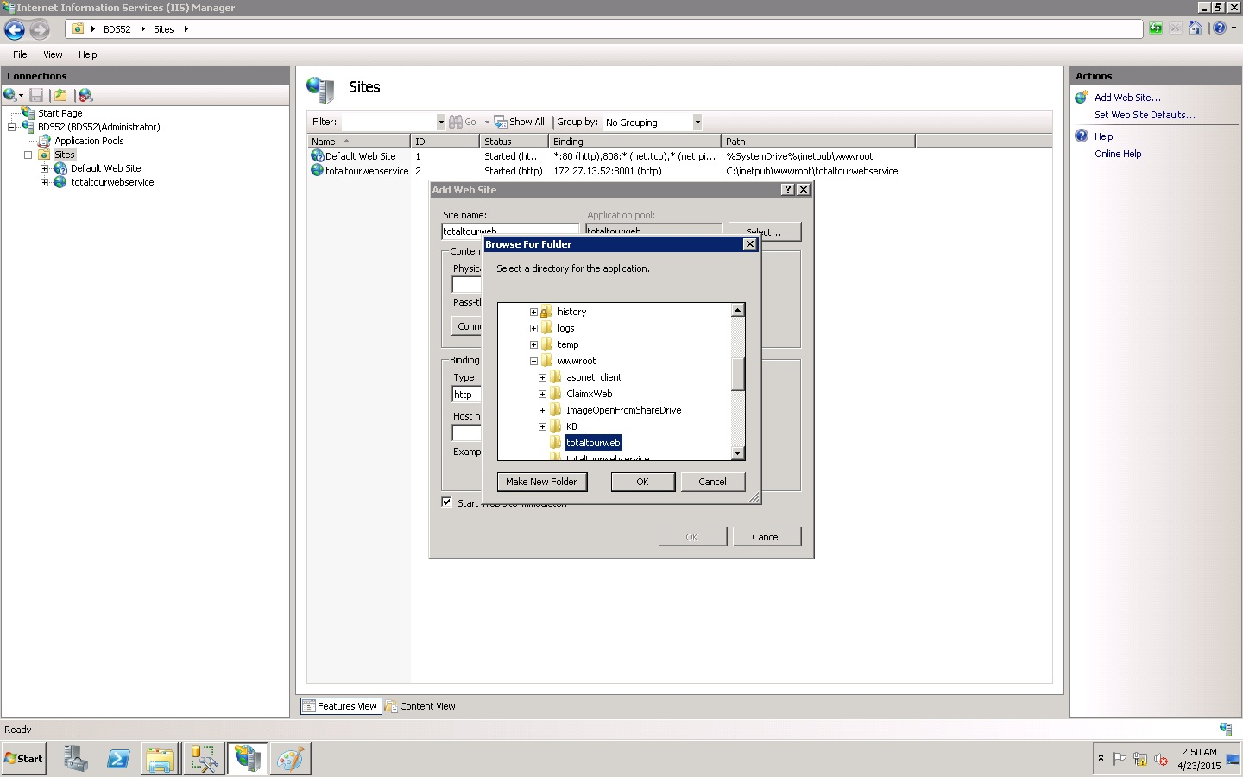

Application Pool 🡪 Edit Application Pool to framework 4

[Otherwise, **default website** will be selected and default virtual directory will be **WebSetup**. In the last phase of installation, you will have the option to change the Site and you can also modify the Virtual Directory path. Application pool name also a another setting which initially will be selected as DefaultAppPool. In our case the Application pool will .Net 4.0 frameworks.]

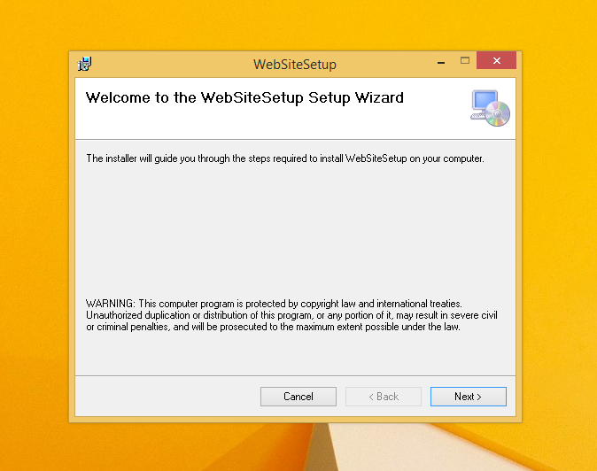

**Provide the connection string value that was supplied earlier during database creation. These values should match.**

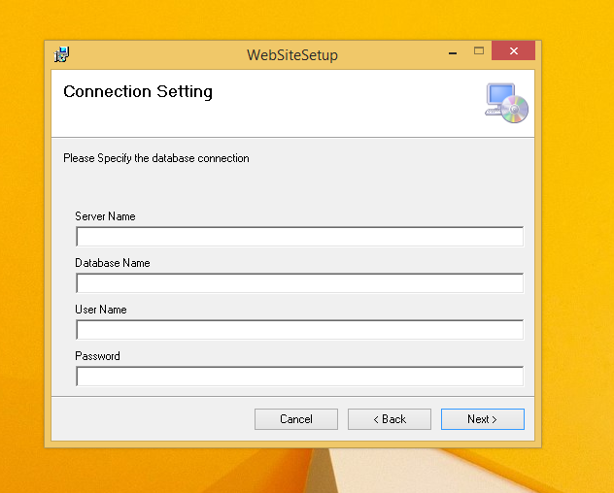

Server Name – SQL Server Name

UserName to be provided for Sql server authentication (like: sa )

Name of the database to be created. (Like: TotalTourPro or your intended database name)

Password to be provided for Sql server authentication (like: Reset123)

The following screens provide all configurations setting information for the web-application. These properties are described in detail in the table that follows

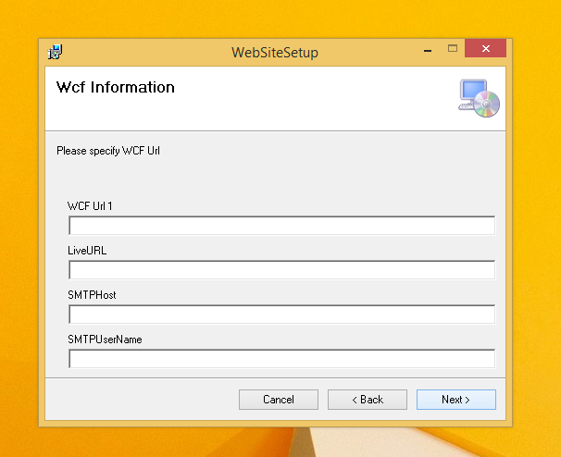

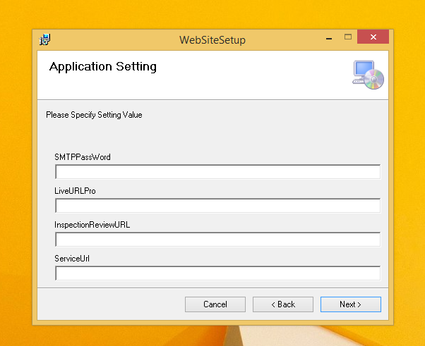

|  |  |
| --- | --- |
| **Field** | **Values** |
| WCF Url 1 | Please go to the IIS hosted web service 🡪 Browse the web service to get information below.  The value of the web-service endpoint file.  Ex : If web-service machine IP is 10.12.1.61 hosting port is 92 and no virtual directory is provided, then the following value would be applicable for this field  http://10.12.1.61:92/TourLiteService.svc |
| LiveUrl | The value of the web-application address.  Ex : If web-application machine IP is 10.12.1.61 hosting port is 95 and no virtual directory is provided, then the following value would be applicable for this field  http://10.12.1.61:95 |
| SMTPHost | Host name for SMTP server (Overridden in code at some places)  Like – smtp.gmail.com |
| SMTPUserName | User name for SMTP server (Overridden in code at some places)  Like - sharepointmst@gmail.com |
| SMTPPassword | Password for SMTP server (Overridden in code at some places)  Like – mst1876! |
| LiveURLPro | The value of the web-application address appended by a front slash.  Ex : If web-application machine IP is 10.12.1.61 hosting port is 95 and no virtual directory is provided, then the following value would be applicable for this field  <http://10.12.1.61:95/> |
| InspectionReviewURL | The value of the web-application address appended by a front slash.  Ex : If web-application machine IP is 10.12.1.61 hosting port is 95 and no virtual directory is provided, then the following value would be applicable for this field  http://10.12.1.61:95/ |
| ServiceUrl | The value of the web-service address.  Ex : If web-service machine IP is 10.12.1.61 hosting port is 92 and no virtual directory is provided, then the following value would be applicable for this field  http://10.12.1.61:92 |

Configure the site for Web-application earlier created via IIS in this page. **Give a name for the directory that needs to be mapped to the site OR leave this empty if all files are to be kept under root site (we have done the latter)** . Provide the application pool name created during site creation as well. **The .Net framework for the app pool needs to be 4.0.** Click on next.

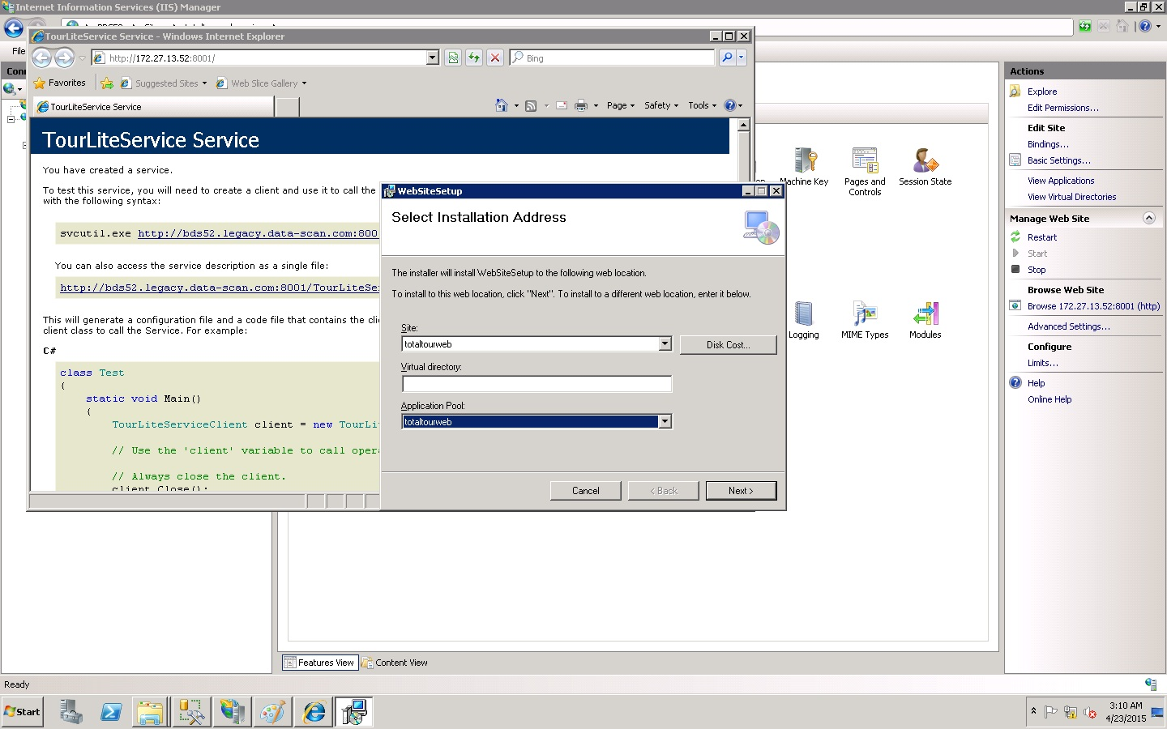

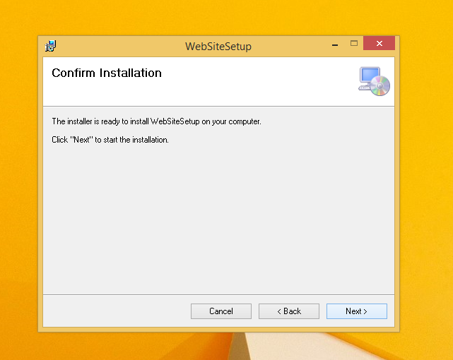

Click ‘Next’ to start Web installation.

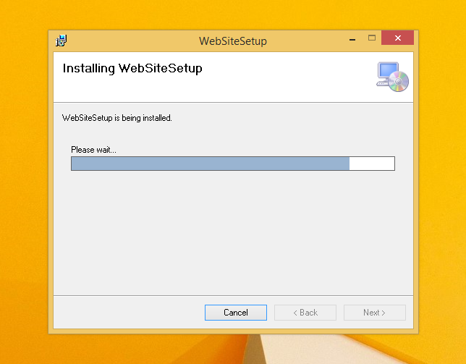

Web installation is going on.

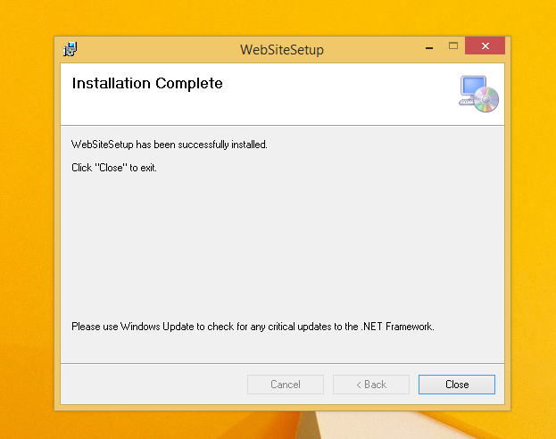

Web installations have been completed, and thereafter your service and web applications are ready to use with the associated database. Before that specific folders should be marked with “Full permission” rights for the user group “**IIS Users**” from IIS server manager.

A table is provided below to fill in the required data.

|  |  |
| --- | --- |
| **Folder** | **Location** |
| ErrorLog | Web-service folder |
| InspectionResponseImages | Web-service folder |
| IncidentResponseImages | Web-service folder |
| XMLData | Web-service folder |
| DARImages | Web-service folder |
| ApkFile | Web-application folder |
| Barcode | Web-application folder |
| Map_Images | Web-application folder |

# APK Configuration:

Once the application is opened for first time, you must press on the menu button. Then this popup dialog will be opened.

Then you have to put service url in text box below the service end point url label properly in a specific format. Like: 10.12.1.61:92/ (without virtual directory name as mention earlier) and 10.12.1.61:92/VD/ (With virtual directory name)

As well as you have to write web url link at web url text box.

Like : 10.12.1.61:98/ (without virtual directory name as mention earlier) and 10.12.1.61:98/VD/ (With virtual directory name ))

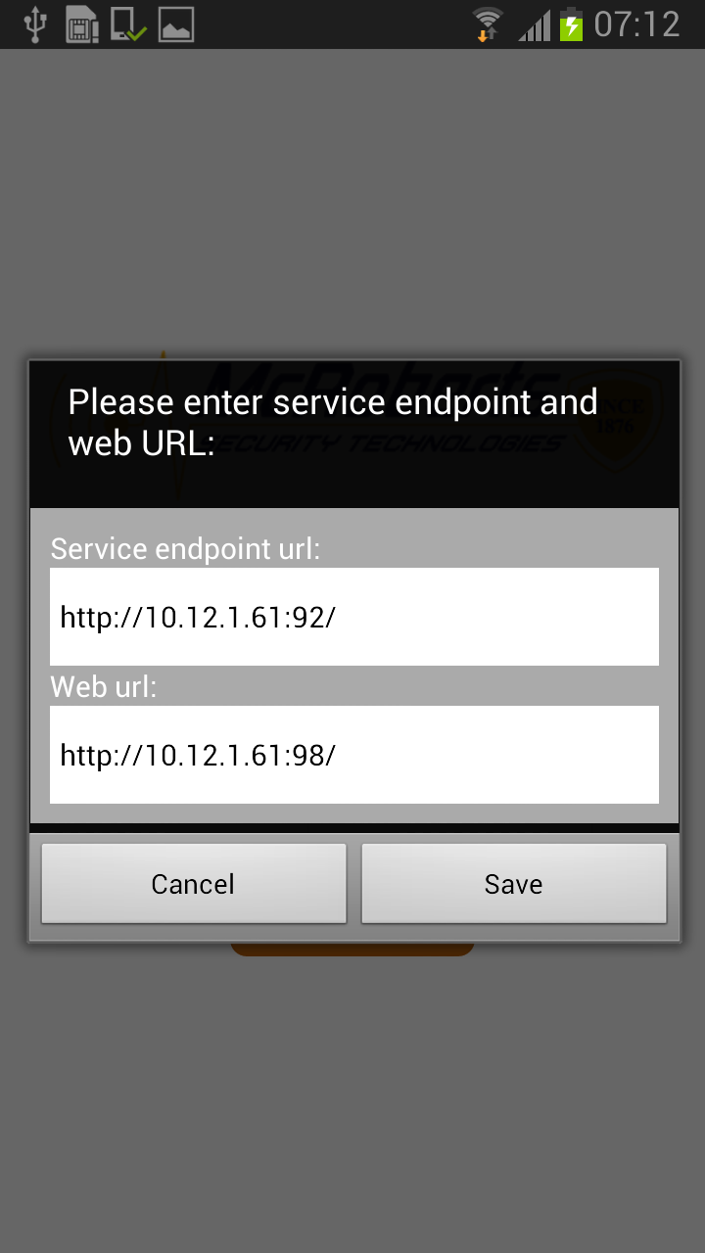

**NB: All configurations must be done properly as per instructions**

# Trouble Shoot:

If there is a problem in installing the webservice / web installer, this section will guide to troubleshoot.

**For Server Machine:**

Control Panel 🡪

Roles 🡪 Web server (IIS) 🡪 Select IIS 6 Management Compatibility

**For Standalone machine (not a server)**

http://www.aspdotnet-suresh.com/2012/04/installer-was-interrupted-

# Project Contacts

## McRoberts Contacts

Ron Frey

Email: ron.frey@mcroberts1876.com

## Data-Core Systems Contacts

Abhijit Chakraborty

Phone: 267-423-0813

Email: [abhijit.chakraborty@datacoresystems.com](mailto:abhijit.chakraborty@datacoresystems.com)