Introduction – Fee Management System
A Fee Management System is a web-based software application designed to manage and automate the complete fee-related activities of an educational institution. In traditional fee management, student fee records, payment details, pending dues, receipts, and reports are often maintained manually, which can be time-consuming and may lead to errors or loss of data.
The proposed Fee Management System provides a centralized platform where administrators can manage student information, fee structures, payments, outstanding dues, and payment history efficiently. The system can allow students or parents to view their fee details and payment status, while administrators can monitor transactions and generate reports.
The system is developed using modern technologies such as Django REST Framework for backend API development, PostgreSQL for database management, Redis for caching and efficient data processing, and React.js with Tailwind CSS and modern UI components for the frontend. The use of these technologies helps make the system secure, scalable, responsive, and user-friendly.
The main purpose of the Fee Management System is to reduce manual work, improve accuracy, provide quick access to fee information, and maintain transparent and organized financial records of students.

Objectives of Fee Management System
- To automate fee management and reduce dependency on manual record keeping.
- To maintain student fee records including total fees, paid amount, pending amount, and payment history.
- To provide secure user access for administrators, staff, students, and other authorized users.
- To manage different fee structures such as tuition fees, examination fees, library fees, hostel fees, and other charges.
- To track fee payments and automatically update the student's payment status.
- To manage pending and overdue fees so that administrators can easily identify students with outstanding payments.
- To generate fee receipts and reports for maintaining proper financial documentation.
- To reduce human errors that may occur during manual calculations and data entry.
- To provide a user-friendly interface through which users can easily access required fee-related information.
- To improve data security and reliability by storing information in a centralized database with proper authentication and authorization.
- To provide quick and accurate reports for administrators and management to support better decision-making.
- To improve transparency by allowing students/parents to view their fee details, payment status, and transaction history.
- To improve system performance and scalability using modern backend technologies, database management, and caching mechanisms.

Project Category
Project Category: RDBMS / OOPS / Networking / Web Application

1. RDBMS (Relational Database Management System)
- The project uses PostgreSQL as the database.
- It stores student, fee, payment, course and user information.
- Different tables are connected using Primary Key and Foreign Key.
- It supports CRUD operations – Create, Read, Update and Delete.
- It helps maintain accurate, organized and secure fee records.

2. OOPS (Object-Oriented Programming)
- The backend is developed using Python and Django.
- OOPS concepts such as Class, Object, Encapsulation, Inheritance and Abstraction are used.
- OOPS makes the system easy to develop, maintain and modify.
- It helps in creating reusable and modular program components.

3. Networking
- The project uses REST API for communication between frontend and backend.
- HTTP/HTTPS protocols are used for data communication.
- The React frontend sends requests to the Django REST Framework backend.
- The backend processes the request and communicates with the PostgreSQL database.

4. Web Application
- The system is a web-based application.
- React.js is used for frontend development.
- Tailwind CSS, DaisyUI and Shadcn/UI are used to create the user interface.
- Django REST Framework is used for backend/API development.
- The system can be accessed through a web browser.

5. Redis / Caching
- Redis is used for caching and improving system performance.
- Frequently required data can be temporarily stored in Redis.
- It reduces unnecessary database requests.
- It helps improve the response speed of the application.
Tools / Platform
Software Requirements
S. No. | Software/ Tool | Purpose
1. | Operating System – Windows 10/11 | Development and testing
2. | Python | Backend programming
3. | Django | Backend web framework
4. | Django REST Framework | Development of REST APIs
5. | React.js | Frontend development
6. | Tailwind CSS | Designing responsive user interface
7. | DaisyUI | UI components
8. | Shadcn/UI | Modern and reusable UI components
9. | PostgreSQL | Relational database management
10. | Redis | Caching and performance improvement
11. | Visual Studio Code | Code development and editing
12. | Git & GitHub | Version control and project management
13. | Postman | Testing REST APIs
14. | Web Browser – Chrome/Edge | Running and testing the web application

Hardware Requirements
S. No. | Hardware | Minimum Requirement
1. | Processor | Intel Core i3 / AMD equivalent
2. | RAM | Minimum 4 GB, 8 GB
3. | Hard Disk/SSD | Minimum 20 GB free space
4. | Display | 1366 × 768 resolution or above
5. | Keyboard | Standard keyboard
6. | Mouse | Standard mouse
7. | Internet | Stable Internet connection
8. | Network | Wi-Fi/Ethernet connection

Development Platform
- Frontend: React.js
- Backend: Python + Django REST Framework
- Database: PostgreSQL
- Caching: Redis
- UI: Tailwind CSS + DaisyUI + Shadcn/UI

1. Problem Definition
Many educational institutions still manage student fee records using manual registers, spreadsheets, or different systems. Managing student details, fee structures, payments, pending dues, receipts, and payment history manually requires considerable time and effort. It may also result in calculation mistakes, duplicate records, loss of information, and difficulty in tracking unpaid fees.
The “Fee Management System” is proposed to solve these problems by providing a centralized web-based system for managing all fee-related activities. The system will allow authorized users to manage student information, fee details, payments, pending amounts, and payment history efficiently.
The system will reduce manual work, improve accuracy, provide quick access to information, and make fee management more organized and transparent.

Main Problems
- Manual maintenance of fee records.
- Difficulty in tracking pending fees.
- Chances of human errors in calculations.
- Difficulty in maintaining payment history.
- Time-consuming report preparation.
- Risk of duplicate or lost records.
- Limited access to real-time fee information.

2. Requirement Specifications
Requirement specification describes the functions and resources required to develop and operate the Fee Management System.

A. Functional Requirements

1. User Registration and Login
- Users can securely log in to the system.
- Authentication will verify the user's identity.
- Different users can have different access permissions.

2. Student Management
- Admin can add new student records.
- Admin can update student information.
- Admin can view student details.
- Admin can delete student records when required.

3. Fee Structure Management
- Admin can create different fee structures.
- The system can maintain tuition fees and other applicable fees.
- Fee details can be associated with students/programs.

B. Non-Functional Requirements

1. Security
The system should protect student and payment information using authentication and authorization.

2. Performance
The system should provide quick responses when retrieving or updating records.

3. Reliability
The system should maintain accurate and consistent fee information.

3. Literature Review
Fee management is an important administrative activity in educational institutions. Traditional fee management systems generally use manual registers, spreadsheets, or basic computerized applications for maintaining student payment information. Although these methods can manage basic records, they become difficult to maintain when the number of students and transactions increases.
Existing computerized fee management systems have improved the process by providing digital storage, student records, payment tracking, and report generation. However, some systems have limitations such as limited accessibility, poor user interfaces, lack of real-time information, and insufficient integration between different modules.
Modern web technologies provide better solutions for developing centralized and scalable fee management applications. React.js can be used to develop an interactive frontend, while Django REST Framework can provide secure and structured REST APIs for communication between the frontend and backend. PostgreSQL provides reliable relational data storage, while Redis can improve performance through caching.
The proposed Fee Management System combines these technologies to provide a centralized platform for managing student fees, payments, pending dues, receipts, and reports. The system aims to reduce manual work, improve data accuracy, increase transparency, and provide faster access to fee-related information.

4. Project Planning
Project planning defines the activities, sequence, time and resources required to complete the Fee Management System.
The project will be developed in different phases:
- Requirement Analysis
- Literature Review
- System Design
- Database Design
- Frontend Development
- Backend Development
- API Integration
- Testing
- Bug Fixing
- Documentation
- Deployment
- Final Presentation
5. Gantt Chart

Activity | W1 | W2 | W3 | W4 | W5 | W6 | W7 | W8 | W9 | W10 | W11
Requirement Analysis | - | -
Literature Review | - | -
System Design |  | - | -
Database Design |  |  | - | -
Frontend Development |  |  |  | - | - | -
Backend Development |  |  |  | - | - | -
API Integration |  |  |  |  |  | -
Testing |  |  |  |  |  |  | - | -
Bug Fixing |  |  |  |  |  |  |  | - | -
Documentation |  |  |  |  |  |  |  | - | - | -
Deployment |  |  |  |  |  |  |  |  |  | - | -
Final Presentation |  |  |  |  |  |  |  |  |  |  | -

6. PERT Chart
PERT (Program Evaluation and Review Technique) is used to represent the sequence and dependency of project activities.
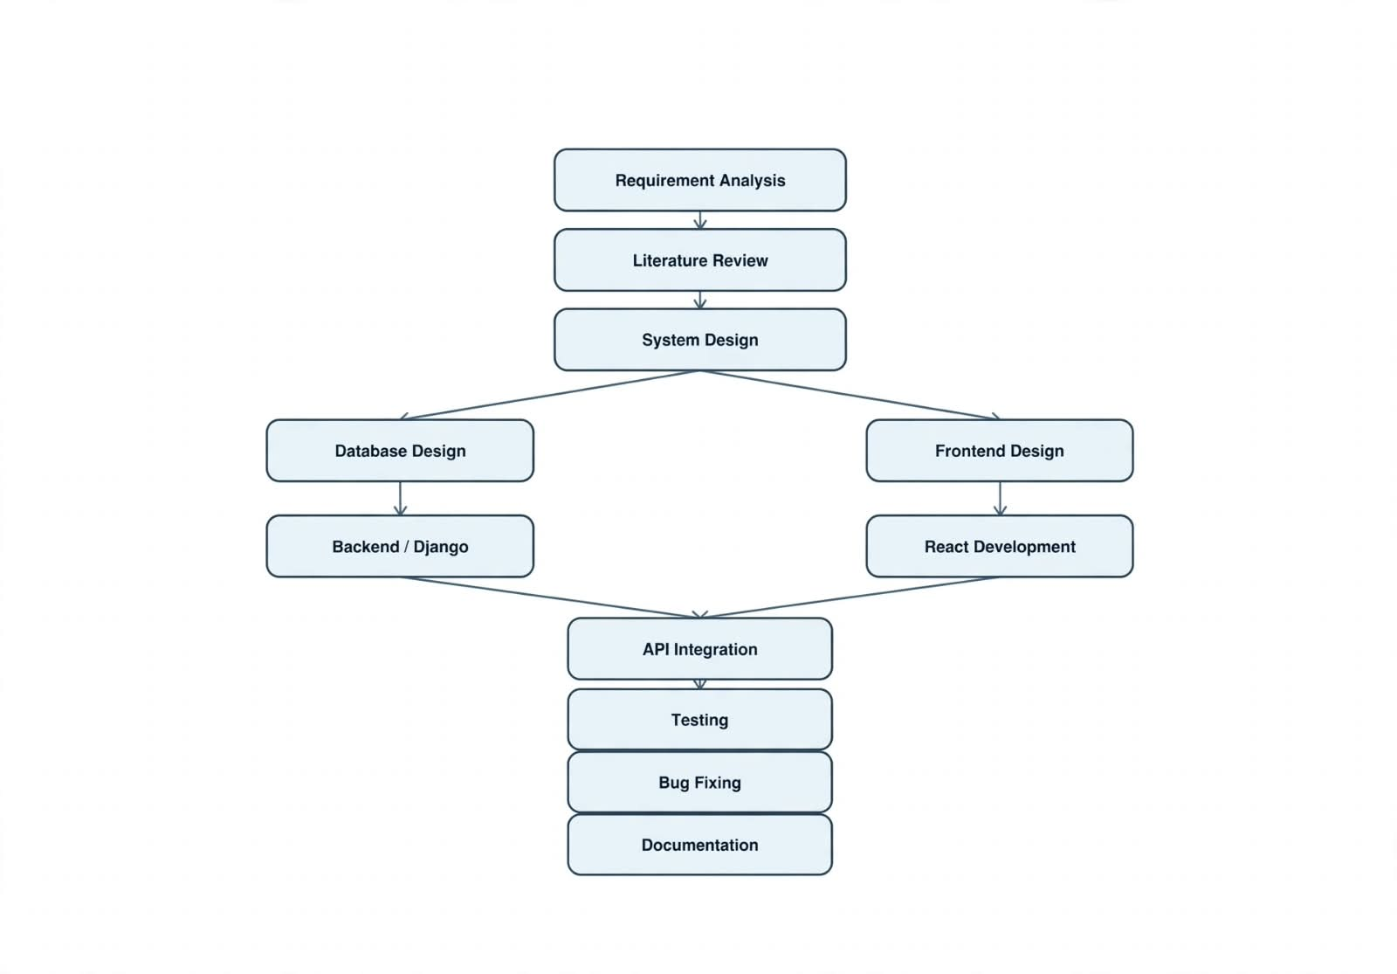

Scope of the Solution
The Fee Management System is a web-based application developed to simplify and automate the management of student fee-related activities in an educational institution. The system provides a centralized platform for maintaining student records, fee structures, payment details, pending fees, receipts, and reports.
The proposed system will allow authorized users to securely manage student and fee information. Administrators can add, update, view, and manage student records and fee structures. The system will record fee payments and maintain payment history, paid amounts, pending amounts, and transaction details. It will also help in identifying students with outstanding fees and generating fee-related reports and receipts.
The system will use React.js for the frontend, Django REST Framework for backend API development, PostgreSQL for relational database management,
and Redis for caching and improving system performance. Authentication and authorization will be implemented to protect sensitive student and payment information.

Future Scope
The system can be further extended with:
- Online payment gateway integration.
- Email/SMS fee payment notifications.
- Automatic due-date reminders.
- Mobile application.
- PDF receipt generation.
- Advanced financial reports and analytics.
- Parent/guardian login.
- Integration with college ERP or student management systems.

DFD FLOW DIAGRAM (DFD)
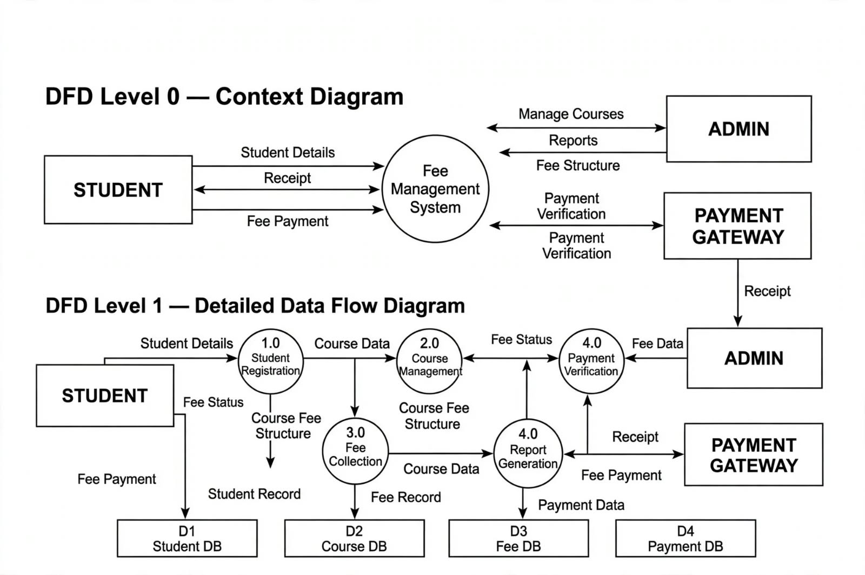

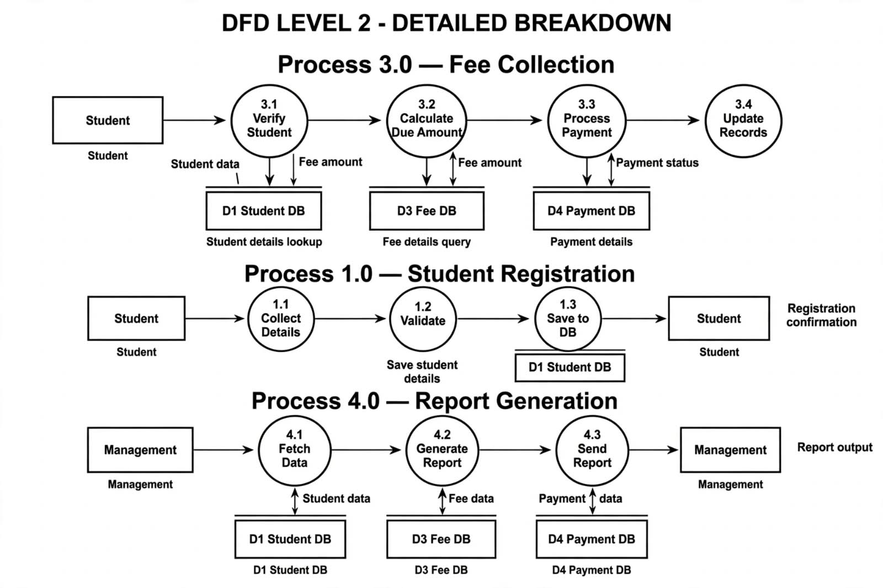

ER DIAGRAM

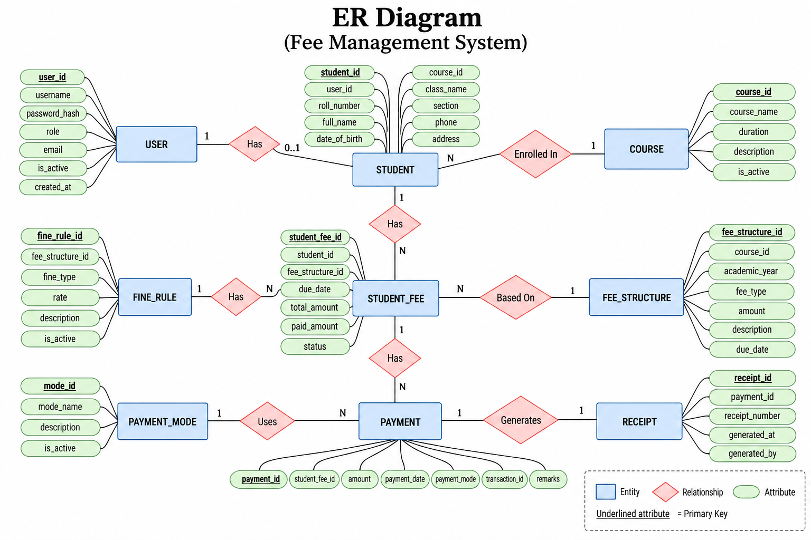

CLASS DIAGRAM

ACTIVITY DIAGRAM
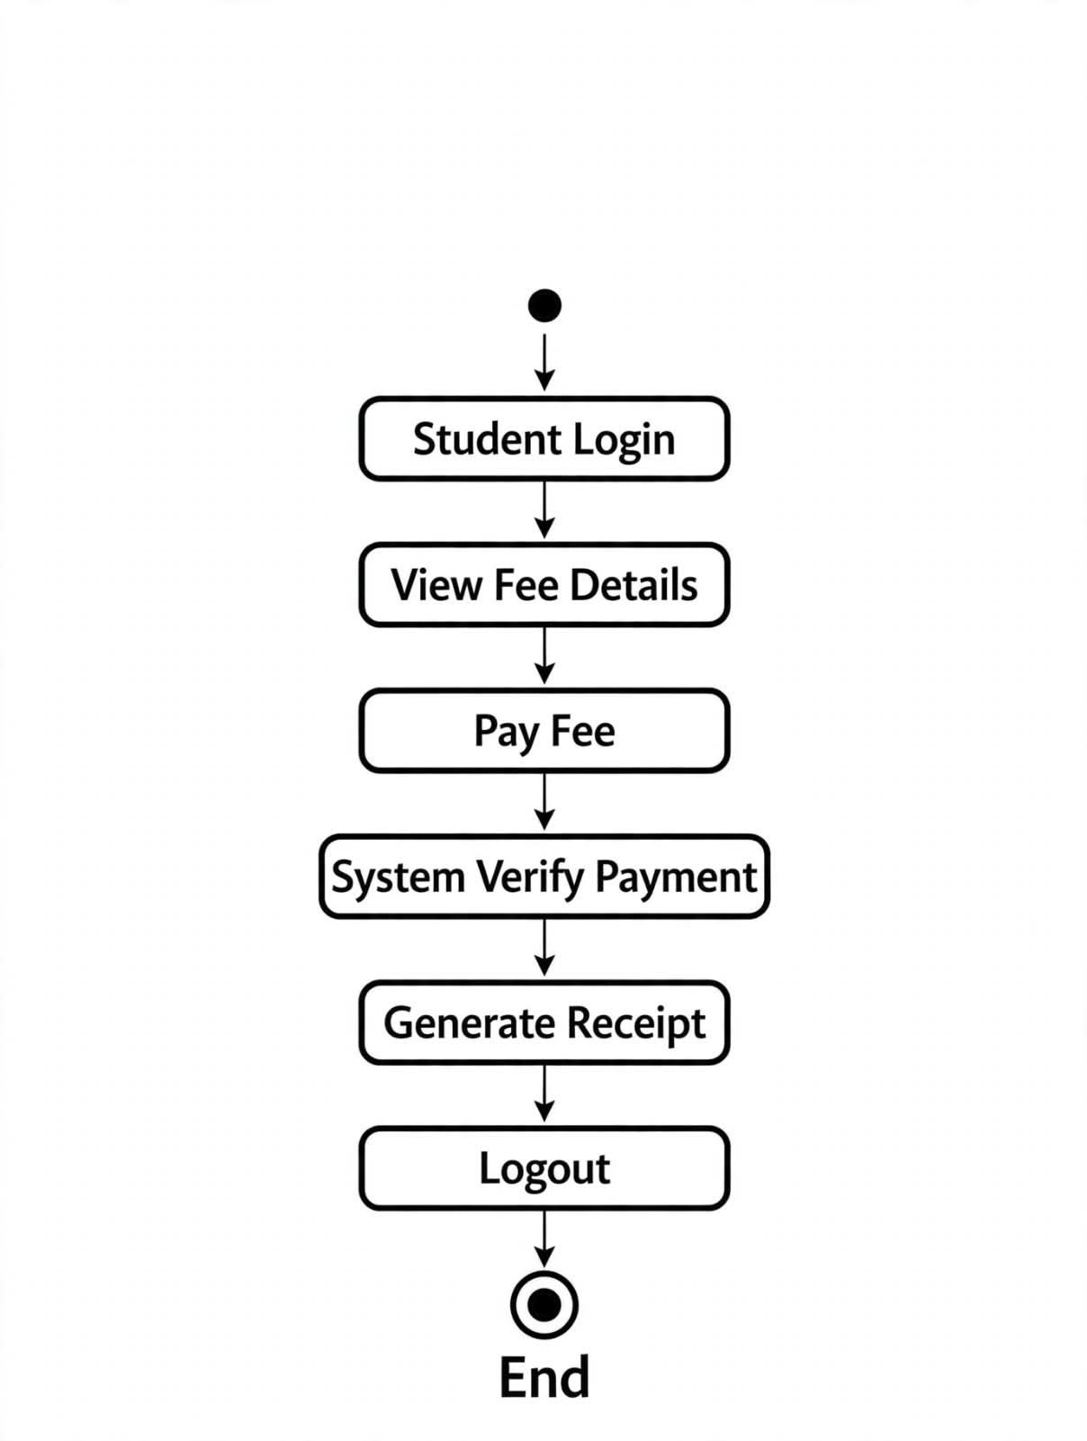

System Design and Database Design

1. System Design
The Fee Management System is designed as a web-based three-tier application. It consists of a frontend, backend, and database layer. The frontend provides an easy-to-use interface, while the backend handles business logic and API requests. The database stores student, fee, and payment information.

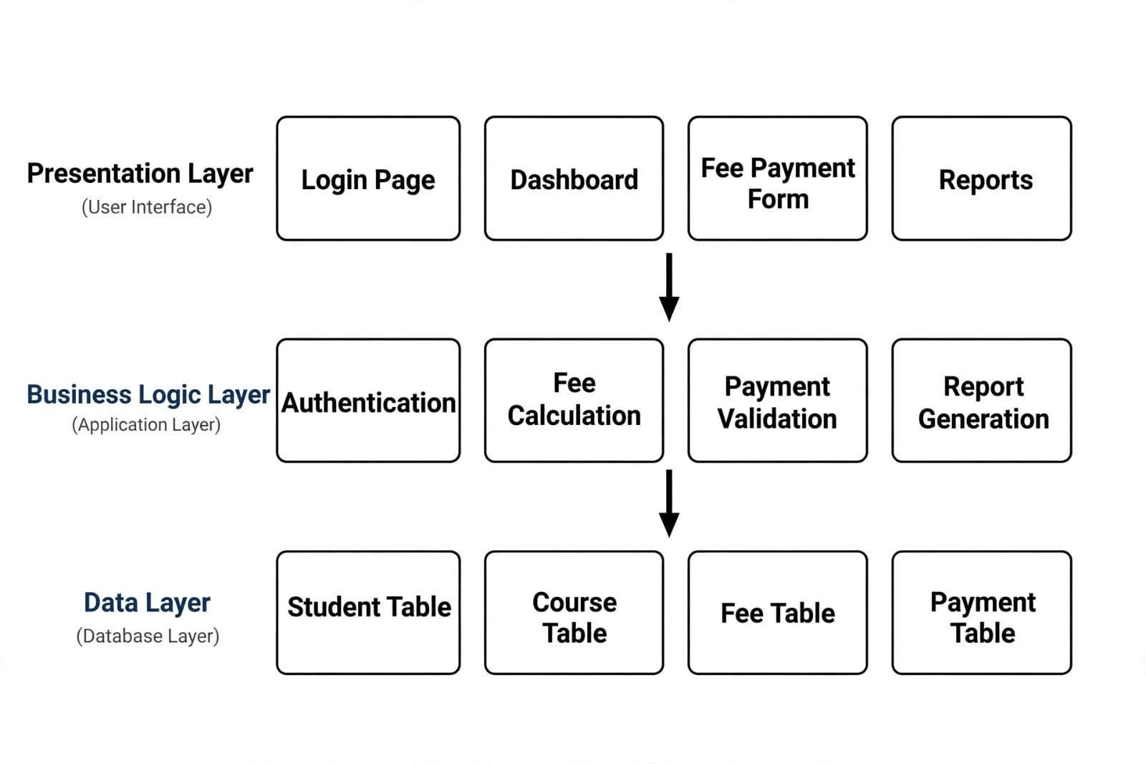

2. Database Design
The database is designed using PostgreSQL, which is a relational database management system. The database contains multiple related tables for storing student, fee and payment information.

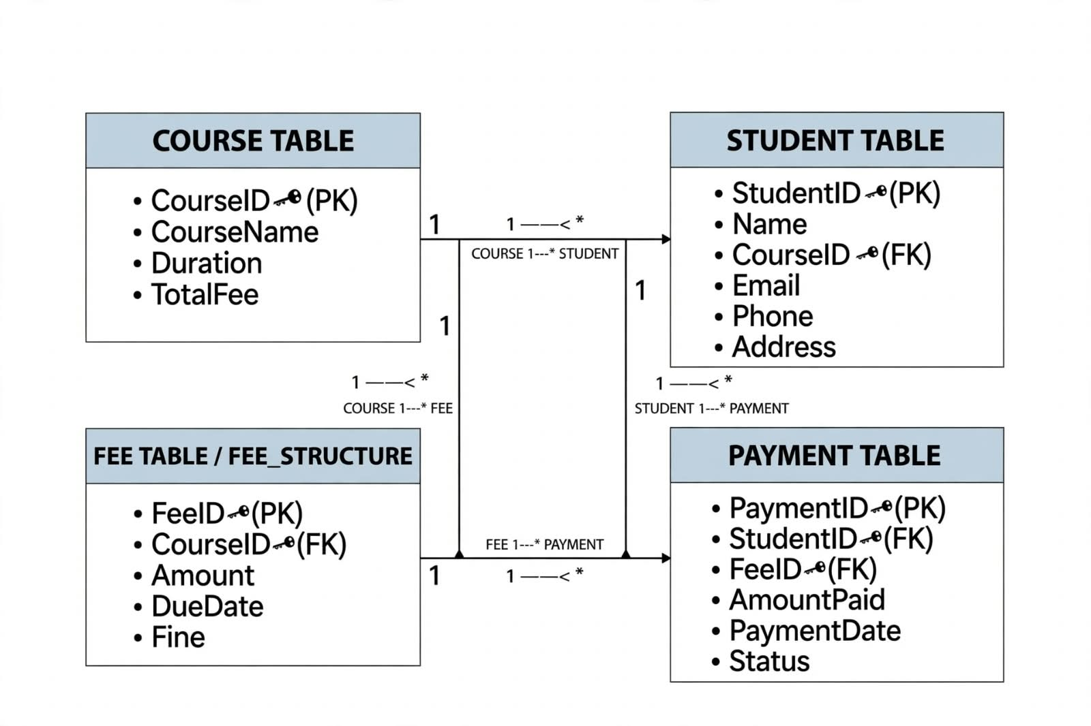

Overall Network Architecture
Network Architecture Diagram

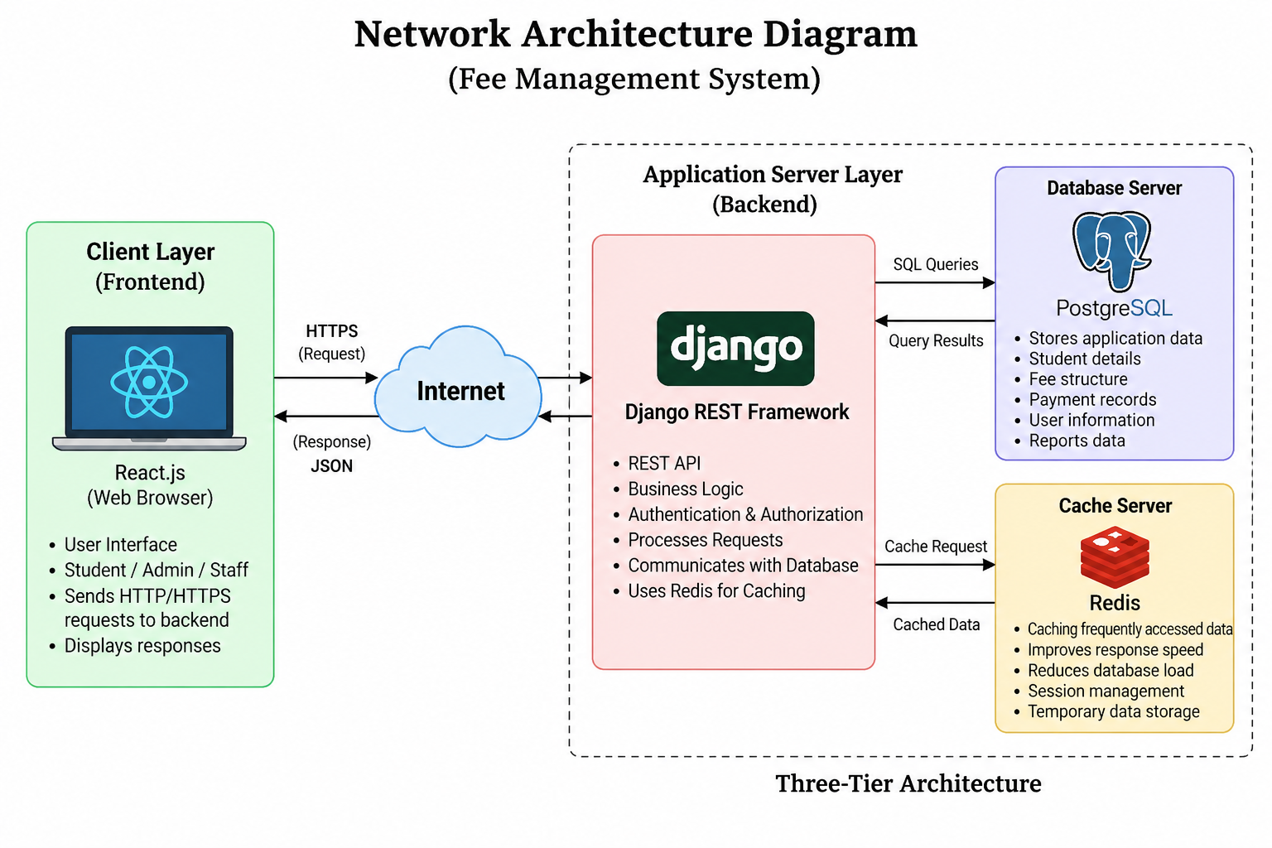

Implementation of Security Mechanisms
The Fee Management System handles important student and payment-related information. Therefore, suitable security mechanisms are required to protect the system from unauthorized access, data loss, and misuse. The proposed system will implement security at the frontend, backend, API, and database levels.

1. User Authentication
- The system will provide a secure login mechanism.
- Users will log in using their username/email and password.
- Only registered users can access the system.
- Authentication will be handled through the Django backend.

2. Password Security
- User passwords will not be stored in plain text.
- Django's built-in password hashing mechanism will be used.
- Strong password policies can be applied to improve account security.

4. API Security
- Django REST Framework APIs will be protected using authentication and permissions.
- Unauthorized requests will be rejected.
- Only authorized users can create, update, or delete sensitive records.
- API input will be validated before processing.

5. HTTPS Communication
- HTTPS will be used in the deployed system.
- It encrypts data transmitted between the user's browser and the server.
- It helps protect login credentials and sensitive information from interception.

6. Database Security
- PostgreSQL will be used for secure data storage.
- Database access will be restricted to authorized backend services.
- Primary keys, foreign keys and constraints will help maintain data integrity.
- Sensitive database credentials will not be exposed in frontend code.

Security Architecture

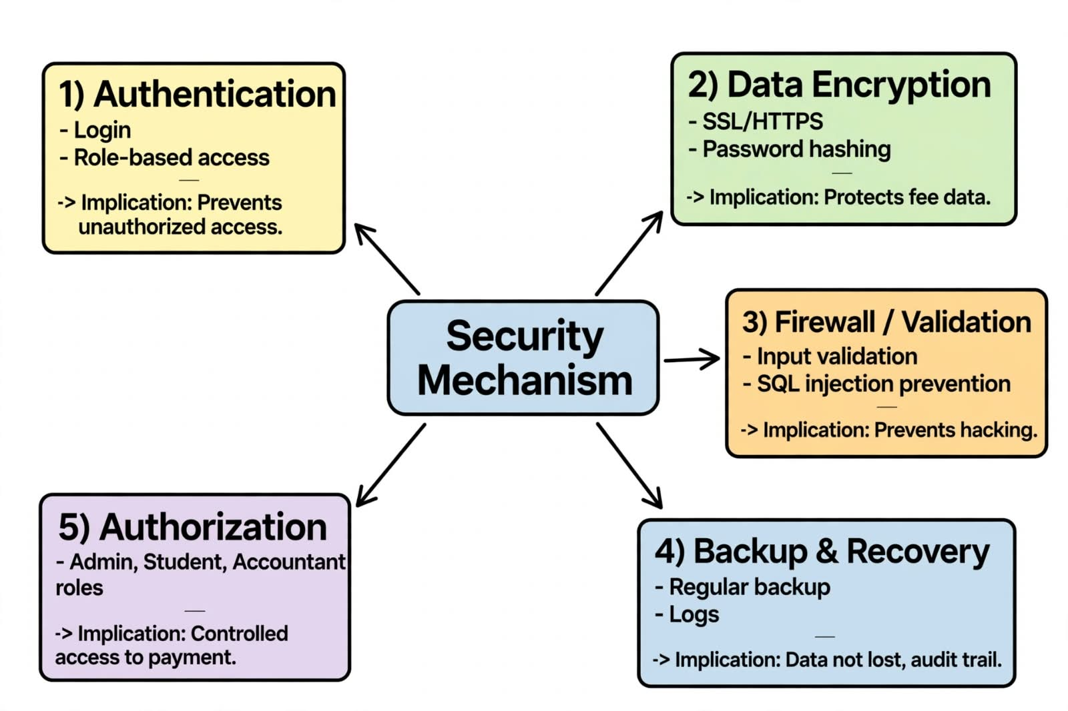

Future Scope and Further Enhancement

1. Online Payment Gateway Integration
Integrate UPI, credit/debit cards and net banking to enable secure online fee payments.
2. Mobile Application Development
Develop Android/iOS applications for students, parents, administrators and staff.
3. Automated Notification System
Implement SMS, email and in-app notifications for payment confirmation, pending fees and due dates.
4. Role-Based Access Control (RBAC)
Provide different access permissions for Admin, Accountant/Staff, Student and Parent based on their roles.
5. Advanced Reporting and Data Visualization
Generate monthly, yearly and course-wise reports using charts, graphs and interactive dashboards.
6. Cloud Deployment
Deploy the application on cloud infrastructure to provide scalability, availability and remote access.
7. Enhanced Database Management
Optimize PostgreSQL queries, indexing and database design to handle a large number of students and transactions efficiently.

Bibliography
1.Django Software Foundation, “Django Documentation,” Django Project.
2. Django Software Foundation, “Django REST Framework Documentation,” Django REST Framework.
3. PostgreSQL Global Development Group, “PostgreSQL Documentation,” PostgreSQL.
4. Redis Ltd., “Redis Documentation,” Redis.
5. React Team, “React Documentation,” React.
Online References
• Django official documentation
• Django REST Framework official documentation
• PostgreSQL official documentation
• Redis official documentation
• React official documentation
• Tailwind CSS official documentation
• DaisyUI official documentation



PROJECT PROPSOAL (MCSP-232)
TITLE: FEE MANAGEMENT SYSTEM

Programme: MCA_NEW
Course Code: MCSP-232
Student Name: SOMIYA RAJ
Enrolment No: 2551566454
Regional Centre: DELHI-2 (29)
Study Centre: 29069
Guide Name: VAIBHAV RANJAN
Year: 2025-26

TITLE OF THE PROJECT

FEE MANAGEMENT SYSTEM

