**BUSINESS PERFORMANCE ANALYSIS**

**Table of Contents**

Graphical presentaion 3

Conclusion: 4

Mitigation approach: 4

# Graphical presentaion

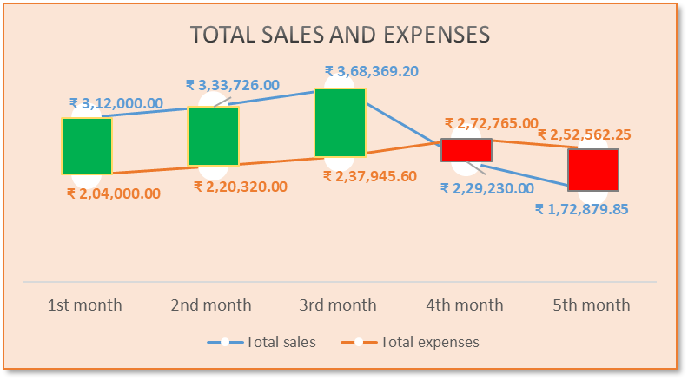

|  |  |
| --- | --- |
|  |  |
|  |  |
|  |  |

# Conclusion:

* Sales and expenses trend analysis indicate excessive consumption of expenses reduces profit volume.
* Sales growth of Pizza and Chicken Kabab are negative, its toward profit impact adverse.
* Veg. food items fail to achieve success in profit making
* Expenses regarding salaries have been impacted negatively to maximisation of positively whereas fixed cost related expenses is less compared to variable cost.
* Veg. food and pizza contribute only 6% and 7% to profitability.

# Mitigation approach:

* Need to implement business Strategies for maximisation of unit of food product sale, Which would be effective for reduce average cost of production
* Focus on best-selling food products to increase sales volume like Briyani, Chicken kabab.