**Import library**

In [3]:

1

**import** pandas **as** pd

2

**import** seaborn **as** sns

3

**import** matplotlib.pyplot **as** plt

In [4]:

1

data **=** pd.read_csv("D:/Top_mentor/Oct/29th oct/b88assignments/Project - 3&4_Multiple_Reg/Project - 3&4_Multiple_Reg/50_Startups.csv")

**Present Top 10 rows**

In [5]:

1

data.head(10)

Out[5]:

|  | **R&D Spend** | **Administration** | **Marketing Spend** | **State** | **Profit** |
| --- | --- | --- | --- | --- | --- |
| **0** | 165349.20 | 136897.80 | 471784.10 | New York | 192261.83 |
| **1** | 162597.70 | 151377.59 | 443898.53 | California | 191792.06 |
| **2** | 153441.51 | 101145.55 | 407934.54 | Florida | 191050.39 |
| **3** | 144372.41 | 118671.85 | 383199.62 | New York | 182901.99 |
| **4** | 142107.34 | 91391.77 | 366168.42 | Florida | 166187.94 |
| **5** | 131876.90 | 99814.71 | 362861.36 | New York | 156991.12 |
| **6** | 134615.46 | 147198.87 | 127716.82 | California | 156122.51 |
| **7** | 130298.13 | 145530.06 | 323876.68 | Florida | 155752.60 |
| **8** | 120542.52 | 148718.95 | 311613.29 | New York | 152211.77 |
| **9** | 123334.88 | 108679.17 | 304981.62 | California | 149759.96 |

**Copy data set**

In [6]:

1

df1**=**data.copy()

**No. of rows**

In [7]:

1

row**=**df1.shape[0]

2

print("No. of rows =", row)

No. of rows = 50

**No. of columns**

In [8]:

1

col **=** df1.shape[1]

2

print("No. of columns =", row)

No. of columns = 50

**Data information**

In [9]:

1

df1.info()

<class 'pandas.core.frame.DataFrame'>

RangeIndex: 50 entries, 0 to 49

Data columns (total 5 columns):

# Column Non-Null Count Dtype

--- ------ -------------- -----

0 R&D Spend 50 non-null float64

1 Administration 50 non-null float64

2 Marketing Spend 50 non-null float64

3 State 50 non-null object

4 Profit 50 non-null float64

dtypes: float64(4), object(1)

memory usage: 2.1+ KB

**Statistics of data**

In [10]:

1

df1.describe(include**=**'all')

Out[10]:

|  | **R&D Spend** | **Administration** | **Marketing Spend** | **State** | **Profit** |
| --- | --- | --- | --- | --- | --- |
| **count** | 50.000000 | 50.000000 | 50.000000 | 50 | 50.000000 |
| **unique** | NaN | NaN | NaN | 3 | NaN |
| **top** | NaN | NaN | NaN | New York | NaN |
| **freq** | NaN | NaN | NaN | 17 | NaN |
| **mean** | 73721.615600 | 121344.639600 | 211025.097800 | NaN | 112012.639200 |
| **std** | 45902.256482 | 28017.802755 | 122290.310726 | NaN | 40306.180338 |
| **min** | 0.000000 | 51283.140000 | 0.000000 | NaN | 14681.400000 |
| **25%** | 39936.370000 | 103730.875000 | 129300.132500 | NaN | 90138.902500 |
| **50%** | 73051.080000 | 122699.795000 | 212716.240000 | NaN | 107978.190000 |
| **75%** | 101602.800000 | 144842.180000 | 299469.085000 | NaN | 139765.977500 |
| **max** | 165349.200000 | 182645.560000 | 471784.100000 | NaN | 192261.830000 |

**Missing or null value findings**

In [11]:

1

null**=** df1.isnull().sum()**\***100**/**len(df1)

2

null

Out[11]:

R&D Spend 0.0

Administration 0.0

Marketing Spend 0.0

State 0.0

Profit 0.0

dtype: float64

In [12]:

1

sns.heatmap(df1.isnull())

Out[12]:

<Axes: >

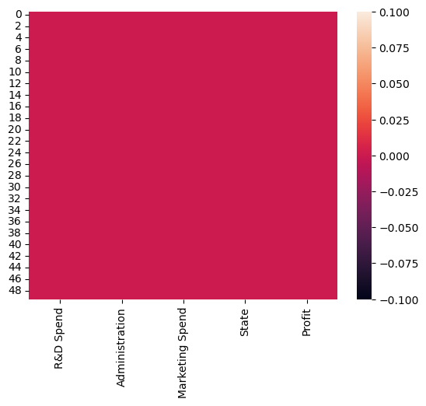

There is no Null value in dataset

**Number of states**

In [13]:

1

state**=**df1['State'].nunique()

2

print('Number of states = ', state)

Number of states = 3

**Profit by state**

In [14]:

1

plt.figure(figsize**=**(8,4))

2

sns.barplot(x**=**'State', y**=**'Profit', data**=**df1)

3

plt.show()

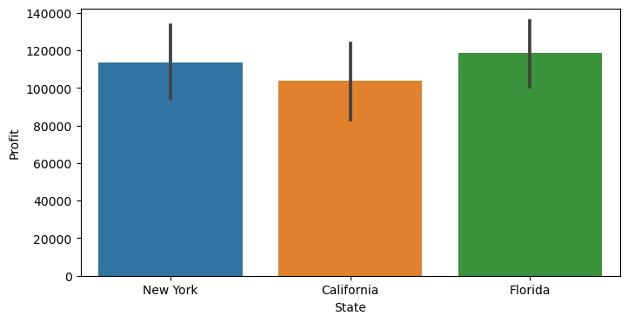

1

Highest profit generated from Florida region

**Average profit by state**

In [15]:

1

df1.groupby('State')['Profit'].mean()

Out[15]:

State

California 103905.175294

Florida 118774.024375

New York 113756.446471

Name: Profit, dtype: float64

1

State wise Average profit

2

State

3

California   103905.175294

4

Florida       118774.024375

5

New York     113756.446471

**Marketing Spend by state**

In [16]:

1

max_mar **=**df1.groupby('State')['Marketing Spend'].mean()

2

max_mar

Out[16]:

State

California 182540.929412

Florida 247323.551250

New York 205346.015882

Name: Marketing Spend, dtype: float64

1

Average marketing Spend by states

2

California   182540.929412

3

Florida       247323.551250

4

New York     205346.015882

In [17]:

1

plt.figure(figsize**=**(8,6))

2

sns.barplot(x**=**'State', y**=**'Marketing Spend', data**=**df1)

3

plt.show()

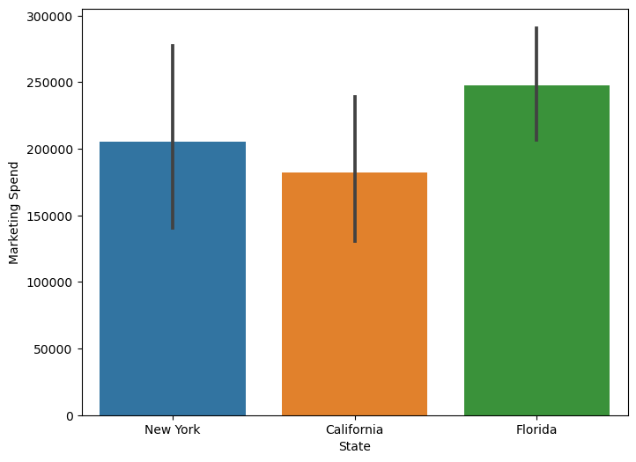

**Relation between 'Profit' and 'Marketing Spend'**

In [18]:

1

plt.figure(figsize**=**(10,6))

2

sns.scatterplot(x**=**'Profit', y**=**'Marketing Spend', hue**=**'State', data**=**df1)

3

plt.show()

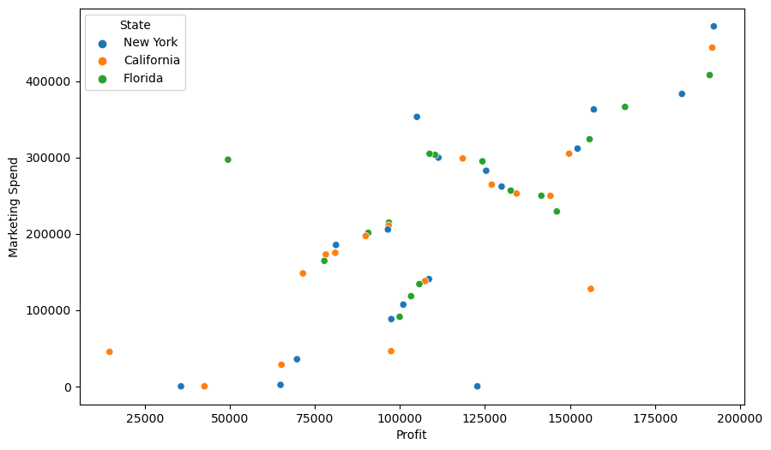

**Highest administartion cost oriented state**

In [19]:

1

df1[df1['Administration'].max()**==**df1['Administration']][['State','Administration']]

Out[19]:

|  | **State** | **Administration** |
| --- | --- | --- |
| **28** | Florida | 182645.56 |

Maximum administartion cost by state Florida around 182645.56

**R&D spend by state**

In [20]:

1

plt.figure(figsize**=**(8,4))

2

sns.barplot(x**=**'State', y**=**'R&D Spend', data**=**df1)

3

plt.xlabel('State', fontsize **=** 12)

4

plt.ylabel('R&D Cost', fontsize **=** 12)

5

​

6

plt.show()

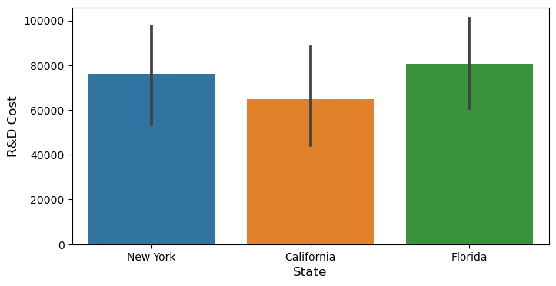

**Maximum R&D spend by state**

In [21]:

1

df1[df1['R&D Spend'].max()**==**df1['R&D Spend']][['State','R&D Spend']]

Out[21]:

|  | **State** | **R&D Spend** |
| --- | --- | --- |
| **0** | New York | 165349.2 |

Maximum R&D cost by state New York around 165349.2

**Graphical presenation of relation between Profit and R&D spend**

In [22]:

1

plt.figure(figsize**=**(8,6))

2

sns.lineplot(x**=**'Profit', y**=**'R&D Spend', hue**=**'State', data**=**df1)

3

plt.show()

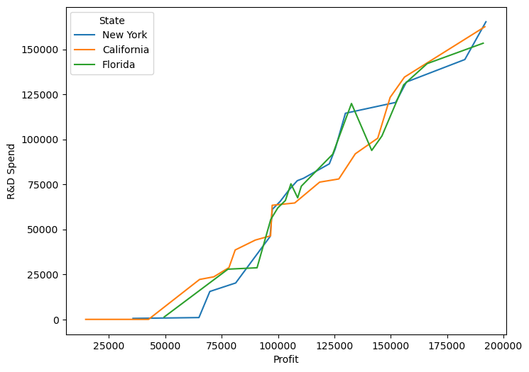

**Calcualtion of total cost**

In [23]:

1

df1.columns

Out[23]:

Index(['R&D Spend', 'Administration', 'Marketing Spend', 'State', 'Profit'], dtype='object')

In [24]:

1

df1['Total_cost']**=**df1['R&D Spend']**+** df1['Administration']**+** df1['Marketing Spend']

In [25]:

1

df1.head()

Out[25]:

|  | **R&D Spend** | **Administration** | **Marketing Spend** | **State** | **Profit** | **Total_cost** |
| --- | --- | --- | --- | --- | --- | --- |
| **0** | 165349.20 | 136897.80 | 471784.10 | New York | 192261.83 | 774031.10 |
| **1** | 162597.70 | 151377.59 | 443898.53 | California | 191792.06 | 757873.82 |
| **2** | 153441.51 | 101145.55 | 407934.54 | Florida | 191050.39 | 662521.60 |
| **3** | 144372.41 | 118671.85 | 383199.62 | New York | 182901.99 | 646243.88 |
| **4** | 142107.34 | 91391.77 | 366168.42 | Florida | 166187.94 | 599667.53 |

**Total cost and profit trend line analysis state wise**

In [26]:

1

plt.figure(figsize**=**(8,6))

2

sns.lineplot(x**=**'Profit', y**=**'Total_cost', hue**=**'State', data**=**df1)

3

plt.show()

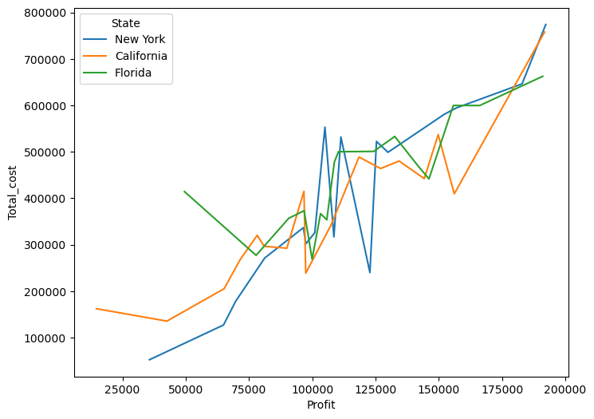

**Max profit and Total cost orineted state**

In [27]:

1

max_pro_tc **=** df1.groupby('State')[['Profit','Total_cost']].max()

2

max_pro_tc

Out[27]:

|  | **Profit** | **Total_cost** |
| --- | --- | --- |
| **State** |  |  |
| **California** | 191792.06 | 757873.82 |
| **Florida** | 191050.39 | 662521.60 |
| **New York** | 192261.83 | 774031.10 |

**Encode State column**

In [28]:

1

dummy **=** pd.get_dummies(df1['State']).astype('int')

2

dummy.head(2)

Out[28]:

|  | **California** | **Florida** | **New York** |
| --- | --- | --- | --- |
| **0** | 0 | 0 | 1 |
| **1** | 1 | 0 | 0 |

**Join DF1 and dummy sheet**

In [29]:

1

final_data **=** pd.concat([df1,dummy], axis**=**1)

In [30]:

1

final_data.head(3)

Out[30]:

|  | **R&D Spend** | **Administration** | **Marketing Spend** | **State** | **Profit** | **Total_cost** | **California** | **Florida** | **New York** |
| --- | --- | --- | --- | --- | --- | --- | --- | --- | --- |
| **0** | 165349.20 | 136897.80 | 471784.10 | New York | 192261.83 | 774031.10 | 0 | 0 | 1 |
| **1** | 162597.70 | 151377.59 | 443898.53 | California | 191792.06 | 757873.82 | 1 | 0 | 0 |
| **2** | 153441.51 | 101145.55 | 407934.54 | Florida | 191050.39 | 662521.60 | 0 | 1 | 0 |

In [31]:

1

final_data.columns

Out[31]:

Index(['R&D Spend', 'Administration', 'Marketing Spend', 'State', 'Profit',

'Total_cost', 'California', 'Florida', 'New York'],

dtype='object')

In [32]:

1

X**=**final_data[['R&D Spend', 'Administration', 'Marketing Spend', 'California', 'Florida', 'New York']]

In [33]:

1

X.head(2)

Out[33]:

|  | **R&D Spend** | **Administration** | **Marketing Spend** | **California** | **Florida** | **New York** |
| --- | --- | --- | --- | --- | --- | --- |
| **0** | 165349.2 | 136897.80 | 471784.10 | 0 | 0 | 1 |
| **1** | 162597.7 | 151377.59 | 443898.53 | 1 | 0 | 0 |

In [34]:

1

y**=**final_data['Profit']

2

​

In [35]:

1

**from** sklearn.model_selection **import** train_test_split

2

​

In [36]:

1

X_train, X_test, y_train, y_test **=** train_test_split(X,y, train_size**=**0.7,random_state**=**5612)

In [37]:

1

final_data.shape

Out[37]:

(50, 9)

In [38]:

1

X_train.shape

Out[38]:

(35, 6)

In [39]:

1

X_test.shape

Out[39]:

(15, 6)

**Model fitting**

In [40]:

1

**from** sklearn.linear_model **import** LinearRegression

In [41]:

1

model**=** LinearRegression()

2

model_train**=**model.fit(X_train, y_train)

In [42]:

1

pred1**=**model_train.predict(X_test)

In [43]:

1

pred1

Out[43]:

array([ 51098.34009208, 104469.38564144, 128689.98483615, 158982.22848538,

114250.21233399, 150487.12858695, 164634.70233416, 190393.24470632,

118985.57208791, 191045.71545156, 73534.81843834, 174943.96973121,

48194.94580221, 74162.00250969, 53075.89956777])

In [44]:

1

p**=**pd.DataFrame(pred1, columns**=**['Pred_profit'])

In [45]:

1

p['Actual']**=**y_test.values

In [46]:

1

p.head(6)

Out[46]:

|  | **Pred_profit** | **Actual** |
| --- | --- | --- |
| **0** | 51098.340092 | 14681.40 |
| **1** | 104469.385641 | 97427.84 |
| **2** | 128689.984836 | 125370.37 |
| **3** | 158982.228485 | 149759.96 |
| **4** | 114250.212334 | 111313.02 |
| **5** | 150487.128587 | 132602.65 |

**Score and error**

In [47]:

1

**from** sklearn.metrics **import** r2_score, mean_squared_error, mean_absolute_error

2

**from** math **import** sqrt

In [48]:

1

round(sqrt(mean_squared_error(p['Actual'], p['Pred_profit'])))

Out[48]:

13851

In [49]:

1

str**=**round(r2_score(p['Actual'], p['Pred_profit'])**\***100)

2

print('Strangth of the model =',str )

Strangth of the model = 93

In [50]:

1

mean_absolute_error(p['Actual'], p['Pred_profit'])

Out[50]:

10495.245965985248

**Save the model**

In [51]:

1

**import** joblib

In [52]:

1

filename **=** 'joblib_reg_model.sav'

2

joblib.dump(model_train,filename)

Out[52]:

['joblib_reg_model.sav']