## Project: Online Course Analytics using BigQuery & Looker Studio

### Project Objective

To build a cloud-based analytics dashboard that empowers stakeholders to monitor course performance, instructor effectiveness, learner demographics, and revenue metrics for an e-learning platform.

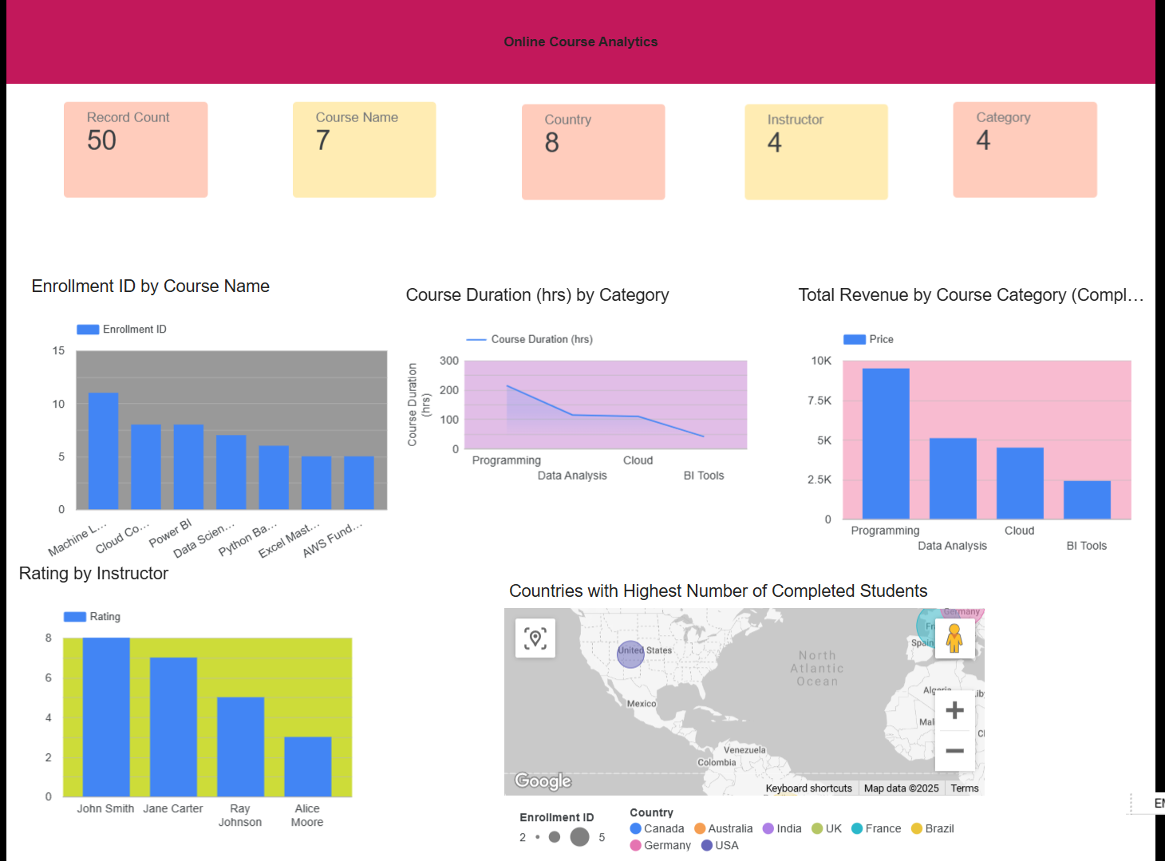

### Project Architecture

1. **Data Source**:
   * Raw course data from online_course_analytics.csv uploaded to **Google BigQuery**.
2. **Cloud Platform**:
   * **BigQuery** was used for scalable storage and querying.
3. **Business Intelligence Tool**:
   * **Looker Studio** (formerly Google Data Studio) connected to BigQuery for real-time, interactive visualizations.

### Dataset Overview

The dataset captures key online course attributes:

* **Course Info**: Course Name, Category, Duration (hrs), Price
* **Enrollment Metrics**: Enrollment ID, Completion Status
* **Learner Data**: Country
* **Instructor Info**: Name, Average Rating
* **Revenue Indicators**: Derived from course completions and pricing

### Key Dashboard Features

1. **Top Courses by Enrollment**
   * Bar chart visualization to show popular courses (e.g., “Machine Learning”, “Power BI”).
2. **Instructor Performance**
   * Average learner ratings for each instructor.
3. **Global Reach**
   * Map and chart showing countries with the highest number of completed learners.
4. **Course Category Duration**
   * Category-wise comparison of total course duration.
5. **Revenue Insights**
   * Total revenue generated per course category (based on completed courses).

**Benefits to Stakeholders**

* **Marketing Team**: Understand where students are coming from and which courses to promote in which regions.
* **Curriculum Designers**: See which course categories need improvement or expansion.
* **Instructors**: Evaluate and improve based on feedback and course completion trends.
* **Management**: Monitor overall performance, profitability, and content value across different categories.

**Key Value Proposition**

* **Real-time Analytics**: Direct connection from BigQuery ensures always-up-to-date insights.
* **Interactive Visualization**: Users can filter, drill down, and view data at various granular levels in Looker Studio.
* **Scalability**: Easily supports future data growth and additional KPIs with minimal overhead.