**File Correspondences Management System (FCMS)**

The Correspondence Management Solution streamlines organizational communication by providing a centralized platform for creating, processing, managing, and tracking correspondences. This streamlined solution focuses on **admin-driven customization**, **project-centric organization**, and **local data control**.[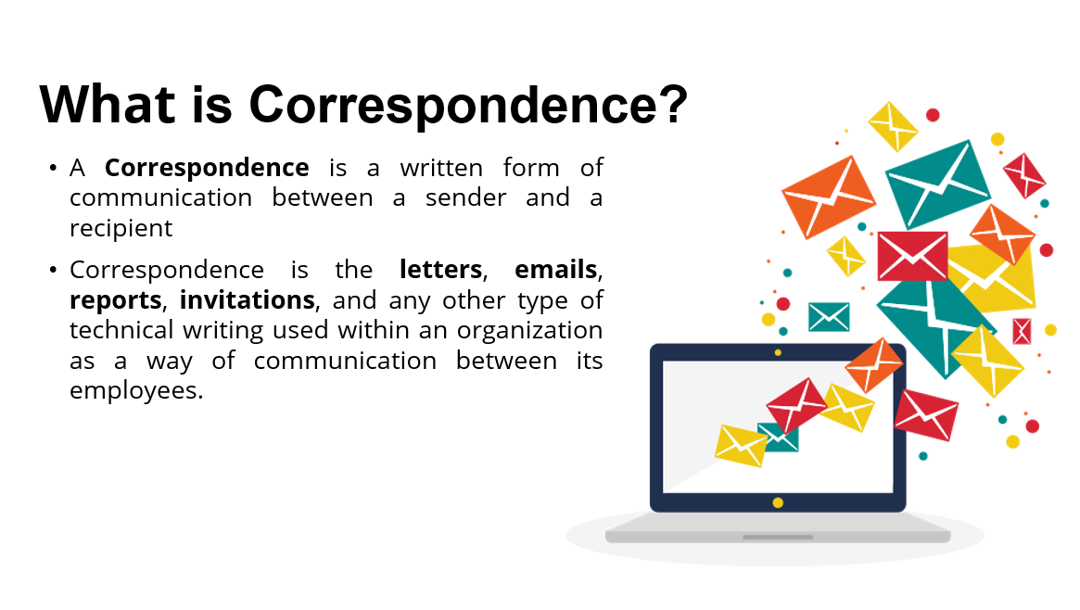](https://user-images.githubusercontent.com/54215462/218521598-9003073e-a872-4c34-ae83-462d3de00061.png)[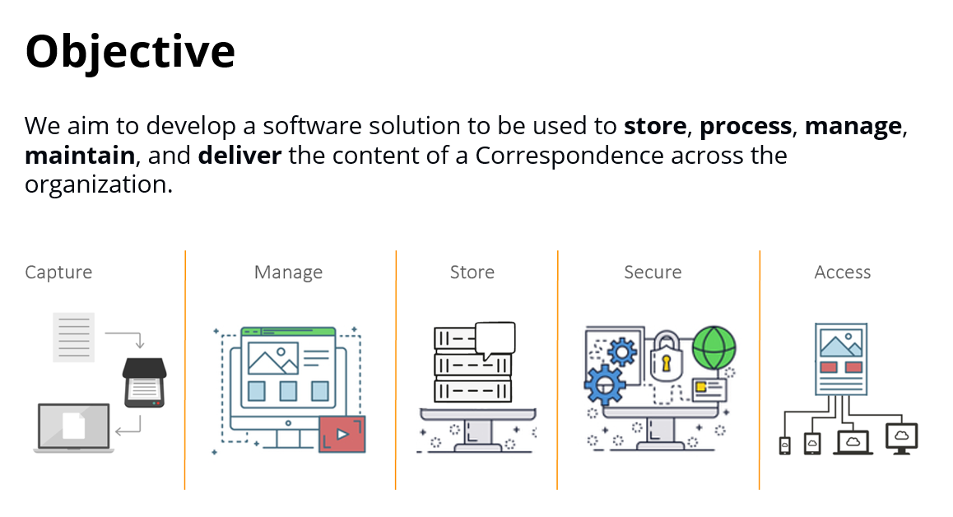](https://user-images.githubusercontent.com/54215462/218522252-7cebcea7-a9df-4e5f-9506-b2cb83ad47e4.png)[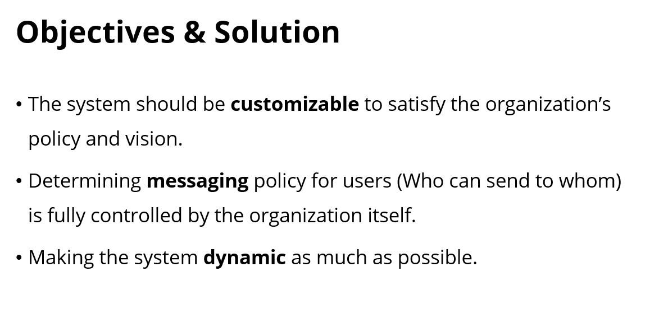](https://user-images.githubusercontent.com/54215462/218522291-045db91f-851a-40bb-b42b-187fede89fff.png)

1. **Project Overview**

The proposed File Correspondences Management System (FCMS) is designed to streamline document organization, upload, and search capabilities. Key features include:

* **File Categorization/Tagging**: Document upload, Custom tags, categories, and metadata.
* **File Search and Retrieval**: Full-text search, metadata filtering, and quick preview.
* **Version Control**: Track file changes and versions.
* **Security & Audit**: Role-based access control (RBAC), encryption, and secure storage.
* **Notifications and Alerts**: Real-time updates when files are uploaded or modified.
* **Local Storage** with automated backup and a local database
* **End-to-End Development** including UI, and deployment on the client’s local system.

1. **Core Features**
2. **Document Upload & Metadata Tagging**
   * Drag-and-drop file upload with mandatory project-based categorization.
   * Admin-configurable metadata fields (e.g., document type, author, date, status, custom tags).
   * Support for common file types (PDF, Word, Excel, images) with file size limits set by the admin.
3. **Advanced Search Functionality**
   * Search by project, document type, date range, author, status, or custom tags.
   * Admin-defined categories (e.g., department, client name) for granular filtering.
   * Basic keyword search within filenames and metadata (no full-text search).
4. **Local Storage & Backup**
   * Files stored on the client’s local system (server/PC).
   * Automated daily backups to a designated local drive.
5. **Admin Dashboard**
   * Create/update metadata fields and categories.
   * Manage user roles (admin, contributor, viewer) and permissions.
   * Monitor storage usage and backup status.
6. **Security & Audit**
   * Role-based access control (RBAC) to restrict document views/edits.

**Functional Features**

* User Login
* User Logout
* Archiving emails
* Pin / Unpin an Email
* Reply / forward / add new action to the currently clicked email
* Print the page as PDF
* Search (filter) Emails

1. **Inward Management**

* Import inwards seamlessly from emails, folders, or attach scanned copies for a digital and efficient process.
* Streamlined handling of internal and external communications with automated creation and processing of inwards.
* Supports various attachment formats, including PDFs, MS Office documents, images, and so on.
* Fosters collaborative inward processing with comments, approvals, reviews, and more with a streamlined and efficient workflow.
* Designated folders for various categories, facilitating efficient organization and visibility into the inward history for transparent processes.

1. **File Management:**

* Efficient creation of digital files from inwards with automated numbering and streamlined file routing processes.
* Ability to create drafts effortlessly using pre-designed templates for circulars, memos, and office notes.
* GUI based workflows to create and process drafts for review, approval, comments, and collaboration.
* Provision to track the movement history of drafts with detailed audit trails.
* Integrates with digital signatures for secured approvals.
* Maintains version history of documents.

1. **Dispatch Management:**

* Configurable dispatch rules based on predefined workflows and permissions.
* Integrates with email systems and other communication channels such as SMS for seamless communication within and across departments.
* Enables tracking within sections, departments and organization based on user permissions.
* Allows users to dispatch documents electronically, physically, and via email with

1. **Search and Retrieval:**

* Search documents based on various attributes such as document meta-data, tags, and content for enhanced search results.
* Enables searches using keywords, Boolean operators, multiple fields, exact phrases, and alpha-numeric criteria for versatile and precise retrieval.
* Advanced filters to refine results, allowing users to easily narrow down their searches based on specific criteria.
* Integrates with connected applications and other data sources for collective information retrieval

1. **Technical Platforms**

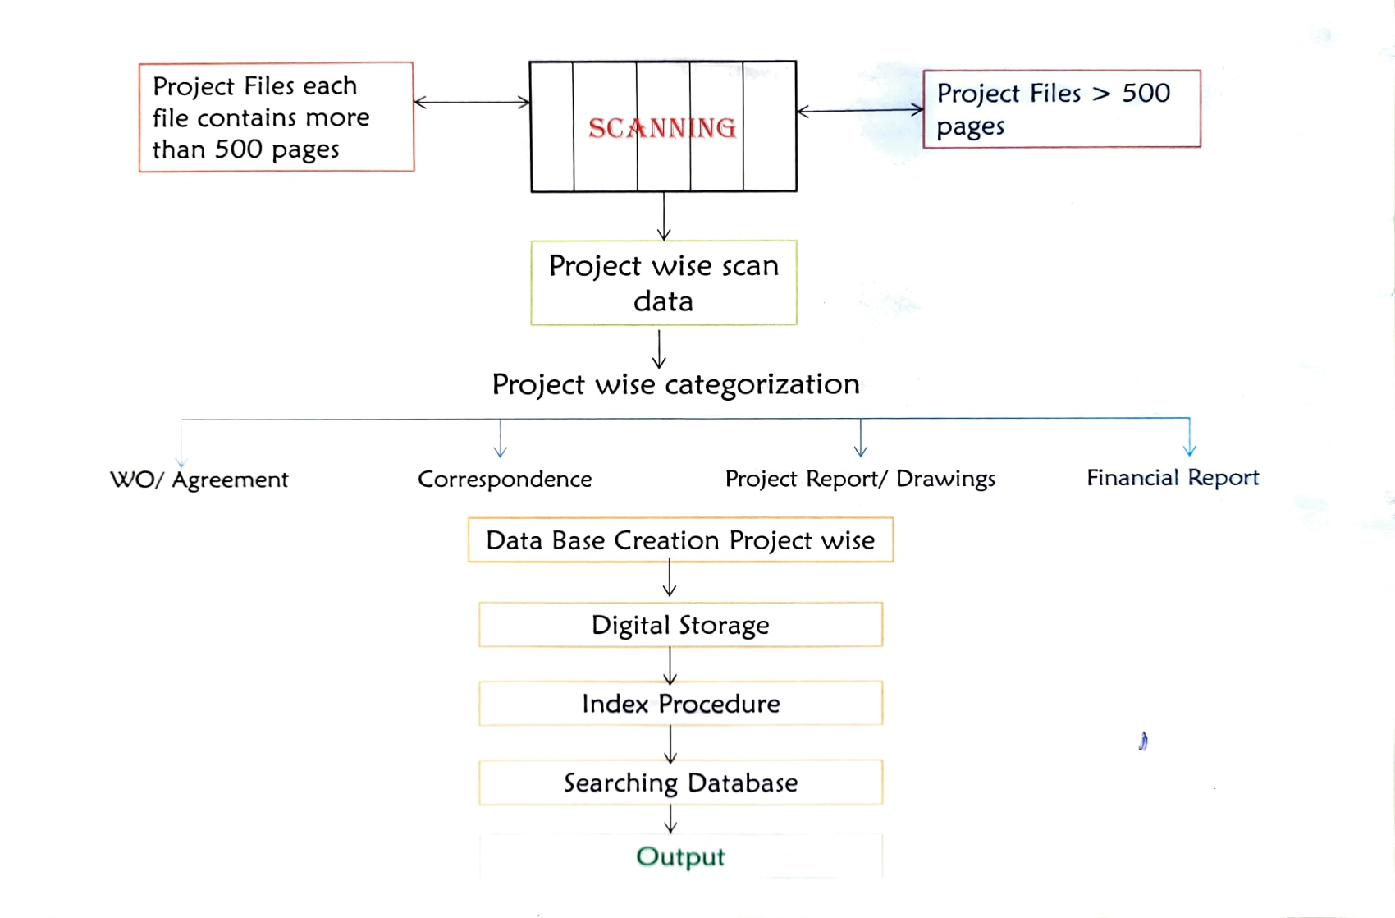

* **Database**: Local **Postgres** for metadata and user management.
* **Platform**: Desktop or web-based (depending on OS/hardware).
* **Backup**: Automated scripts for local backups; no cloud dependency.

### ****System Design****

* **Architecture**: Design the architecture of the system, which could involve:
  + **Database**: Define a relational or NoSQL database to store file metadata (name, date, category, etc.) and possibly the files themselves.
  + **File Storage**: Decide whether to store files on a server, cloud, or a hybrid system.
  + **Search Engine**: Choose or design a search engine for file indexing (e.g., Elasticsearch, Solr) that can efficiently search metadata and content within files.
* **User Interface**: Design an intuitive and accessible interface for users to upload, search, and manage files. Include:
  + Simple search bar with filters for metadata (date, sender, etc.)
  + File preview or quick view functionality.
  + Categories/tags for easier organization.
  + User dashboards showing recent activity or important files.
* **Security Features**: Implement user authentication (e.g., single sign-on, multi-factor authentication) and role-based access control (RBAC) for file management.

| 1. **Development Timeline excluding Deployment: 6 week** |  |  |
| --- | --- | --- |
|  |  |  |

1. **Cost Estimate**

| **Component** | **Cost Breakdown** |
| --- | --- |
| **Development** | (one-time) for end-to-end development. |
| **Local Hosting** | Client-provided hardware (no additional cost). |
| **Backup Storage** | Optional external drive. |
| **Maintenance** | for updates and support (optional). |

* 1. **Trade-offs of Local Storage**
* **Pros**: Full data control, no third-party dependencies, faster local access.
* **Cons**: No remote access without VPN, scalability limited by hardware, manual disaster recovery.
  1. **Scope Exclusions**
* No full-text search, OCR, or version control.
* No cloud integration or API support.
* Data migration from existing systems billed separately.