**CSE4002 - Mobile Application Development**

**LAB ASSIGNMENT -2**

**M.Sumana**

**19BCE7316**

**1.Design the following APP for the IOT store. The cost of Arduino Uno is 500RS, the cost of WIFI module is 250RS and the Bluetooth module is 150RS. Based clear is clicked clear all the Editboxes.**

**MainActivity.java**

package com.example.lab2;  
import androidx.appcompat.app.AppCompatActivity;  
import android.os.Bundle;  
import android.view.View;  
import android.widget.Button;  
import android.widget.EditText;  
  
  
public class MainActivity extends AppCompatActivity {  
 EditText t1, t2, t3, t4;  
  
 Button b1,b2;  
  
 @Override  
 protected void onCreate(Bundle savedInstanceState) {  
 super.onCreate(savedInstanceState);  
 setContentView(R.layout.*activity_main*);  
 t1 = findViewById(R.id.*uno*);  
 t2 = findViewById(R.id.*wifi*);  
 t3 = findViewById(R.id.*bluetooth*);  
 t4 = findViewById(R.id.*Total*);  
 b1 = findViewById(R.id.*submitButton*);  
 b2 = findViewById(R.id.*clearButton*);  
 b1.setOnClickListener(new View.OnClickListener()  
 {  
 @Override  
 public void onClick(View v)  
 {  
 int a = Integer.*parseInt*(t1.getText().toString());  
 int b = Integer.*parseInt*(t2.getText().toString());  
 int c = Integer.*parseInt*(t3.getText().toString());  
 int x = a*500;  
 int y = b*250;  
 int z = c*200;  
 int s = x+y+z;  
 t4.setText(String.*valueOf*(s));  
 }  
 });  
 b2.setOnClickListener(new View.OnClickListener()  
 {  
 @Override  
 public void onClick(View v)  
 {  
 t1.setText("");  
 t2.setText("");  
 t3.setText("");  
 t4.setText("");  
 }  
 });  
  
 }  
}

**activity_main.xml**

<?xml version="1.0" encoding="utf-8"?>  
<androidx.constraintlayout.widget.ConstraintLayout xmlns:android="http://schemas.android.com/apk/res/android"  
 xmlns:app="http://schemas.android.com/apk/res-auto"  
 xmlns:tools="http://schemas.android.com/tools"  
 android:layout_width="match_parent"  
 android:layout_height="match_parent"  
 tools:context=".MainActivity">  
  
 <EditText  
 android:id="@+id/bluetooth"  
 android:layout_width="128dp"  
 android:layout_height="wrap_content"  
 android:ems="10"  
 android:inputType="number"  
 app:layout_constraintBottom_toBottomOf="@+id/textView5"  
 app:layout_constraintStart_toStartOf="@+id/textView2" />  
  
 <EditText  
 android:id="@+id/Total"  
 android:layout_width="128dp"  
 android:layout_height="wrap_content"  
 android:layout_marginStart="12dp"  
 android:layout_marginLeft="12dp"  
 android:ems="10"  
 android:inputType="number"  
 app:layout_constraintBottom_toBottomOf="@+id/textView6"  
 app:layout_constraintStart_toEndOf="@+id/textView6" />  
  
 <EditText  
 android:id="@+id/wifi"  
 android:layout_width="128dp"  
 android:layout_height="wrap_content"  
 android:ems="10"  
 android:inputType="number"  
 app:layout_constraintBottom_toBottomOf="@+id/textView4"  
 app:layout_constraintStart_toStartOf="@+id/textView2" />  
  
 <TextView  
 android:id="@+id/textView"  
 android:layout_width="wrap_content"  
 android:layout_height="wrap_content"  
 android:layout_marginStart="64dp"  
 android:layout_marginLeft="64dp"  
 android:layout_marginTop="128dp"  
 android:text="Items"  
 android:textSize="24sp"  
 android:textStyle="bold"  
 app:layout_constraintStart_toStartOf="parent"  
 app:layout_constraintTop_toTopOf="parent" />  
  
 <TextView  
 android:id="@+id/textView2"  
 android:layout_width="wrap_content"  
 android:layout_height="wrap_content"  
 android:layout_marginStart="96dp"  
 android:layout_marginLeft="96dp"  
 android:layout_marginTop="128dp"  
 android:text="Quantity"  
 android:textSize="24sp"  
 android:textStyle="bold"  
 app:layout_constraintStart_toEndOf="@+id/textView"  
 app:layout_constraintTop_toTopOf="parent" />  
  
 <TextView  
 android:id="@+id/textView3"  
 android:layout_width="wrap_content"  
 android:layout_height="wrap_content"  
 android:layout_marginTop="32dp"  
 android:text="Arduino Uno"  
 android:textSize="24sp"  
 android:textStyle="bold"  
 app:layout_constraintStart_toStartOf="@+id/textView"  
 app:layout_constraintTop_toBottomOf="@+id/textView" />  
  
 <TextView  
 android:id="@+id/textView4"  
 android:layout_width="wrap_content"  
 android:layout_height="wrap_content"  
 android:layout_marginTop="16dp"  
 android:text="Wifi Module"  
 android:textSize="24sp"  
 android:textStyle="bold"  
 app:layout_constraintStart_toStartOf="@+id/textView3"  
 app:layout_constraintTop_toBottomOf="@+id/textView3" />  
  
 <TextView  
 android:id="@+id/textView5"  
 android:layout_width="wrap_content"  
 android:layout_height="wrap_content"  
 android:layout_marginTop="16dp"  
 android:text="Bluetooth"  
 android:textSize="24sp"  
 android:textStyle="bold"  
 app:layout_constraintStart_toStartOf="@+id/textView4"  
 app:layout_constraintTop_toBottomOf="@+id/textView4" />  
  
 <TextView  
 android:id="@+id/textView6"  
 android:layout_width="wrap_content"  
 android:layout_height="wrap_content"  
 android:layout_marginTop="28dp"  
 android:text="Amount Payable"  
 android:textSize="24sp"  
 android:textStyle="bold"  
 app:layout_constraintStart_toStartOf="@+id/submitButton"  
 app:layout_constraintTop_toBottomOf="@+id/submitButton" />  
  
 <EditText  
 android:id="@+id/uno"  
 android:layout_width="128dp"  
 android:layout_height="wrap_content"  
 android:ems="10"  
 android:inputType="number"  
 app:layout_constraintBottom_toBottomOf="@+id/textView3"  
 app:layout_constraintStart_toStartOf="@+id/textView2" />  
  
 <Button  
 android:id="@+id/submitButton"  
 android:layout_width="wrap_content"  
 android:layout_height="wrap_content"  
 android:layout_marginTop="20dp"  
 android:text="Submit"  
 app:layout_constraintStart_toStartOf="@+id/textView5"  
 app:layout_constraintTop_toBottomOf="@+id/textView5" />  
  
 <Button  
 android:id="@+id/clearButton"  
 android:layout_width="wrap_content"  
 android:layout_height="wrap_content"  
 android:layout_marginStart="13dp"  
 android:layout_marginLeft="13dp"  
 android:text="Clear"  
 app:layout_constraintBottom_toBottomOf="@+id/submitButton"  
 app:layout_constraintStart_toEndOf="@+id/submitButton" />  
</androidx.constraintlayout.widget.ConstraintLayout>

**OUTPUT:**

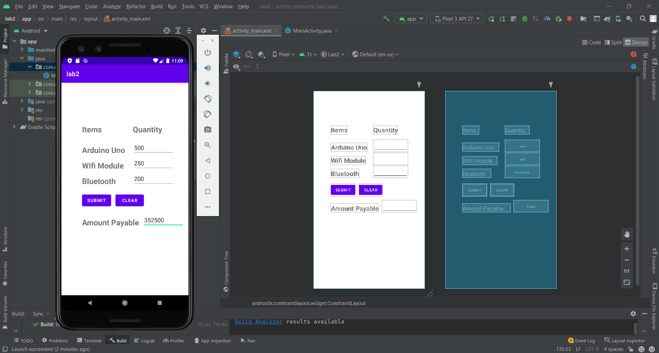

**2.Design a Currency converter App. 1 RS=**

**CURRENCY CONVERTER**

**MainActivity.java:**

package com.example.lab2;  
  
import androidx.appcompat.app.AppCompatActivity;  
  
import android.os.Bundle;  
import android.view.View;  
import android.widget.Button;  
import android.widget.EditText;  
import android.widget.RadioButton;  
import android.widget.RadioGroup;  
  
public class MainActivity extends AppCompatActivity {  
 EditText t1, t2;  
 RadioGroup rg;  
 RadioButton rb;  
 Button b;  
 @Override  
 protected void onCreate(Bundle savedInstanceState) {  
 super.onCreate(savedInstanceState);  
 setContentView(R.layout.*activity_main*);  
 t1 = findViewById(R.id.*input*);  
 t2 = findViewById(R.id.*result*);  
 rg = findViewById(R.id.*radioGroup*);  
 b = findViewById(R.id.*convertButton*);  
 b.setOnClickListener(new View.OnClickListener() {  
 @Override  
 public void onClick(View v) {  
 int radioId = rg.getCheckedRadioButtonId();  
 rb = findViewById(radioId);  
 float rs = Float.*parseFloat*(t1.getText().toString());  
 String str = rb.getText().toString();  
  
 if(str.equals("USD"))  
 t2.setText(String.*valueOf*(rs*14/1000));  
 else if(str.equals("EURO"))  
 t2.setText(String.*valueOf*(rs*11/1000));  
 else if(str.equals("YEN"))  
 t2.setText(String.*valueOf*(rs*148/100));  
 else  
 t2.setText("");  
  
 }  
 });  
 }  
}

**activity_main.xml:**

<?xml version="1.0" encoding="utf-8"?>  
<androidx.constraintlayout.widget.ConstraintLayout xmlns:android="http://schemas.android.com/apk/res/android"  
 xmlns:app="http://schemas.android.com/apk/res-auto"  
 xmlns:tools="http://schemas.android.com/tools"  
 android:layout_width="match_parent"  
 android:layout_height="match_parent"  
 tools:context=".MainActivity">  
  
 <TextView  
 android:id="@+id/textView"  
 android:layout_width="wrap_content"  
 android:layout_height="wrap_content"  
 android:layout_marginTop="48dp"  
 android:text=" CURRENCY \n CONVERTER"  
 android:textAllCaps="false"  
 android:textSize="36sp"  
 android:textStyle="bold|italic"  
 app:layout_constraintEnd_toEndOf="parent"  
 app:layout_constraintStart_toStartOf="parent"  
 app:layout_constraintTop_toTopOf="parent" />  
  
 <EditText  
 android:id="@+id/input"  
 android:layout_width="wrap_content"  
 android:layout_height="wrap_content"  
 android:layout_marginTop="32dp"  
 android:ems="10"  
 android:hint="in rs"  
 android:inputType="number|textPersonName"  
 app:layout_constraintEnd_toEndOf="parent"  
 app:layout_constraintStart_toStartOf="parent"  
 app:layout_constraintTop_toBottomOf="@+id/textView" />  
  
 <RadioGroup  
 android:id="@+id/radioGroup"  
 android:layout_width="128dp"  
 android:layout_height="wrap_content"  
 android:layout_marginTop="16dp"  
 android:checkedButton="@id/usdButton"  
 app:layout_constraintStart_toStartOf="@+id/input"  
 app:layout_constraintTop_toBottomOf="@+id/input">  
  
 <RadioButton  
 android:id="@+id/usdButton"  
 android:layout_width="match_parent"  
 android:layout_height="wrap_content"  
 android:text="USD" />  
  
 <RadioButton  
 android:id="@+id/euroButton"  
 android:layout_width="match_parent"  
 android:layout_height="wrap_content"  
 android:text="EURO" />  
  
 <RadioButton  
 android:id="@+id/yenButton"  
 android:layout_width="match_parent"  
 android:layout_height="wrap_content"  
 android:text="YEN" />  
 </RadioGroup>  
  
 <Button  
 android:id="@+id/convertButton"  
 android:layout_width="200dp"  
 android:layout_height="wrap_content"  
 android:layout_marginTop="16dp"  
 android:text="CONVERT"  
 app:layout_constraintStart_toStartOf="@+id/input"  
 app:layout_constraintTop_toBottomOf="@+id/radioGroup" />  
  
 <EditText  
 android:id="@+id/result"  
 android:layout_width="wrap_content"  
 android:layout_height="wrap_content"  
 android:layout_marginTop="16dp"  
 android:ems="10"  
 android:inputType="number|textPersonName"  
 app:layout_constraintStart_toStartOf="@+id/convertButton"  
 app:layout_constraintTop_toBottomOf="@+id/convertButton" />  
</androidx.constraintlayout.widget.ConstraintLayout>

OUTPUT:

