**CSE4002 - Mobile Application Development**

**LAB ASSIGNMENT -10**

**M.SUMANA**

**19BCE7316**

**1. Design an App Activity that finds the distance between Guntur to Chennai. When the image buttons car is clicked then the time 7hrs should display in the textfield1, when bike is clicked 9hrs should display in second textfield, when train image button is presses 6hrs should display and when run image button is presses then 40hrs should display in fouth textfiled. When the arrow button is clicked, the editText should be swapped.**

**MainActivity.java**

package com.example.lab10;  
  
import androidx.annotation.IdRes;  
import androidx.appcompat.app.AppCompatActivity;  
  
import android.annotation.SuppressLint;  
import android.os.Bundle;  
import android.view.View;  
import android.widget.EditText;  
import android.widget.ImageButton;  
import android.widget.Toast;  
  
import com.google.android.material.chip.Chip;  
import com.google.android.material.chip.ChipGroup;  
  
public class MainActivity extends AppCompatActivity {  
 EditText start,end,car,bike,train,walk;  
 ImageButton reverse;  
 @Override  
 protected void onCreate(Bundle savedInstanceState) {  
 super.onCreate(savedInstanceState);  
 setContentView(R.layout.*activity_main*);  
 start = findViewById(R.id.*editTextTextPersonName*);  
 end = findViewById(R.id.*editTextTextPersonName2*);  
 car = findViewById(R.id.*editTextTextPersonName3*);  
 bike = findViewById(R.id.*editTextTextPersonName4*);  
 train = findViewById(R.id.*editTextTextPersonName5*);  
 walk = findViewById(R.id.*editTextTextPersonName6*);  
 reverse = findViewById(R.id.*imageButton*);  
 ChipGroup chipGroup = findViewById(R.id.*chipGroup*);  
  
 chipGroup.setOnCheckedChangeListener(new ChipGroup.OnCheckedChangeListener() {  
 @SuppressLint("SetTextI18n")  
 @Override  
 public void onCheckedChanged(ChipGroup chipGroup, int i) {  
 car.setText("");bike.setText("");train.setText("");walk.setText("");  
 Chip chip = chipGroup.findViewById(i);  
 if (chip != null) {  
 switch(i){  
 case 1: car.setText("7 hrs");  
 break;  
 case 2: bike.setText("9 hrs");  
 break;  
 case 3: train.setText("6 hrs");  
 break;  
 case 4: walk.setText("40 hrs");  
 break;  
 }  
 }  
 }  
  
 });  
  
 reverse.setOnClickListener(new View.OnClickListener() {  
 @Override  
 public void onClick(View v) {  
 String temp = start.getText().toString();  
 String temp1 = end.getText().toString();  
 if(!temp.isEmpty() && !temp1.isEmpty()){  
 start.setText(temp1);  
 end.setText(temp);  
 }  
 else{  
 Toast.*makeText*(getApplicationContext(), "Enter start and end point", Toast.*LENGTH_SHORT*).show();  
 }  
 }  
 });  
 }  
}

**Activity_main.xml**

<?xml version="1.0" encoding="utf-8"?>  
<androidx.constraintlayout.widget.ConstraintLayout xmlns:android="http://schemas.android.com/apk/res/android"  
 xmlns:app="http://schemas.android.com/apk/res-auto"  
 xmlns:tools="http://schemas.android.com/tools"  
 android:layout_width="match_parent"  
 android:layout_height="match_parent"  
 android:orientation="vertical"  
 tools:context=".MainActivity">  
  
 <com.google.android.material.chip.ChipGroup  
 android:id="@+id/chipGroup"  
 android:layout_width="337dp"  
 android:layout_height="45dp"  
 android:layout_marginTop="20dp"  
 app:layout_constraintEnd_toEndOf="parent"  
 app:layout_constraintHorizontal_bias="0.531"  
 app:layout_constraintStart_toStartOf="parent"  
 app:layout_constraintTop_toBottomOf="@+id/editTextTextPersonName2"  
 app:singleSelection="true">  
  
 <com.google.android.material.chip.Chip  
 style="@style/Widget.MaterialComponents.Chip.Choice"  
 android:layout_width="78dp"  
 android:layout_height="wrap_content"  
 android:checkable="true"  
 android:textAllCaps="false"  
 app:checkedIconVisible="true"  
 app:chipIcon="@drawable/car"  
 app:chipIconVisible="true"  
 app:closeIconVisible="false" />  
  
 <com.google.android.material.chip.Chip  
 style="@style/Widget.MaterialComponents.Chip.Choice"  
 android:layout_width="78dp"  
 android:layout_height="wrap_content"  
 android:checkable="true"  
 app:chipIcon="@drawable/bike"  
 app:chipIconVisible="true" />  
  
 <com.google.android.material.chip.Chip  
 style="@style/Widget.MaterialComponents.Chip.Choice"  
 android:layout_width="78dp"  
 android:layout_height="wrap_content"  
 android:checkable="true"  
 app:chipIcon="@drawable/train"  
 app:chipIconVisible="true" />  
  
 <com.google.android.material.chip.Chip  
 style="@style/Widget.MaterialComponents.Chip.Choice"  
 android:layout_width="78dp"  
 android:layout_height="wrap_content"  
 android:checkable="true"  
 app:chipIcon="@drawable/walk"  
 app:chipIconVisible="true" />  
  
 </com.google.android.material.chip.ChipGroup>  
  
 <ImageView  
 android:id="@+id/imageView1"  
 android:layout_width="32dp"  
 android:layout_height="32dp"  
 android:layout_marginStart="48dp"  
 android:layout_marginLeft="48dp"  
 android:layout_marginTop="28dp"  
 app:layout_constraintStart_toStartOf="parent"  
 app:layout_constraintTop_toTopOf="parent"  
 app:srcCompat="@drawable/gps" />  
  
 <ImageView  
 android:id="@+id/imageView2"  
 android:layout_width="52dp"  
 android:layout_height="67dp"  
 android:layout_marginStart="8dp"  
 android:layout_marginTop="68dp"  
 app:layout_constraintStart_toStartOf="@+id/imageView1"  
 app:layout_constraintTop_toBottomOf="@+id/imageView1"  
 app:srcCompat="@drawable/location" />  
  
  
 <EditText  
 android:id="@+id/editTextTextPersonName"  
 android:layout_width="wrap_content"  
 android:layout_height="wrap_content"  
 android:layout_marginStart="20dp"  
 android:ems="10"  
 android:hint="STARTING POINT"  
 android:inputType="textPersonName"  
 app:layout_constraintStart_toEndOf="@+id/imageView1"  
 app:layout_constraintTop_toTopOf="@+id/imageView1" />  
  
 <EditText  
 android:id="@+id/editTextTextPersonName2"  
 android:layout_width="wrap_content"  
 android:layout_height="wrap_content"  
 android:layout_marginStart="24dp"  
 android:layout_marginTop="4dp"  
 android:ems="10"  
 android:hint="END POINT"  
 android:inputType="textPersonName"  
 app:layout_constraintStart_toStartOf="@+id/editTextTextPersonName"  
 app:layout_constraintTop_toTopOf="@+id/imageView2" />  
  
 <ImageButton  
 android:id="@+id/imageButton"  
 android:layout_width="32dp"  
 android:layout_height="32dp"  
 android:layout_marginStart="4dp"  
 android:layout_marginLeft="4dp"  
 android:layout_marginTop="4dp"  
 app:layout_constraintStart_toStartOf="@+id/imageView3"  
 app:layout_constraintTop_toTopOf="@+id/editTextTextPersonName2"  
 app:srcCompat="@drawable/arrows" />  
  
 <LinearLayout  
 android:layout_width="0dp"  
 android:layout_height="50dp"  
 android:orientation="horizontal"  
 app:layout_constraintEnd_toEndOf="@+id/chipGroup"  
 app:layout_constraintHorizontal_bias="0.0"  
 app:layout_constraintStart_toStartOf="@+id/chipGroup"  
 app:layout_constraintTop_toBottomOf="@+id/chipGroup">  
  
 <EditText  
 android:id="@+id/editTextTextPersonName3"  
 android:layout_width="wrap_content"  
 android:layout_height="wrap_content"  
 android:layout_weight="1"  
 android:ems="10"  
 android:inputType="textPersonName" />  
  
 <EditText  
 android:id="@+id/editTextTextPersonName4"  
 android:layout_width="wrap_content"  
 android:layout_height="wrap_content"  
 android:layout_weight="1"  
 android:ems="10"  
 android:inputType="textPersonName" />  
  
 <EditText  
 android:id="@+id/editTextTextPersonName5"  
 android:layout_width="wrap_content"  
 android:layout_height="wrap_content"  
 android:layout_weight="1"  
 android:ems="10"  
 android:inputType="textPersonName" />  
  
 <EditText  
 android:id="@+id/editTextTextPersonName6"  
 android:layout_width="wrap_content"  
 android:layout_height="wrap_content"  
 android:layout_weight="1"  
 android:ems="10"  
 android:inputType="textPersonName" />  
 </LinearLayout>  
  
</androidx.constraintlayout.widget.ConstraintLayout>

**Output:**

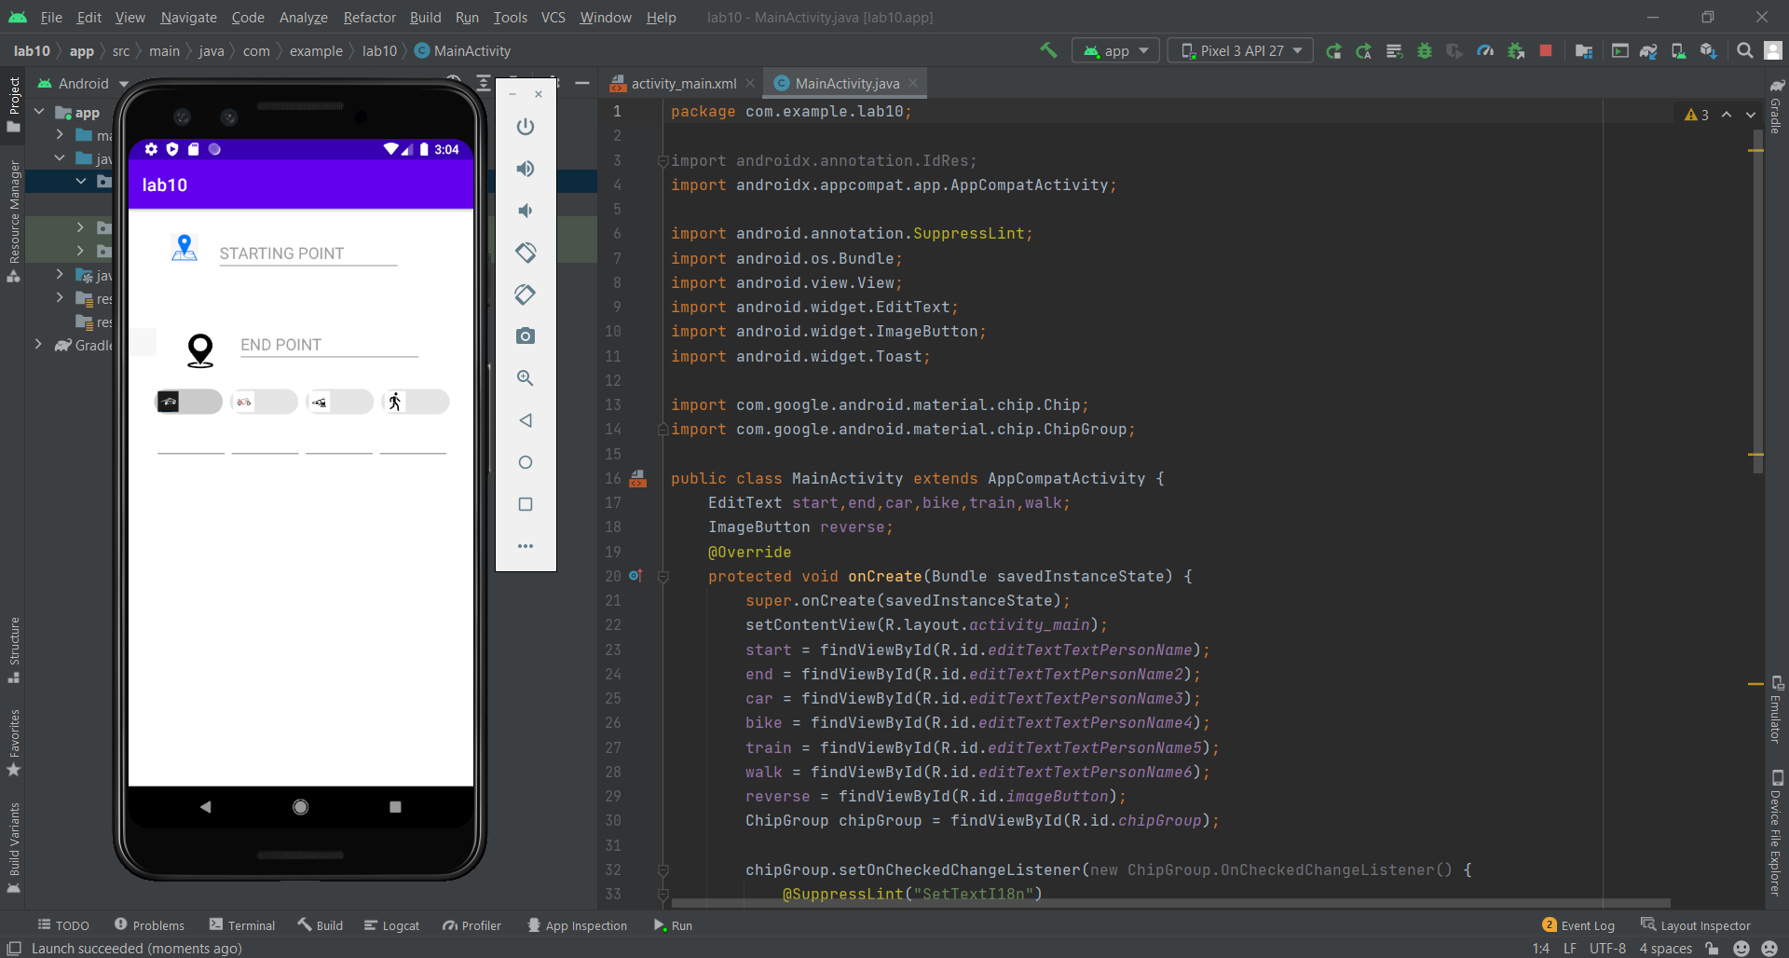

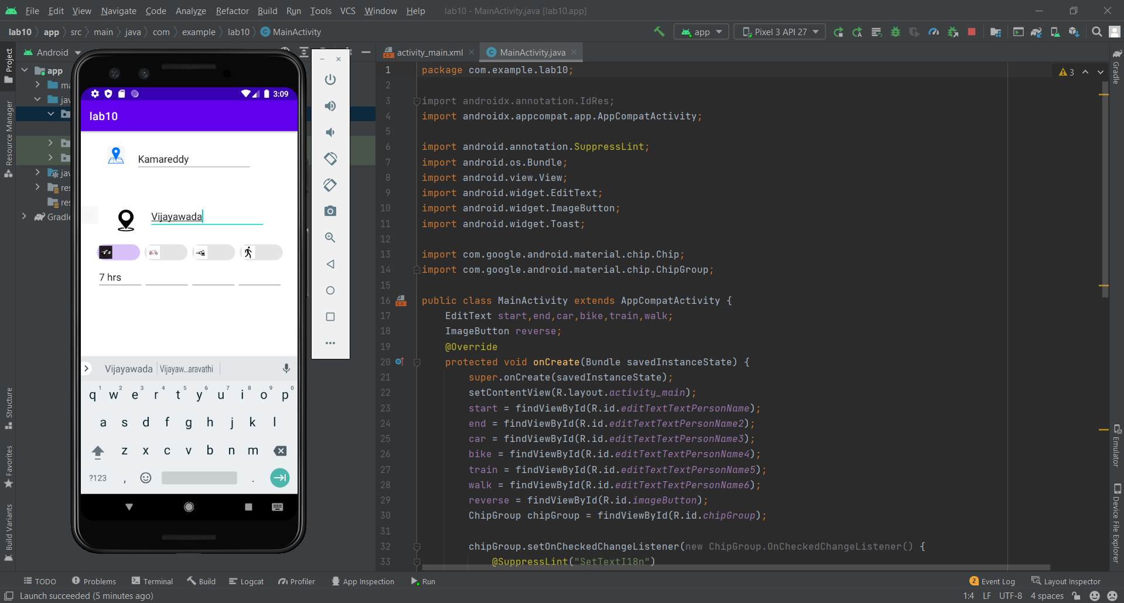

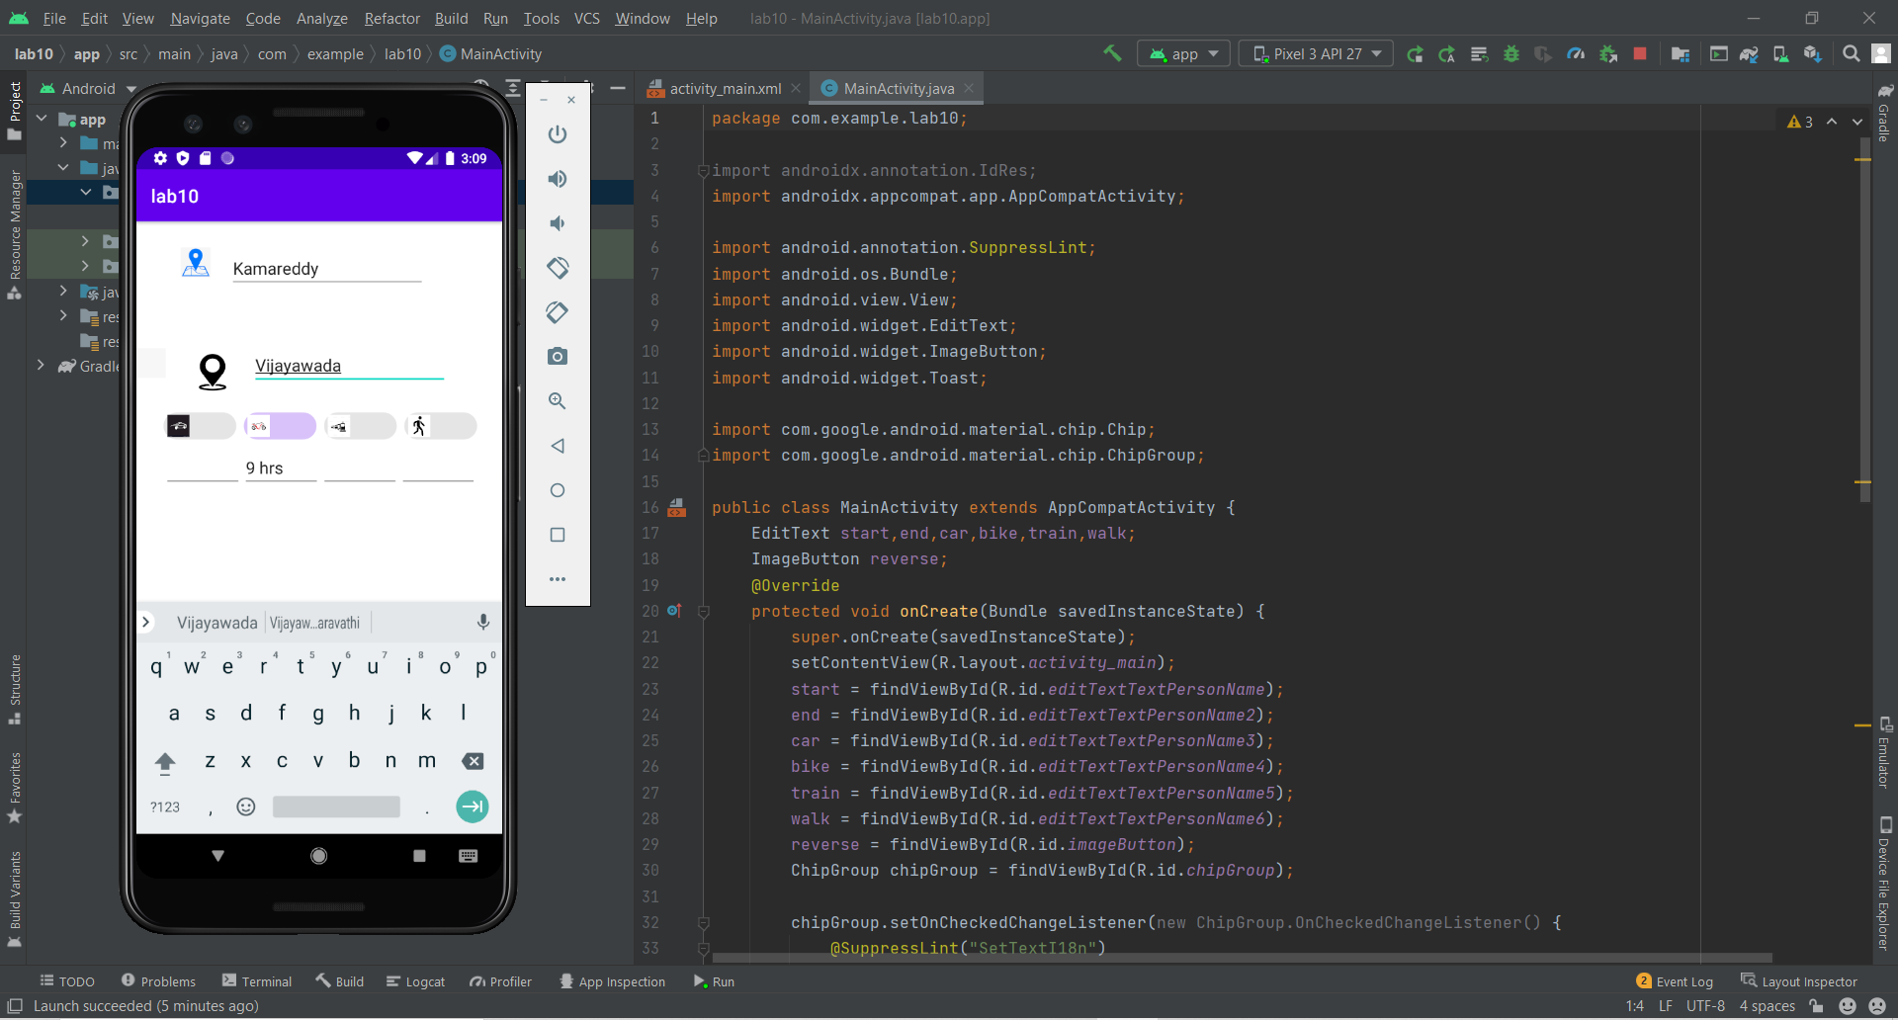

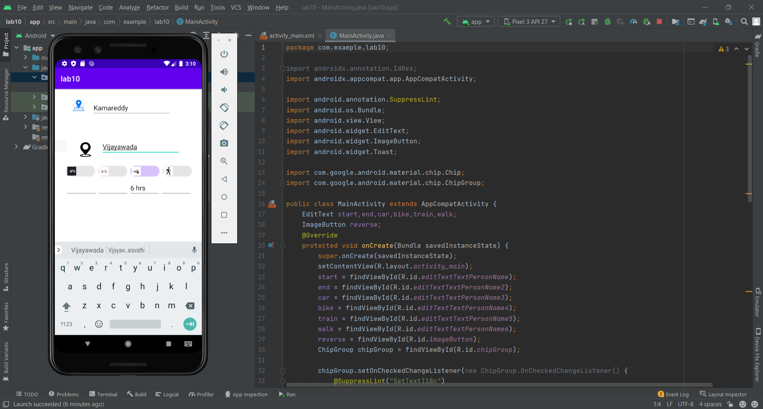

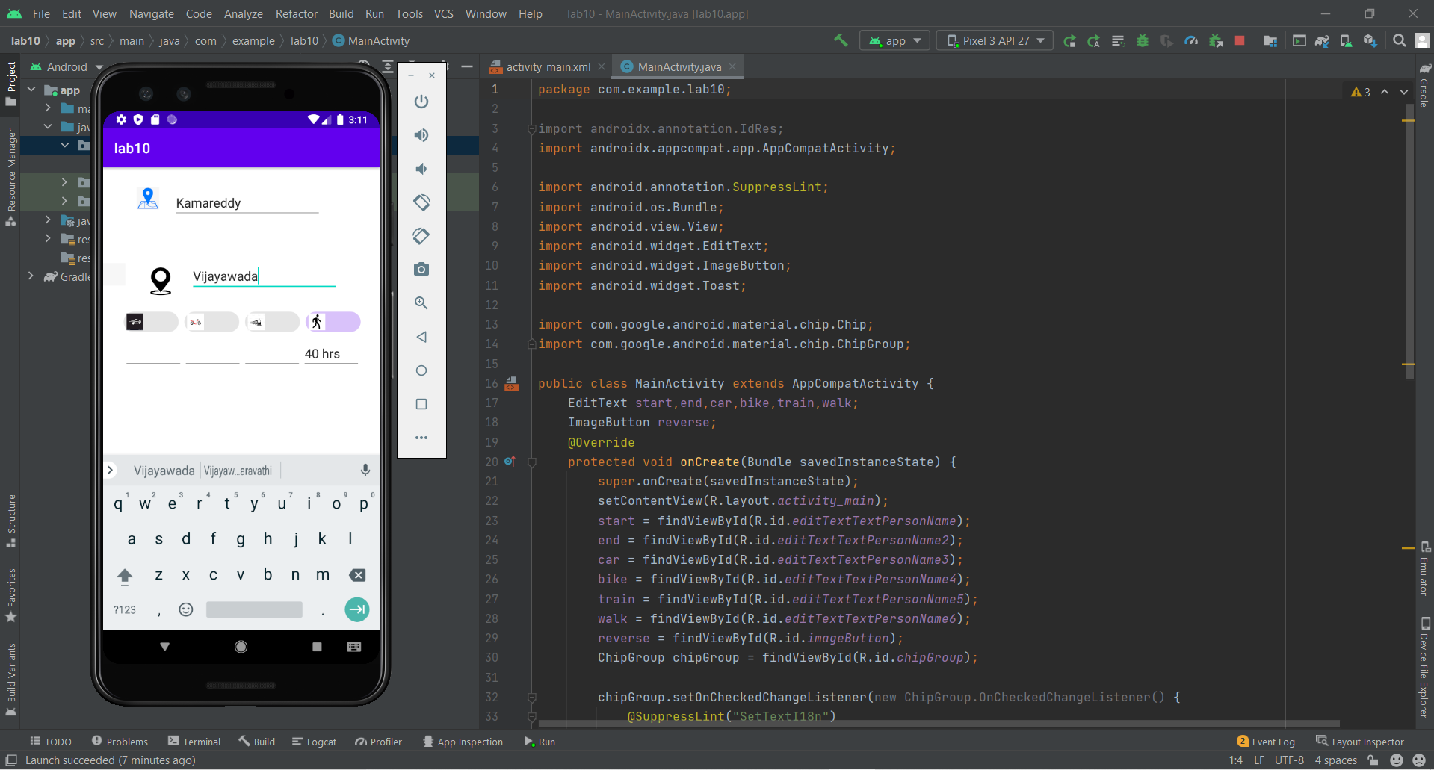

**2. Design an Application that reads a random number between 1 to 6 whenever the user clicks Roll Dice. Do this for both the user. When the Winner button is pressed, the user whose number is greater will be identified and raise an Alert notification indicating whether user1 or user2 is the winner.**

**MainActivity.java**

package com.example.lab10;  
import androidx.appcompat.app.AppCompatActivity;  
import android.os.Bundle;  
import android.view.View;  
import android.widget.Button;  
import android.widget.EditText;  
import android.widget.TextView;  
import android.widget.Toast;  
  
import java.text.BreakIterator;  
import java.util.Random;  
public class MainActivity extends AppCompatActivity { public static TextView *d1*, *d2*, *result*;  
  
 //  
 public static Button *b1*, *b2*; //EditText winner;  
 public static int *v1*, *v2*;  
 @Override  
 protected void onCreate(Bundle savedInstanceState) {  
 super.onCreate(savedInstanceState);  
 setContentView(R.layout.*activity_main*);  
 *d1* = findViewById(R.id.*d1*);  
 *d2* = findViewById(R.id.*d2*);  
 *b1* = findViewById(R.id.*b1*);  
 *b2* = findViewById(R.id.*b2*);  
 *b1*.setOnClickListener(new View.OnClickListener() {  
 @Override  
 public void onClick(View view) {  
 Random r = new Random();  
 *v1* = r.nextInt(5) + 1;  
 *d1*.setText(Integer.*toString*(*v1*));  
 BreakIterator winner = null;  
 winner.setText("User-2 is winner");  
 }  
 }  
 );  
 *b2*.setOnClickListener(new View.OnClickListener() {  
 @Override  
 public void onClick(View view) {  
 Random r = new Random();  
 *v2* = r.nextInt(5) + 1;  
 *d2*.setText(Integer.*toString*(*v2*));  
 if (*v1* > *v2*) {  
 Toast.*makeText*(getApplicationContext(), "User-1 is winner", Toast.*LENGTH_LONG*).show();  
// result.setText("User-1 is winner");  
 } else if (*v1* < *v2*) {  
// result.setText("User-2 is winner");  
 Toast.*makeText*(getApplicationContext(), "User-2 is winner", Toast.*LENGTH_LONG*).show();  
 } else {  
// result.setText("Draw");  
 Toast.*makeText*(getApplicationContext(), "Draw", Toast.*LENGTH_LONG*).show();  
 }  
 }  
 });  
 }  
 }

**Activity_main.xml**

<?xml version="1.0" encoding="utf-8"?> <androidx.constraintlayout.widget.ConstraintLayout xmlns:android="http://schemas.android.com/apk/res/android"  
 xmlns:app="http://schemas.android.com/apk/res-auto"  
 xmlns:tools="http://schemas.android.com/tools"  
 android:layout_width="match_parent"  
 android:layout_height="match_parent"  
 tools:context=".MainActivity">  
 <TextView  
 android:id="@+id/d1"  
 android:layout_width="78dp"  
 android:layout_height="50dp"  
 android:textSize="40dp"  
 app:layout_constraintBottom_toBottomOf="parent"  
 app:layout_constraintEnd_toEndOf="parent"  
 app:layout_constraintHorizontal_bias="0.546"  
 app:layout_constraintStart_toStartOf="parent"  
 app:layout_constraintTop_toTopOf="parent"  
 app:layout_constraintVertical_bias="0.099" />  
 <TextView  
 android:id="@+id/d2"  
 android:layout_width="89dp"  
 android:layout_height="50dp"  
 android:textSize="40dp"  
 app:layout_constraintBottom_toBottomOf="parent"  
 app:layout_constraintEnd_toEndOf="parent"  
 app:layout_constraintHorizontal_bias="0.565"  
 app:layout_constraintStart_toStartOf="parent"  
 app:layout_constraintTop_toTopOf="parent"  
 app:layout_constraintVertical_bias="0.378" />  
 <Button  
 android:id="@+id/b1"  
 android:layout_width="246dp"  
  
  
 android:layout_height="48dp"  
 android:text="roll Dice user-1"  
 app:layout_constraintBottom_toBottomOf="parent"  
 app:layout_constraintEnd_toEndOf="parent"  
 app:layout_constraintStart_toStartOf="parent"  
 app:layout_constraintTop_toTopOf="parent"  
 app:layout_constraintVertical_bias="0.222" />  
 <Button  
 android:id="@+id/b2"  
 android:layout_width="252dp"  
 android:layout_height="48dp"  
 android:text="roll Dice user-2"  
 app:layout_constraintBottom_toBottomOf="parent"  
 app:layout_constraintEnd_toEndOf="parent"  
 app:layout_constraintStart_toStartOf="parent"  
 app:layout_constraintTop_toTopOf="parent"  
 app:layout_constraintVertical_bias="0.518" />  
 <TextView  
 android:id="@+id/result"  
 android:layout_width="196dp"  
 android:layout_height="77dp"  
 app:layout_constraintBottom_toBottomOf="parent"  
 app:layout_constraintEnd_toEndOf="parent"  
 app:layout_constraintHorizontal_bias="0.602"  
 app:layout_constraintStart_toStartOf="parent"  
 app:layout_constraintTop_toTopOf="parent"  
 app:layout_constraintVertical_bias="0.798" />  
</androidx.constraintlayout.widget.ConstraintLayout>

**Output:**

