**CSE4002 - Mobile Application Development**

**LAB ASSIGNMENT -8**

**SUMANA MUPPARAPU**

**19BCE7316**

**Design an app that creates dynamic adding and removing of chip buttons.**

**MainActivity.java**

package com.example.lab8;  
  
import androidx.appcompat.app.AppCompatActivity;  
  
import android.os.Bundle;  
import android.view.View;  
import android.widget.Button;  
  
import com.google.android.material.chip.Chip;  
import com.google.android.material.chip.ChipGroup;  
  
public class MainActivity extends AppCompatActivity {  
 Button b1,b2;  
 ChipGroup c;  
  
 @Override  
 protected void onCreate(Bundle savedInstanceState) {  
 super.onCreate(savedInstanceState);  
 setContentView(R.layout.*activity_main*);  
  
 b1 = findViewById(R.id.*b1*);  
 b2 = findViewById(R.id.*b2*);  
 c = findViewById(R.id.*chipgr*);  
 b1.setOnClickListener(new View.OnClickListener() {  
 @Override  
 public void onClick(View v) {  
 Chip chip = new Chip(MainActivity.this);  
 chip.setCloseIconVisible(true);  
 c.addView(chip);  
 chip.setOnCloseIconClickListener(new View.OnClickListener() {  
 @Override  
 public void onClick(View v) {  
 c.removeView(chip);  
 }  
 });  
 b2.setOnClickListener(new View.OnClickListener() {  
 @Override  
 public void onClick(View v) {  
 c.removeView(chip);  
 }  
 });  
 }  
 });  
 }  
}

<?xml version="1.0" encoding="utf-8"?>  
<androidx.constraintlayout.widget.ConstraintLayout xmlns:android="http://schemas.android.com/apk/res/android"  
 xmlns:app="http://schemas.android.com/apk/res-auto"  
 xmlns:tools="http://schemas.android.com/tools"  
 android:layout_width="match_parent"  
 android:layout_height="match_parent"  
 tools:context=".MainActivity">  
  
 <Button  
 android:id="@+id/b1"  
 android:layout_width="wrap_content"  
 android:layout_height="wrap_content"  
 android:layout_marginStart="75dp"  
 android:layout_marginBottom="137dp"  
 android:text="create"  
 app:layout_constraintBottom_toBottomOf="parent"  
 app:layout_constraintStart_toStartOf="parent" />  
  
 <Button  
 android:id="@+id/b2"  
 android:layout_width="wrap_content"  
 android:layout_height="wrap_content"  
 android:layout_marginEnd="59dp"  
 android:text="delete"  
 app:layout_constraintBottom_toBottomOf="@+id/b1"  
 app:layout_constraintEnd_toEndOf="parent"  
 app:layout_constraintTop_toTopOf="@+id/b1" />  
  
 <com.google.android.material.chip.ChipGroup  
 android:id="@+id/chipgr"  
 android:layout_width="332dp"  
 android:layout_height="415dp"  
 android:layout_marginStart="44dp"  
 android:layout_marginTop="88dp"  
 app:layout_constraintStart_toStartOf="parent"  
 app:layout_constraintTop_toTopOf="parent">  
  
 </com.google.android.material.chip.ChipGroup>  
</androidx.constraintlayout.widget.ConstraintLayout>

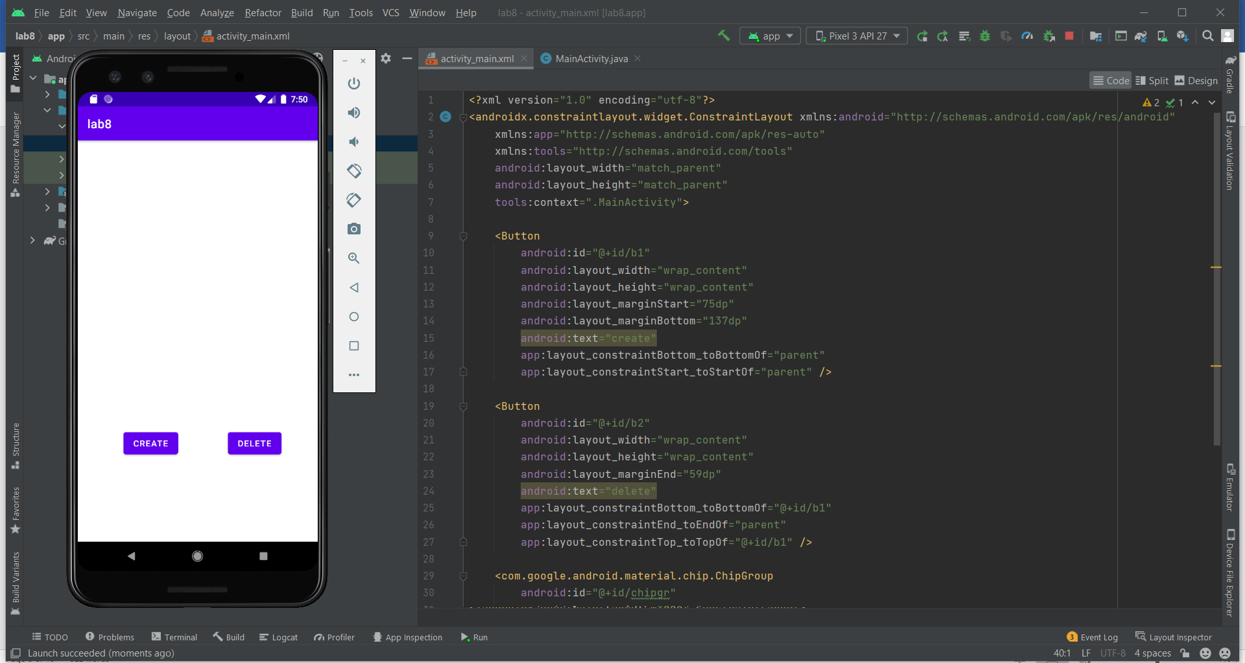

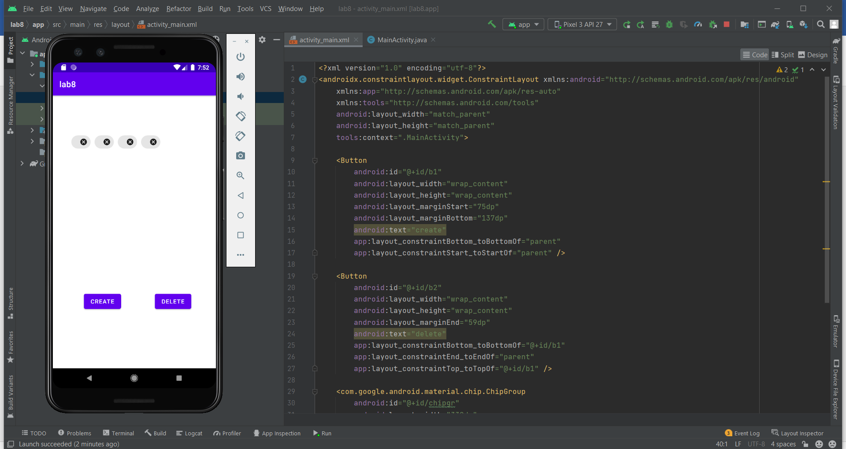

**Design an App for the Gmail header. Whenever the user enters an email in the “To“ section create a chip button with photo and the email. It should also contain close button to remove the chip button.**

**MainActivity.java**

package com.example.lab8_2;  
  
import androidx.annotation.DrawableRes;  
import androidx.appcompat.app.AppCompatActivity;  
  
import android.os.Bundle;  
import android.view.View;  
import android.widget.Button;  
import android.widget.EditText;  
import android.widget.Toast;  
  
import com.google.android.material.chip.Chip;  
import com.google.android.material.chip.ChipGroup;  
  
public class MainActivity extends AppCompatActivity {  
 Button b1;  
 EditText e1,e2,e3,e4;  
 private ChipGroup c;  
  
 @Override  
 protected void onCreate(Bundle savedInstanceState) {  
 super.onCreate(savedInstanceState);  
 setContentView(R.layout.*activity_main*);  
 b1 = findViewById(R.id.*b*);  
 e1 = findViewById(R.id.*from*);  
 e2 = findViewById(R.id.*to*);  
 e3 = findViewById(R.id.*msg*);  
 e4 = findViewById(R.id.*subject*);  
 c = findViewById(R.id.*chipgr*);  
  
 b1.setOnClickListener(new View.OnClickListener() {  
 @Override  
 public void onClick(View v) {  
 Chip chip = new Chip(MainActivity.this);  
 c.addView(chip);  
 chip.setText(e2.getText());  
 chip.setChipIcon(getDrawable(R.drawable.*user*));  
 e2.setText(null);  
 chip.setCloseIconVisible(true);  
  
 chip.setOnCloseIconClickListener(new View.OnClickListener() {  
 @Override  
 public void onClick(View v) {  
 c.removeView(chip);  
 }  
 });  
  
 }  
 });  
 }  
}

activity_main.xml

<?xml version="1.0" encoding="utf-8"?>  
<androidx.constraintlayout.widget.ConstraintLayout xmlns:android="http://schemas.android.com/apk/res/android"  
 xmlns:app="http://schemas.android.com/apk/res-auto"  
 xmlns:tools="http://schemas.android.com/tools"  
 android:layout_width="match_parent"  
 android:layout_height="match_parent"  
 tools:context=".MainActivity">  
  
 <EditText  
 android:id="@+id/from"  
 android:layout_width="wrap_content"  
 android:layout_height="wrap_content"  
 android:layout_marginTop="51dp"  
 android:ems="10"  
 android:hint="from"  
 android:inputType="textEmailAddress"  
 android:textSize="16sp"  
 app:layout_constraintEnd_toEndOf="@+id/to"  
 app:layout_constraintStart_toStartOf="@+id/to"  
 app:layout_constraintTop_toTopOf="parent"  
 tools:ignore="TouchTargetSizeCheck" />  
  
 <EditText  
 android:id="@+id/to"  
 android:layout_width="wrap_content"  
 android:layout_height="wrap_content"  
 android:layout_marginTop="196dp"  
 android:layout_marginEnd="25dp"  
 android:ems="10"  
 android:hint="To"  
 android:inputType="textEmailAddress"  
 android:textSize="16sp"  
 app:layout_constraintEnd_toStartOf="@+id/b"  
 app:layout_constraintTop_toTopOf="parent"  
 tools:ignore="TouchTargetSizeCheck" />  
  
 <EditText  
 android:id="@+id/subject"  
 android:layout_width="wrap_content"  
 android:layout_height="wrap_content"  
 android:layout_marginStart="5dp"  
 android:layout_marginTop="42dp"  
 android:ems="10"  
 android:hint="subject"  
 android:inputType="textPersonName"  
 android:textSize="16sp"  
 app:layout_constraintStart_toStartOf="@+id/to"  
 app:layout_constraintTop_toBottomOf="@+id/to"  
 tools:ignore="TouchTargetSizeCheck" />  
  
 <EditText  
 android:id="@+id/msg"  
 android:layout_width="0dp"  
 android:layout_height="248dp"  
 android:layout_marginStart="46dp"  
 android:layout_marginEnd="46dp"  
 android:layout_marginBottom="33dp"  
 android:background="@drawable/round"  
 android:ems="10"  
 android:hint="message"  
 android:inputType="textMultiLine"  
 android:textSize="18sp"  
 app:layout_constraintBottom_toBottomOf="parent"  
 app:layout_constraintEnd_toEndOf="parent"  
 app:layout_constraintStart_toStartOf="parent" />  
  
 <Button  
 android:id="@+id/b"  
 android:layout_width="wrap_content"  
 android:layout_height="wrap_content"  
 android:layout_marginEnd="33dp"  
 android:text="enter"  
 app:layout_constraintBaseline_toBaselineOf="@+id/to"  
 app:layout_constraintEnd_toEndOf="parent" />  
  
 <com.google.android.material.chip.ChipGroup  
 android:id="@+id/chipgr"  
 android:layout_width="0dp"  
 android:layout_height="50dp"  
 android:layout_marginStart="16dp"  
 android:layout_marginTop="50dp"  
 android:layout_marginEnd="16dp"  
 android:layout_marginBottom="48dp"  
 android:background="@color/white"  
 app:layout_constraintBottom_toBottomOf="@+id/b"  
 app:layout_constraintEnd_toEndOf="@+id/to"  
 app:layout_constraintStart_toStartOf="@+id/to"  
 app:layout_constraintTop_toBottomOf="@+id/from">  
  
 </com.google.android.material.chip.ChipGroup>  
</androidx.constraintlayout.widget.ConstraintLayout>

**User.xml:**

?xml version="1.0" encoding="utf-8"?>  
<selector xmlns:android="http://schemas.android.com/apk/res/android">  
 <translate  
 android:duration="1000"  
 android:fromXDelta="0%"  
 android:fromYDelta="0%"  
 android:interpolator="@android:anim/linear_interpolator"  
 android:toXDelta="100%"  
 android:toYDelta="100%"></translate>  
 <alpha android:duration="2000"  
 android:fromAlpha="1.0"  
 android:interpolator="@android:anim/accelerate_interpolator"  
 android:toAlpha="0.0"></alpha>  
</selector>

**Output:**



