**CSE4002 MOBILE APPLICATION DEVELOPMENT**

**M.SUMANA 19BCE7316**

1.Design an app to display the below 3 imageView, 3 TextView,

3 buttons. Three Buttons (-, Add,+) are there. Oncreate only

Add button is visible. If you click the button add it should

display the “–“ and “+” button

**MainActivity.java:**

package com.example.lab9;  
  
import android.os.Bundle;  
import android.view.View;  
import android.widget.Button;  
import android.widget.TextView;  
  
import androidx.annotation.Nullable;  
import androidx.appcompat.app.AppCompatActivity;  
  
public class MainActivity extends AppCompatActivity{  
 private final View[] qtyContainers = new View[3];  
 private final Button[] increaseButtons = new Button[3];  
 private final Button[] decreaseButtons = new Button[3];  
 private final Button[] addButtons = new Button[3];  
 private final TextView[] qtyTextViews = new TextView[3];  
 private final int[] quantities = {0,0,0};  
  
 @Override  
 protected void onCreate(@Nullable Bundle savedInstanceState) {  
 super.onCreate(savedInstanceState);  
 setContentView(R.layout.*activity_main*);  
  
 qtyContainers[0] = findViewById(R.id.*qty_container1*);  
 qtyContainers[1] = findViewById(R.id.*qty_container2*);  
 qtyContainers[2] = findViewById(R.id.*qty_container3*);  
 increaseButtons[0] = findViewById(R.id.*increaseButton1*);  
 increaseButtons[1] = findViewById(R.id.*increaseButton2*);  
 increaseButtons[2] = findViewById(R.id.*increaseButton3*);  
 decreaseButtons[0] = findViewById(R.id.*decreaseButton1*);  
 decreaseButtons[1] = findViewById(R.id.*decreaseButton2*);  
 decreaseButtons[2] = findViewById(R.id.*decreaseButton3*);  
 addButtons[0] = findViewById(R.id.*addButton1*);  
 addButtons[1] = findViewById(R.id.*addButton2*);  
 addButtons[2] = findViewById(R.id.*addButton3*);  
 qtyTextViews[0] = findViewById(R.id.*qty_textView1*);  
 qtyTextViews[1] = findViewById(R.id.*qty_textView2*);  
 qtyTextViews[2] = findViewById(R.id.*qty_textView3*);  
  
 //add click listeners to the addButtons  
 for (int i = 0; i < addButtons.length; i++) {  
 int finalI = i;  
 addButtons[i].setOnClickListener(new View.OnClickListener() {  
 @Override  
 public void onClick(View v) {  
 showQtyContainer(finalI);  
 }  
 });  
 }  
 }  
  
 private void showQtyContainer(int position) {  
 quantities[position] = 1;  
 qtyTextViews[position].setText(String.*valueOf*(quantities[position]));  
 addButtons[position].setVisibility(View.*INVISIBLE*);  
 qtyContainers[position].setVisibility(View.*VISIBLE*);  
 increaseButtons[position].setOnClickListener(new View.OnClickListener() {  
 @Override  
 public void onClick(View v) {  
 //increase button increases the quantity of the item at position index  
 quantities[position] += 1;  
 qtyTextViews[position].setText(String.*valueOf*(quantities[position]));  
 }  
 });  
 decreaseButtons[position].setOnClickListener(new View.OnClickListener() {  
 @Override  
 public void onClick(View v) {  
 //decrease button decreases the quantity of the item at position index  
 quantities[position] -= 1;  
 qtyTextViews[position].setText(String.*valueOf*(quantities[position]));  
 //if the quantity gets 0 at any point  
 if(quantities[position] <= 0){  
 //the add button is made visible and quantity container is made invisible  
 quantities[position] = 0;  
 addButtons[position].setVisibility(View.*VISIBLE*);  
 qtyContainers[position].setVisibility(View.*INVISIBLE*);  
 }  
 }  
 });  
 }  
}

**Activity_main.xml:**

<?xml version="1.0" encoding="utf-8"?>  
<LinearLayout  
 xmlns:android="http://schemas.android.com/apk/res/android"  
 xmlns:app="http://schemas.android.com/apk/res-auto"  
 xmlns:tools="http://schemas.android.com/tools"  
 android:orientation="vertical"  
 android:layout_width="match_parent"  
 android:layout_height="wrap_content">  
 <androidx.constraintlayout.widget.ConstraintLayout  
 android:layout_width="match_parent"  
 android:layout_height="200dp">  
 <ImageView  
 android:id="@+id/image1"  
 android:layout_width="128dp"  
 android:layout_height="128dp"  
 android:layout_margin="16dp"  
 android:scaleType="fitXY"  
 android:src="@drawable/image1"  
 app:layout_constraintBottom_toBottomOf="parent"  
 app:layout_constraintStart_toStartOf="parent"  
 app:layout_constraintTop_toTopOf="parent" />  
 <TextView  
 android:id="@+id/title1"  
 android:layout_width="0dp"  
 android:layout_height="wrap_content"  
 app:layout_constraintEnd_toEndOf="parent"  
 android:text="Aamras Mango Fruit Juice"  
 android:textColor="#de000000"  
 android:layout_marginHorizontal="16dp"  
 android:textStyle="bold"  
 android:textSize="24sp"  
 app:layout_constraintStart_toEndOf="@+id/image1"  
 app:layout_constraintTop_toTopOf="@+id/image1" />  
  
 <LinearLayout  
 android:id="@+id/qty_container1"  
 android:layout_width="128dp"  
 android:layout_height="wrap_content"  
 android:orientation="horizontal"  
 android:visibility="invisible"  
 app:layout_constraintBottom_toBottomOf="@+id/image1"  
 app:layout_constraintEnd_toEndOf="parent"  
 app:layout_constraintStart_toEndOf="@+id/image1"  
 app:layout_constraintTop_toBottomOf="@+id/title1">  
 <Button  
 android:id="@+id/decreaseButton1"  
 android:layout_width="0dp"  
 android:layout_height="wrap_content"  
 style="@style/Widget.MaterialComponents.Button.OutlinedButton"  
 android:text="-"  
 android:textSize="20sp"  
 android:textStyle="bold"  
 android:textColor="#de000000"  
 android:layout_weight="1"/>  
 <TextView  
 android:id="@+id/qty_textView1"  
 android:layout_width="0dp"  
 android:layout_height="wrap_content"  
 tools:text="1"  
 android:paddingVertical="5dp"  
 android:background="?colorPrimary"  
 android:textSize="20sp"  
 android:textColor="#fff"  
 android:gravity="center"  
 android:layout_weight="1"/>  
 <Button  
 android:id="@+id/increaseButton1"  
 android:layout_width="0dp"  
 android:layout_height="wrap_content"  
 style="@style/Widget.MaterialComponents.Button.OutlinedButton"  
 android:textSize="20sp"  
 android:textStyle="bold"  
 android:textColor="#de000000"  
 android:text="+"  
 android:layout_weight="1"/>  
 </LinearLayout>  
  
 <Button  
 android:id="@+id/addButton1"  
 android:layout_width="0dp"  
 android:layout_height="wrap_content"  
 android:text="Add"  
 app:layout_constraintBottom_toBottomOf="@+id/qty_container1"  
 app:layout_constraintEnd_toEndOf="@+id/qty_container1"  
 app:layout_constraintStart_toStartOf="@+id/qty_container1" />  
 </androidx.constraintlayout.widget.ConstraintLayout>  
 <androidx.constraintlayout.widget.ConstraintLayout  
 android:layout_width="match_parent"  
 android:layout_height="200dp">  
 <ImageView  
 android:id="@+id/image2"  
 android:layout_width="128dp"  
 android:layout_height="128dp"  
 android:layout_margin="16dp"  
 android:scaleType="fitXY"  
 android:src="@drawable/image2"  
 app:layout_constraintBottom_toBottomOf="parent"  
 app:layout_constraintStart_toStartOf="parent"  
 app:layout_constraintTop_toTopOf="parent" />  
 <TextView  
 android:id="@+id/title2"  
 android:layout_width="0dp"  
 android:layout_height="wrap_content"  
 app:layout_constraintEnd_toEndOf="parent"  
 android:text="Aamras Mango Fruit Juice"  
 android:textColor="#de000000"  
 android:layout_marginHorizontal="16dp"  
 android:textStyle="bold"  
 android:textSize="24sp"  
 app:layout_constraintStart_toEndOf="@+id/image2"  
 app:layout_constraintTop_toTopOf="@+id/image2" />  
  
 <LinearLayout  
 android:id="@+id/qty_container2"  
 android:layout_width="128dp"  
 android:layout_height="wrap_content"  
 android:orientation="horizontal"  
 android:visibility="invisible"  
 app:layout_constraintBottom_toBottomOf="@+id/image2"  
 app:layout_constraintEnd_toEndOf="parent"  
 app:layout_constraintStart_toEndOf="@+id/image2"  
 app:layout_constraintTop_toBottomOf="@+id/title2">  
 <Button  
 android:id="@+id/decreaseButton2"  
 android:layout_width="0dp"  
 android:layout_height="wrap_content"  
 style="@style/Widget.MaterialComponents.Button.OutlinedButton"  
 android:text="-"  
 android:textSize="20sp"  
 android:textStyle="bold"  
 android:textColor="#de000000"  
 android:layout_weight="1"/>  
 <TextView  
 android:id="@+id/qty_textView2"  
 android:layout_width="0dp"  
 android:layout_height="wrap_content"  
 tools:text="1"  
 android:paddingVertical="5dp"  
 android:background="?colorPrimary"  
 android:textSize="20sp"  
 android:textColor="#fff"  
 android:gravity="center"  
 android:layout_weight="1"/>  
 <Button  
 android:id="@+id/increaseButton2"  
 android:layout_width="0dp"  
 android:layout_height="wrap_content"  
 style="@style/Widget.MaterialComponents.Button.OutlinedButton"  
 android:textSize="20sp"  
 android:textStyle="bold"  
 android:textColor="#de000000"  
 android:text="+"  
 android:layout_weight="1"/>  
 </LinearLayout>  
  
 <Button  
 android:id="@+id/addButton2"  
 android:layout_width="0dp"  
 android:layout_height="wrap_content"  
 android:text="Add"  
 app:layout_constraintBottom_toBottomOf="@+id/qty_container2"  
 app:layout_constraintEnd_toEndOf="@+id/qty_container2"  
 app:layout_constraintStart_toStartOf="@+id/qty_container2" />  
 </androidx.constraintlayout.widget.ConstraintLayout>  
 <androidx.constraintlayout.widget.ConstraintLayout  
 android:layout_width="match_parent"  
 android:layout_height="200dp">  
 <ImageView  
 android:id="@+id/image3"  
 android:layout_width="128dp"  
 android:layout_height="128dp"  
 android:layout_margin="16dp"  
 android:scaleType="fitXY"  
 android:src="@drawable/image3"  
 app:layout_constraintBottom_toBottomOf="parent"  
 app:layout_constraintStart_toStartOf="parent"  
 app:layout_constraintTop_toTopOf="parent" />  
 <TextView  
 android:id="@+id/title3"  
 android:layout_width="0dp"  
 android:layout_height="wrap_content"  
 app:layout_constraintEnd_toEndOf="parent"  
 android:text="Juice - Mango Refresh"  
 android:textColor="#de000000"  
 android:layout_marginHorizontal="16dp"  
 android:textStyle="bold"  
 android:textSize="24sp"  
 app:layout_constraintStart_toEndOf="@+id/image3"  
 app:layout_constraintTop_toTopOf="@+id/image3" />  
  
 <LinearLayout  
 android:id="@+id/qty_container3"  
 android:layout_width="128dp"  
 android:layout_height="wrap_content"  
 android:orientation="horizontal"  
 android:visibility="invisible"  
 app:layout_constraintBottom_toBottomOf="@+id/image3"  
 app:layout_constraintEnd_toEndOf="parent"  
 app:layout_constraintStart_toEndOf="@+id/image3"  
 app:layout_constraintTop_toBottomOf="@+id/title3">  
 <Button  
 android:id="@+id/decreaseButton3"  
 android:layout_width="0dp"  
 android:layout_height="wrap_content"  
 style="@style/Widget.MaterialComponents.Button.OutlinedButton"  
 android:text="-"  
 android:textSize="20sp"  
 android:textStyle="bold"  
 android:textColor="#de000000"  
 android:layout_weight="1"/>  
 <TextView  
 android:id="@+id/qty_textView3"  
 android:layout_width="0dp"  
 android:layout_height="wrap_content"  
 tools:text="1"  
 android:paddingVertical="5dp"  
 android:background="?colorPrimary"  
 android:textSize="20sp"  
 android:textColor="#fff"  
 android:gravity="center"  
 android:layout_weight="1"/>  
 <Button  
 android:id="@+id/increaseButton3"  
 android:layout_width="0dp"  
 android:layout_height="wrap_content"  
 style="@style/Widget.MaterialComponents.Button.OutlinedButton"  
 android:textSize="20sp"  
 android:textStyle="bold"  
 android:textColor="#de000000"  
 android:text="+"  
 android:layout_weight="1"/>  
 </LinearLayout>  
  
 <Button  
 android:id="@+id/addButton3"  
 android:layout_width="0dp"  
 android:layout_height="wrap_content"  
 android:text="Add"  
 app:layout_constraintBottom_toBottomOf="@+id/qty_container3"  
 app:layout_constraintEnd_toEndOf="@+id/qty_container3"  
 app:layout_constraintStart_toStartOf="@+id/qty_container3" />  
 </androidx.constraintlayout.widget.ConstraintLayout>  
</LinearLayout>

Output-

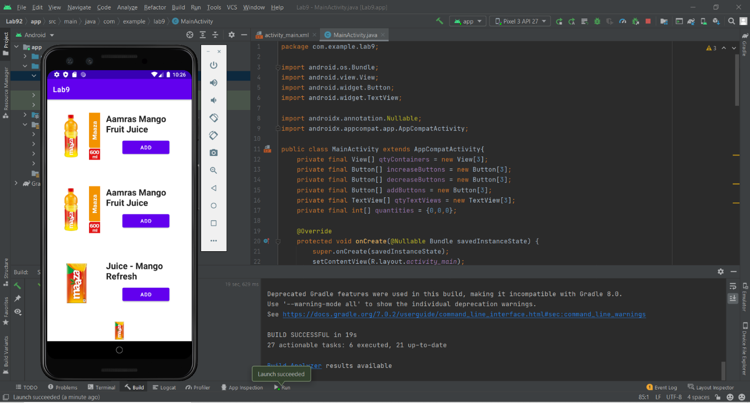

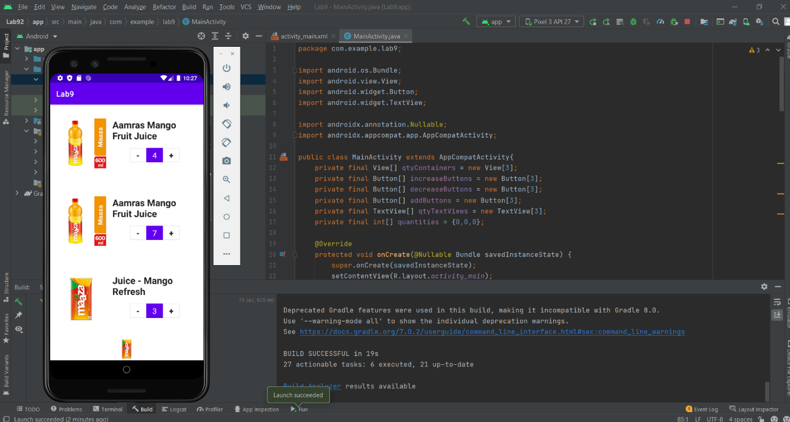

2.Design an Application to create one FAB and 4 image view. When the FAB is clicked each image should be applied with animation property scale, rotate, translate and alpha property respectively and when clicked again it should perform the same in reverse.

MainActivity.java:

package com.example.lab9;  
  
import androidx.appcompat.app.AppCompatActivity;  
  
import android.os.Bundle;  
import android.view.animation.AnimationUtils;  
import android.widget.ImageView;  
import android.view.View;  
  
public class MainActivity extends AppCompatActivity {  
  
 @Override  
 protected void onCreate(Bundle savedInstanceState) {  
 super.onCreate(savedInstanceState);  
 setContentView(R.layout.*activity_main*);  
  
 ImageView tenz=findViewById(R.id.*tenz*);  
 findViewById(R.id.*btnAdd*).setOnClickListener(new View.OnClickListener() {  
 @Override  
 public void onClick(View view) {  
 tenz.startAnimation(AnimationUtils.*loadAnimation*(  
 getApplicationContext(),  
 R.anim.*zoom_in* ));  
 }  
 });  
  
 findViewById(R.id.*btnAdd*).setOnClickListener(new View.OnClickListener() {  
 @Override  
 public void onClick(View view) {  
 tenz.startAnimation(AnimationUtils.*loadAnimation*(  
 getApplicationContext(),  
 R.anim.*zoom_out* ));  
 }  
 });  
  
 ImageView neymar=findViewById(R.id.*neymar*);  
 findViewById(R.id.*btnAdd*).setOnClickListener(new View.OnClickListener() {  
 @Override  
 public void onClick(View view) {  
 tenz.startAnimation(AnimationUtils.*loadAnimation*(  
 getApplicationContext(),  
 R.anim.*zoom_in* ));  
 neymar.startAnimation(AnimationUtils.*loadAnimation*(  
 getApplicationContext(),  
 R.anim.*fade_in* ));  
 }  
 });  
  
  
 findViewById(R.id.*btnAdd*).setOnClickListener(new View.OnClickListener() {  
 @Override  
 public void onClick(View view) {  
 tenz.startAnimation(AnimationUtils.*loadAnimation*(  
 getApplicationContext(),  
 R.anim.*zoom_out* ));  
 neymar.startAnimation(AnimationUtils.*loadAnimation*(  
 getApplicationContext(),  
 R.anim.*fade_out* ));  
 }  
 });  
  
 ImageView scream=findViewById(R.id.*scream*);  
 findViewById(R.id.*btnAdd*).setOnClickListener(new View.OnClickListener() {  
 @Override  
 public void onClick(View view) {  
 tenz.startAnimation(AnimationUtils.*loadAnimation*(  
 getApplicationContext(),  
 R.anim.*zoom_in* ));  
 neymar.startAnimation(AnimationUtils.*loadAnimation*(  
 getApplicationContext(),  
 R.anim.*fade_in* ));  
 scream.startAnimation(AnimationUtils.*loadAnimation*(  
 getApplicationContext(),  
 R.anim.*rotate* ));  
 }  
 });  
  
 findViewById(R.id.*btnAdd*).setOnClickListener(new View.OnClickListener() {  
 @Override  
 public void onClick(View view) {  
 tenz.startAnimation(AnimationUtils.*loadAnimation*(  
 getApplicationContext(),  
 R.anim.*zoom_out* ));  
 neymar.startAnimation(AnimationUtils.*loadAnimation*(  
 getApplicationContext(),  
 R.anim.*fade_out* ));  
 scream.startAnimation(AnimationUtils.*loadAnimation*(  
 getApplicationContext(),  
 R.anim.*rotate* ));  
 }  
 });  
  
 ImageView jett2=findViewById(R.id.*jett2*);  
 findViewById(R.id.*btnAdd*).setOnClickListener(new View.OnClickListener() {  
 @Override  
 public void onClick(View view) {  
 tenz.startAnimation(AnimationUtils.*loadAnimation*(  
 getApplicationContext(),  
 R.anim.*zoom_in* ));  
 neymar.startAnimation(AnimationUtils.*loadAnimation*(  
 getApplicationContext(),  
 R.anim.*fade_in* ));  
 scream.startAnimation(AnimationUtils.*loadAnimation*(  
 getApplicationContext(),  
 R.anim.*rotate* ));  
 jett2.startAnimation(AnimationUtils.*loadAnimation*(  
 getApplicationContext(),  
 R.anim.*translate* ));  
 }  
 });  
  
 findViewById(R.id.*btnAdd*).setOnClickListener(new View.OnClickListener() {  
 @Override  
 public void onClick(View view) {  
 tenz.startAnimation(AnimationUtils.*loadAnimation*(  
 getApplicationContext(),  
 R.anim.*zoom_out* ));  
 neymar.startAnimation(AnimationUtils.*loadAnimation*(  
 getApplicationContext(),  
 R.anim.*fade_out* ));  
 scream.startAnimation(AnimationUtils.*loadAnimation*(  
 getApplicationContext(),  
 R.anim.*rotate* ));  
 jett2.startAnimation(AnimationUtils.*loadAnimation*(  
 getApplicationContext(),  
 R.anim.*translate* ));  
 }  
 });  
  
  
  
  
 }  
}

**activity_main.xml:**

<?xml version="1.0" encoding="utf-8"?>  
<androidx.constraintlayout.widget.ConstraintLayout  
 xmlns:android="http://schemas.android.com/apk/res/android"  
 xmlns:app="http://schemas.android.com/apk/res-auto"  
 xmlns:tools="http://schemas.android.com/tools"  
 android:layout_width="match_parent"  
 android:layout_height="match_parent"  
 tools:context=".MainActivity">  
  
 <ImageView  
 android:id="@+id/tenz"  
 android:layout_width="172dp"  
 android:layout_height="128dp"  
 android:layout_marginBottom="564dp"  
 app:layout_constraintBottom_toBottomOf="parent"  
 app:layout_constraintStart_toStartOf="parent"  
 app:srcCompat="@drawable/image1" />  
  
 <ImageView  
 android:id="@+id/neymar"  
 android:layout_width="211dp"  
 android:layout_height="157dp"  
 android:layout_marginStart="16dp"  
 android:layout_marginBottom="404dp"  
 app:layout_constraintBottom_toBottomOf="parent"  
 app:layout_constraintStart_toStartOf="parent"  
 app:srcCompat="@drawable/image2" />  
  
 <ImageView  
 android:id="@+id/scream"  
 android:layout_width="194dp"  
 android:layout_height="185dp"  
 android:layout_marginStart="16dp"  
 android:layout_marginBottom="216dp"  
 app:layout_constraintBottom_toBottomOf="parent"  
 app:layout_constraintStart_toStartOf="parent"  
 app:srcCompat="@drawable/image3" />  
  
 <com.google.android.material.floatingactionbutton.FloatingActionButton  
 android:id="@+id/btnAdd"  
 android:layout_width="wrap_content"  
 android:layout_height="wrap_content"  
 android:layout_marginStart="321dp"  
 android:layout_marginBottom="16dp"  
 android:clickable="true"  
 app:layout_constraintBottom_toBottomOf="parent"  
 app:layout_constraintStart_toStartOf="parent"  
 app:srcCompat="@android:drawable/ic_input_add"  
 tools:ignore="SpeakableTextPresentCheck" />  
  
 <ImageView  
 android:id="@+id/jett2"  
 android:layout_width="134dp"  
 android:layout_height="199dp"  
 android:layout_marginStart="45dp"  
 android:layout_marginBottom="16dp"  
 app:layout_constraintBottom_toBottomOf="parent"  
 app:layout_constraintStart_toStartOf="parent"  
 app:srcCompat="@drawable/image4" />  
  
</androidx.constraintlayout.widget.ConstraintLayout>

**animation files**

**fade_in.xml**

<?xml version="1.0" encoding="utf-8"?>  
<set xmlns:android="http://schemas.android.com/apk/res/android">  
 android:fillAfter="true">  
  
 <alpha  
 android:duration="800"  
 android:fromAlpha="0"  
 android:interpolator="@android:anim/accelerate_interpolator"  
 android:toAlpha="1" />  
  
  
  
</set>

**fade_out.xml**

<?xml version="1.0" encoding="utf-8"?>  
<set xmlns:android="http://schemas.android.com/apk/res/android">  
 android:fillAfter="true">  
  
 <alpha  
 android:duration="800"  
 android:fromAlpha="1"  
 android:interpolator="@android:anim/accelerate_interpolator"  
 android:toAlpha="0" />  
  
</set>

**Rotate.xml**

<?xml version="1.0" encoding="utf-8"?>  
<set xmlns:android="http://schemas.android.com/apk/res/android">  
  
 <rotate  
 android:duration="600"  
 android:fromDegrees="0"  
 android:interpolator="@android:anim/cycle_interpolator"  
 android:pivotX="50%"  
 android:pivotY="50%"  
 android:repeatMode="restart"  
 android:toDegrees="360" />  
  
  
</set>

**Translate.xml**

<?xml version="1.0" encoding="utf-8"?>  
<set xmlns:android="http://schemas.android.com/apk/res/android">  
 android:fillAfter="true">  
  
 <translate  
 android:fromXDelta="0"  
 android:toXDelta="65%p"  
 android:toYDelta="0%"  
 android:duration="600"  
 android:fromYDelta="0"  
 android:zAdjustment="top"/>  
  
</set>

**Zoom_in.xml**

<?xml version="1.0" encoding="utf-8"?>  
<set xmlns:android="http://schemas.android.com/apk/res/android">  
 android:fillAfter="true">  
  
 <scale  
 android:duration="800"  
 android:fromXScale="0"  
 android:fromYScale="0"  
 android:pivotX="50%"  
 android:pivotY="50%"  
 android:toXScale="1"  
 android:toYScale="1" />  
  
  
  
</set>

**Zoom_out.xml**

<?xml version="1.0" encoding="utf-8"?>  
<set xmlns:android="http://schemas.android.com/apk/res/android">  
 android:fillAfter="true">  
  
  
 <scale  
 android:duration="800"  
 android:fromXScale="1"  
 android:fromYScale="1"  
 android:pivotX="50%"  
 android:pivotY="50%"  
 android:toXScale="0"  
 android:toYScale="0" />  
  
</set>

**Output-**

