% slice and dice coeffiecient
clear all
close all
clc
load('mri_knee.mat')
load('mri_knee_seg.mat')
folder=('C:\Users\Sumana\Documents\HW & Assignments\Signal and Image processing\Hw 6\Segementations\prob 2\40 seed');
filePattern = fullfile(folder,'*.jpg'); % Change to whatever pattern you need.
theFiles = dir(filePattern);
for k=1:10
baseFileName = theFiles(k).name;
fullFileName = fullfile(folder, baseFileName);
[filepath,name,ext] = fileparts(fullFileName);
manualseg = logical(imread(fullFileName));
expertseg = logical(mri_knee_seg(:,:,k));
dicevalue(k) = dice(expertseg,manualseg)
end
max=max(dicevalue)
min=min(dicevalue)
mean=mean(dicevalue)
S=std(dicevalue)
slice=[1:1:10];
plot(slice,dicevalue);
axis([1 10 0.5 1]);
xlabel('slice');
ylabel('dice coefficients');
title('Slice Vs Dice coefficients');
dicevalue =
0.9145
dicevalue =
0.9145 0.7119
dicevalue =
0.9145 0.7119 0.8888
dicevalue =
0.9145 0.7119 0.8888 0.9140
dicevalue =
0.9145 0.7119 0.8888 0.9140 0.9062
dicevalue =
0.9145 0.7119 0.8888 0.9140 0.9062 0.9066
dicevalue =
0.9145 0.7119 0.8888 0.9140 0.9062 0.9066 0.8987
dicevalue =
Columns 1 through 7
0.9145 0.7119 0.8888 0.9140 0.9062 0.9066 0.8987
Column 8
0.8947
dicevalue =
Columns 1 through 7
0.9145 0.7119 0.8888 0.9140 0.9062 0.9066 0.8987
Columns 8 through 9
0.8947 0.9157
dicevalue =
Columns 1 through 7
0.9145 0.7119 0.8888 0.9140 0.9062 0.9066 0.8987
Columns 8 through 10
0.8947 0.9157 0.8872
max =
0.9157
min =
0.7119
mean =
0.8838
S =
0.0613
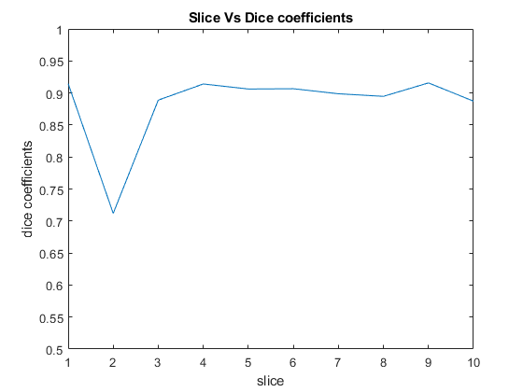
Published with MATLAB® R2019a

