

National Institute Of Technology – Calicut
Data Mining
(Data pre-processing assignment)

Que 01.
(AUTO MPG data set)
Data Pre-processing Open refine

T.G. Deshan K. Sumanathilaka
B150413CS
Computer Science and Engineering
(B.Tech)

1)Loading the Data Set to Open Refine
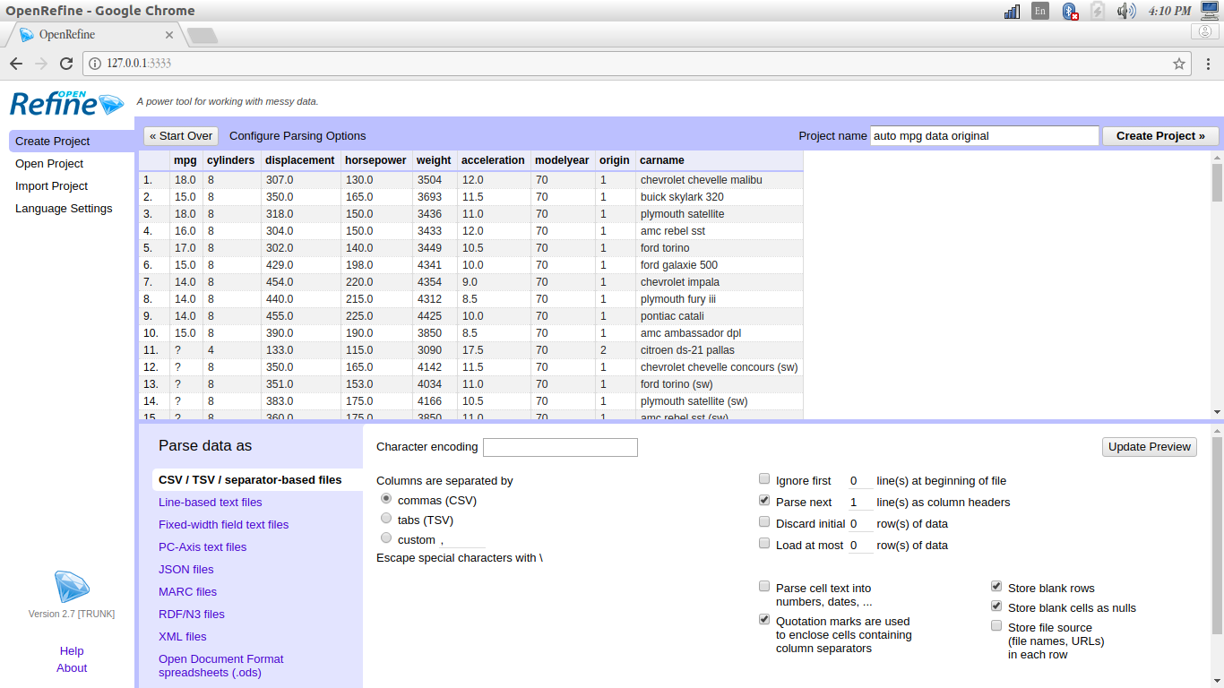
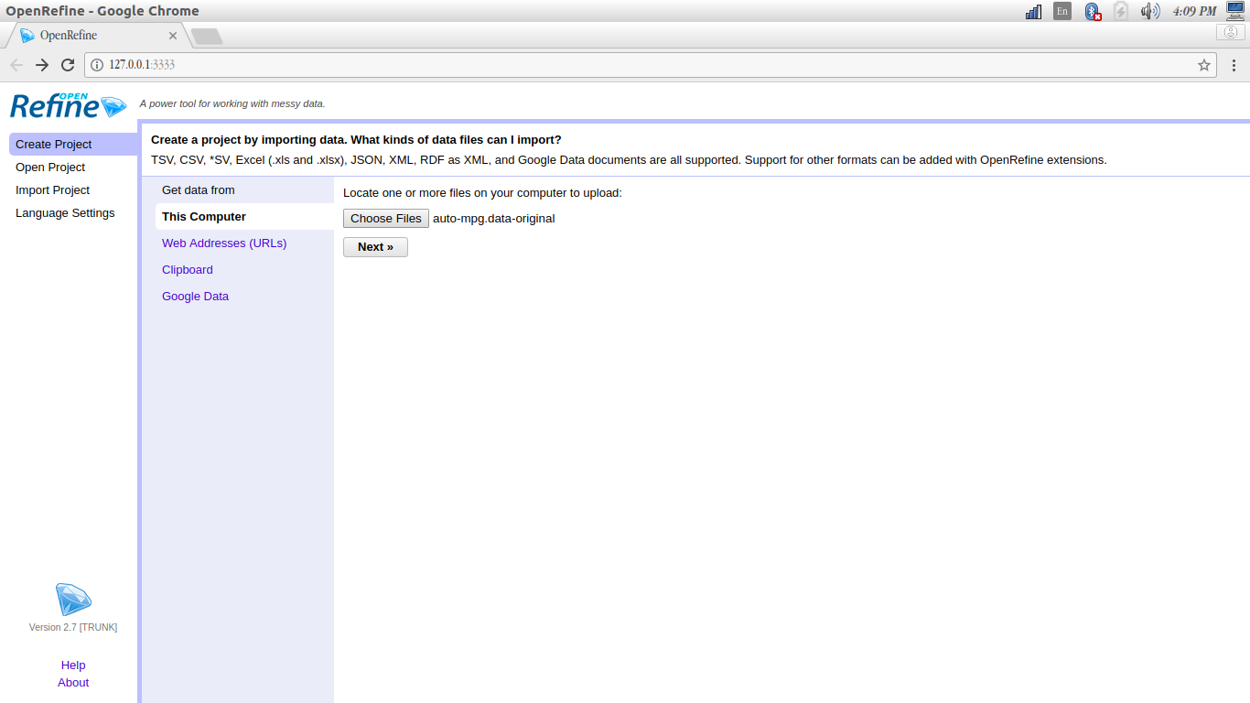

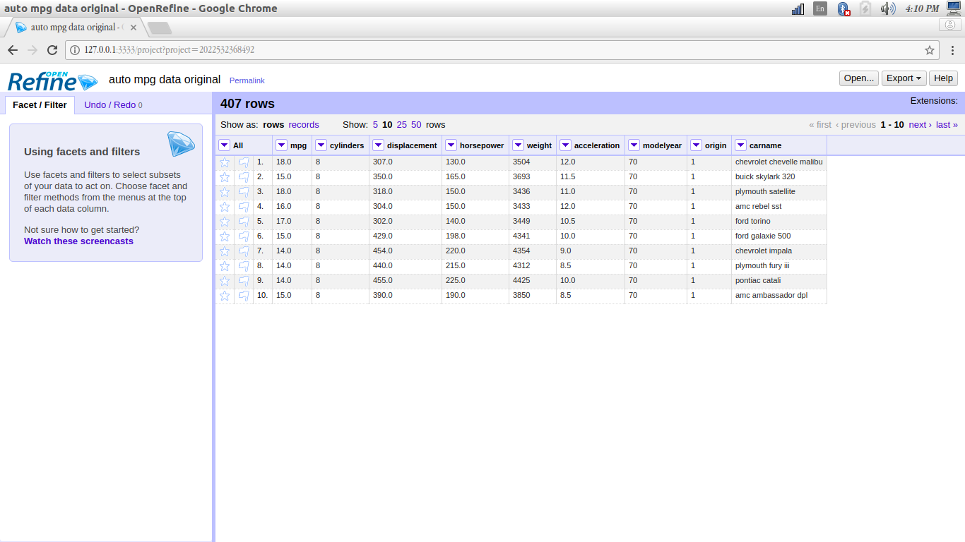
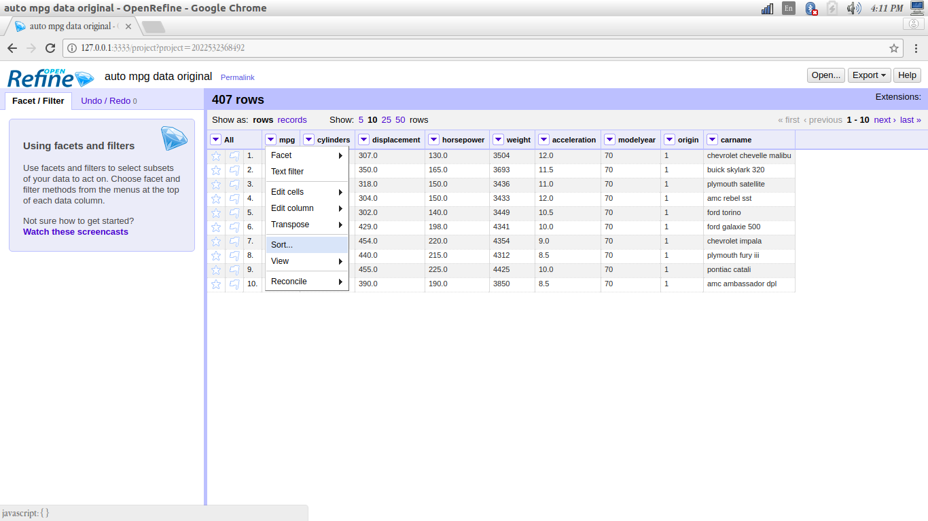
2) Sort the position of the blank ,error data tuples to a order , and flag the data tuples with missing values.

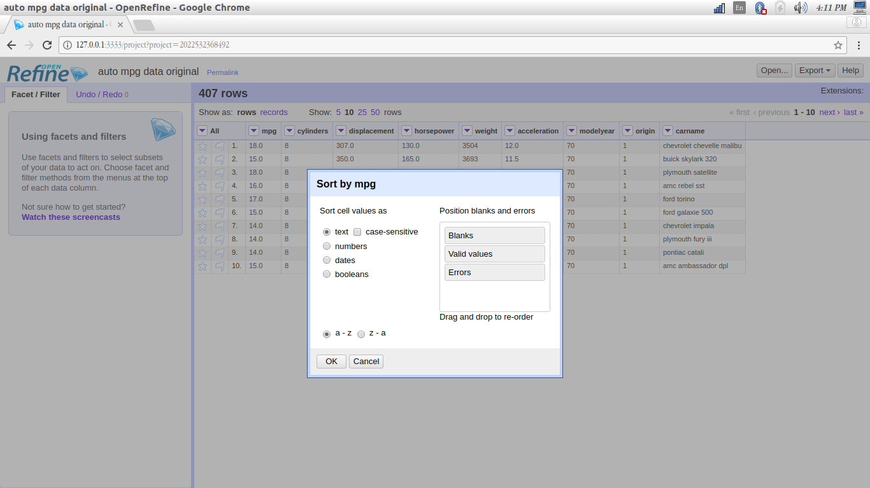
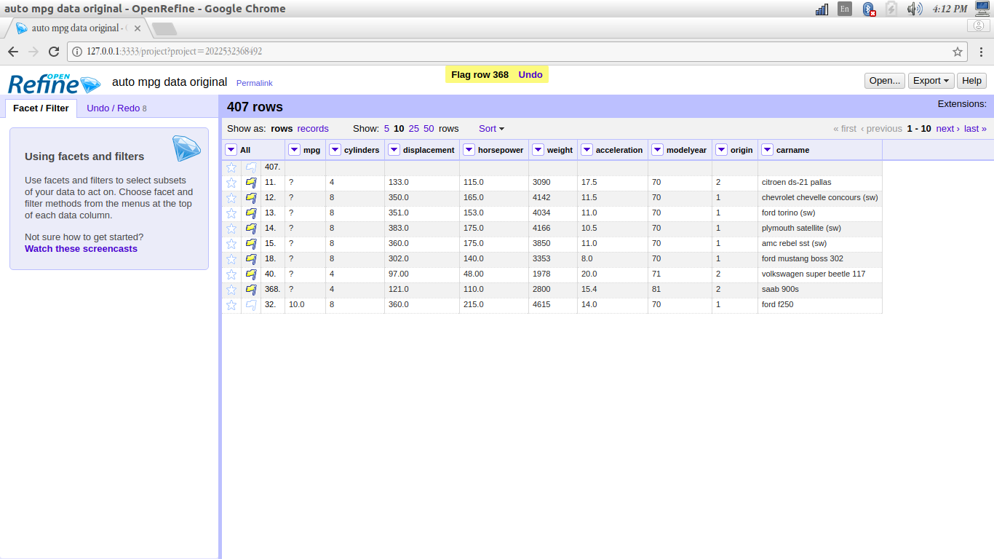

3) Change the non-numeric attribute to lowercase before it begins to cluster.
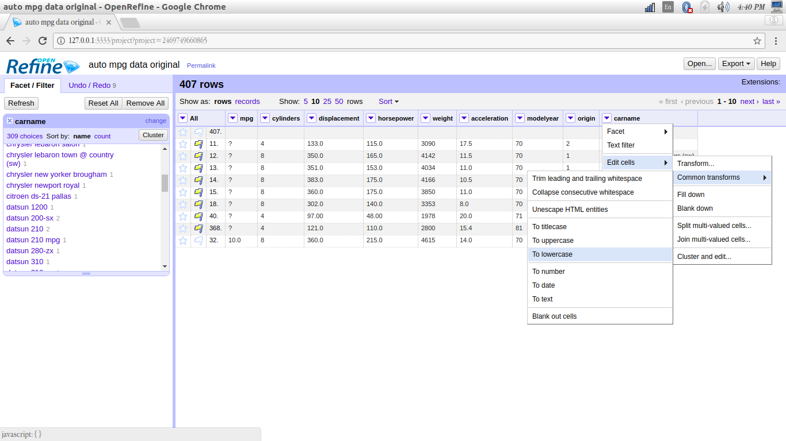
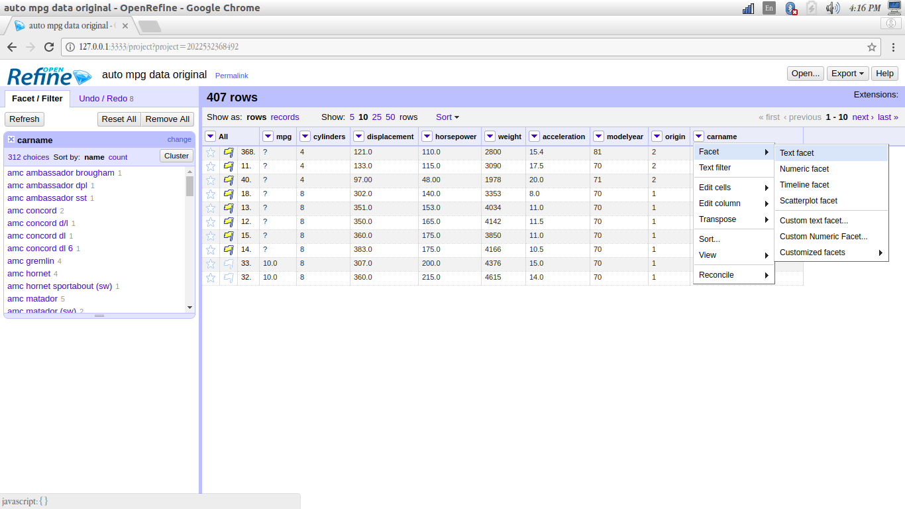

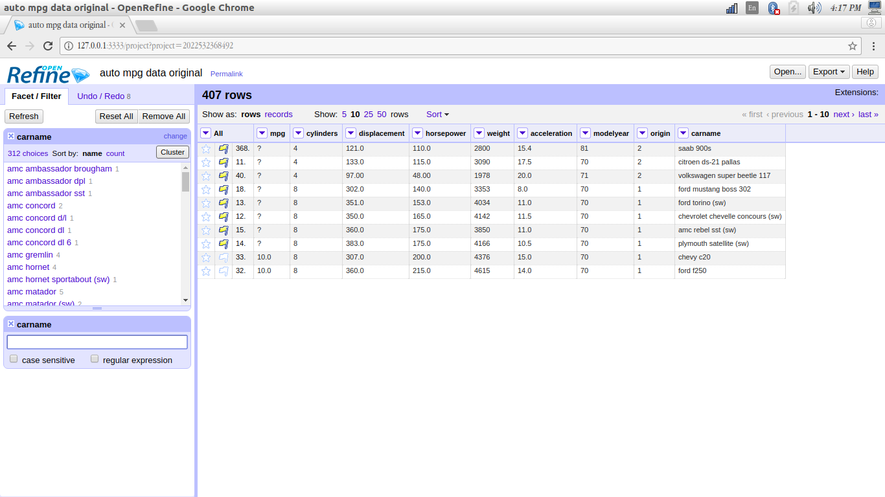
4)Cluster it and merger the related cells to remove inconsistent spellings.
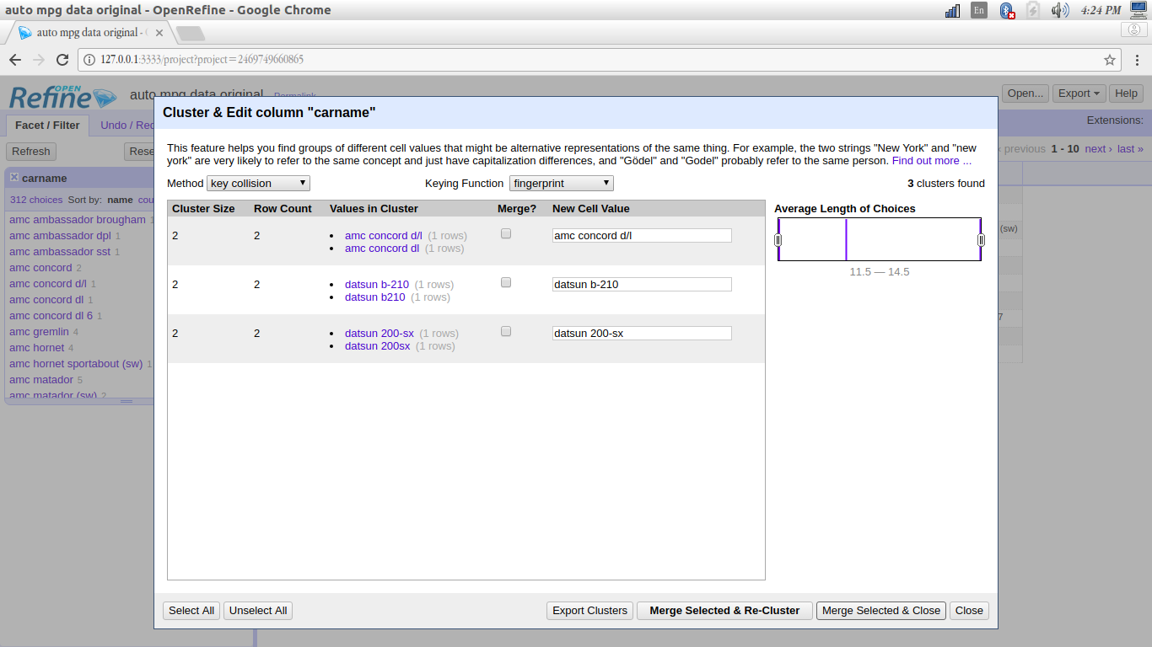

5) Extracting and cleaning values for dates

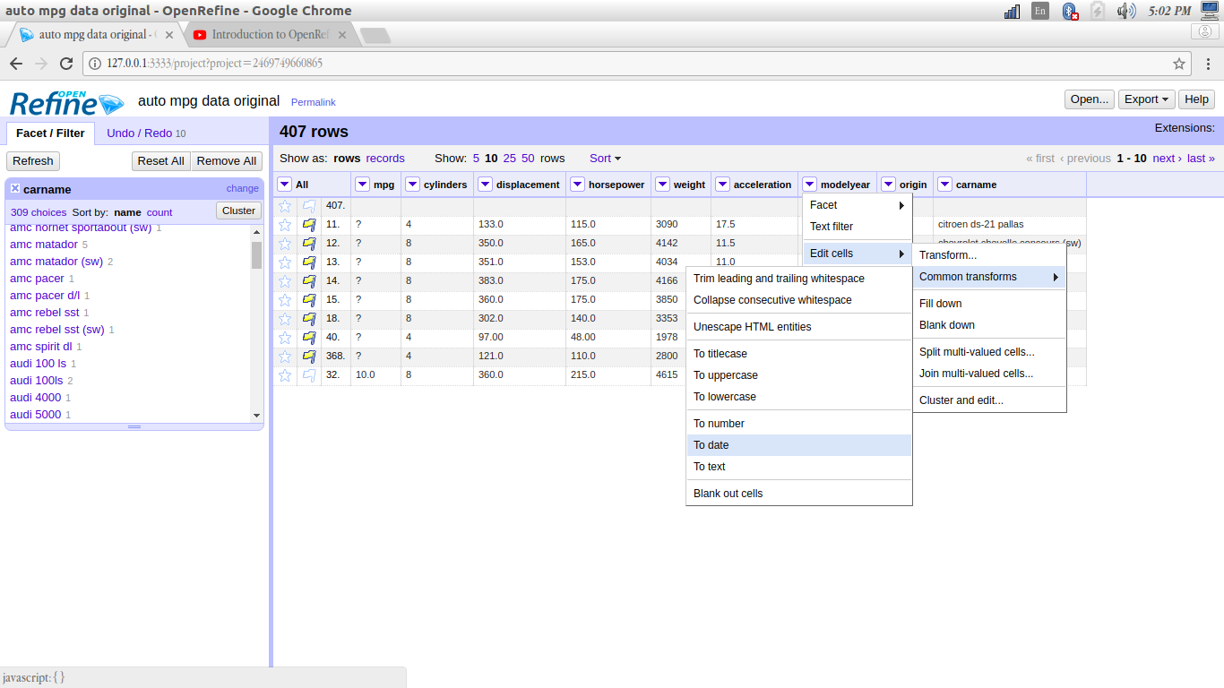
(but in this data set changing the date to a specific order is not required.)

6) Fill in the missing values by the various options supported by Open refine
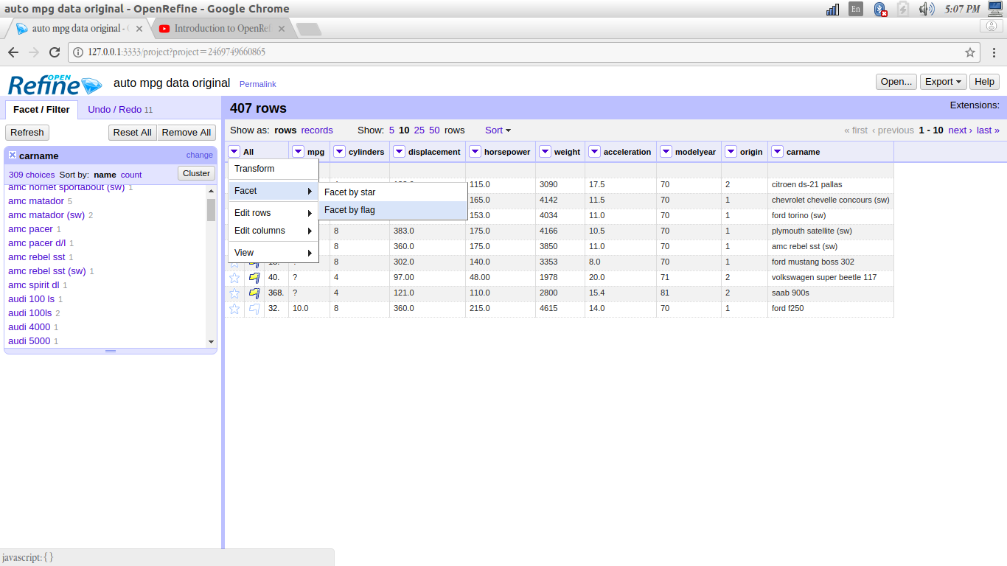

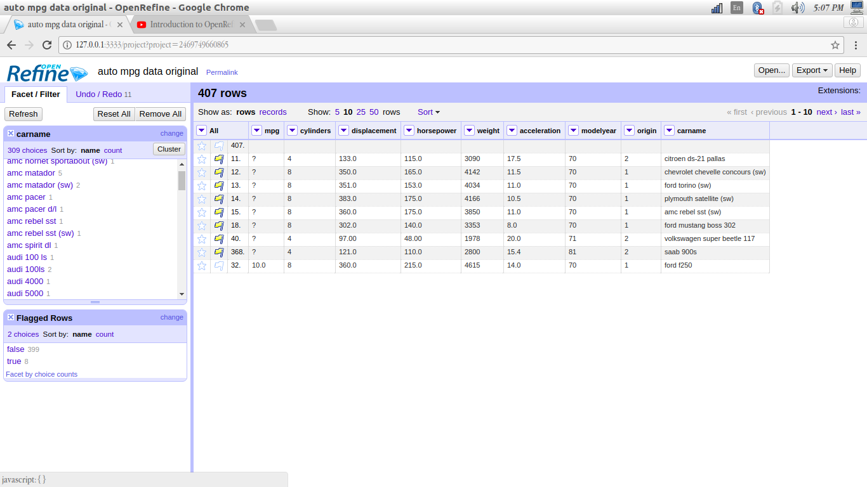

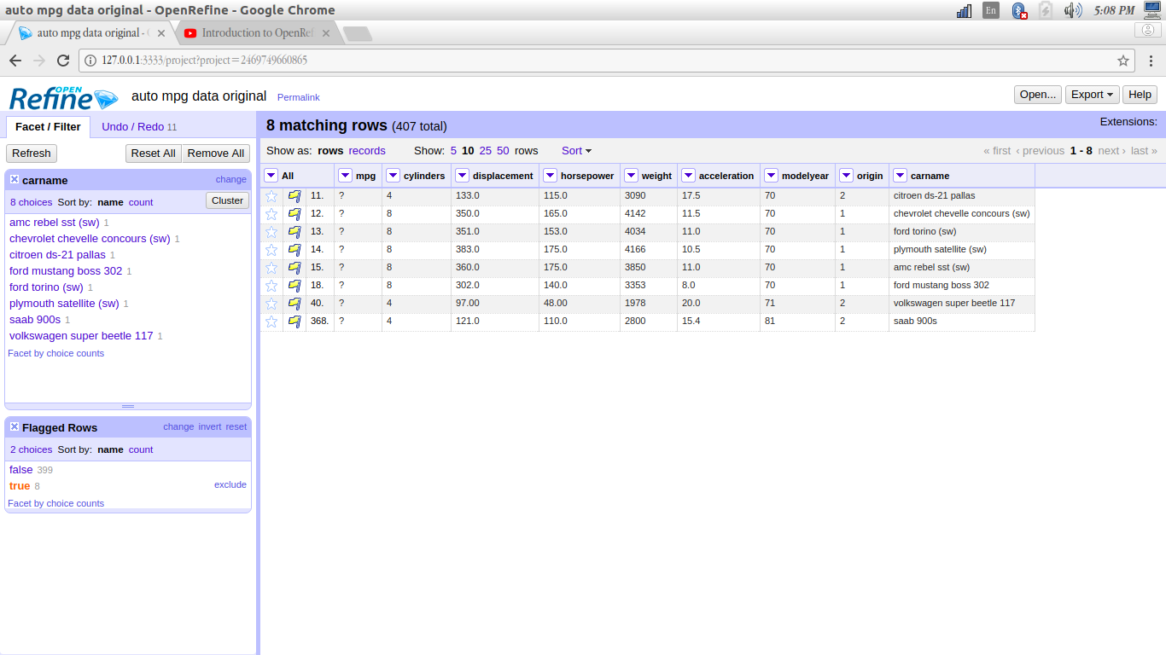

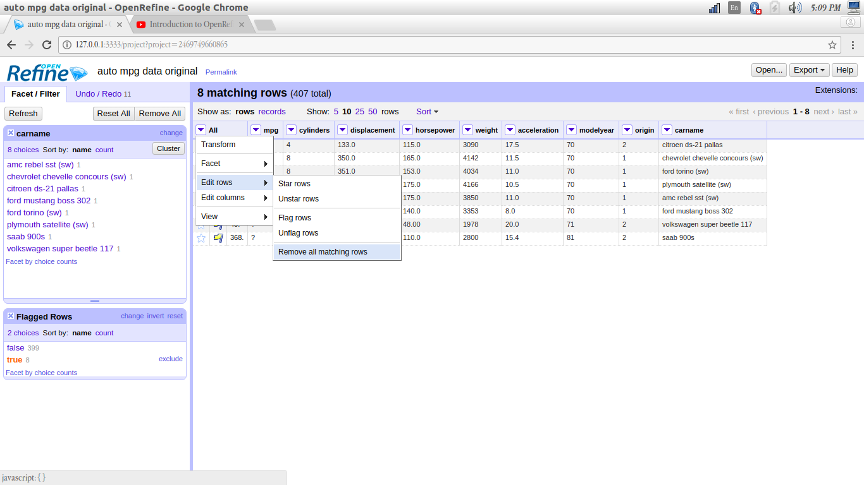

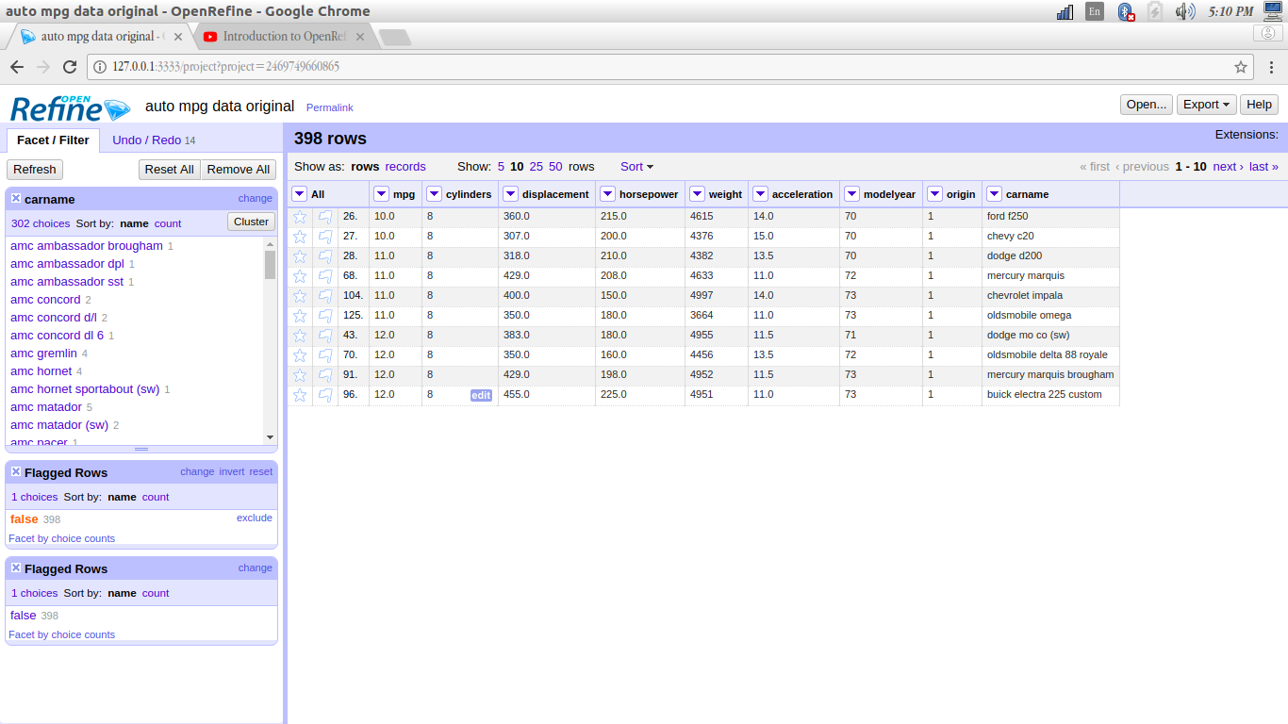
(by removing the missing values tuples, no of rows changed.)

7) Removing duplicate columns(in some cases)
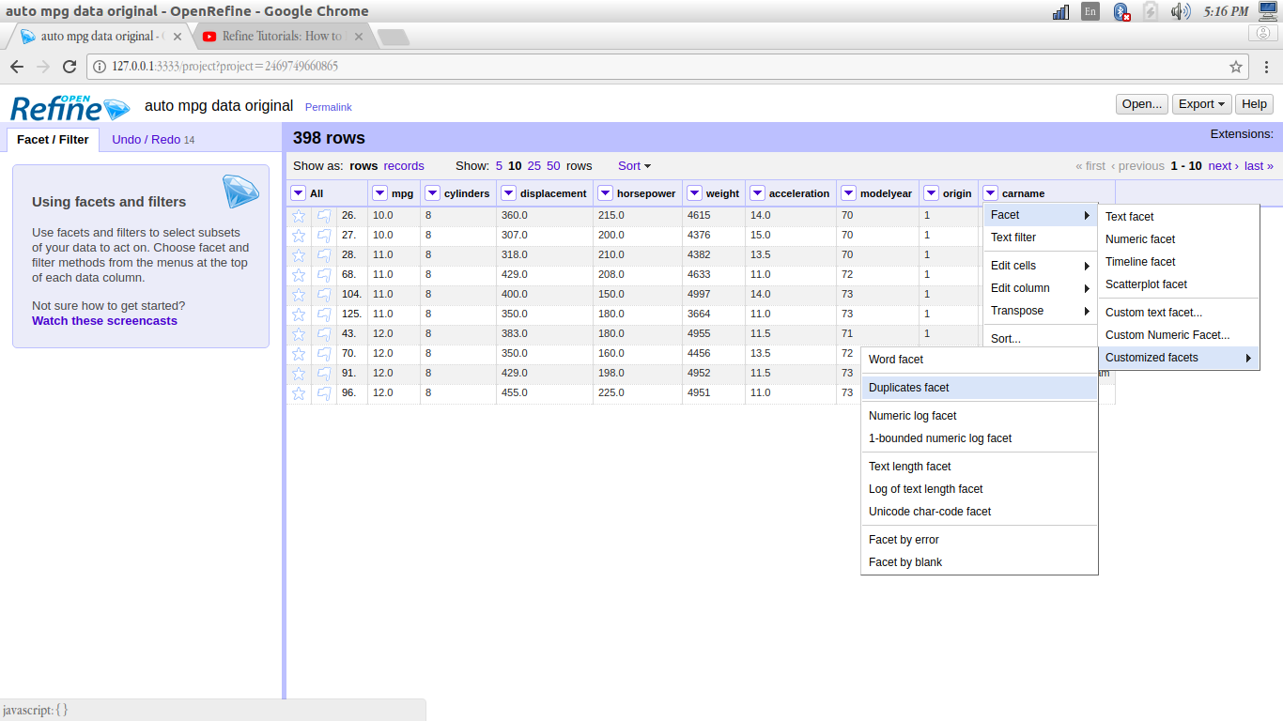
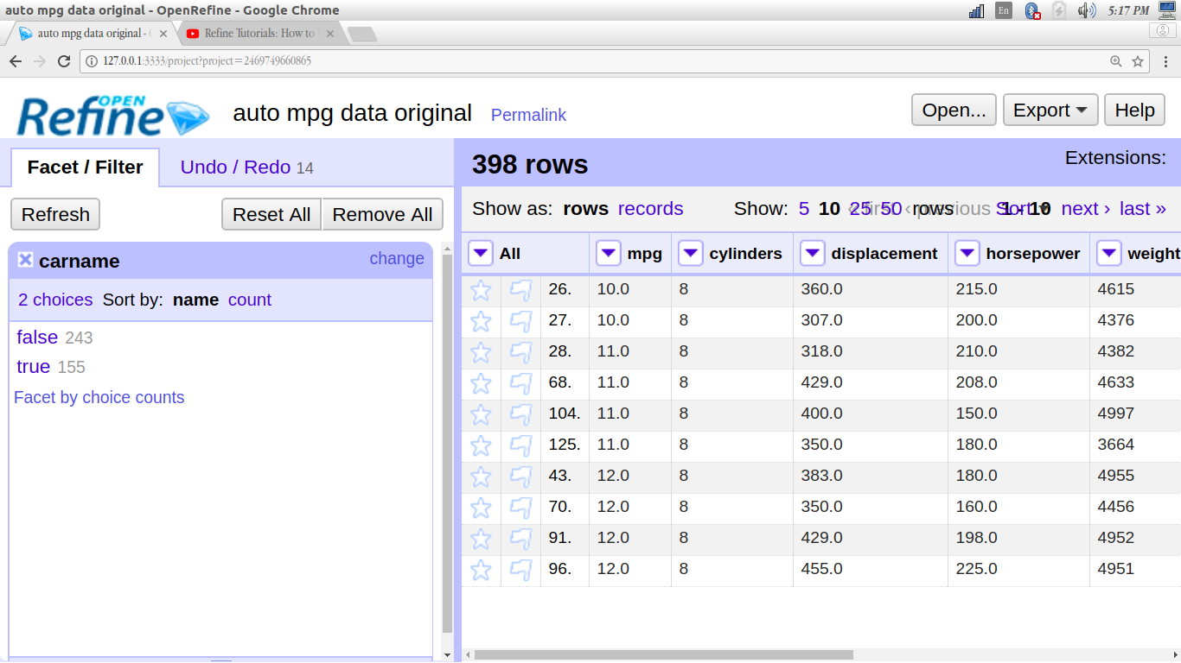
( In the dataset Removing column Duplicate value will be cause for a miss prediction because column )

8.Scatter plot
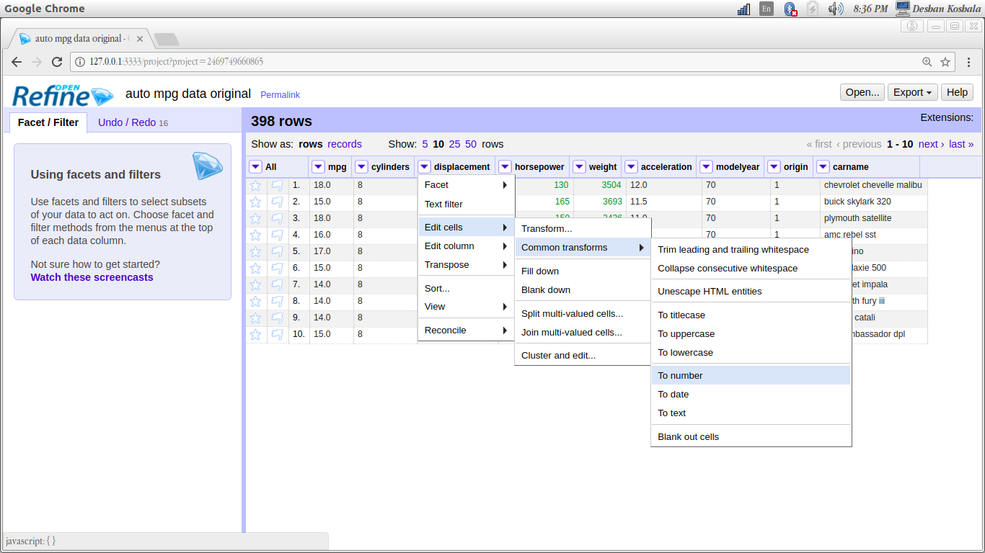
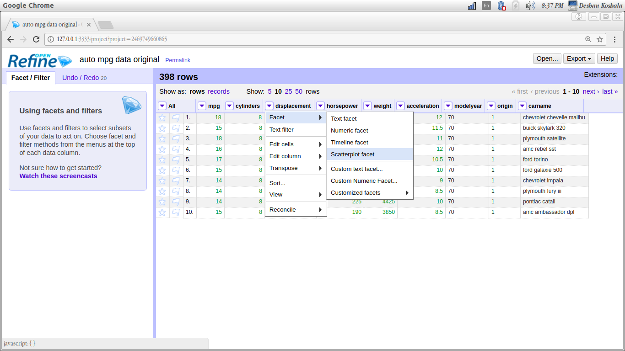

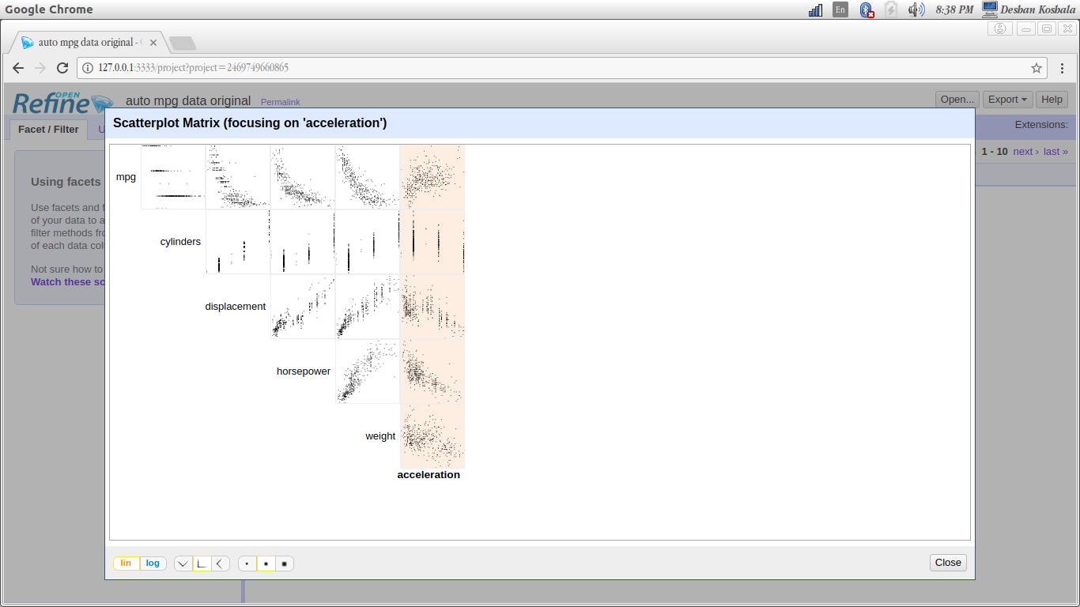
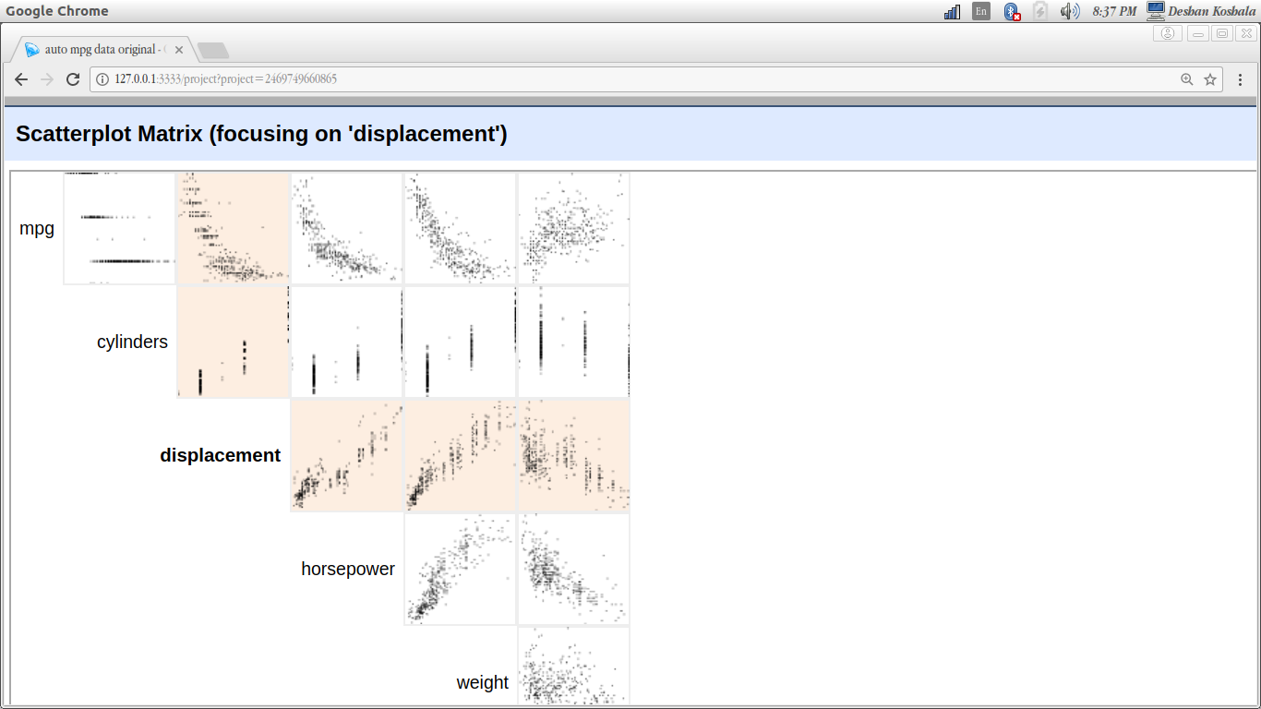

9.Removing duplicate Rows

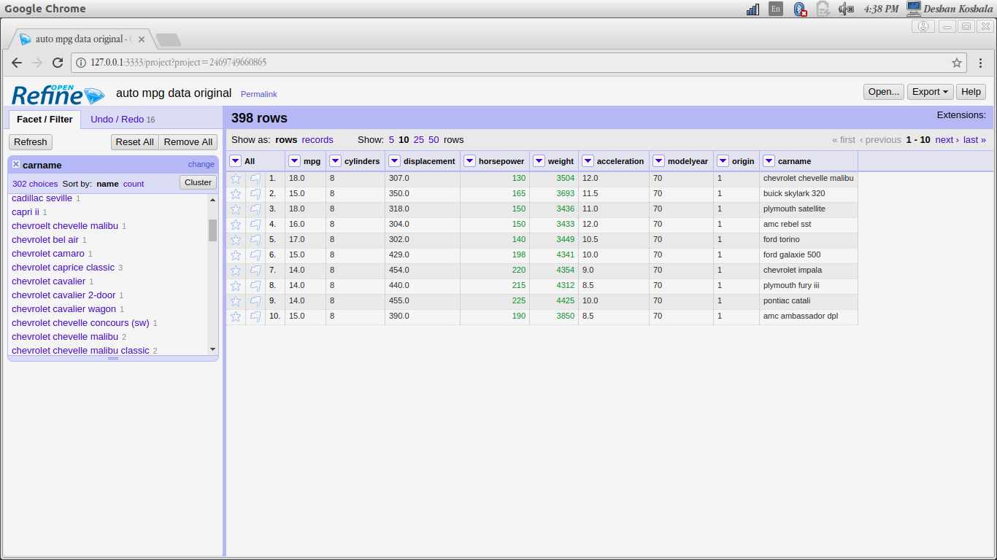

(
After clustering is over, we can select the cluster with higher no of rows, and search for duplicate values.
Flag those rows and remove .
)

No Duplicate is available in this data Set :(

10.Exporting cleaned data to Excel

