

National Institute Of Technology – Calicut
Data Mining
(Data pre-processing assignment)

Que 02.
(AUTO MPG data set)
Data Pre-processing Using Weka

T.G. Deshan K. Sumanathilaka
B150413CS
Computer Science and Engineering
(B.Tech)
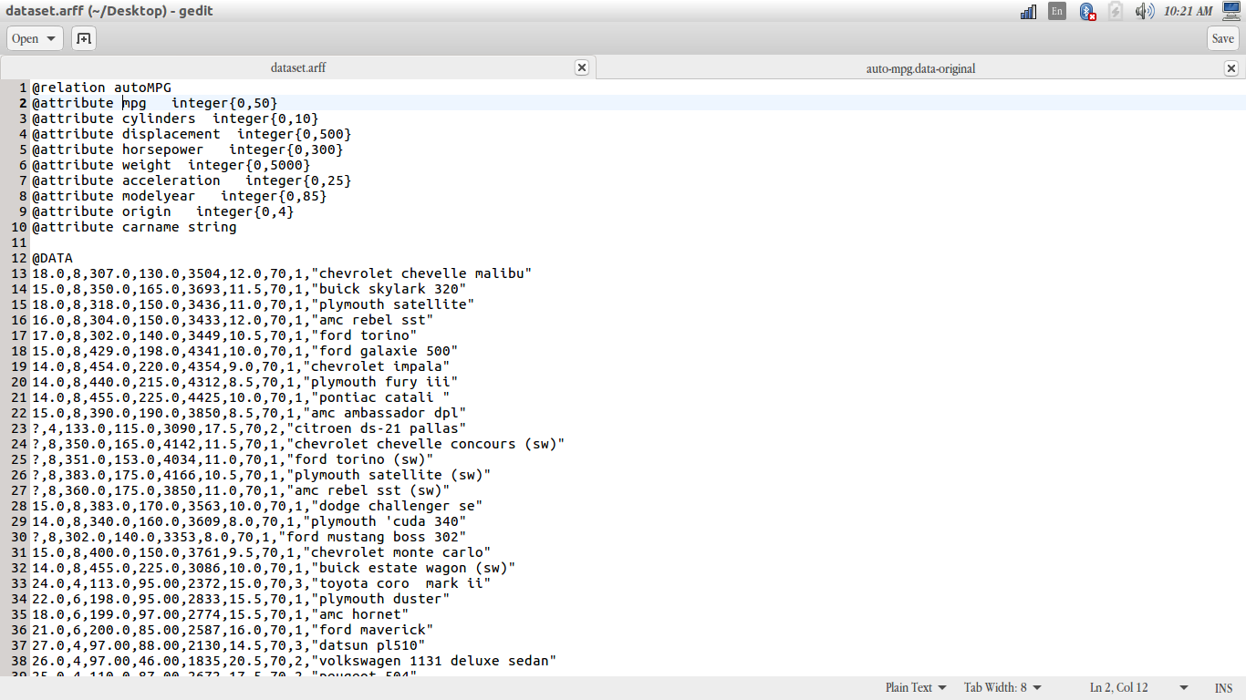
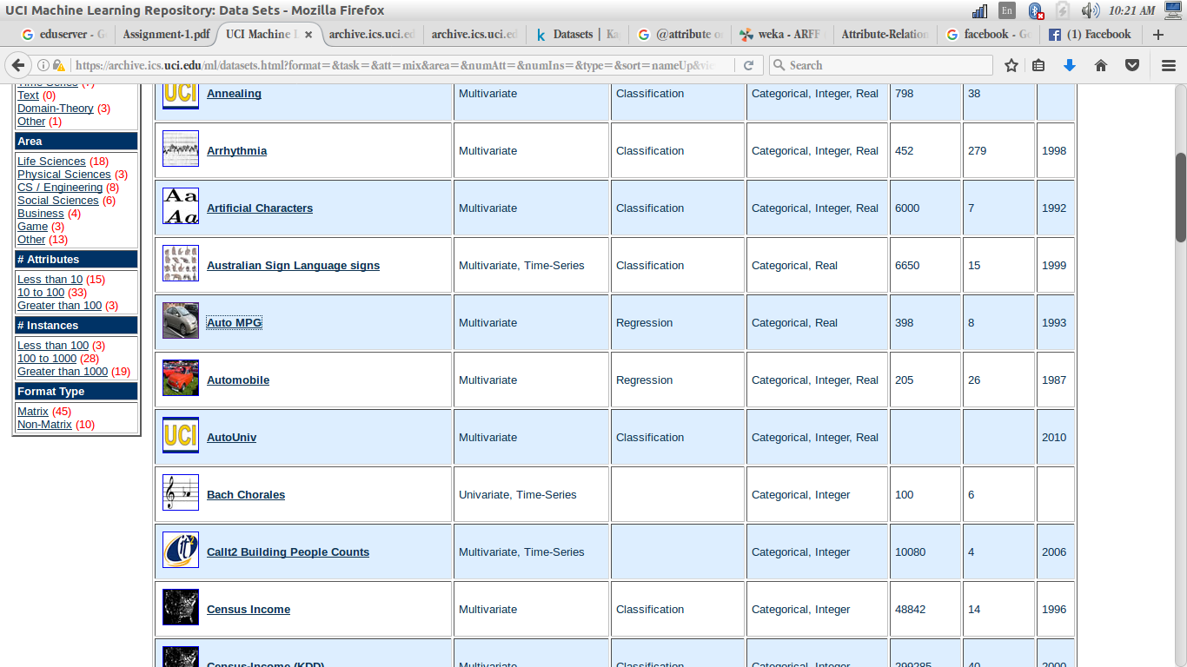
Selected Data Set ............

Step 1 :Loading Data Set to Weka

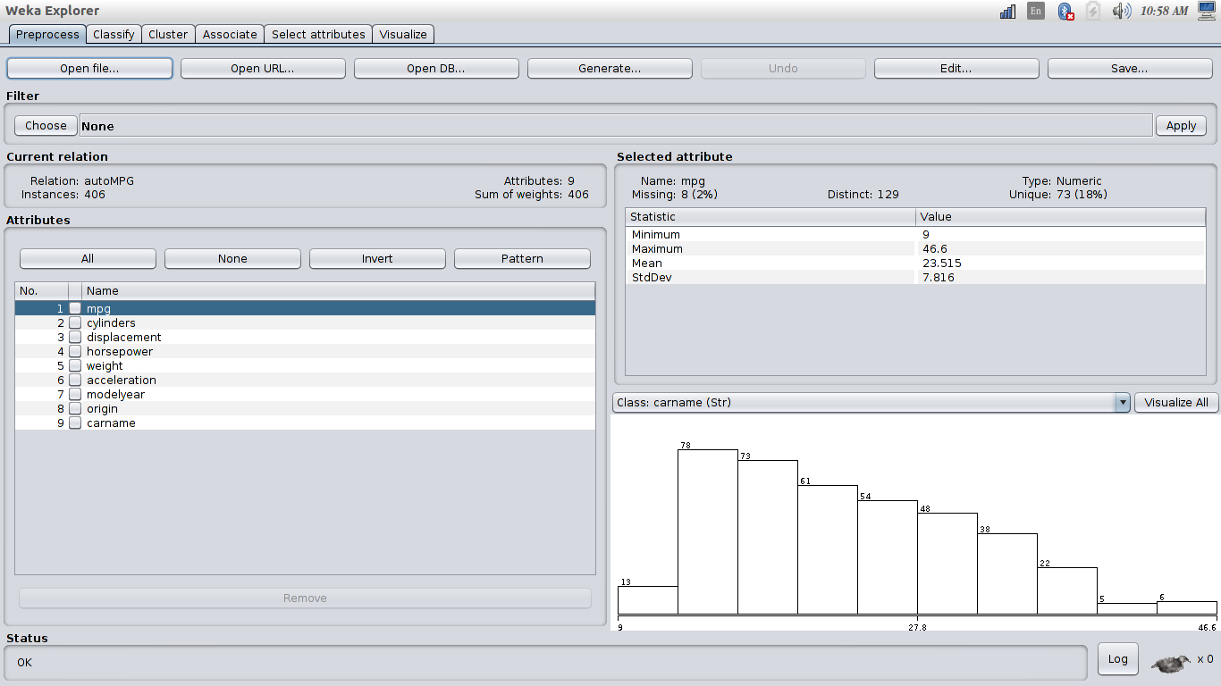

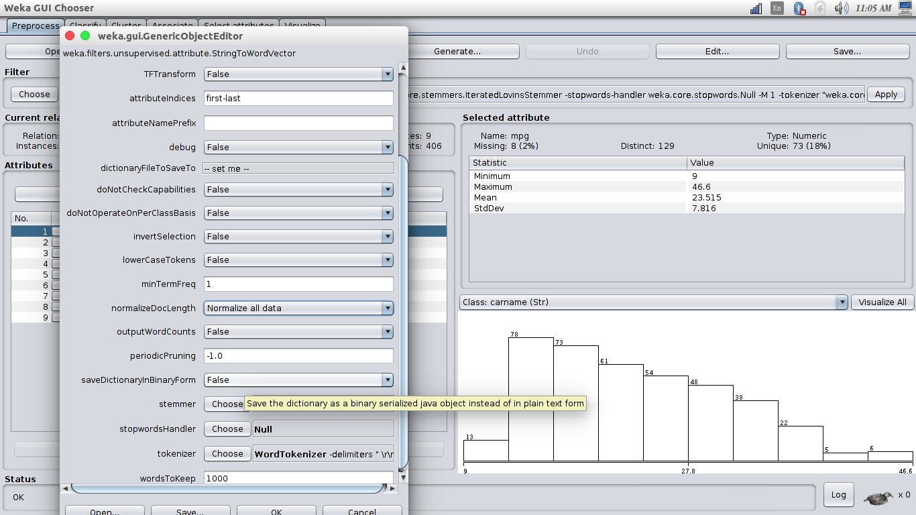
Step 2
a)Cleaning up inconsistent spelling of terms

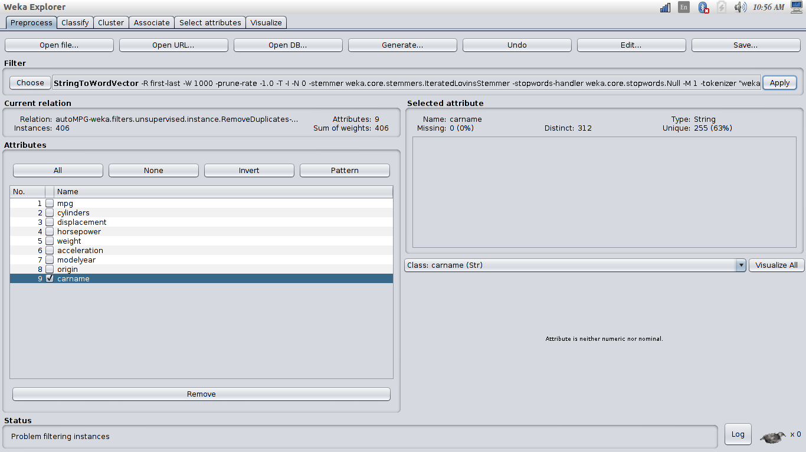

b)Converting values that are text descriptions of numeric values to actual numeric values which are usable for analysis.

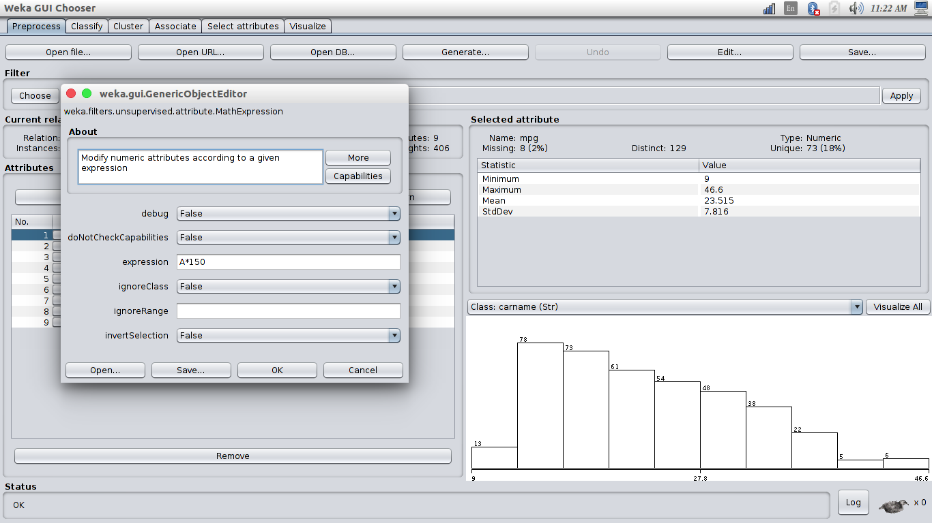
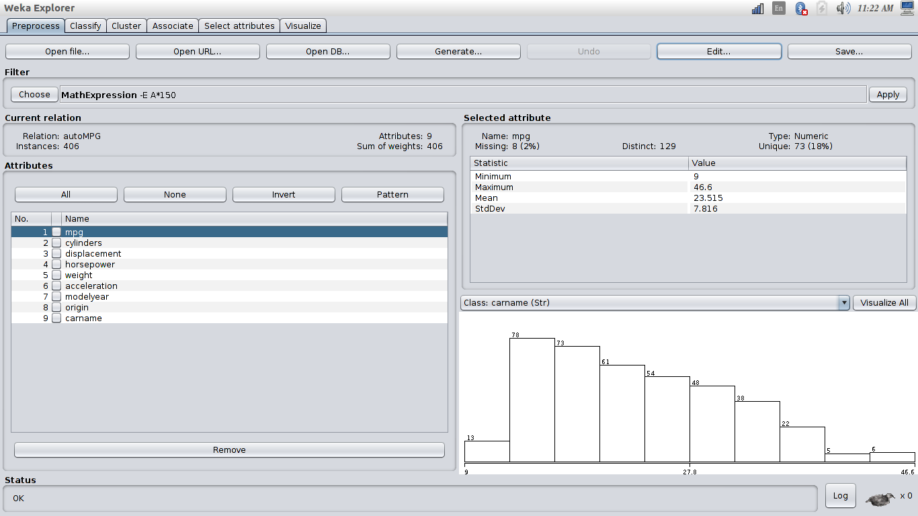

c)Extracting and cleaning values for dates

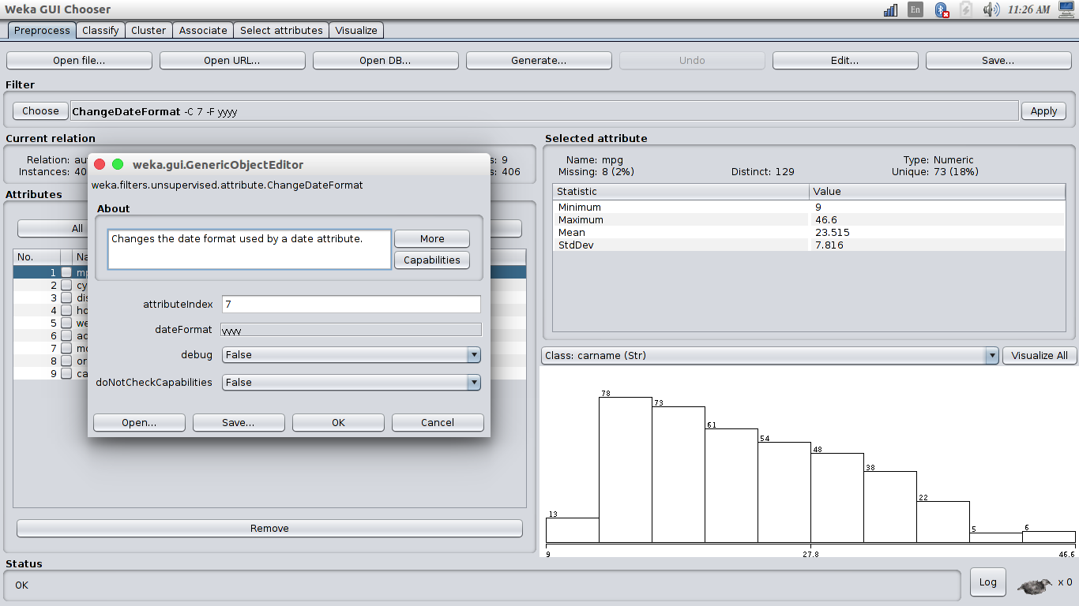
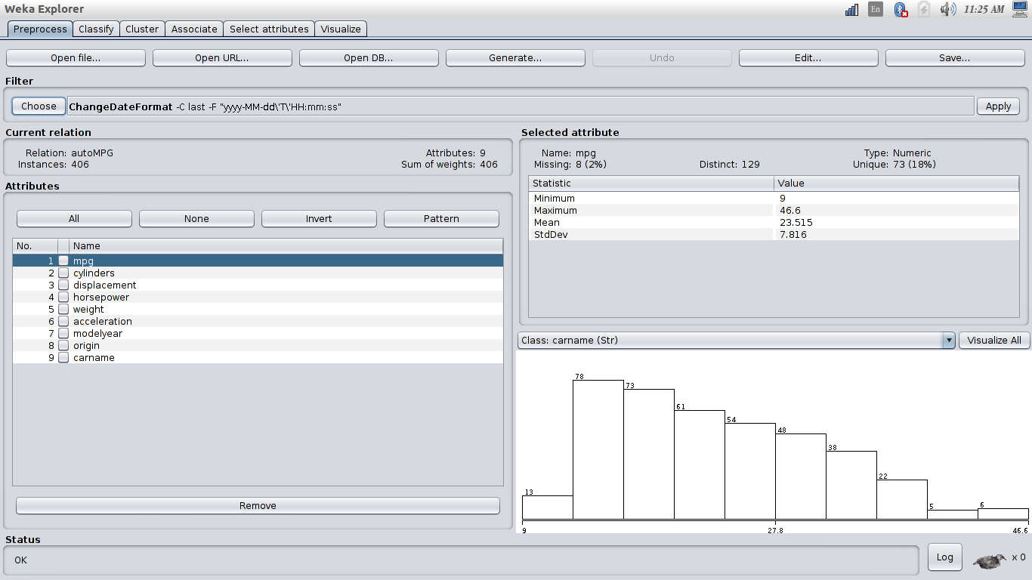

d)Fill in the missing values by the various options

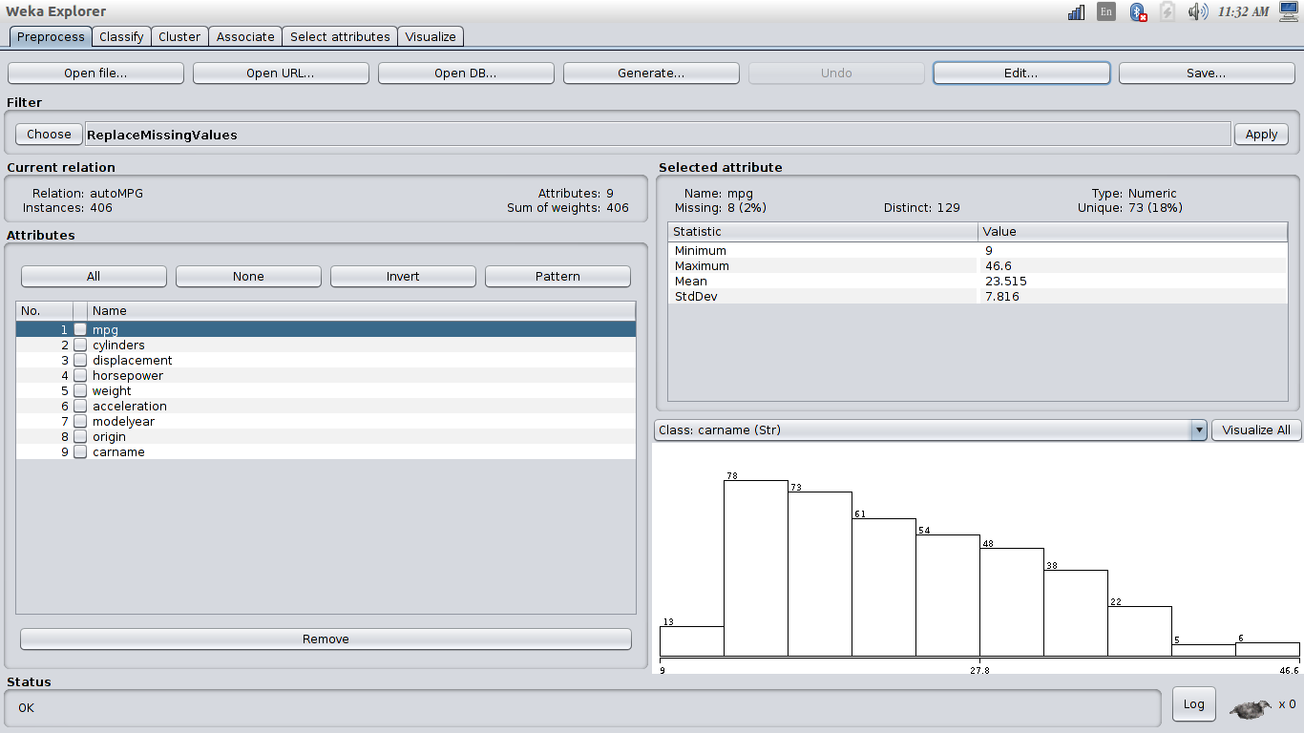
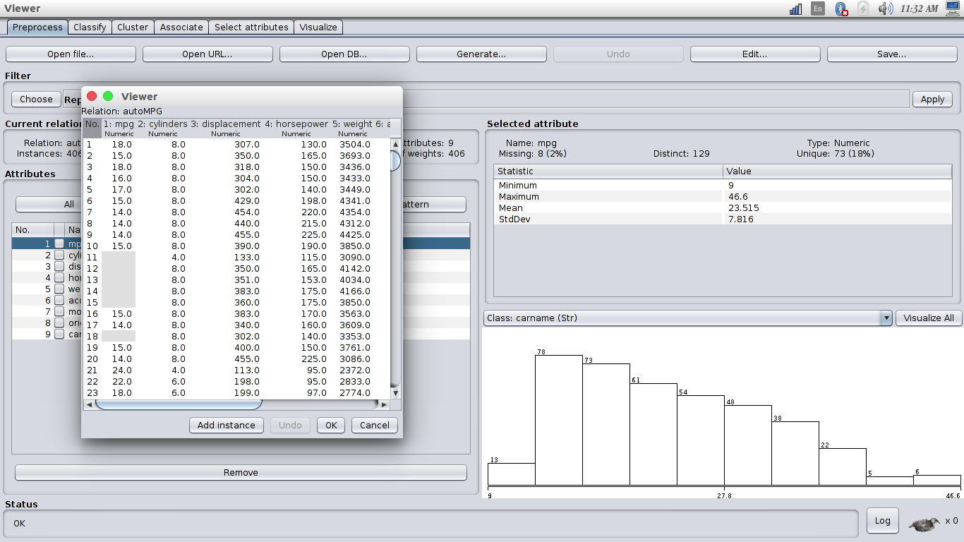

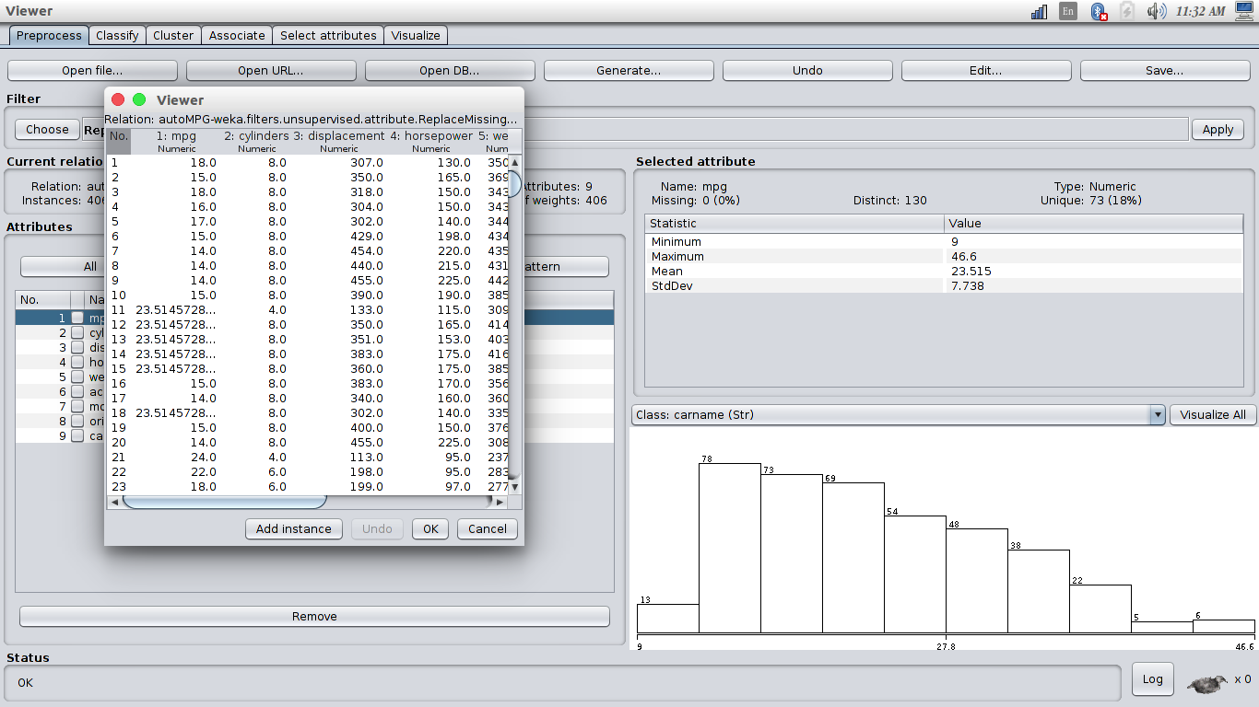
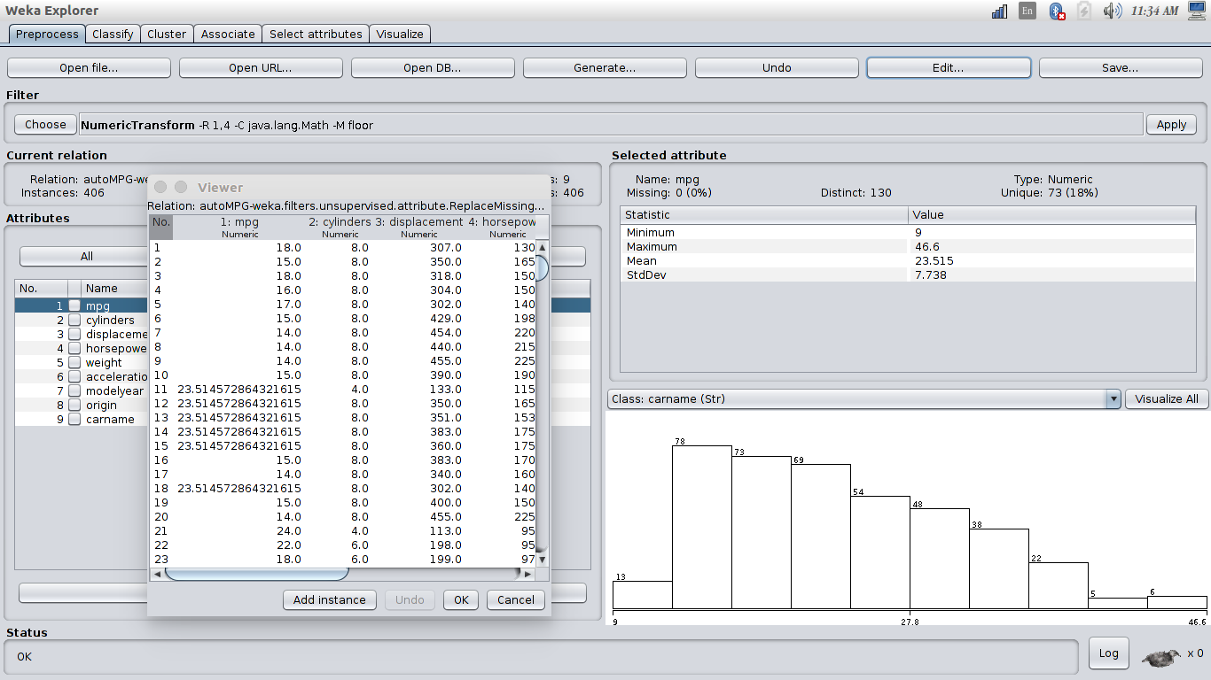

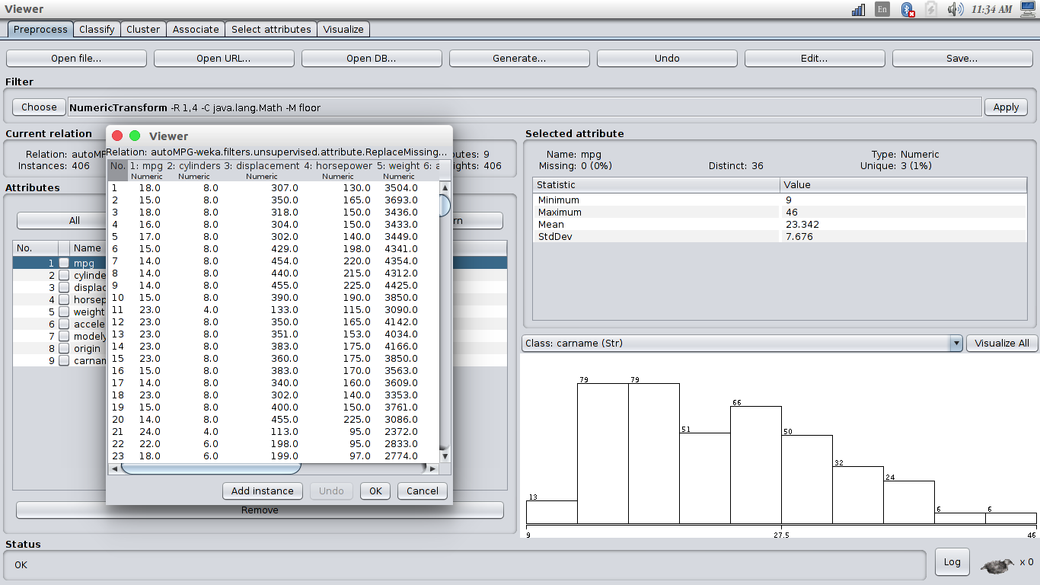

e) Removing duplicate rows

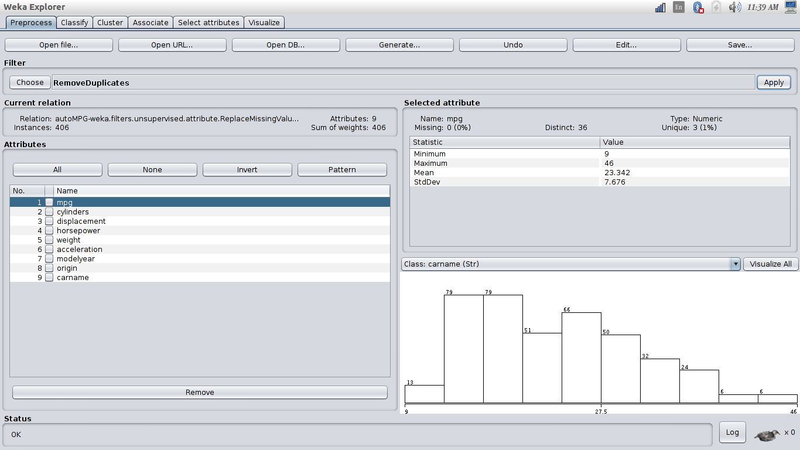
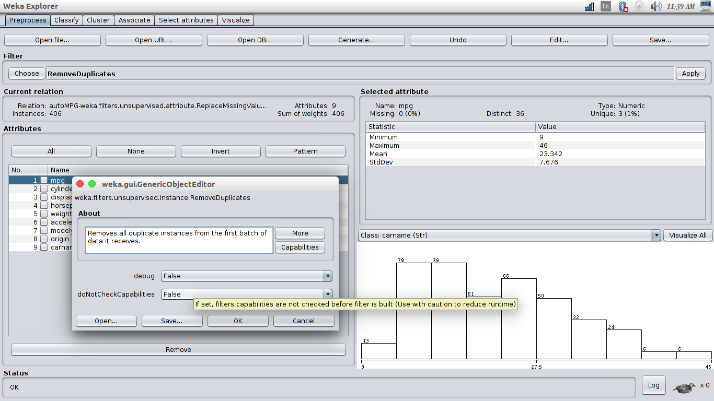

f)Using a scatter plot to visualize relationships between values in different columns

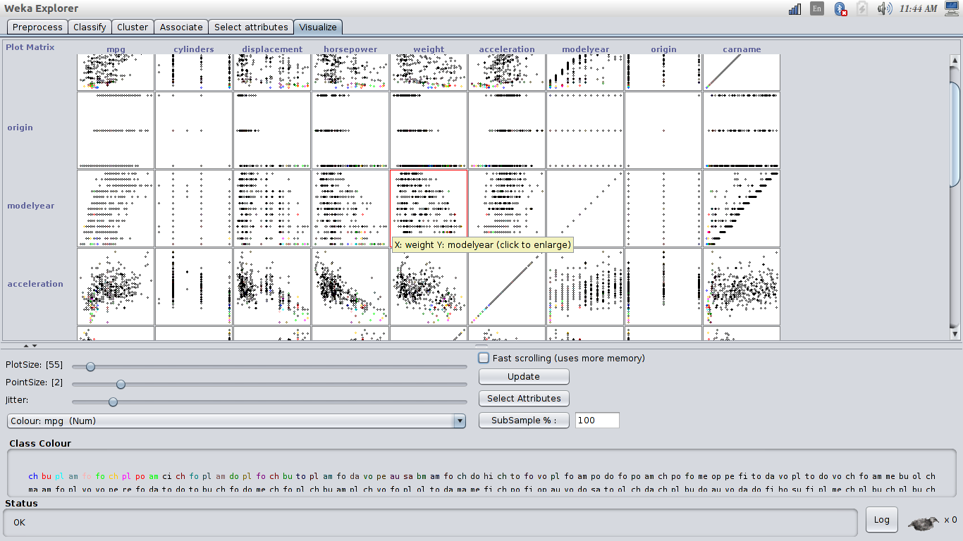

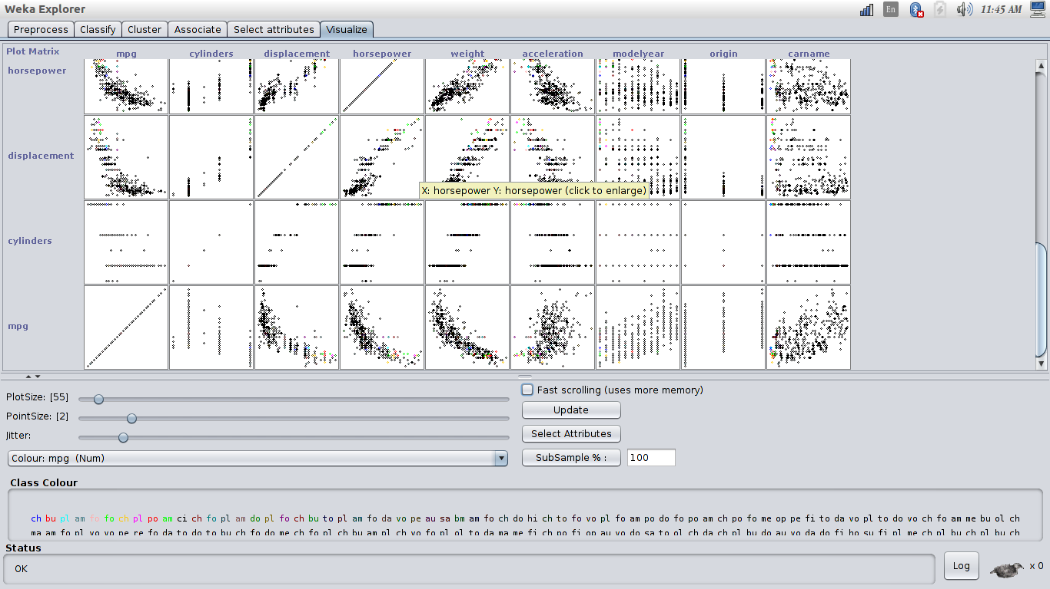

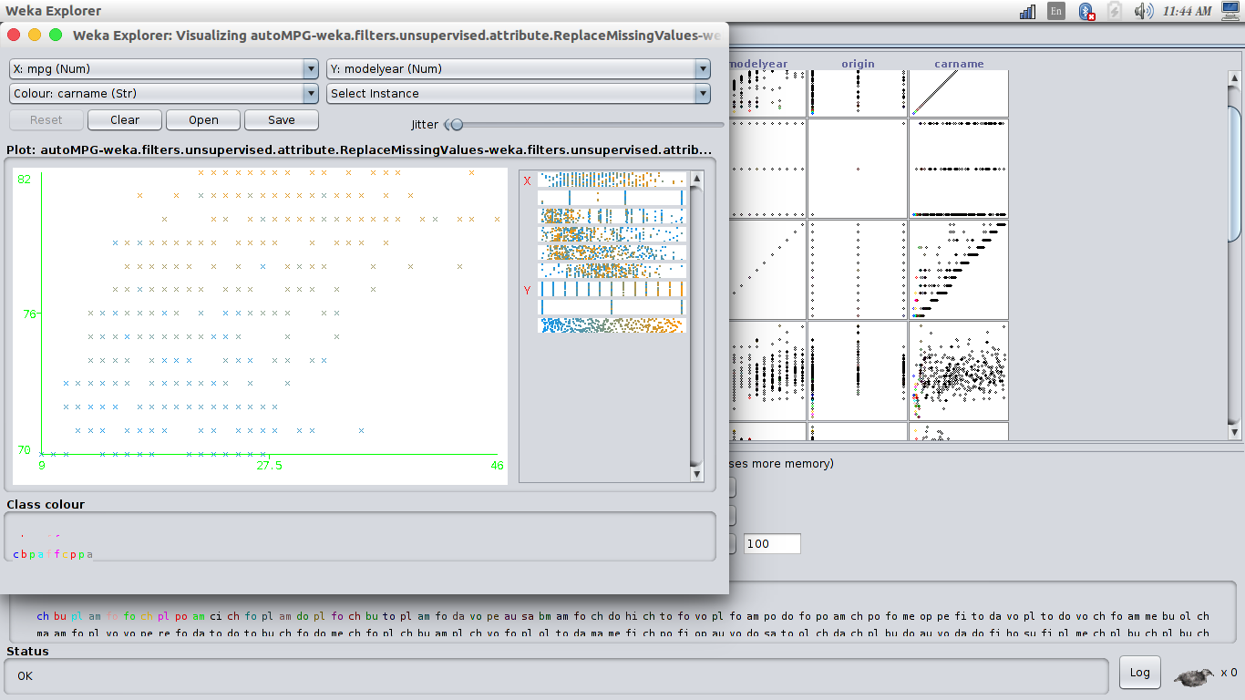
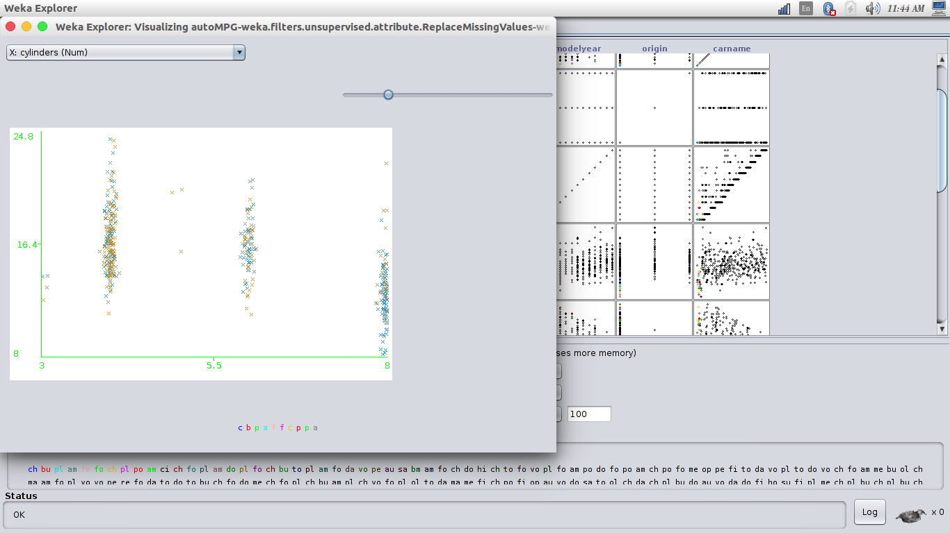

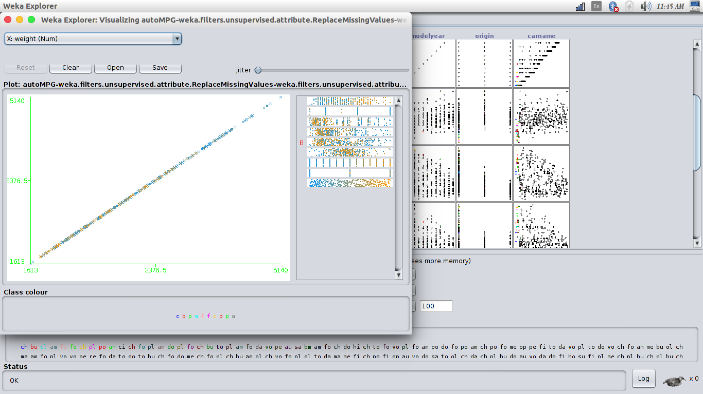
(using same attribute as x-axis and y-axis)
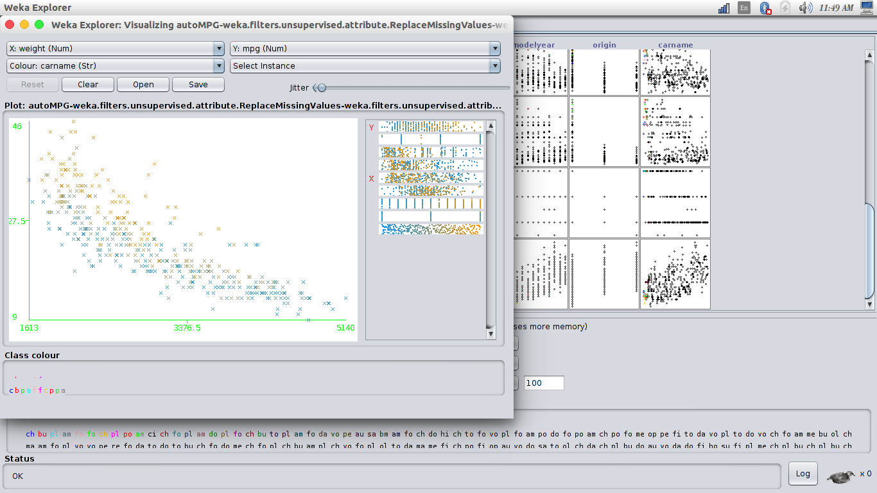

g)Exporting cleaned data to Excel

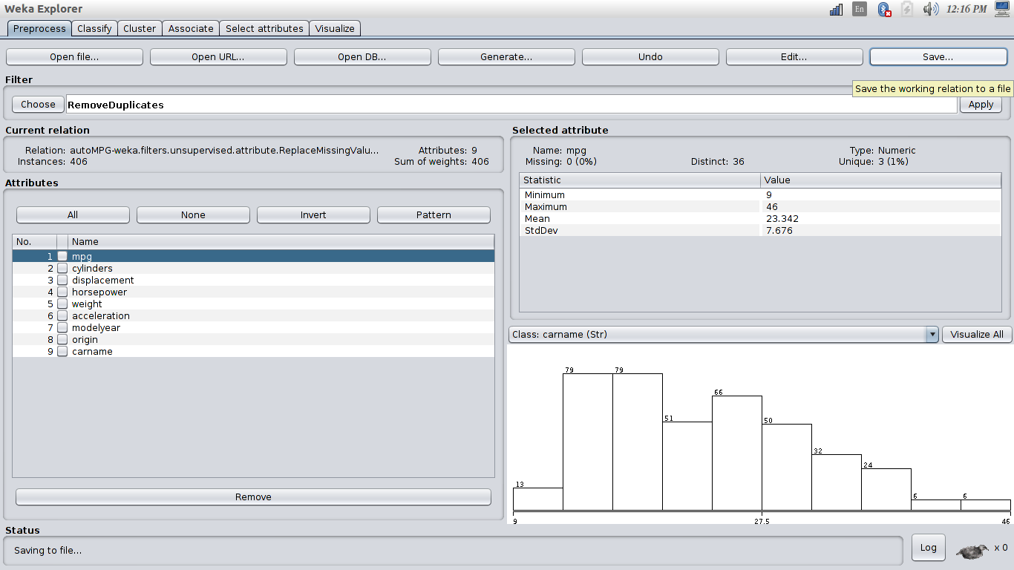
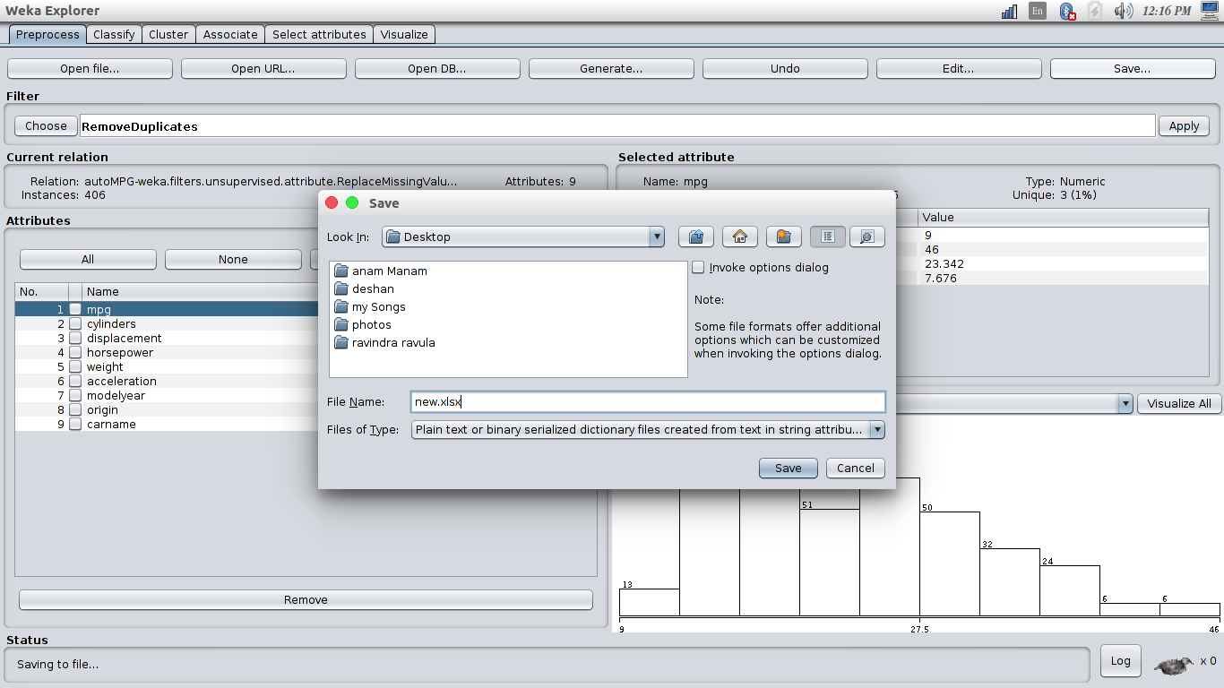

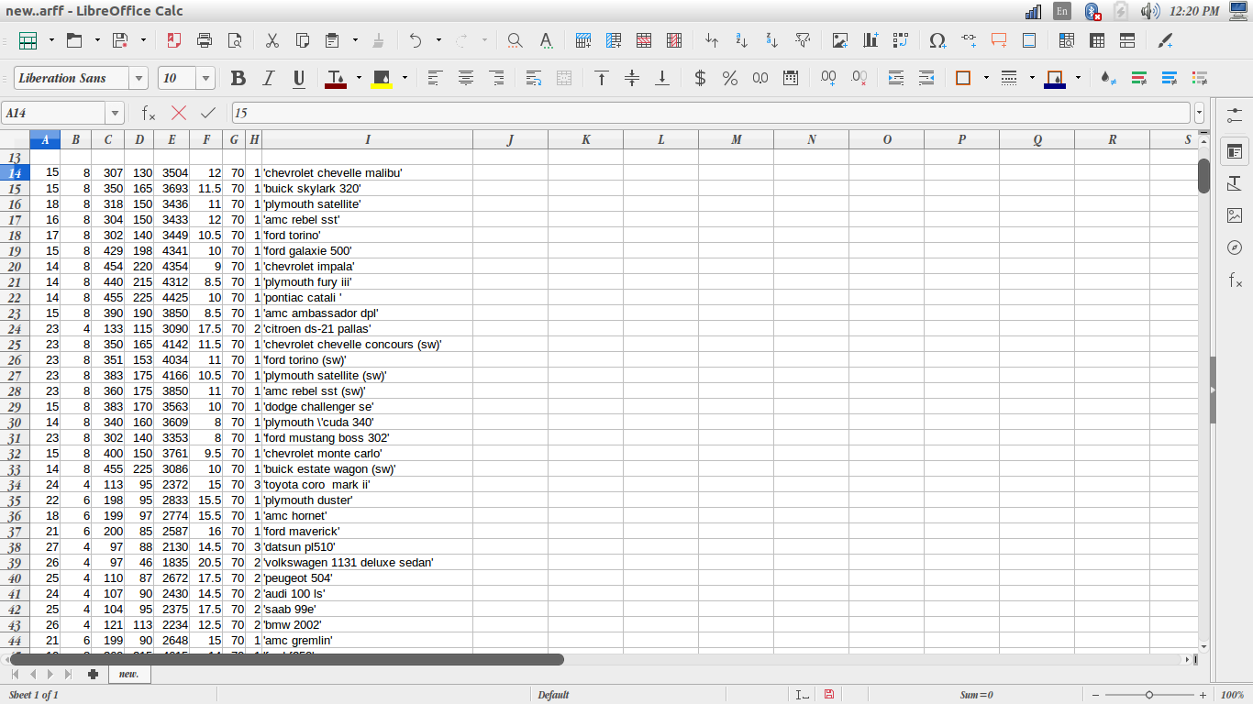

Differences of Weka And Open Refine

1) visualization of data in weka is much more clear compare to refine and easy.
The plot matrix of weka will give a good visualization and easy to understand the properties of data set.

2)weka supports histogram visualized method.but not in refine.

3)Operations like Removing Duplicates, removing inconsistent spelling of terms can be easily perform in weka.

4)Tuple format data consideration can perform in weka while column format data classification can perform in open refine.

5)Clustering and merging can perform easily in open refine compared to Weka.

6) Replacing missing Values can be perform only in weka while removing data tuples with missing value can be perform in both open refine and weka.

7) No inbuild, direct function to remove duplicate rows in open refine.but in weka .

