# Required Resources for Python and Django

## Python

1. VS Code
2. Python (latest version recommended)
3. PIP (usually gets installed while installing Python)
4. VS Code Extension:

* Code Runner
* Black Formatter
* Python
* Python Debugger
* Pylance

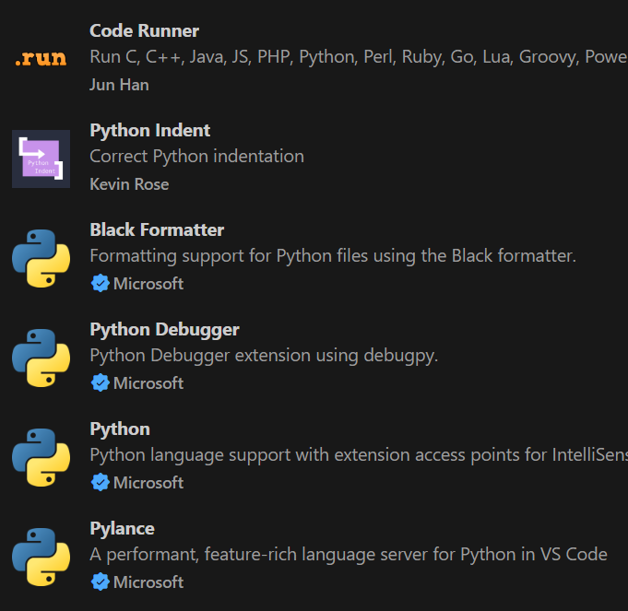

## Django

1. Virtualenv (should be installed and activated inside the project)
2. Django (install after activating virtualenv)
3. VS Code Extensions

* Django
* Django Template Support
* Djaneiro – Django Snippet

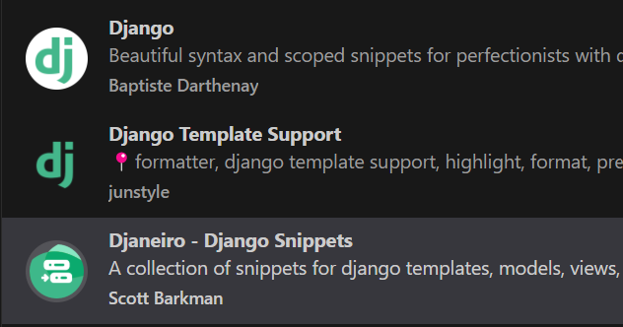

# Additional Resources

## Documentation

* Python: <https://docs.python.org/3/>
* Django: <https://docs.djangoproject.com/en/5.2/>
* Tailwind: <https://v2.tailwindcss.com/docs>

## Mentor GitHub

* <https://github.com/SumaniqueCode/SumaniqueCode>

## Mentors’ Reference Website

* <https://www.sumanr.com.np/commands>