suman@ST MINGW64 /c/ST/Automation/git&CI
$ git init
Initialized empty Git repository in C:/ST/Automation/git&CI/.git/

suman@ST MINGW64 /c/ST/Automation/git&CI (master)
$ git status
On branch master

No commits yet

nothing to commit (create/copy files and use "git add" to track)

suman@ST MINGW64 /c/ST/Automation/git&CI (master)
$ git remote add origin https://github.com/Sumanpractice/Gitpractice.git

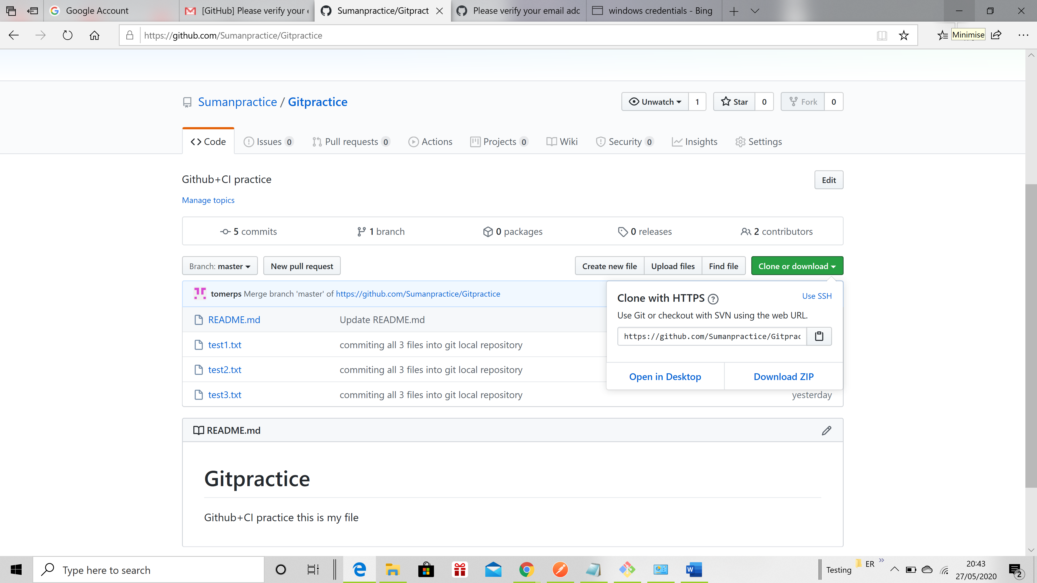git

suman@ST MINGW64 /c/ST/Automation/git&CI (master)
$ git pull origin master
remote: Enumerating objects: 3, done.
remote: Counting objects: 100% (3/3), done.
remote: Total 3 (delta 0), reused 0 (delta 0), pack-reused 0
Unpacking objects: 100% (3/3), 609 bytes | 40.00 KiB/s, done.
From https://github.com/Sumanpractice/Gitpractice
* branch master -> FETCH_HEAD
* [new branch] master -> origin/master

suman@ST MINGW64 /c/ST/Automation/git&CI (master)
$ git log
commit 642ff2953fcbbdb0f6725d914ed671cc8b22c2db (HEAD -> master, origin/master)
Author: Sumanpractice <65957317+Sumanpractice@users.noreply.github.com>
Date: Tue May 26 13:31:12 2020 +0100

Initial commit

suman@ST MINGW64 /c/ST/Automation/git&CI (master)
$ git status
On branch master
Untracked files:
(use "git add <file>..." to include in what will be committed)
test1.txt

nothing added to commit but untracked files present (use "git add" to track)

suman@ST MINGW64 /c/ST/Automation/git&CI (master)
$ git add test1.txt

suman@ST MINGW64 /c/ST/Automation/git&CI (master)
$ git commit -m"commiting my first file to local repos git rep"
[master ef3158c] commiting my first file to local repos git rep
1 file changed, 0 insertions(+), 0 deletions(-)
create mode 100644 test1.txt

suman@ST MINGW64 /c/ST/Automation/git&CI (master)
$ git status
On branch master
nothing to commit, working tree clean

suman@ST MINGW64 /c/ST/Automation/git&CI (master)
$ git status
On branch master
Changes not staged for commit:
(use "git add <file>..." to update what will be committed)
(use "git restore <file>..." to discard changes in working directory)
modified: test1.txt

Untracked files:
(use "git add <file>..." to include in what will be committed)
test2.txt
test3.txt

no changes added to commit (use "git add" and/or "git commit -a")

suman@ST MINGW64 /c/ST/Automation/git&CI (master)
$ git add -A

suman@ST MINGW64 /c/ST/Automation/git&CI (master)
$ git status
On branch master
Changes to be committed:
(use "git restore --staged <file>..." to unstage)
modified: test1.txt
new file: test2.txt
new file: test3.txt

suman@ST MINGW64 /c/ST/Automation/git&CI (master)
$ git commit -a -m"commiting all 3 files into git local repository"
[master 3043c91] commiting all 3 files into git local repository
3 files changed, 1 insertion(+)
create mode 100644 test2.txt
create mode 100644 test3.txt

suman@ST MINGW64 /c/ST/Automation/git&CI (master)
$ git log
commit 3043c91f140bc8b95f865d395dfffc8397c22a73 (HEAD -> master)
Author: suman tomer <tomerps@gmail.com>
Date: Tue May 26 18:37:20 2020 +0100

commiting all 3 files into git local repository

commit ef3158cbbc0a796450fc9640ba643e8db6cc8e1b
Author: suman tomer <tomerps@gmail.com>
Date: Tue May 26 18:27:12 2020 +0100

commiting my first file to local repos git rep

commit 642ff2953fcbbdb0f6725d914ed671cc8b22c2db (origin/master)
Author: Sumanpractice <65957317+Sumanpractice@users.noreply.github.com>
Date: Tue May 26 13:31:12 2020 +0100

Initial commit

suman@ST MINGW64 /c/ST/Automation/git&CI (master)
$ git push origin master
remote: Permission to Sumanpractice/Gitpractice.git denied to tomerps.
fatal: unable to access 'https://github.com/Sumanpractice/Gitpractice.git/': The requested URL returned error: 403

suman@ST MINGW64 /c/ST/Automation/git&CI (master)

$ ^C

Sometimes it ask username and password
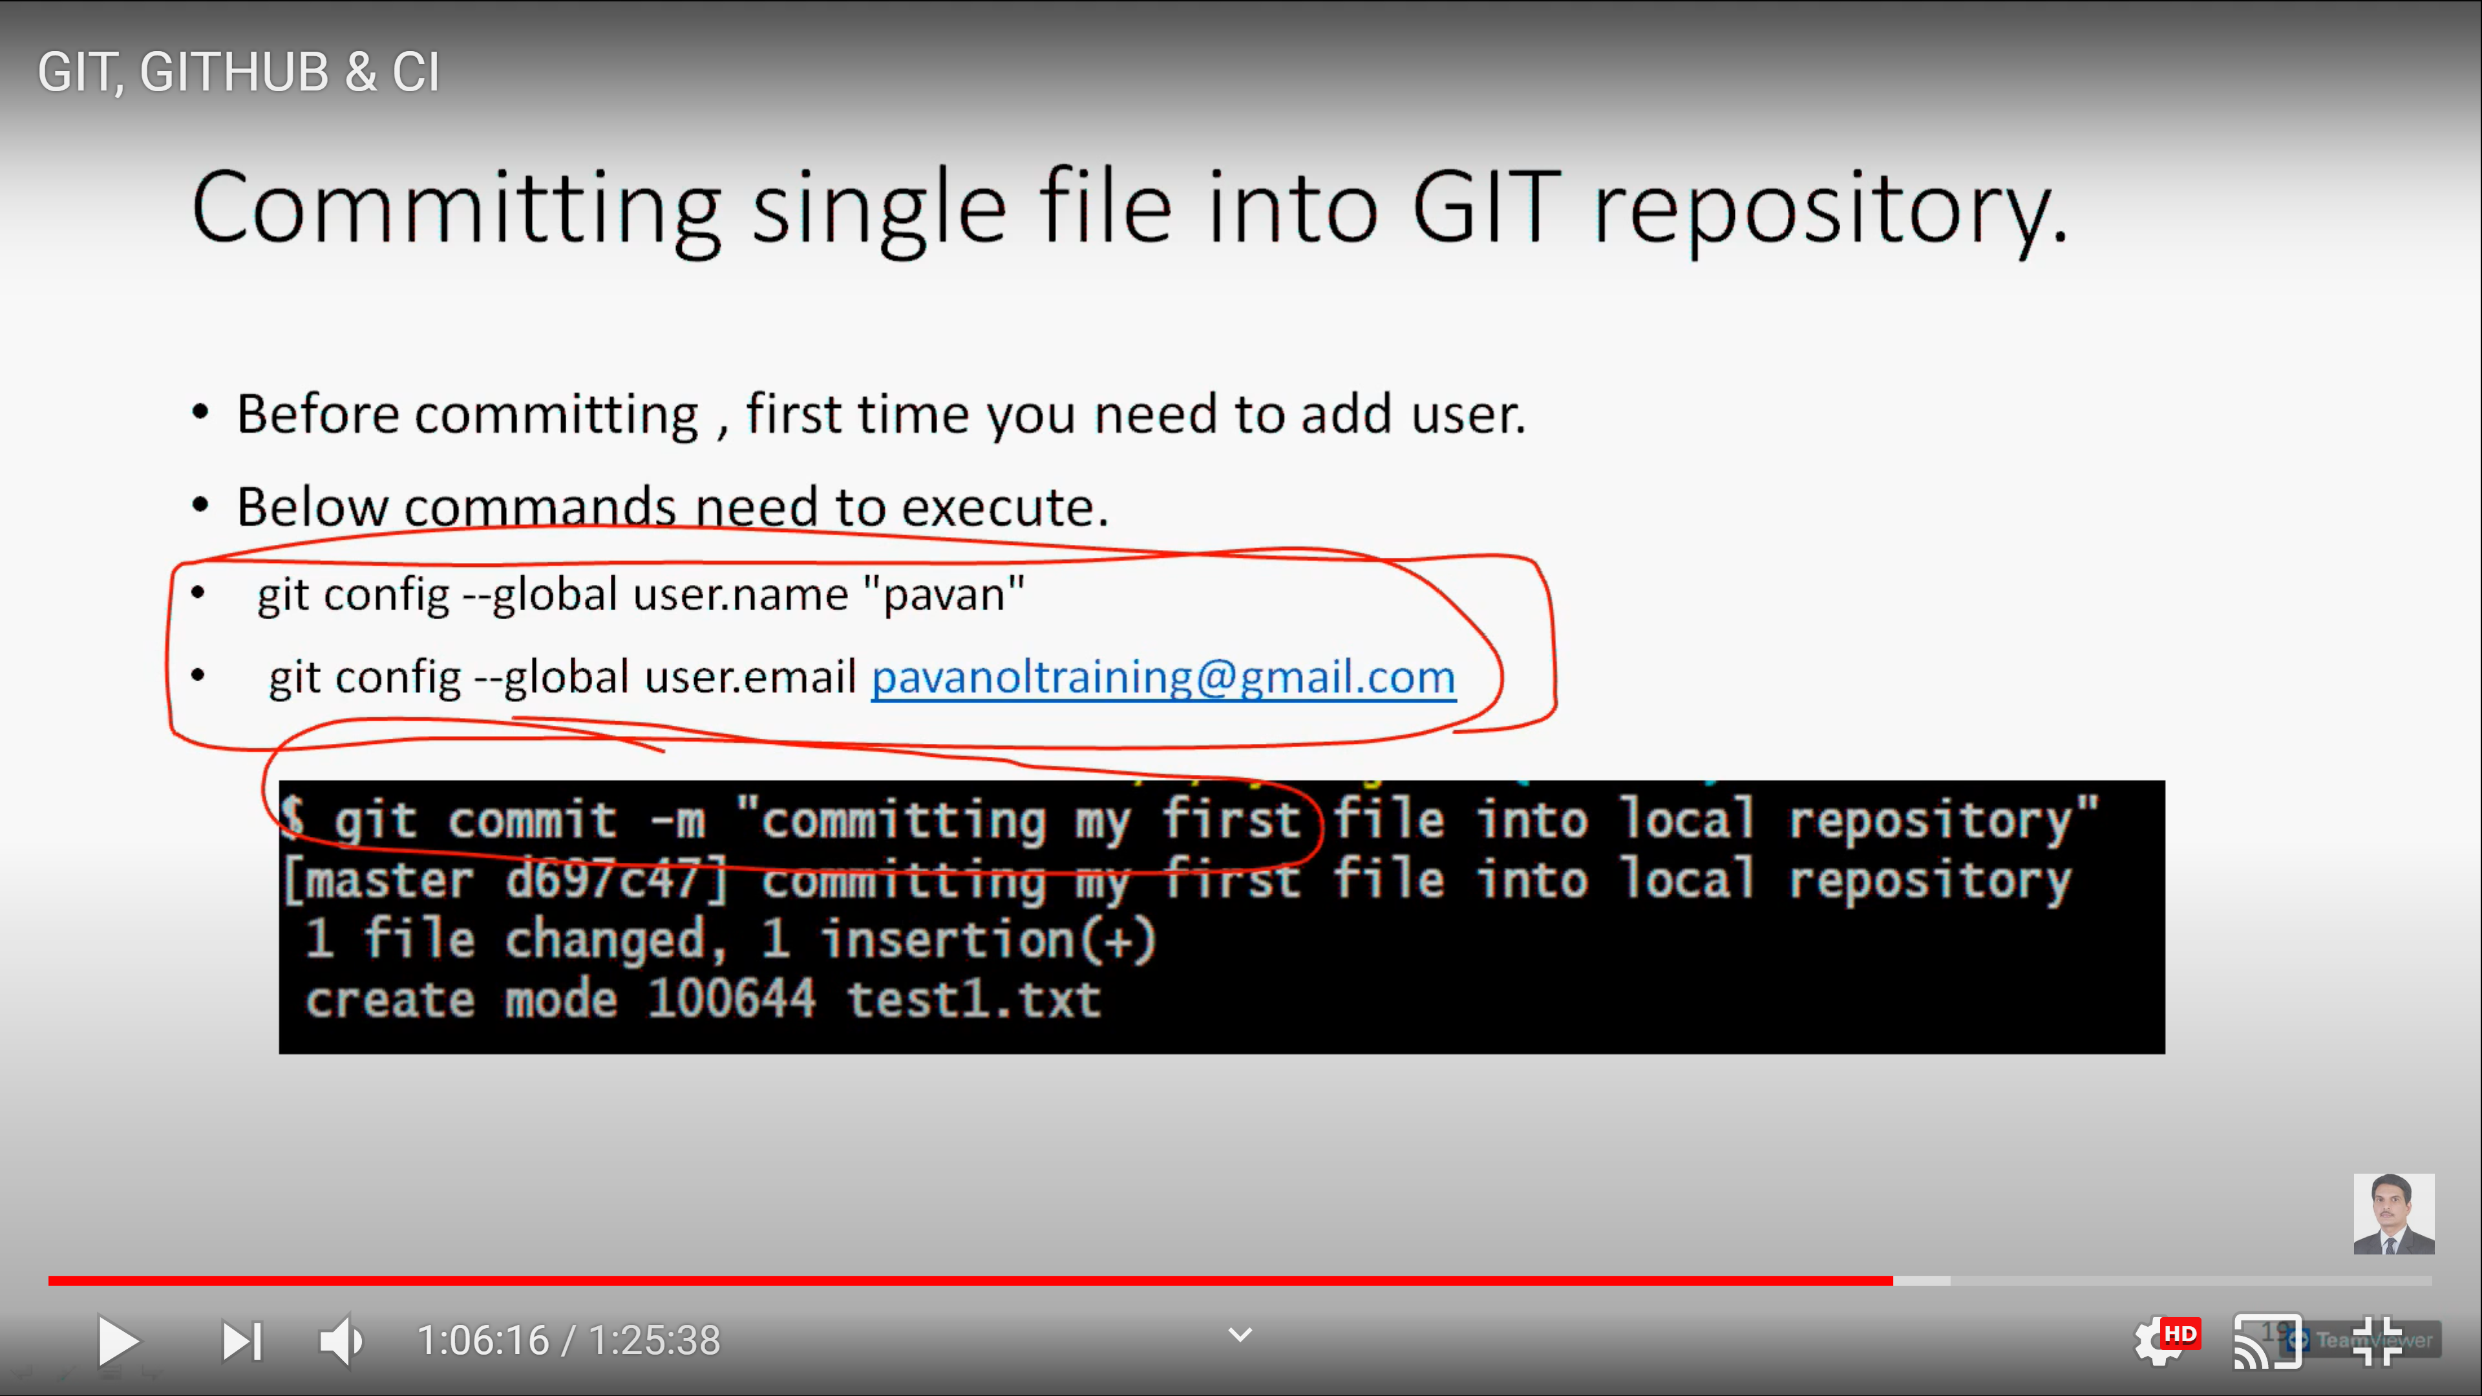

Or u need to change windows credentials username and password if Github
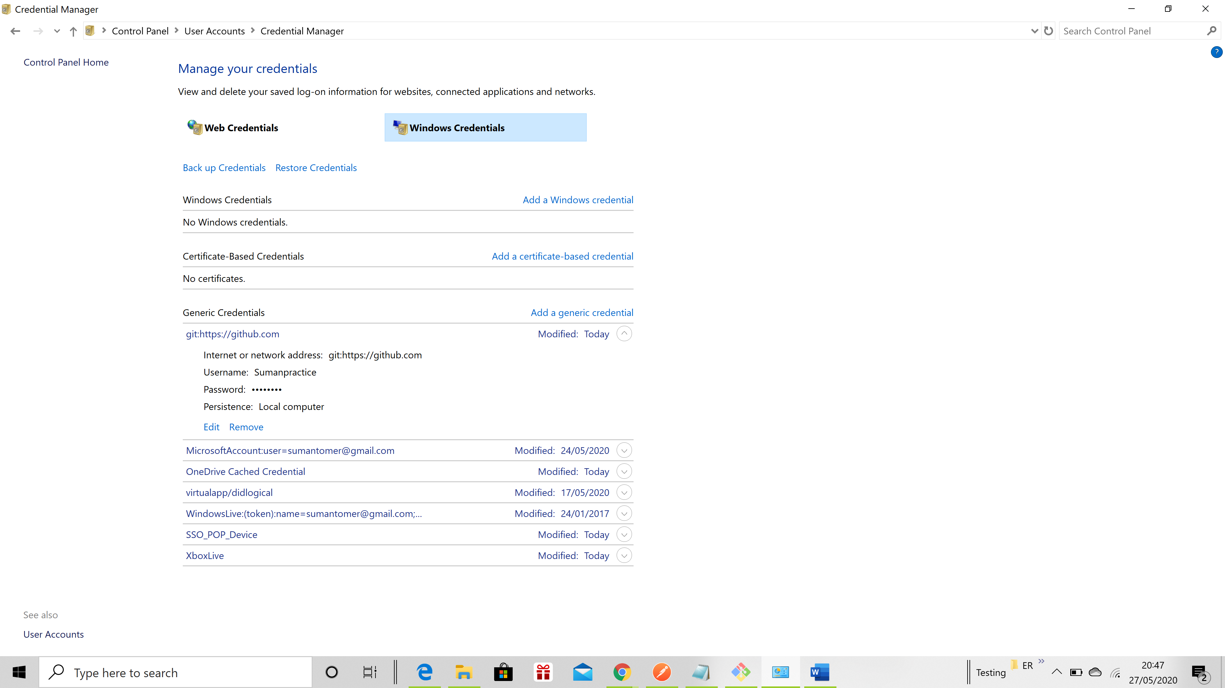

suman@ST MINGW64 /c/ST/Automation/git&CI (master)
$ git push origin master
To https://github.com/Sumanpractice/Gitpractice.git
! [rejected] master -> master (fetch first)
error: failed to push some refs to 'https://github.com/Sumanpractice/Gitpractice.git'
hint: Updates were rejected because the remote contains work that you do
hint: not have locally. This is usually caused by another repository pushing
hint: to the same ref. You may want to first integrate the remote changes
hint: (e.g., 'git pull ...') before pushing again.
hint: See the 'Note about fast-forwards' in 'git push --help' for details.

suman@ST MINGW64 /c/ST/Automation/git&CI (master)
$ ^C

suman@ST MINGW64 /c/ST/Automation/git&CI (master)
$ git pull origin master
remote: Enumerating objects: 5, done.
remote: Counting objects: 100% (5/5), done.
remote: Total 3 (delta 0), reused 0 (delta 0), pack-reused 0
Unpacking objects: 100% (3/3), 661 bytes | 34.00 KiB/s, done.
From https://github.com/Sumanpractice/Gitpractice
* branch master -> FETCH_HEAD
642ff29..6b020de master -> origin/master
Merge made by the 'recursive' strategy.
README.md | 1 +
1 file changed, 1 insertion(+)

suman@ST MINGW64 /c/ST/Automation/git&CI (master)
$ git push origin master
Enumerating objects: 10, done.
Counting objects: 100% (10/10), done.
Delta compression using up to 4 threads
Compressing objects: 100% (6/6), done.
Writing objects: 100% (8/8), 946 bytes | 473.00 KiB/s, done.
Total 8 (delta 0), reused 0 (delta 0), pack-reused 0
To https://github.com/Sumanpractice/Gitpractice.git
6b020de..0d2b797 master -> master

suman@ST MINGW64 /c/ST/Automation/git&CI (master)
$

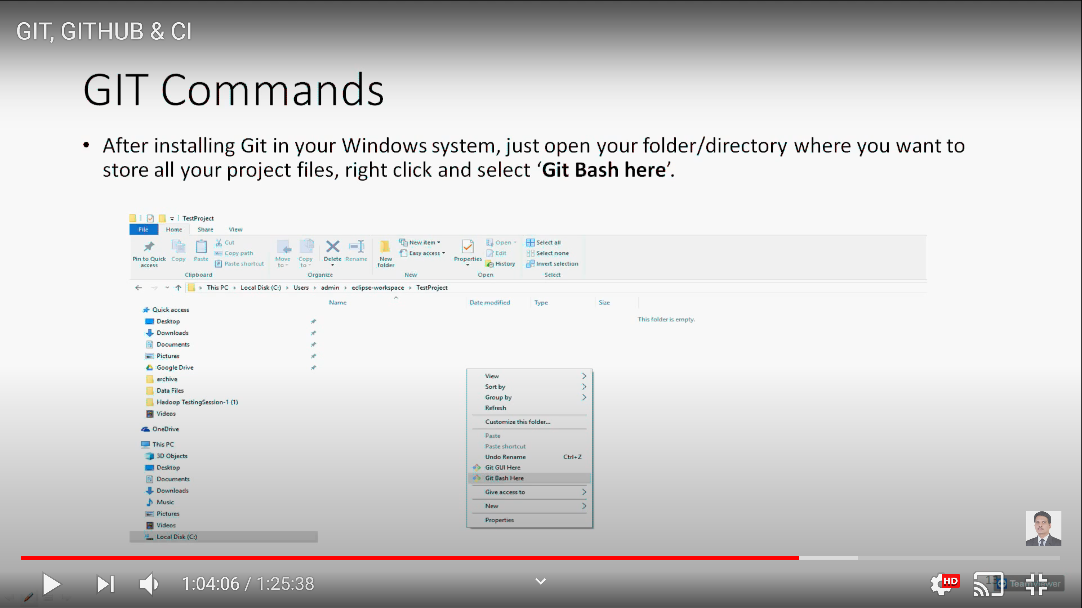
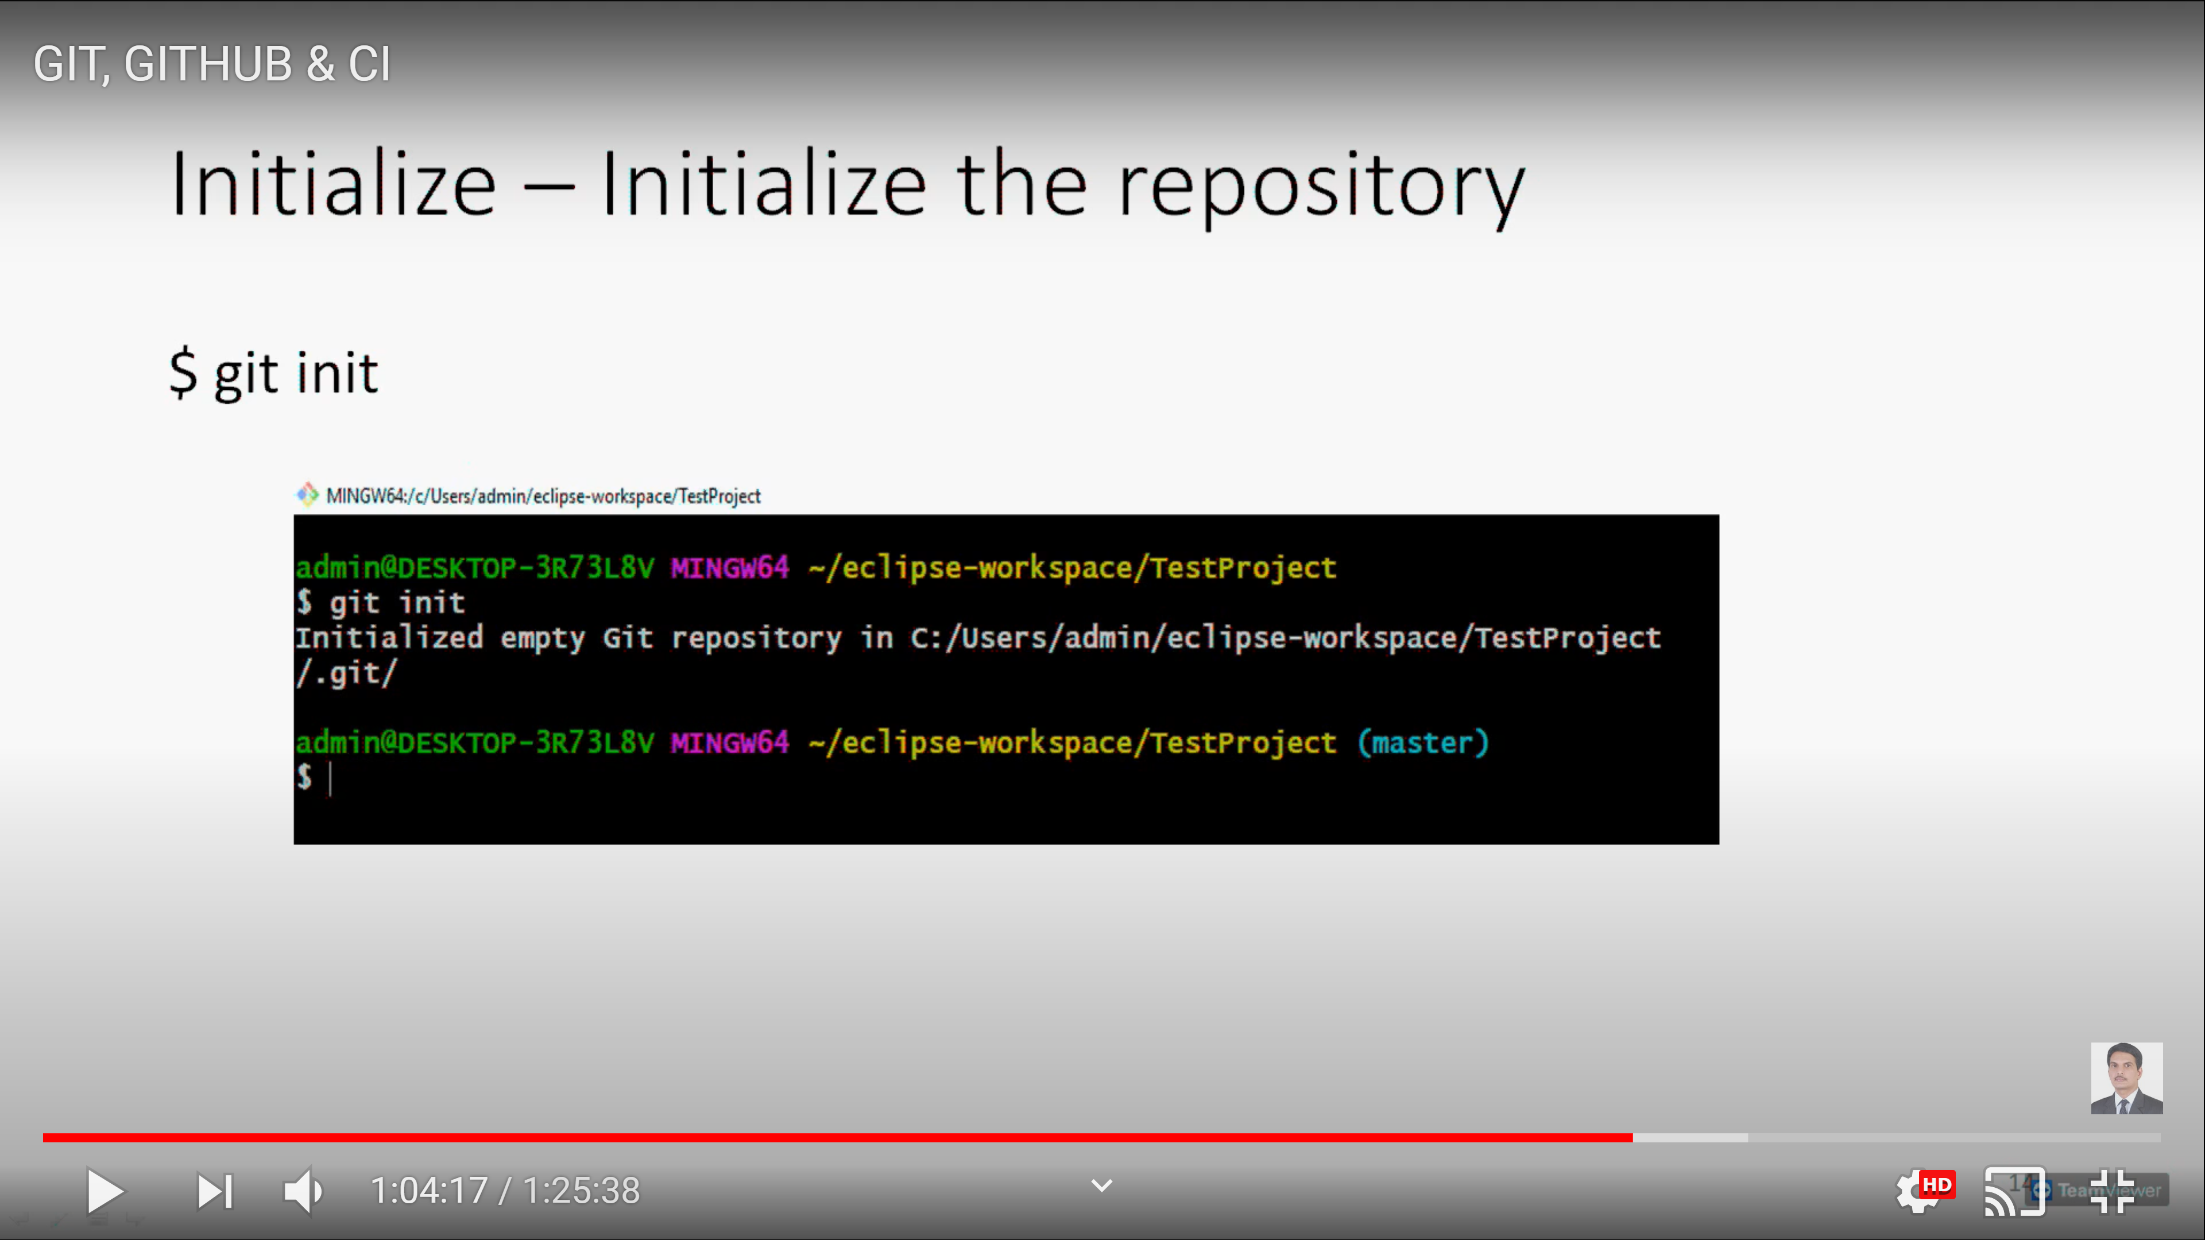
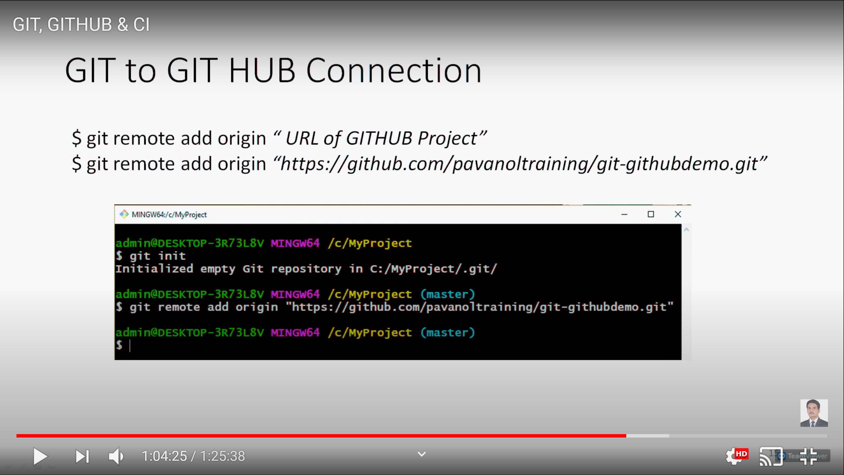
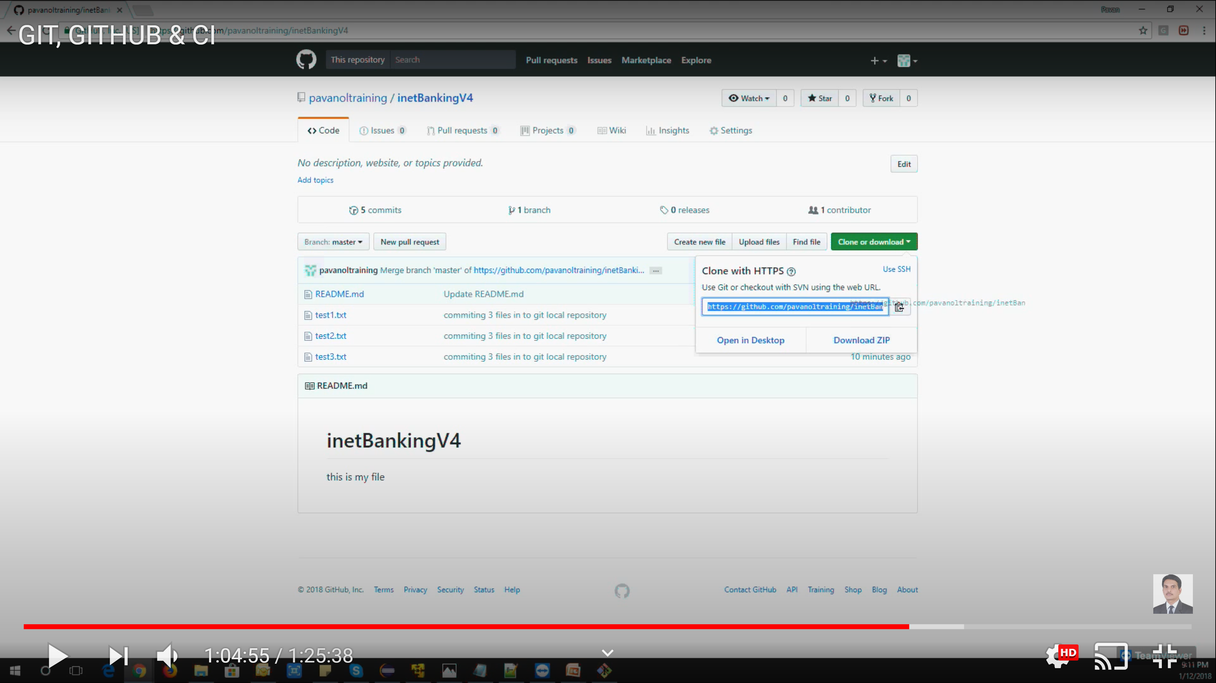
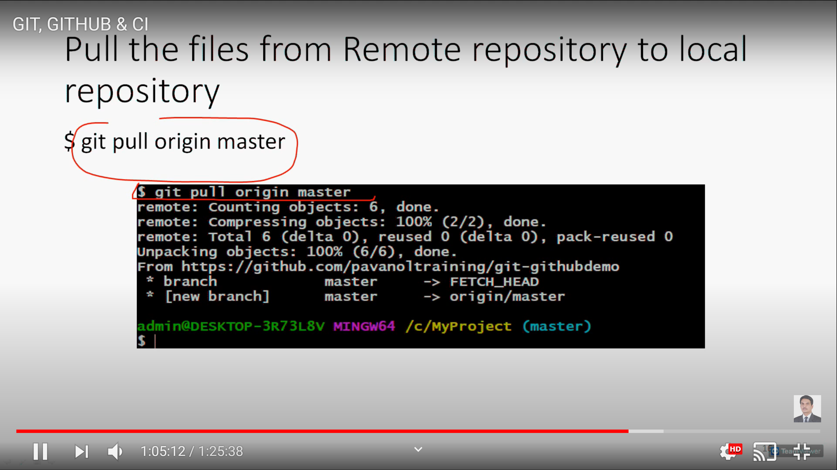
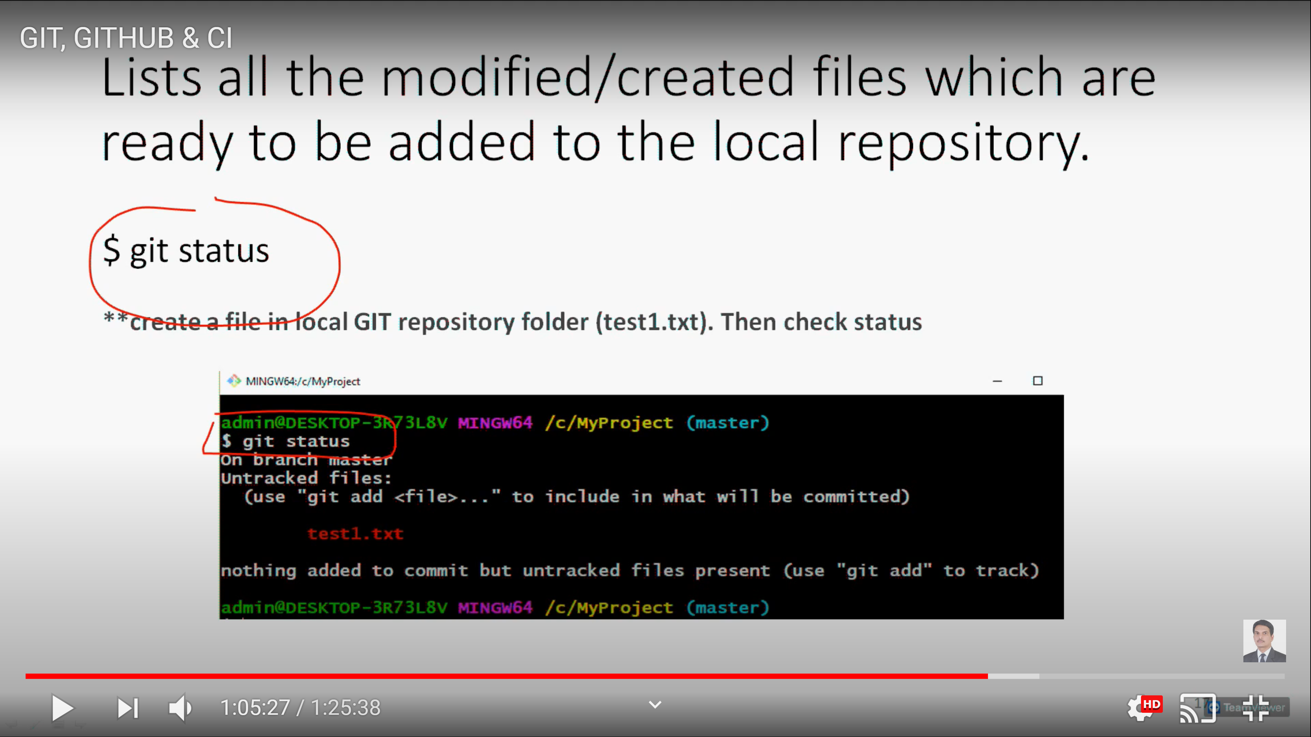
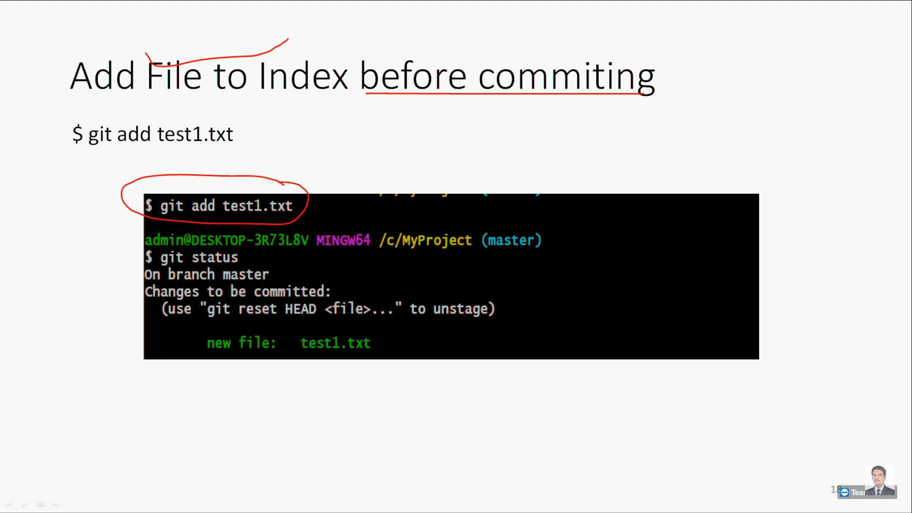
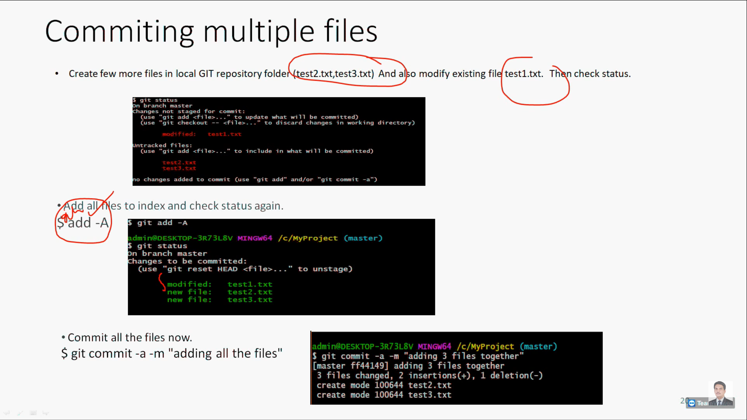
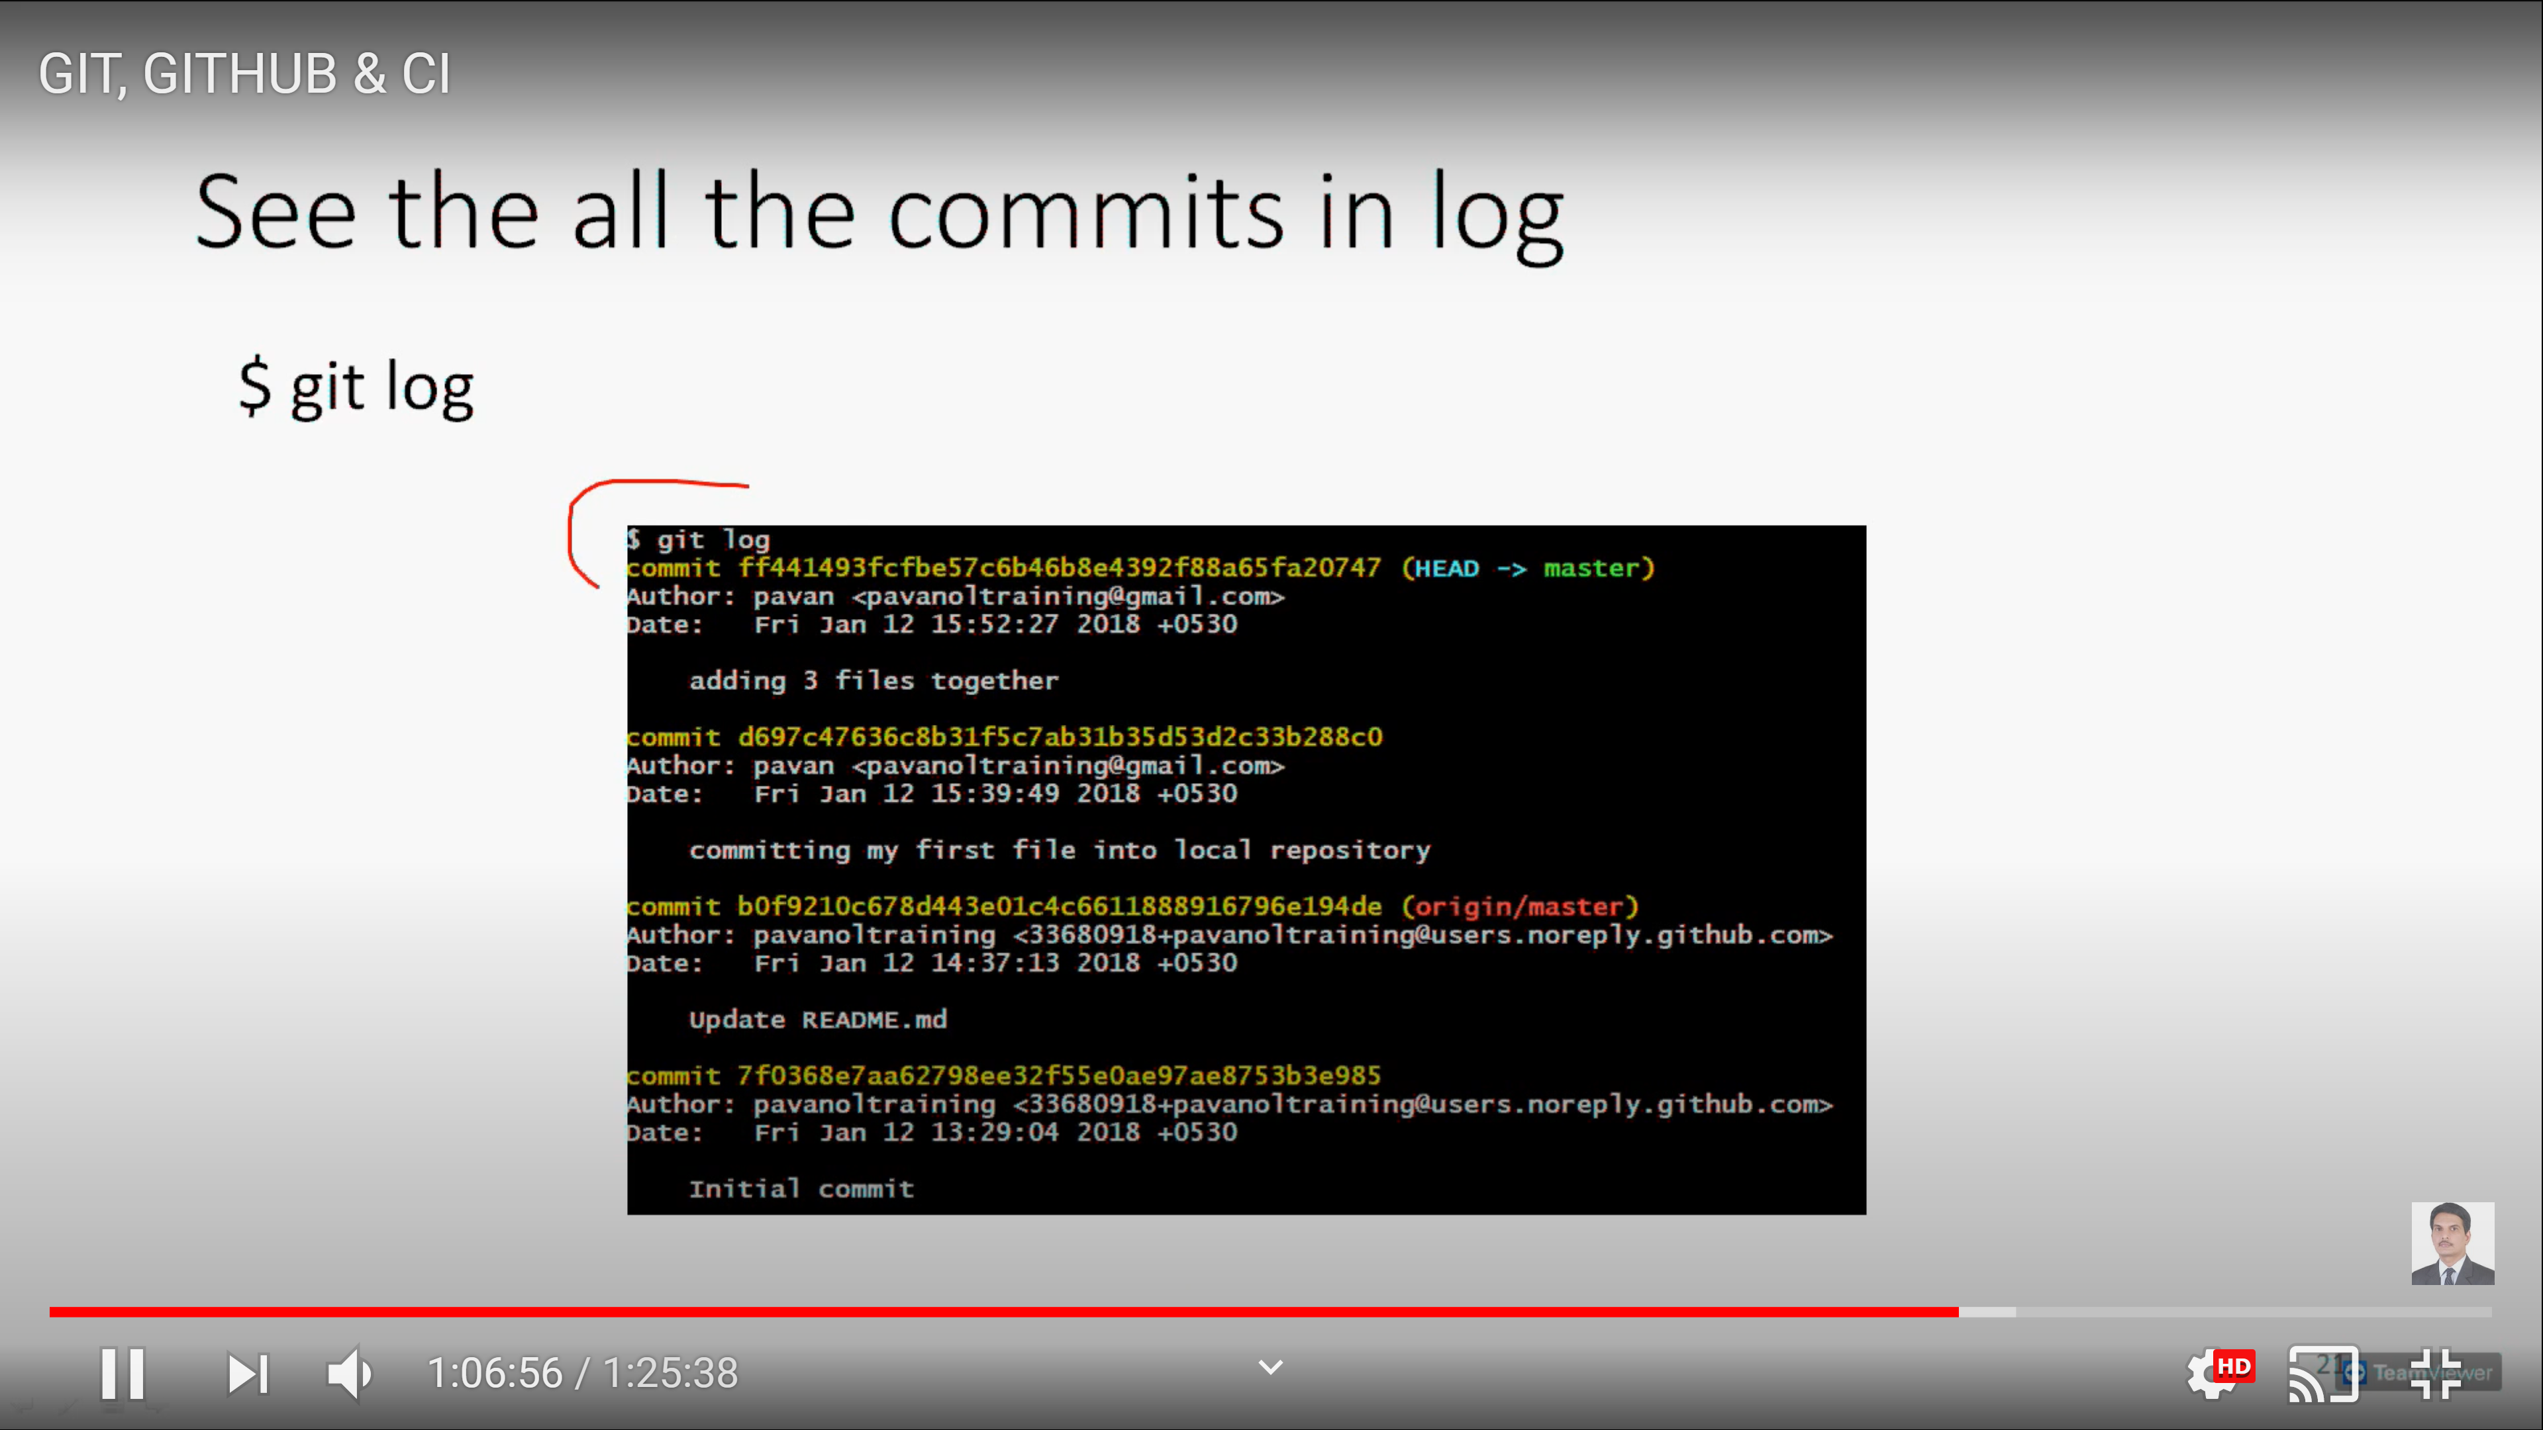
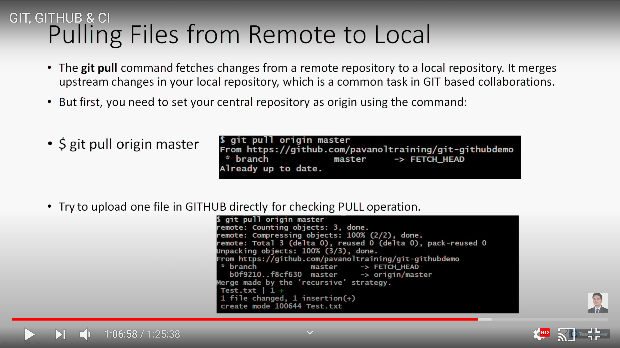
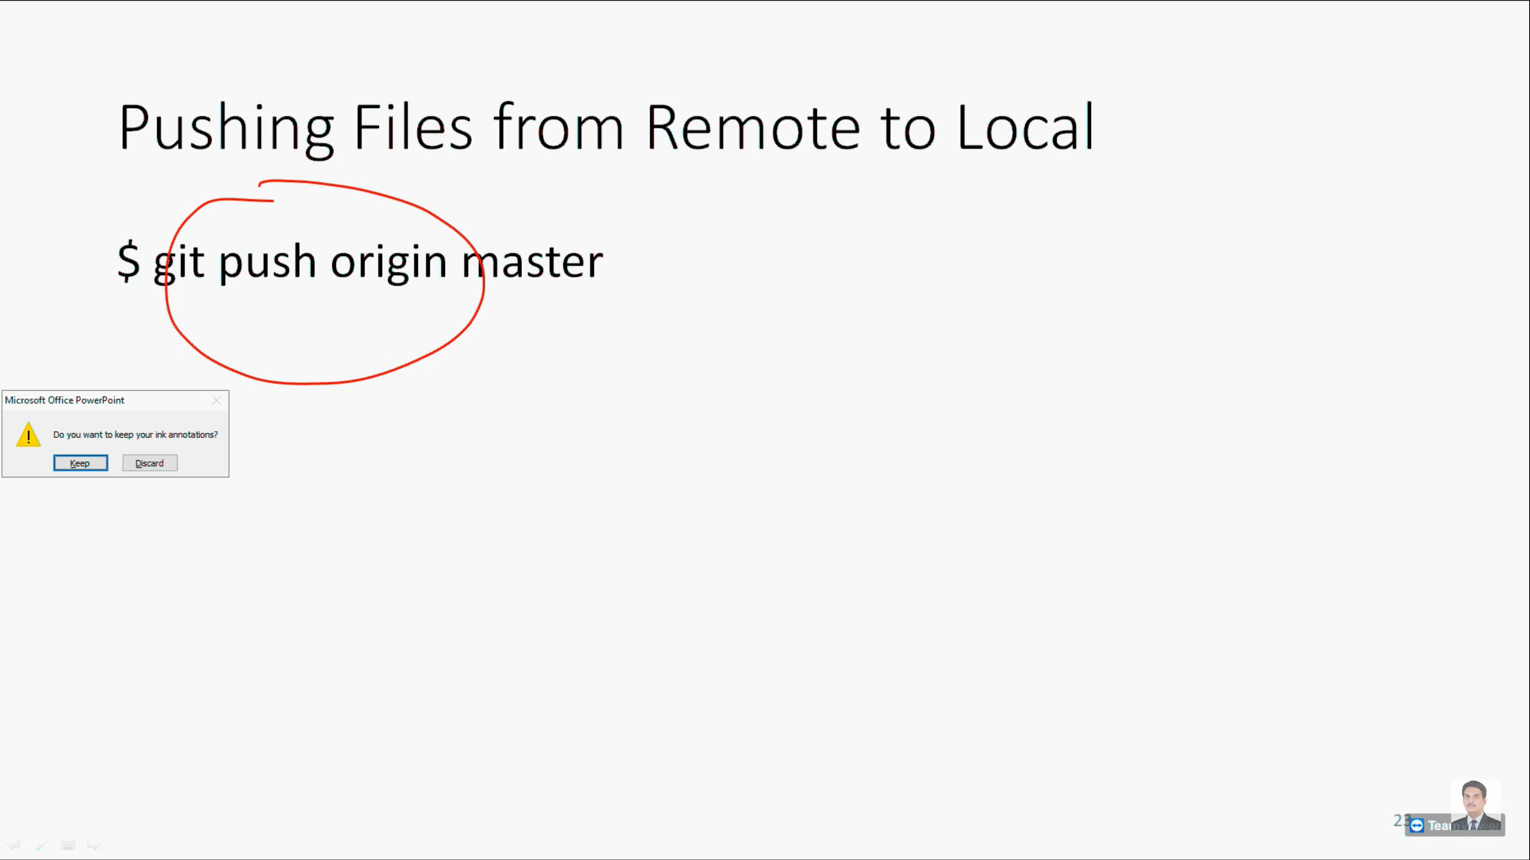

To change from ORIGIN to another name

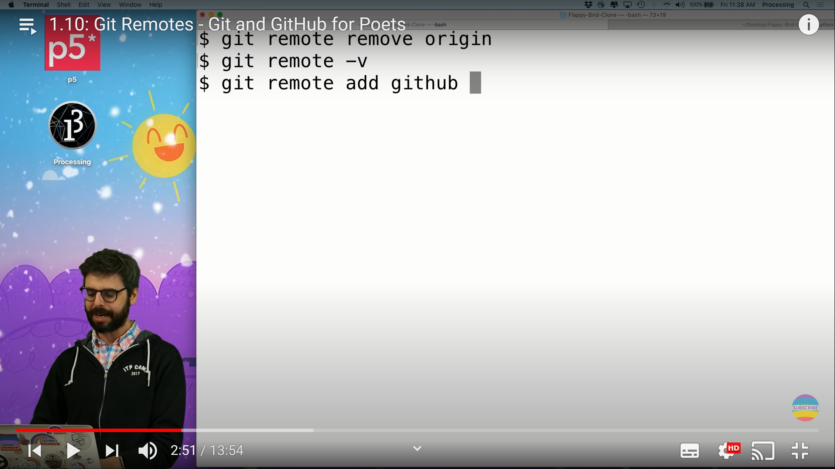
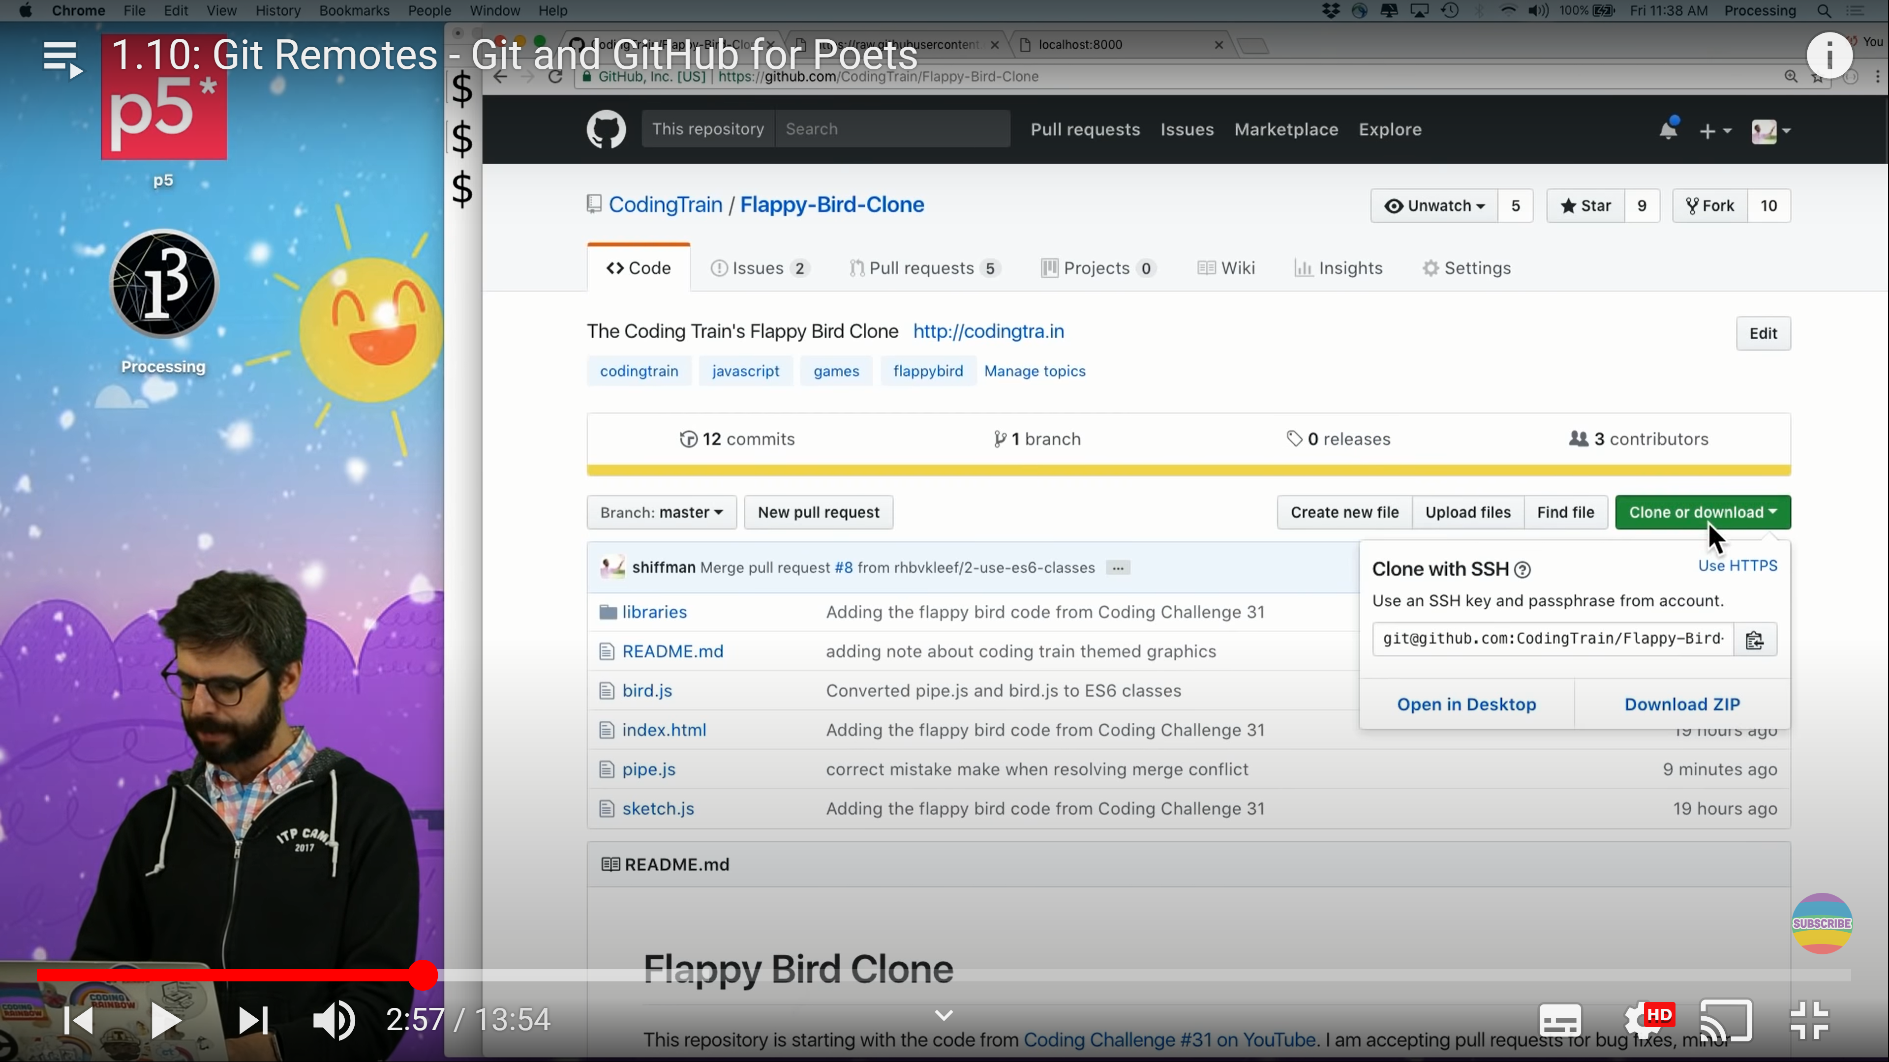
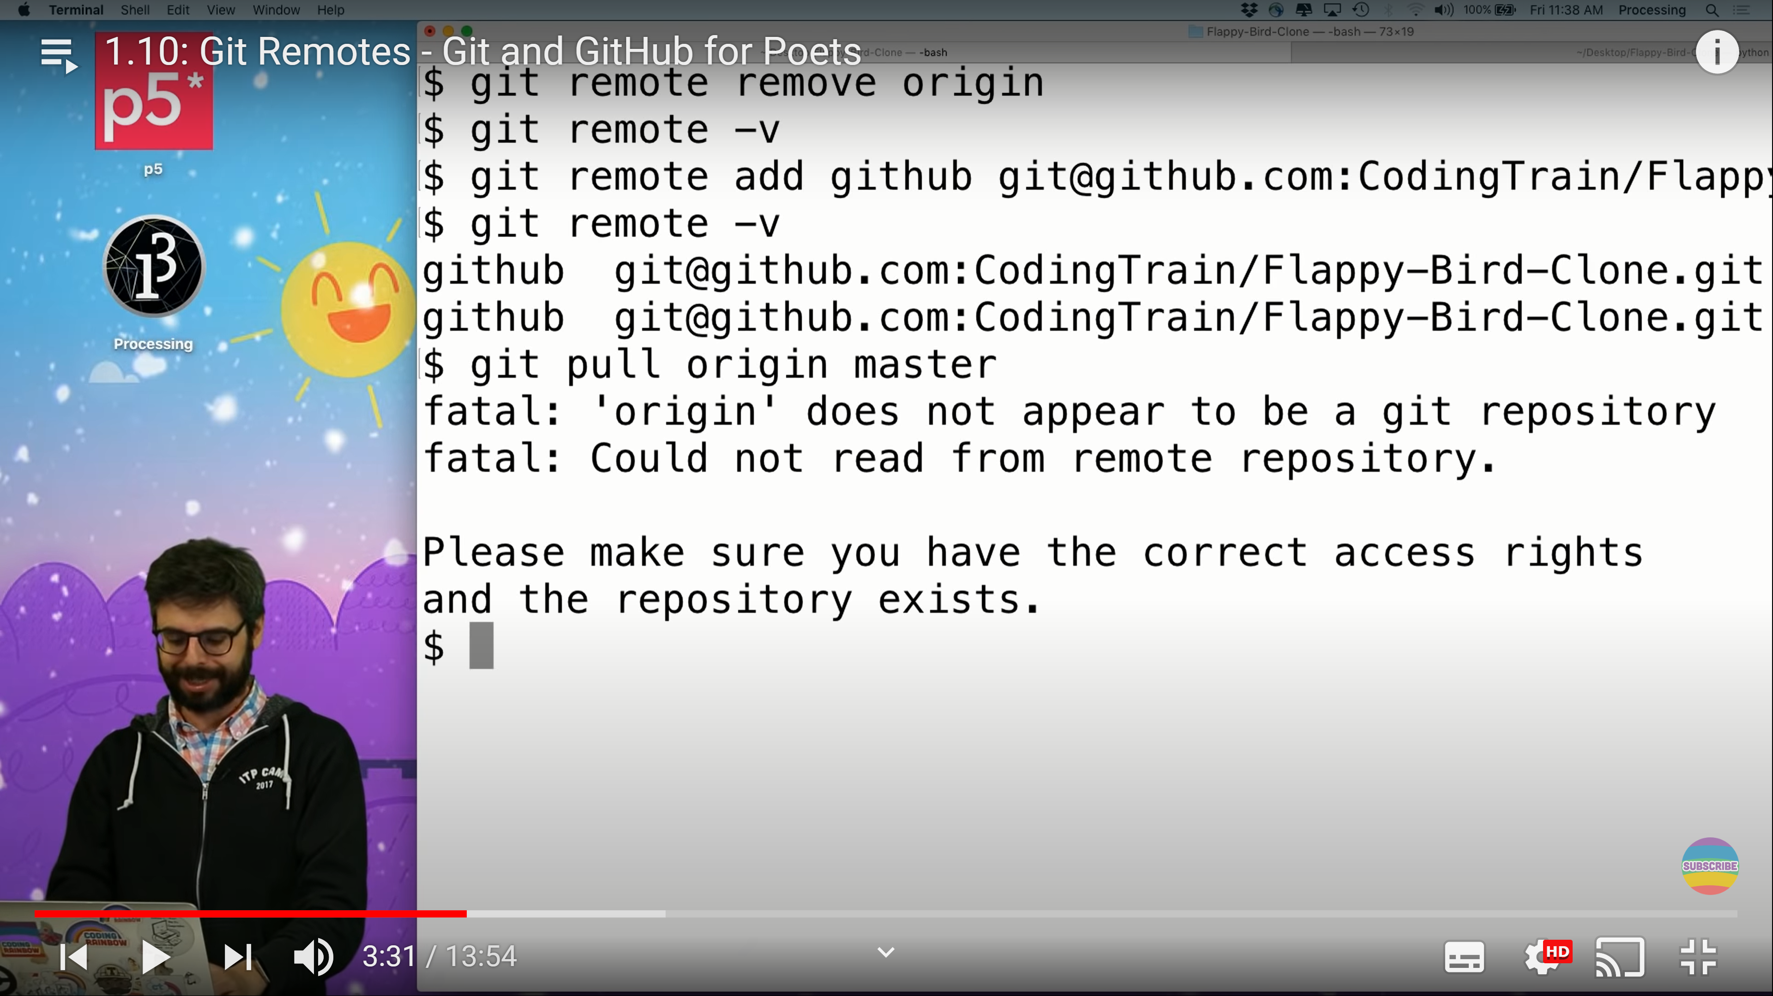
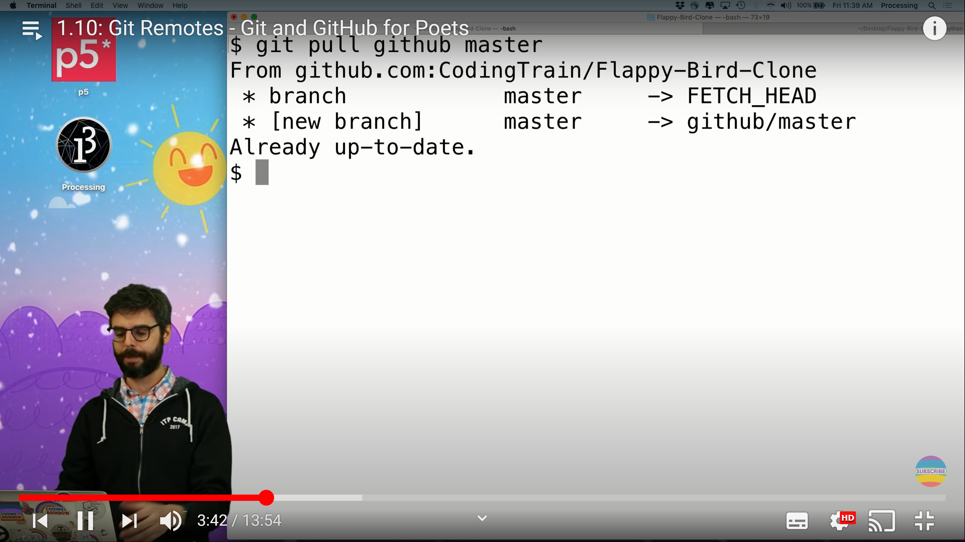
Kegham has done changesin graphics file so how to go there
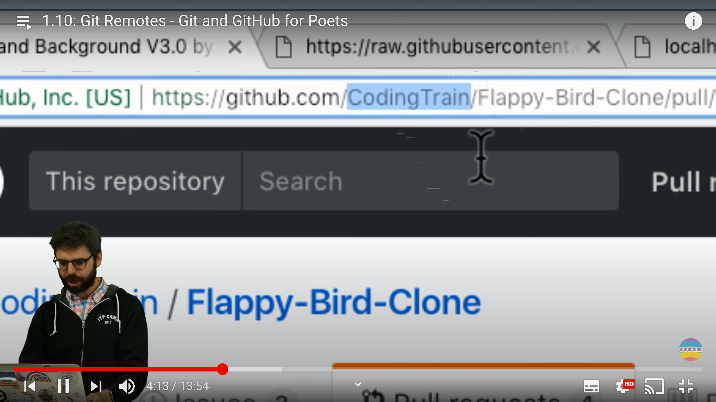
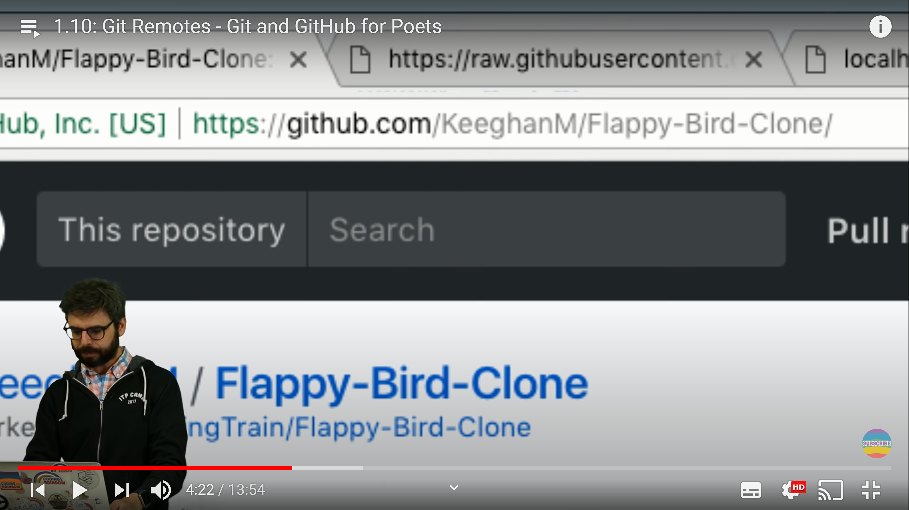
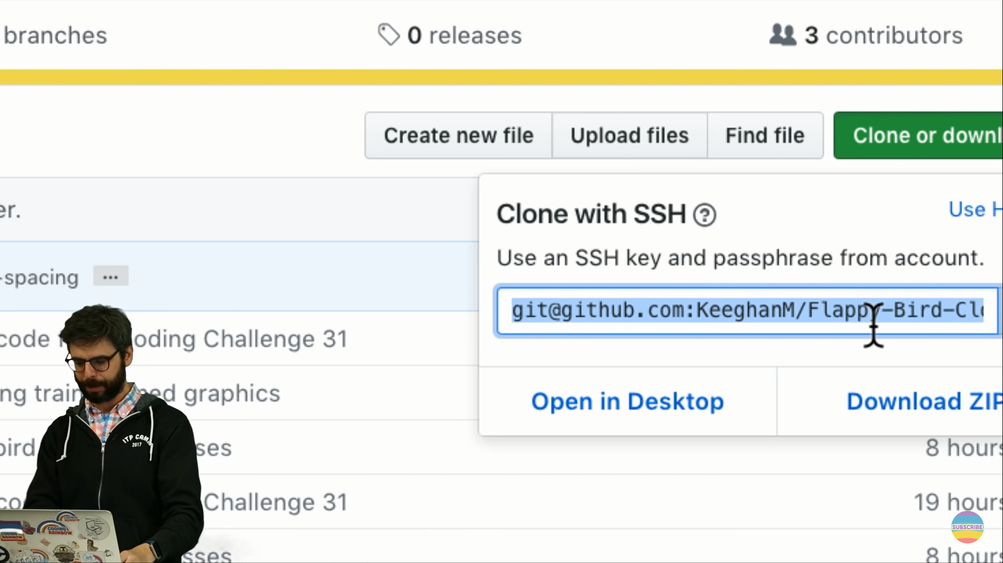
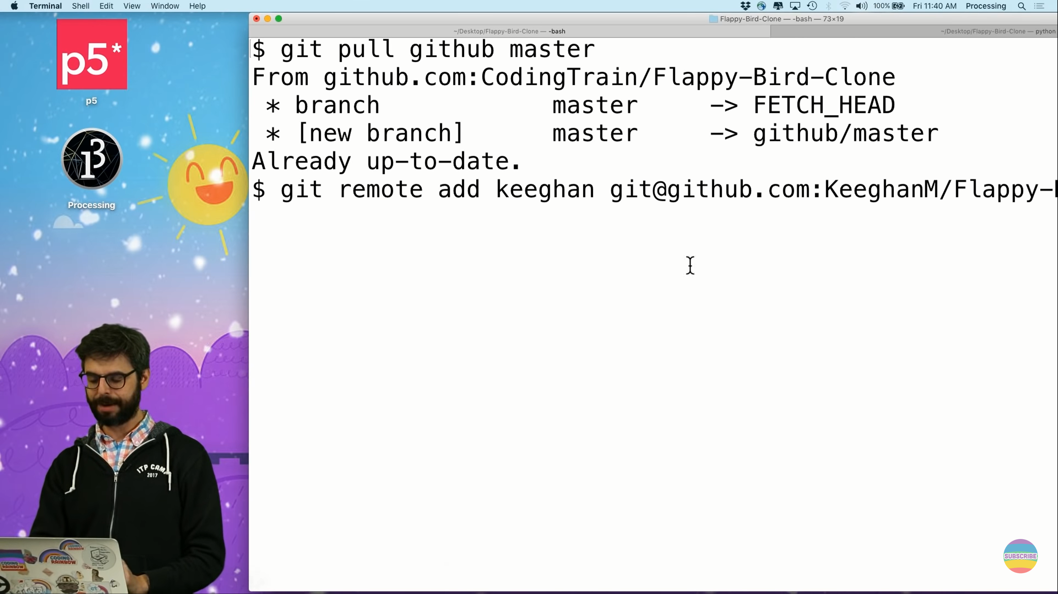
POSTMAN


