**Assignmnet_6 [SUBQUERIES]**

* CREATING DATABASE AND TABLE

create database assignment6;

use assignment6;

* TABLE 1

create table employee(emp_id int,

name varchar(50),

department varchar(50),

salary int);

insert into employee(emp_id, name, department, salary)

values (1,'John','HR',5000),

(2,'Alice','IT',7000),

(3,'Bob','Finance',6000),

(4,'Eve','IT',8000),

(5,'Charlie','Finance',7500);

select * from employee;

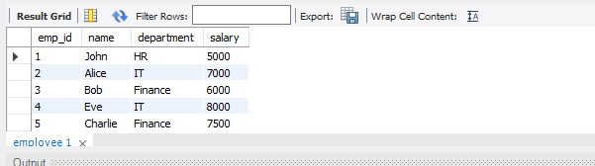

* TABLE 2

create table departments(dept_id int,dept_name varchar(50));

insert into departments(dept_id,dept_name)

values(1,'HR'),

(2,'IT'),

(3,'Finance');

select * from departments;

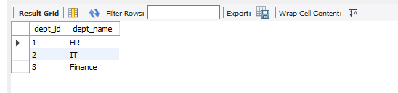

1. Find employees with salaries greater than the average salary of all employees.

select name from employee where salary >(select avg(salary) from employee);

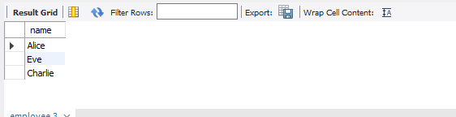

1. Find employees whose salary is higher than the salary of 'Alice'.

select name from employee where salary > (select salary from employee where name = 'Alice');

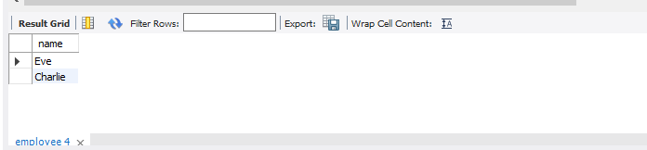

1. List employees who belong to a department that has the name 'IT'.

select name from employee where department = 'IT';

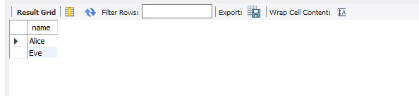

1. Get the names of employees who earn the highest salary in their department.

select department,name from employee where department = (select department from employee group by department having salary = max(salary));

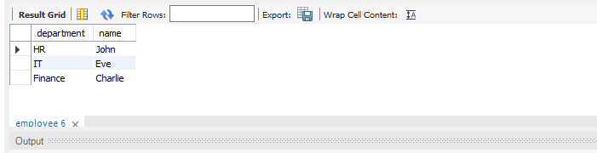

1. Retrieve the departments where at least one employee earns more than 7000.

select department from employee where emp_id in (select emp_id from employee group by emp_id having salary>7000 );

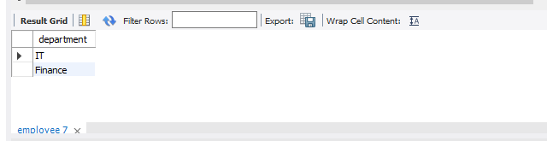

1. List employees who do not belong to any department in the departments table.

select name from employee where department not in (select dept_name from departments );

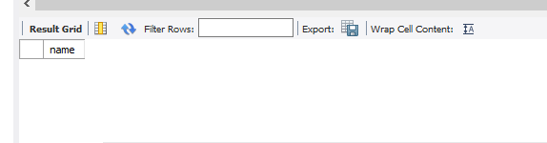

1. Find the second-highest salary among employees.

select max(salary) from employee where salary < (select max(salary) from employee);

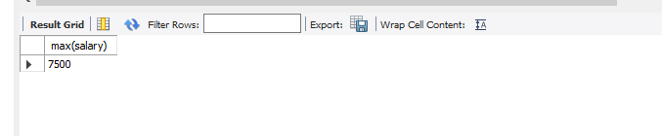

1. Retrieve the names of employees who work in the department with the highest number of employees.

with DepartmentCounts as (select department,COUNT(*) as EmployeeCount from employee group by Department)select e.name from employee e inner join DepartmentCounts dc on e.Department = dc.Department where dc.employeeCount = (select max(employeeCount) from DepartmentCounts);

ALSO BY :- select name from employee where department = (select department from employee group by department order by count(emp_id) desc limit 1);



1. Find employees who earn more than the average salary in their department.

select e.name, e.Department, e.Salary, d.AvgSalary from employee e join (select Department, avg(Salary) as AvgSalary from employee group by Department) d on e.Department = d.Department where e.Salary > d.AvgSalary;

select name,department,salary from employee e1 where salary > (select avg(salary) from employee e2 where e1.department = e2.department);

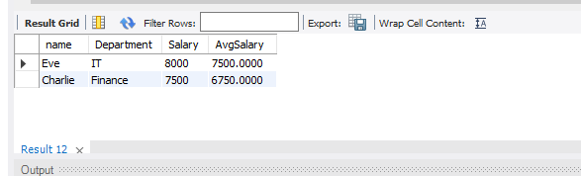

10. Retrieve employees whose salary is above 7000 and belong to departments in the

departments table.

select name, department from employee e where emp_id in (select e.emp_id from departments d group by d.dept_id having salary>7000 );

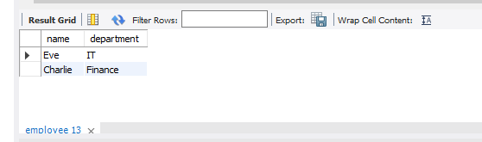

1. List all departments that have no employees.

select name,department from employee where department in (select department from employee where emp_id is null);

select d.dept_id,d.dept_name from departments d left join employee e on d.dept_id=e.emp_id where e.department is null;

select department from employee where emp_id is null;



12. Find employees who have the same salary as another employee in a different

department.

select name from employee e1 where salary in (select salary from employee e2 where e1.department<>e2.department);

select e1.emp_id as emp_id_1,e1.name as Employee_name_1,e1.department as dept_id_1,e2.emp_id as employee_id_2,e2.name as Employee_name_2,e2.dept_id as department_id_2,e1.salary from employee e1 join employee e2 on e1.salary = e2.salary and e1.dept_id <> e2.dept_id where e1.id <e2.id order by e1.salary;

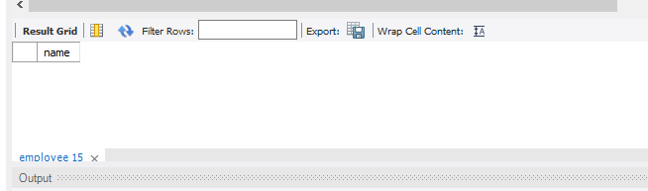

13. Get the total salary of the department with the maximum total salary.

select sum(salary) from employee where department =

(select department from employee group by department order by sum(salary) desc limit 1);

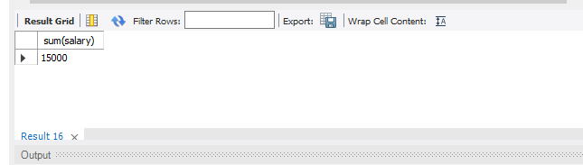

14. Retrieve employees whose department has more than two employees.

select name from employee where department = (select department from employee group by department having count(emp_id)>2);

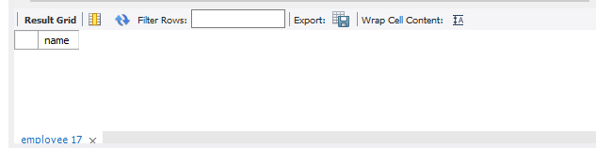

15. Find employees whose salary is higher than the average salary of employees in the IT department.

select name from employee where salary > (select avg(salary) from employee where department = "IT");

