**ARRAY**

**$ arrayElemAt**

**db.mongo14.aggregate([{$project:{name:1,**

**selectedHobby:{$arrayElemAt:["$hobbies",1]}}}])**

**$firstN/lastN**

**db.mongo13.aggregate([{$project:**

**{name:1,**

**topHobbies:**

**{$firstN:{input:"$hobbies",n:1}}}}])**

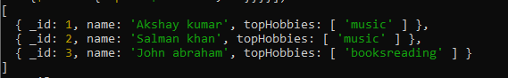

**db.mongo13.aggregate([{$project:**

**{name:1,**

**lastHobbies:**

**{$lastN:{input:"$hobbies",n:2}}}}])**

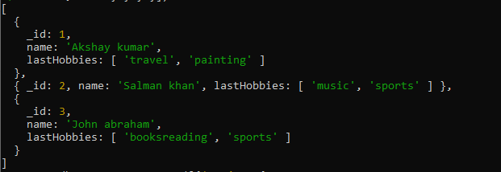

**$maxN/minN**

**db.mongoab1.aggregate([{$project:{name:1, topmarks:**

**{$maxN:{input:"$marks",n:1}}}}])**



**db.mongoab1.aggregate([{$project:{name:1, topmarks:**

**{$minN:{input:"$marks",n:2}}}}])**

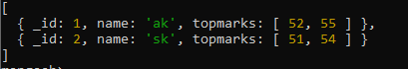

**$slice**

**db.actors.aggregate([{$project:{name:1,**

**selectedHobbies:{$slice:["$hobbies",1]}}}])**

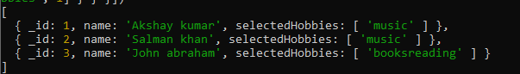

**db.actors.aggregate([{$project:{name:1,**

**selectedHobbies:{$slice:["$hobbies",1,2]}}}])**

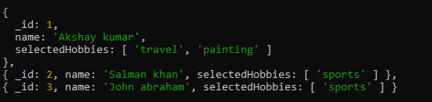

**db.actors.aggregate([{$project:{name:1,**

**selectedHobbies:{$slice:["$hobbies",-2]}}}])**

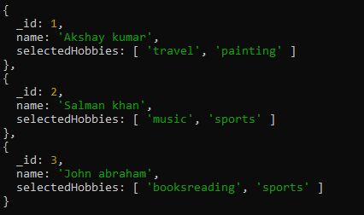

**db.actors.aggregate([{$project:{name:1,**

**selectedHobbies:{$slice:["$hobbies",-2,1]}}}])**

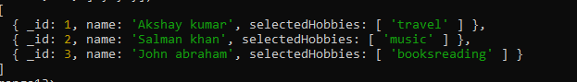

**Sorting**

**$sortArray**

**db.mongo13.aggregate([{$project:{name:1,**

**sortedHobbies:{$sortArray:{input:"$hobbies", sortBy:1}}}}])**

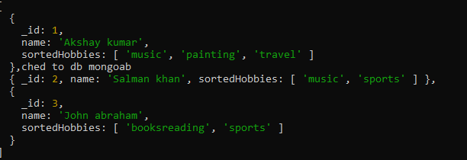

**db.mongoab1.aggregate([{$project:{name:1,**

**selectedHobbies:{$sortArray:{input:"$marks", sortBy:1}}}}])**

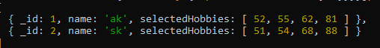

**$reverseArray**

**db.mongo14.aggregate([{$project:{name:1,**

**reversedHobbies:{$reverseArray:"$hobbies"}}}])**

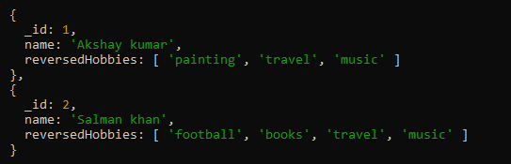

**$size**

**db.actors.aggregate([{$project:{name:1,**

**HobbiesCount:{$size:"$hobbies"}}}])**



**$in**

**db.mongo14.aggregate([{$project:{name:1,**

**check:{$in:["music","$hobbies"]}}}])**



**$indexOfArray**

**db.mongo14.aggregate([{$project:{name:1,**

**index:{$indexOfArray:["$hobbies","music"]}}}])**



**db.mongo14.aggregate([{$project:{name:1,**

**index:{$indexOfArray:["$hobbies","football",1,3]}}}])**



**db.mongo14.aggregate([{$project:{name:1,**

**index:{$indexOfArray:["$hobbies","football",1,4]}}}])**



**$isArray**

**db.mongo14.aggregate([{$project:{name:1,**

**isArray:{$isArray:"$hobbies"}}}])**



**db.mongo14.aggregate([{$project:{name:1,**

**isArray:{$isArray:"$name"}}}])**



**$map**

**db.mongo14.aggregate([{$project:{**

**uppercaseHobbies:{$map: {input:"$hobbies",as:"hobbies",in:{$toUpper:"$$hobbies"}}}}}])**

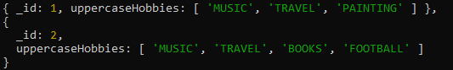

**db.mongo14a.aggregate([{$project:{**

**newMarks:{$map:{input:"$marks",as:"marks",in:{$add:["$$marks",2]}}}}}])**



**db.mongo14a.aggregate([{$project:{**

**AboveMarks:{$filter:{input:"$marks",as:"marks",cond:{$gte:["$$marks",60]}}}}}])**



**$filter**

**db.mongo14a.aggregate([{$project:{**

**AboveMarks:{$filter: {input:"$marks",as:"marks",cond:{$gte:["$$marks",60]},limit:1}}}}])**



**$reduce**

**db.mongo14a.aggregate([{$project:{**

**totalMarks:**

**{$reduce:**

**{input:"$marks",initialValue:0,in:{$add:["$$value","$$this"]}}}}}])**



**db.mongo14.aggregate([{$project:{**

**CombineHobbies:**

**{$reduce:**

**{input:"$hobbies",initialValue:"",in:{$concat:["$$value","$$this"]}}}}}])**



**db.mongo14.aggregate([{$project:{**

**CombineHobbies:**

**{$reduce:**

**{input:"$hobbies",initialValue:"",in:{$concat:["$$value","$$this"," "]}}}}}])**



**$concatArrays**

**db.mongoab5.aggregate([{$project:{**

**name:1,**

**allSubjects:{**

**$concatArrays:["$subjects", "$extrasubjects"] }}}])**

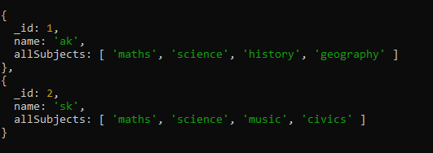

**db.mongoab6.aggregate([{$project:{**

**name:1,**

**data:{**

**$zip:{inputs:["$subjects","$marks"]}}}}])**

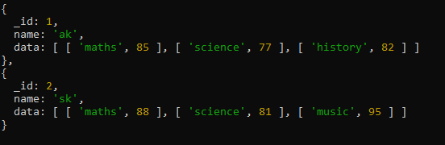

**db.mongoab7.aggregate([{$project:{**

**name:1,**

**SubjectInfo:{**

**$arrayToObject:"$subjects"}}}])**

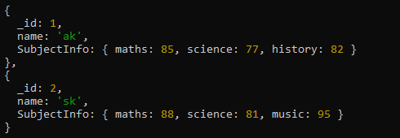

**db.mongoab8.aggregate([{$project:{**

**name:1,**

**SubjectInfo:{**

**$objectToArray:"$studentInfo"}}}])**

