EXPERIMENT – 10
NAME – SUMANSHU JINDAL | UID – 24BCS11091
BRANCH – BE – CSE | SECTION/GROUP – 24BCS_APP-707A
SEMESTER – 5th | DATE OF PERFORMANCE – 21/9/2026
SUBJECT NAME – COMPETITIVE CODING | SUBJECT CODE – 24CSP – 305

Aim – To efficiently find the redundant directed edge whose removal restores a valid rooted tree structure.
Objectives
- Classify the problem into three cases using in-degree analysis.
- Apply Union-Find with path compression to detect directed cycles.
- Identify redundant parent edge when node has two parents.
- Analyze time and space complexity of the implemented algorithm.
Theory
In-degrees are scanned to find a node with two parents, recording both incoming edges as candidates. Union-Find then runs skipping the second candidate. A cycle returns the first candidate, or the cycle edge when no candidate exists. Otherwise the second candidate is returned. Time is nearly linear; space is O(n).
IMPLEMENTATION/INPUT CODE
#include <iostream>
#include <vector>
#include <algorithm>
using namespace std;
struct DSU {
vector<int> parent, rnk;
DSU(int n) : parent(n + 1), rnk(n + 1, 0) {
for (int i = 0; i <= n; ++i) parent[i] = i;
}
int find(int x) {
return parent[x] == x ? x : parent[x] = find(parent[x]);
}
bool unite(int u, int v) {
u = find(u); v = find(v);
if (u == v) return false;
if (rnk[u] < rnk[v]) swap(u, v);
parent[v] = u;
if (rnk[u] == rnk[v]) ++rnk[u];
return true;
}
};
vector<int> findRedundantDirectedConnection(vector<vector<int> >& edges) {
int n = edges.size();
vector<int> parent(n + 1, 0), cand1, cand2;
for (size_t i = 0; i < edges.size(); ++i) { // find in-degree 2
int u = edges[i][0], v = edges[i][1];
if (parent[v] == 0) parent[v] = u;
else {
cand1 = vector<int>{parent[v], v};
cand2 = edges[i];
}
}
DSU dsu(n); // skip cand2 if present
for (size_t i = 0; i < edges.size(); ++i) {
if (edges[i] == cand2) continue;
if (!dsu.unite(edges[i][0], edges[i][1]))
return cand1.empty() ? edges[i] : cand1;
}
return cand2;
}
int main() {
int n;
cin >> n;
vector<vector<int> > edges(n, vector<int>(2));
for (int i = 0; i < n; ++i)
cin >> edges[i][0] >> edges[i][1];
vector<int> res = findRedundantDirectedConnection(edges);
cout << "[" << res[0] << "," << res[1] << "]" << endl;
return 0;
}
OUTPUT
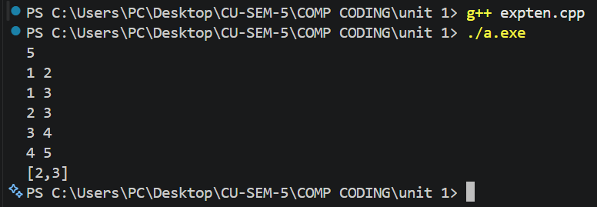
Learning Outcomes
- Understand three structural cases created by adding extra directed edge.
- Detect directed cycles using Union-Find with path compression and rank.
- Record both candidate edges when a node has in-degree two.
- Skip the second candidate edge while performing cycle detection safely.
- Analyze nearly linear time complexity and auxiliary space complexity O(n).

