EXPERIMENT – 1.3
NAME – SUMANSHU JINDAL | UID – 24BCS11091
BRANCH – BE – CSE | SECTION/GROUP – 24BCS_APP-707A
SEMESTER – 5th | DATE OF PERFORMANCE – 8/9/2026
SUBJECT NAME – COMPETITIVE CODING | SUBJECT CODE – 24CSP – 305

Aim – To select at most k engineers maximizing overall team performance using greedy sorting and heaps.
Objectives
- Apply greedy methods and priority queues to optimization problems.
- Calculate maximum team performance efficiently using sorting and min-heaps.
- Analyze time and space complexity of the implemented algorithm.
- Test solutions using normal, boundary, and edge case inputs.
Theory
Engineers are sorted by efficiency in descending order. Each engineer's efficiency acts as the team's current minimum. A min-heap retains the k largest speeds, discarding the smallest when exceeded. Performance equals speed sum multiplied by current efficiency; the maximum is tracked. Time complexity is O(n log n); space is O(n).
IMPLEMENTATION/INPUT CODE
#include <iostream>
#include <vector>
#include <queue>
#include <algorithm>
using namespace std;

int maxPerformance(int n, vector<int>& speed, vector<int>& efficiency, int k) {
const int MOD = 1e9 + 7;
vector<pair<int, int>> eng(n);
for (int i = 0; i < n; ++i)
eng[i] = {efficiency[i], speed[i]};

sort(eng.rbegin(), eng.rend());

priority_queue<int, vector<int>, greater<int>> minHeap;
unsigned long long speedSum = 0, best = 0;

for (int i = 0; i < n; ++i) {
int eff = eng[i].first;
int spd = eng[i].second;

minHeap.push(spd);
speedSum += spd;

if ((int)minHeap.size() > k) {
speedSum -= minHeap.top();
minHeap.pop();
}
best = max(best, speedSum * eff);
}
return best % MOD;
}

int main() {
int n, k;
cin >> n;

vector<int> speed(n), efficiency(n);
for (int &x : speed) cin >> x;
for (int &x : efficiency) cin >> x;
cin >> k;

cout << maxPerformance(n, speed, efficiency, k) << endl;
return 0;
}
OUTPUT
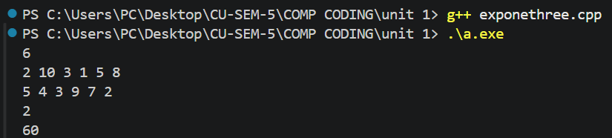
Learning Outcomes
- Understand how fixing minimum efficiency simplifies the team selection problem.
- Use min-heaps to efficiently maintain the k largest speeds dynamically.
- Prevent overflow using unsigned long long and modulo 10^9+7 correctly.
- Apply descending sorting to process engineers by decreasing efficiency order.
- Analyze time complexity O(n log n) and space O(n) accurately.

