EXPERIMENT – 2
NAME – SUMANSHU JINDAL | UID – 24BCS11091
BRANCH – BE – CSE | SECTION/GROUP – 24BCS_APP-707A
SEMESTER – 5th | DATE OF PERFORMANCE – 9/9/2026
SUBJECT NAME – COMPETITIVE CODING | SUBJECT CODE – 24CSP – 305

Aim – To efficiently format an array of words into fully justified lines of exactly maxWidth characters.
Objectives
- Apply greedy line-packing and string simulation to formatting problems.
- Distribute spaces evenly between words so each line fits.
- Handle edge cases such as single-word and last lines.
- Analyze time and space complexity of the implemented algorithm.
Theory
Words are packed greedily into each line without exceeding maxWidth. The remaining spaces are distributed evenly across gaps, with extra spaces assigned to the leftmost gaps. The last line and single-word lines are left-justified, padded with trailing spaces. Time complexity is O(n) over total input characters; auxiliary space is O(maxWidth).
IMPLEMENTATION/INPUT CODE
#include <iostream>
#include <vector>
#include <string>
using namespace std;

vector<string> fullJustify(vector<string>& words, int maxWidth) {
vector<string> result;
int n = words.size(), i = 0;
while (i < n) {
int lineLen = words[i].size(), j = i + 1;
while (j < n && lineLen + 1 + (int)words[j].size() <= maxWidth)
lineLen += 1 + words[j++].size();
int numWords = j - i;
int totalSpaces = maxWidth - (lineLen - (numWords - 1));
string line;
line.reserve(maxWidth);
line += words[i];
if (numWords == 1 || j == n) {
for (int k = i + 1; k < j; ++k) {
line += ' ';
line += words[k];
}
line.append(maxWidth - line.size(), ' ');
} else {
int gaps = numWords - 1;
int spaceEach = totalSpaces / gaps;
int extra = totalSpaces % gaps;
for (int k = i + 1; k < j; ++k) {
line.append(spaceEach + (k - i <= extra ? 1 : 0), ' ');
line += words[k];
}
}
result.push_back(line);
i = j;
}
return result;
}

int main() {
int n, maxWidth;
cin >> n;
vector<string> words(n);
for (int i = 0; i < n; ++i)
cin >> words[i];
cin >> maxWidth;
vector<string> res = fullJustify(words, maxWidth);
for (int i = 0; i < (int)res.size(); ++i)
cout << "\"" << res[i] << "\"\n";
return 0;
}
OUTPUT
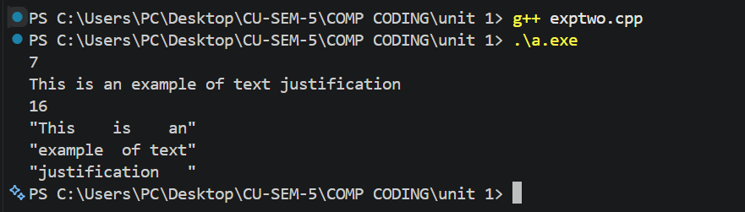

Learning Outcomes
- Understand greedy packing of words to fill each line optimally.
- Distribute remaining spaces evenly, giving extra spaces to leftmost gaps.
- Handle left-justified special cases for single-word and final lines correctly.
- Build lines efficiently using string operations without repeated unnecessary concatenation.
- Analyze time complexity O(n) and auxiliary space per output line.

