EXPERIMENT – 3
NAME – SUMANSHU JINDAL | UID – 24BCS11091
BRANCH – BE – CSE | SECTION/GROUP – 24BCS_APP-707A
SEMESTER – 5th | DATE OF PERFORMANCE – 15/9/2026
SUBJECT NAME – COMPETITIVE CODING | SUBJECT CODE – 24CSP – 305

Aim – To efficiently find the minimum element in a rotated sorted array containing possible duplicate values.
Objectives
- Apply modified binary search handling rotation and duplicate elements.
- Eliminate search halves by comparing midpoint with rightmost element.
- Handle equal midpoint and rightmost values by shrinking boundary.
- Analyze time and space complexity of the implemented algorithm.
Theory
Binary search compares the midpoint with the rightmost element. If the midpoint is greater, the minimum lies right; if smaller, it lies left including midpoint. If equal, the right boundary decrements by one. The loop ends when pointers meet. Average time is O(log n), worst case O(n); space is O(1).
IMPLEMENTATION/INPUT CODE
#include <iostream>
#include <vector>
using namespace std;

int findMin(vector<int>& nums) {
int lo = 0, hi = (int)nums.size() - 1;

while (lo < hi) {
int mid = lo + (hi - lo) / 2;

if (nums[mid] > nums[hi])
lo = mid + 1; // minimum lies in right half
else if (nums[mid] < nums[hi])
hi = mid; // minimum lies in left half (with mid)
else
--hi; // equal: safely shrink right boundary
}
return nums[lo];
}

int main() {
int n;
cin >> n;

vector<int> nums(n);
for (int &x : nums)
cin >> x;

cout << findMin(nums) << endl;
return 0;
}
OUTPUT
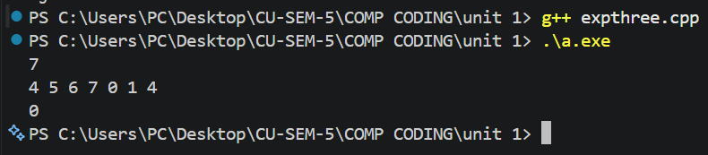
Learning Outcomes
- Understand how rotation divides a sorted array into two segments.
- Apply binary search by comparing the midpoint with the boundary.
- Resolve ambiguity caused by duplicates using safe right boundary shrinking.
- Prevent overflow by computing midpoint as lo plus half difference.
- Analyze time complexity O(log n) average and O(n) worst case.

