EXPERIMENT – 4
NAME – SUMANSHU JINDAL | UID – 24BCS11091
BRANCH – BE – CSE | SECTION/GROUP – 24BCS_APP-707A
SEMESTER – 5th | DATE OF PERFORMANCE – 16/9/2026
SUBJECT NAME – COMPETITIVE CODING | SUBJECT CODE – 24CSP – 305

Aim – To create the maximum number of length k from two digit arrays preserving relative order.
Objectives
- Enumerate all valid splits of k between both arrays.
- Extract maximum subsequences using a greedy monotonic stack technique.
- Merge subsequences into largest number using lexicographic suffix comparison.
- Analyze time and space complexity of the implemented algorithm.
Theory
For each valid split of k, a monotonic stack greedily extracts the maximum subsequence from each array. The two subsequences are merged by repeatedly choosing the lexicographically greater suffix. The best merged candidate across all splits is retained as the answer. Worst-case time complexity is O(k·(m+n+k²)); auxiliary space is O(m+n).
IMPLEMENTATION/INPUT CODE
#include <iostream>
#include <vector>
#include <algorithm>
using namespace std;
vector<int> maxSubseq(const vector<int>& nums, int len) {
int drop = (int)nums.size() - len;
vector<int> st;
for (int x : nums) {
while (drop > 0 && !st.empty() && st.back() < x) {
st.pop_back();
--drop;
}
st.push_back(x);
}
st.resize(len);
return st;
}
vector<int> mergeSeq(const vector<int>& a, const vector<int>& b) {
vector<int> res;
vector<int>::const_iterator i = a.begin(), j = b.begin();
while (i != a.end() || j != b.end()) {
if (lexicographical_compare(j, b.end(), i, a.end()))
res.push_back(*i++);
else
res.push_back(*j++);
}
return res;
}
vector<int> maxNumber(vector<int>& n1, vector<int>& n2, int k) {
int m = n1.size(), n = n2.size();
vector<int> best;
for (int i = max(0, k - n); i <= min(k, m); ++i) {
vector<int> cand = mergeSeq(maxSubseq(n1, i), maxSubseq(n2, k - i));
if (cand > best) best = cand;
}
return best;
}
int main() {
int m, n, k;
cin >> m;
vector<int> nums1(m);
for (int &x : nums1) cin >> x;
cin >> n;
vector<int> nums2(n);
for (int &x : nums2) cin >> x;
cin >> k;
vector<int> res = maxNumber(nums1, nums2, k);
for (int x : res) cout << x << " ";
cout << endl;
}
OUTPUT
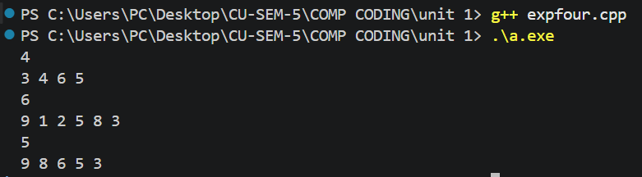

Learning Outcomes
- Understand enumerating every valid split of digits between two arrays.
- Apply monotonic stack to extract maximum subsequences of fixed length.
- Merge subsequences correctly by comparing remaining suffixes to break ties.
- Compare merged candidates lexicographically to retain the overall maximum result.
- Analyze worst-case time complexity O(k·(m+n+k²)) and auxiliary space O(m+n) accurately.

