EXPERIMENT – 5
NAME – SUMANSHU JINDAL | UID – 24BCS11091
BRANCH – BE – CSE | SECTION/GROUP – 24BCS_APP-707A
SEMESTER – 5th | DATE OF PERFORMANCE – 23/9/2026
SUBJECT NAME – COMPETITIVE CODING | SUBJECT CODE – 24CSP – 305

Aim – To efficiently find the maximum value in each sliding window of size k moving rightward.
Objectives
- Use monotonic decreasing deque storing indices of useful elements.
- Remove outdated front indices that fall outside the window.
- Remove smaller back elements to maintain decreasing deque order.
- Analyze time and space complexity of the implemented algorithm.
Theory
A monotonic deque stores decreasing-value indices. For each element, smaller back values are removed and the index is pushed. Front indices outside the window are removed. Once the window is full, the front element is the maximum. Each index is pushed and popped once, giving O(n) time and O(k) space.
IMPLEMENTATION/INPUT CODE
#include <iostream>
#include <vector>
#include <deque>
using namespace std;

vector<int> maxSlidingWindow(vector<int>& nums, int k) {
vector<int> result;
int n = nums.size();
if (k <= 0 || k > n) return result;
result.reserve(n - k + 1);
deque<int> dq; // stores indices

for (int i = 0; i < n; ++i) {
if (!dq.empty() && dq.front() <= i - k)
dq.pop_front(); // index outside window

while (!dq.empty() && nums[dq.back()] <= nums[i])
dq.pop_back(); // remove smaller elements

dq.push_back(i);

if (i >= k - 1)
result.push_back(nums[dq.front()]);
}
return result;
}

int main() {
int n, k;
cin >> n;

vector<int> nums(n);
for (int &x : nums)
cin >> x;
cin >> k;

vector<int> res = maxSlidingWindow(nums, k);
for (int x : res)
cout << x << " ";
cout << endl;
return 0;
}
OUTPUT
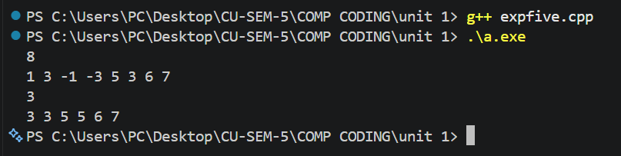
Learning Outcomes
- Understand why monotonic deques give amortized sliding window maximum queries.
- Maintain decreasing order by removing smaller elements from deque back.
- Expire outdated indices from the front using the window boundary.
- Record results only after the first full window is formed.
- Analyze time complexity O(n) and auxiliary space complexity O(k) accurately.

