EXPERIMENT – 6
NAME – SUMANSHU JINDAL | UID – 24BCS11091
BRANCH – BE – CSE | SECTION/GROUP – 24BCS_APP-707A
SEMESTER – 5th | DATE OF PERFORMANCE – 30/9/2026
SUBJECT NAME – COMPETITIVE CODING | SUBJECT CODE – 24CSP – 305

Aim – To efficiently find shortest transformation sequence length between two words changing single letters each step.
Objectives
- Apply Breadth First Search (BFS) to shortest path problems.
- Generate valid one-letter transformations efficiently using hash set dictionary.
- Analyze time and space complexity of the implemented algorithm.
- Test solutions using normal, boundary, and edge case inputs.
Theory
BFS explores words level by level from the begin word. Each position is replaced by letters a-z, and valid dictionary words are queued. Visited words are erased from the set to avoid revisits. The first time the end word appears gives the shortest length. Time is O(N·L²); space is O(N·L).
IMPLEMENTATION/INPUT CODE
#include <iostream>
#include <vector>
#include <queue>
#include <string>
#include <unordered_set>
using namespace std;
int ladderLength(string beginWord, string endWord, vector<string>& wordList) {
unordered_set<string> words(wordList.begin(), wordList.end());
if (words.find(endWord) == words.end()) return 0;
queue<pair<string, int> > q;
q.push(make_pair(beginWord, 1));
words.erase(beginWord);
while (!q.empty()) {
string word = q.front().first;
int steps = q.front().second;
q.pop();
if (word == endWord) return steps;
for (size_t i = 0; i < word.size(); ++i) {
char original = word[i];
for (char ch = 'a'; ch <= 'z'; ++ch) {
word[i] = ch;
if (words.find(word) != words.end()) {
q.push(make_pair(word, steps + 1));
words.erase(word);
}
}
word[i] = original;
}
}
return 0;
}
int main() {
string beginWord, endWord;
int n;
cin >> beginWord >> endWord >> n;
vector<string> wordList(n);
for (int i = 0; i < n; ++i)
cin >> wordList[i];
cout << ladderLength(beginWord, endWord, wordList) << endl;
return 0;
}
OUTPUT
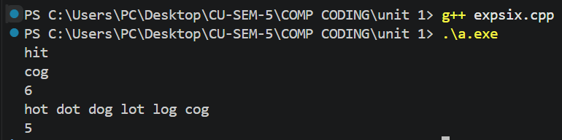
Learning Outcomes
- Understand how BFS guarantees shortest paths in implicit unweighted graphs.
- Generate neighbor words by replacing each character with every letter.
- Use unordered sets for constant-time dictionary lookups and visited tracking.
- Handle edge cases when end word is absent from dictionary.
- Analyze time complexity O(N·L²) and auxiliary space complexity O(N·L) accurately.

