EXPERIMENT – 7
NAME – SUMANSHU JINDAL | UID – 24BCS11091
BRANCH – BE – CSE | SECTION/GROUP – 24BCS_APP-707A
SEMESTER – 5th | DATE OF PERFORMANCE – 6/10/2026
SUBJECT NAME – COMPETITIVE CODING | SUBJECT CODE – 24CSP – 305

Aim – To efficiently find the median of each sliding window of size k in an array.
Objectives
- Apply two-heap median maintenance using ordered multisets for balancing.
- Process sliding window insertions and deletions in logarithmic time.
- Analyze time and space complexity of the implemented algorithm.
- Test solutions using normal, boundary, and edge case inputs.
Theory
Two multisets split the window: low holds the smaller half, high the larger half. Each new element is inserted, the outgoing one erased, and sizes rebalanced. The median is the top of low for odd k, otherwise the average of both tops. Time is O(n log k); space is O(k).
IMPLEMENTATION/INPUT CODE
#include <iostream>
#include <vector>
#include <set>
#include <iterator>
#include <iomanip>
using namespace std;
vector<double> medianSlidingWindow(vector<int>& nums, int k) {
multiset<int> low, high;
vector<double> result;
int n = nums.size();
if (k <= 0 || k > n) return result;
auto balance = [&]() {
while (low.size() > high.size() + 1) {
high.insert(*low.rbegin());
low.erase(prev(low.end()));
}
while (low.size() < high.size()) {
low.insert(*high.begin());
high.erase(high.begin());
}
};
for (int i = 0; i < n; ++i) {
if (low.empty() || nums[i] <= *low.rbegin()) low.insert(nums[i]);
else high.insert(nums[i]);
balance();
if (i >= k) {
multiset<int>::iterator it = low.find(nums[i - k]);
if (it != low.end()) low.erase(it);
else high.erase(high.find(nums[i - k]));
balance();
}
if (i >= k - 1) {
if (k % 2) result.push_back(*low.rbegin());
else result.push_back(((double)*low.rbegin() + *high.begin()) / 2.0);
}
}
return result;
}
int main() {
int n, k;
cin >> n;
vector<int> nums(n);
for (int &x : nums) cin >> x;
cin >> k;
vector<double> ans = medianSlidingWindow(nums, k);
cout << fixed << setprecision(1);
for (double x : ans) cout << x << " ";
cout << endl;
return 0;
}
OUTPUT
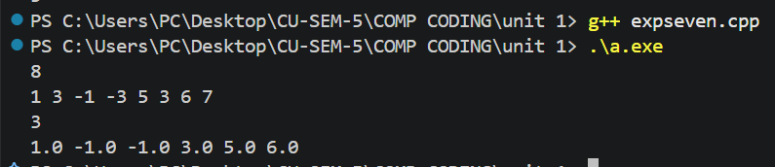
Learning Outcomes
- Understand how two balanced halves give the window median quickly.
- Insert and erase elements using ordered multisets in logarithmic time.
- Rebalance both halves after every insertion and removal operation correctly.

