EXPERIMENT – 8
NAME – SUMANSHU JINDAL | UID – 24BCS11091
BRANCH – BE – CSE | SECTION/GROUP – 24BCS_APP-707A
SEMESTER – 5th | DATE OF PERFORMANCE – 7/10/2026
SUBJECT NAME – COMPETITIVE CODING | SUBJECT CODE – 24CSP – 305

Aim – To efficiently find the length of the longest valid parentheses substring in a given string.
Objectives
- Apply a stack-based approach to track unmatched parenthesis indices.
- Compute valid substring lengths using index differences from stack.
- Analyze time and space complexity of the implemented algorithm.
- Test solutions using normal, boundary, and edge case inputs.
Theory
A stack stores indices, starting with base -1. Opening brackets push index. Closing brackets pop the top; if the stack becomes empty, the current index becomes the new base. Otherwise the current index minus the top gives a valid length, and maximum is updated. Time is O(n); space is O(n).
IMPLEMENTATION/INPUT CODE
#include <iostream>
#include <stack>
#include <string>
#include <algorithm>
using namespace std;
int longestValidParentheses(const string& s) {
int maxLen = 0, n = s.size();
stack<int> st;
st.push(-1); // base index
for (int i = 0; i < n; ++i) {
if (s[i] == '(') {
st.push(i);
} else {
st.pop();
if (st.empty())
st.push(i); // new base
else
maxLen = max(maxLen, i - st.top());
}
}
return maxLen;
}
int main() {
string s;
getline(cin, s);
cout << longestValidParentheses(s) << endl;
return 0;
}
OUTPUT
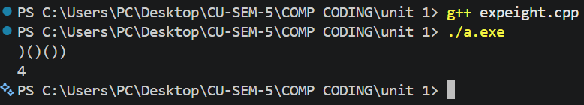
Learning Outcomes
- Understand how base index separates valid substrings from unmatched brackets.
- Use stack operations to match opening and closing parentheses correctly.
- Compute lengths directly using differences between current and top indices.
- Handle edge cases like empty strings and only closing brackets.
- Analyze time complexity O(n) and auxiliary space complexity O(n) accurately.

