EXPERIMENT – 9
NAME – SUMANSHU JINDAL | UID – 24BCS11091
BRANCH – BE – CSE | SECTION/GROUP – 24BCS_APP-707A
SEMESTER – 5th | DATE OF PERFORMANCE – 21/9/2026
SUBJECT NAME – COMPETITIVE CODING | SUBJECT CODE – 24CSP – 305

Aim – To compute the sum of distances from every node to all others in a tree.
Objectives
- Apply two-pass DFS rerooting to compute all distance sums.
- Use subtree sizes from first DFS to derive answers.
- Understand the rerooting relation between parent and child answers.
- Analyze time and space complexity of the implemented algorithm.
Theory
The first DFS from root 0 computes subtree sizes and the root's total distance sum. The second DFS reroots: when moving from parent to child, count[c] nodes each get closer while the remaining n minus count[c] get farther. Both passes together run in linear O(n) time using O(n) auxiliary space.
IMPLEMENTATION/INPUT CODE
#include <iostream>
#include <vector>
using namespace std;
int n;
vector<vector<int> > adj;
vector<int> cnt;
vector<long long> ans;
void dfs1(int u, int par) { // subtree sizes and ans[0]
cnt[u] = 1;
for (size_t k = 0; k < adj[u].size(); ++k) {
int v = adj[u][k];
if (v == par) continue;
dfs1(v, u);
cnt[u] += cnt[v];
ans[0] += cnt[v];
}
}
void dfs2(int u, int par) { // reroot for all nodes
for (size_t k = 0; k < adj[u].size(); ++k) {
int v = adj[u][k];
if (v == par) continue;
ans[v] = ans[u] - cnt[v] + (n - cnt[v]);
dfs2(v, u);
}
}
int main() {
int e;
cin >> n >> e;
adj.assign(n, vector<int>());
cnt.assign(n, 1);
ans.assign(n, 0);
for (int i = 0; i < e; ++i) {
int a, b;
cin >> a >> b;
adj[a].push_back(b);
adj[b].push_back(a);
}
dfs1(0, -1);
dfs2(0, -1);
for (int i = 0; i < n; ++i)
cout << ans[i] << " ";
cout << endl;
return 0;
}
OUTPUT
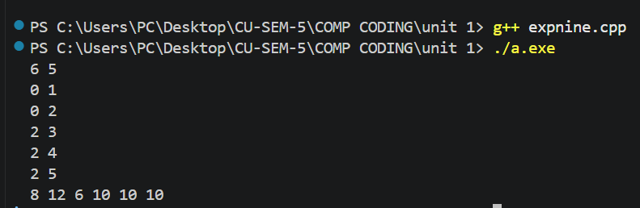
Learning Outcomes
- Understand how rerooting reuses parent answers to compute child answers.
- Compute subtree sizes and root distance sum using one DFS.
- Apply rerooting relation to move answers from parent to child.
- Handle edge cases such as single-node and two-node tree inputs.
- Analyze time complexity O(n) and auxiliary space complexity O(n) accurately.

